Industrial Managed Ethernet Switch User Manual – Layers 2 & 3

_______________________________________________________________________________

Firmware Version 1.2.10
User Manual

Compliant: For Military contracts that require the continuous monitoring and protection of industrial control systems (ICS) Networks Operating / monitoring the operating utilities such as Water, Sewer, Electrical, Security, Video, Building Controls, Street, and Intelligent Transportation Systems (ITS).

Uses: Cyber-Lock, IP Device Binding, Cyber-Secure Video, Clean Code Technology, & Secure Console / Chassis (Patent Pending)

Meets NSA Guidelines for Secure Network Endpoints

Copyright DYMEC 2021 – All Rights Reserved

DYMEC Series Layer 3 Switches

_______________________________________________________________________________

DYMEC Models Covered by This Manual
Specifications Subject to Change at the Direction of DYMEC

0802 Series: | CPG0802, CSX0802
0804 Series: | CPG0804, CPX0804, CTG0804
1002 Series: | CSG1002
1604 Series: | CSX1604, CPX1604  CP1604GB, CP1604XB
2404 Series: | CS2404GS-8C, CSX2404  CPG2404, CPX2404

Models Covered by This Manual
0802 Series | CP-0802G, CS-0802X
0804 Series: | CP-0804G, CP-0804X, CT-0804G
0812 Series: | CS-0812X
1002 Series: | CP-1002G, CS-1002G
1604 Series: | CS-1604X, CP-1604X  CP-1604GB, CP-1604XB
2404 Series: | CS-2404GS-8C, CS-2404X  CP-2404G, CP-2404X

Content

Overview 4
Basic Settings
System 9
IPv4 (VLAN IP) 10
IPv6 (VLAN IP) 12
System Time 13
Precision Time Protocol (PTP) 15
Redundancy
Spanning Tree 21
ERPS 30
MRP 36
Management
SNMP 41
DHCP 46
PoE 53
Industrial Protocols 59
UPnP 75
L2 Switching
Port Management 76
IGMP Snooping 85
802.1Q VLAN 89
Quality of Service 94
Port Trunk 98
L3 Routing
Static Route 100
OSPFv2 106
OSPFv3 115
RIPv1/v2 118
RIPng 127
VRRP 130
Security
Storm Control 133
802.1X 134
Service Control 138
Access Control List 140
SSH 143
Diagnostics
Port Mirroring 145
Remote SPAN (RSPAN) 146
Ping 151
Cable Diagnostic 153
Monitoring
LLDP 154
System Warning 156
Data Collection 162
MAC Table 167
Maintenance
Authorization 169
Firmware Upgrade 173
Config Backup 177
Config Restore 178
USB Auto-Load & Auto-Backup 179
SFTP File Access 180
Command Line Interface
Connect to CLI via Console Port 181
Connect to CLI via Telnet 182
Command Groups 189

Overview

CONFIGURATION VIA WEB CONSOLE
- Open the web browser. We recommend using "Google Chrome".
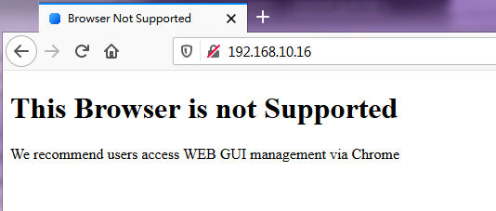
Note: If the web browser is not supported, the warning message will be showed up.

- Enter the IP Address in the URL field to connect to the switch and click "Enter" key.
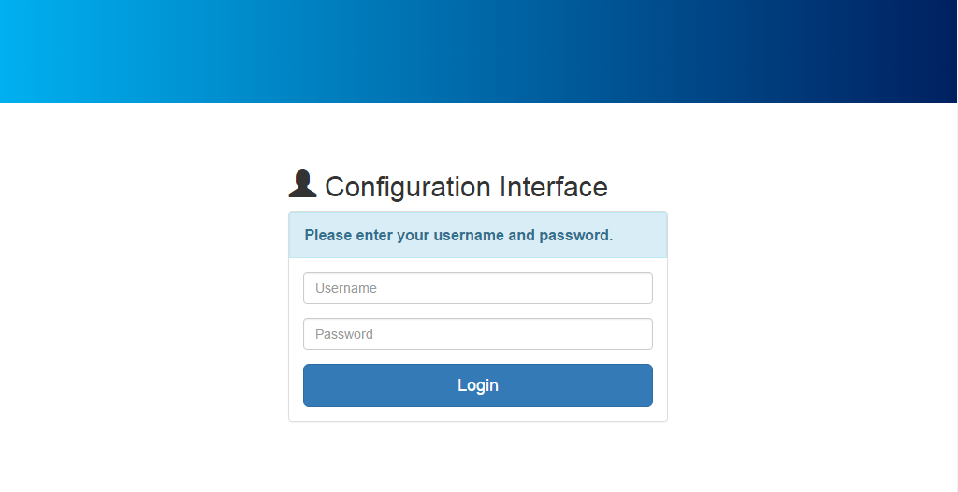
Note: The default IP Address is "192.168.10.1". The Login Page is displayed.

- Enter the Username and Password and click "Login" Button to login to the system.
Note: The default Username and Password is admin / admin.
After logging into the system, the "Overview" page is displayed.
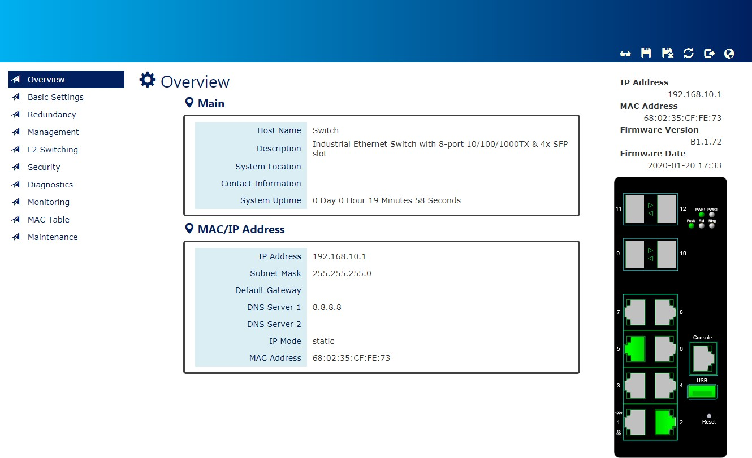

GLOBAL FUNCTIONS
Five global functions are provided in the header field.
1. Hide/Show Model Information
When a low-resolution environment is used to configure the system via the web console, the "Model Information" field can be hidden to have a better view.
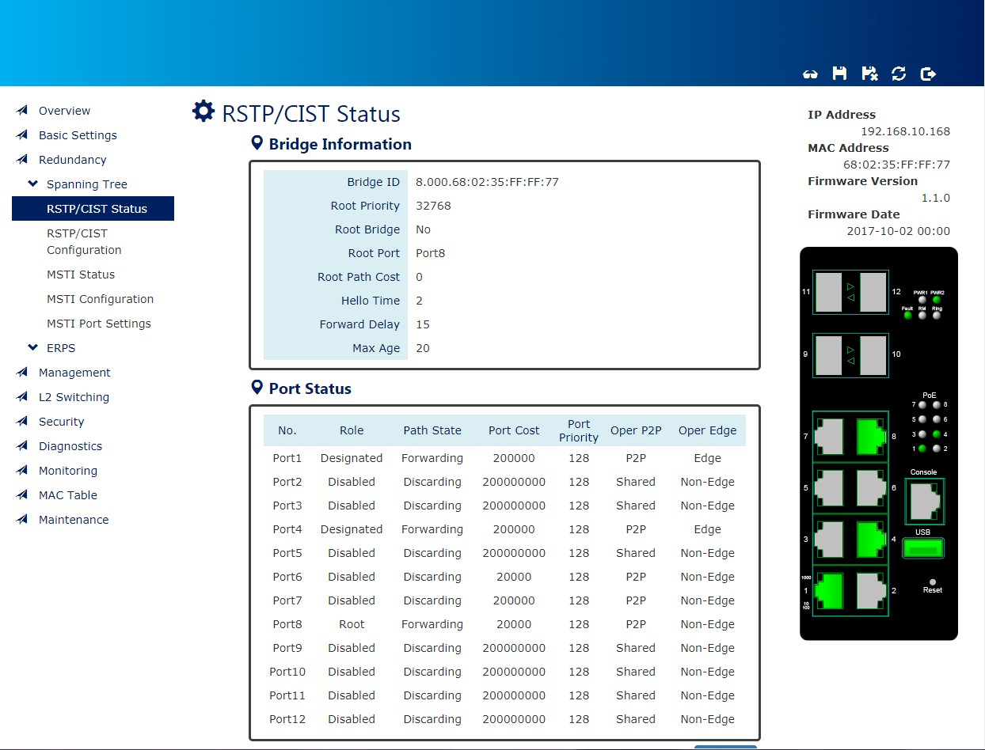
Show Model Information:

Hide Model Information:
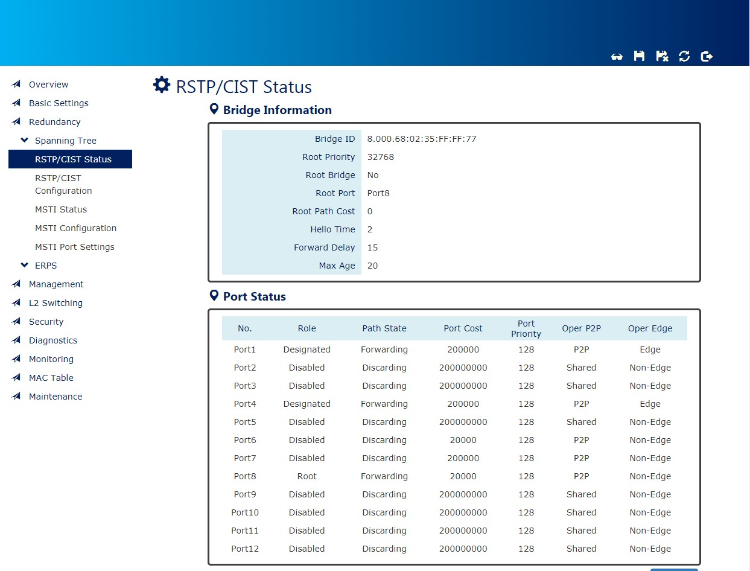

2.  Save Configuration
After configuring, click the icon to save the configurations to the "startup-config" file. The configurations are retained in the system until a factory reset default is done.

3.  Restore Factory Default
Removes the configurations saved in the system. After restoring factory default, all the settings will be set to default values.
4.  Reboot System
Reboots the device and restarts the system.
5.  System Logout
This option enables you to sign out from the system. Users have to login again if they want to configure the settings.
The system will auto-logout after the "timeout" timer expires. The "timeout" timer is configured in the CLI mode by using the "exec-timeout" command.
The maximum value of the timer in the web console is 30 mins.

6. Change Language
We support multi-language from firmware version 1.1.72. The default language is English and
Traditional Chinese is also supported by default. If you need other languages, please contact us.

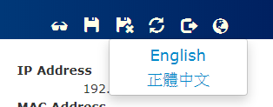
A USER-FRIENDLY DATA TABLE
A user-friendly data table is provided on the “IPv6 Neighbor Table”, “IGMP Snooping Table”, “VLAN Table”, “LLDP Neighbor Table”, and “MAC Address Table”. The following section details how to use the data table functions to help the users to observe the information easily.
The following example is “MAC Address Table”.
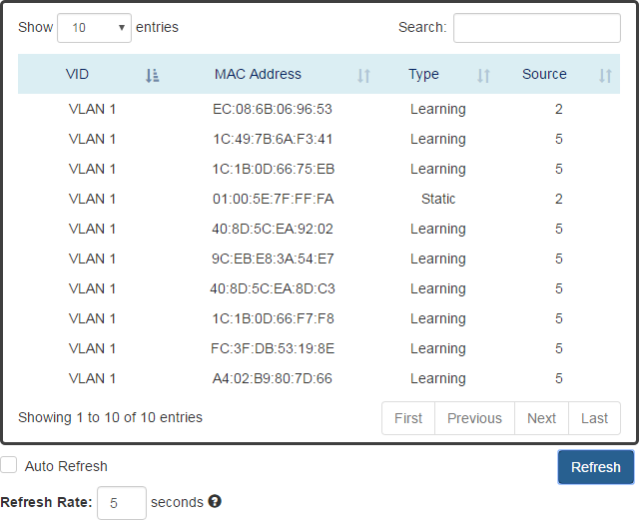
•
Users will be able to select a value to display the number of entries in one page. The following values can be selected - “10”, “25”, “50”, and “100” selections. By default, “10” is selected.

•

The search option enables you to search a key word in the data. It will search all the columns and identify the data rows that match the search criteria.
•
It displays the total number of entries and the current entry number.

  - and

This option orders the field from smaller to larger or from larger to smaller.
• 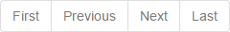
Changes to “First”, “Previous”, “Next”, or “Last” page.

In addition to the above functions, “Refresh” and “Auto Refresh” function are available for all status page including “IPv6 Neighbor Table”, “RSTP Port Status”, “DHCP Leased Table”, “Port Status”, “IGMP Snooping Table”, “VLAN Table”, “Trunking Status”, “LLDP Neighbor Table”, and “MAC Address Table”.
•
Selecting this checkbox enables the “Auto Refresh” function and deselecting the checkbox disables the “Auto Refresh” function.
• 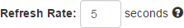
The Refresh Rate option is a global configurable variable. When the Auto Refresh option is enabled, the status will refresh automatically based on the Refresh Rate interval.
The range of the Refresh Rate is from 5 to 300 second(s). The default Refresh Rate is 5 seconds.


  - (Refresh Button)

You can click the “Refresh” button to manually refresh the status.

System Information

CONFIGURE SYSTEM INFORMATION
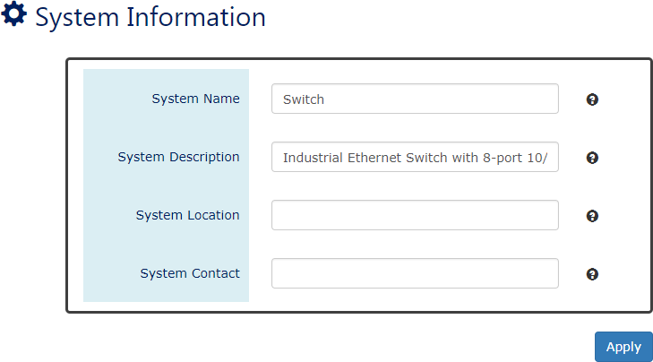
For more information, hover the mouse over the icon in the system.


Host Name
It is useful to identify the difference between the switches, for example: CoreSwitch01. The max. length for the Host Name is 32 characters.
Note: #, \, ', ", ? are invalid characters.

System Description
The System Description is default defined by the system.
It contains the copper port number, fiber port number, and PoE information (if supported). The max. length for the System Description is 68 characters.
Note: #, \, ', ", ? are invalid characters.

Switch Location
It is useful to find the location of the switches, for example: Area01. The max. length for the Switch Location is 32 characters.
Note: #, \, ', ", ? are invalid characters.

Contact Information
Records the information of the person responsible for this device and the contact details.
Note: #, \, ', ", ? are invalid characters.
•  (Apply Button)
After configuring above fields, click "Apply" button to make the changes effective.

IPv4 (VLAN IP)

Internet Protocol Version 4 (IPv4) is the fourth version of the Internet Protocol. It is used on the packet-switched networks and with connectionless communication. IPv4 has four bytes (32 bits) address and the address space is limited to 4,294,967,296 (2³²) unique addresses. On the local area network (LAN), the “Private Network” is used. It starts from 192.168.0.0 and the address space contains 65,025 (2¹⁶) IP addresses. The frames can only be sent to the host in the same subnet. For example, the default IP Address of the switch is “192.168.10.1”. When the users want to connect to the web console of the switch, an IP address from “192.168.10.2” to “192.168.10.254” must be assigned to the host.
We usually configure VLANs to divide broadcast domains in the Local Area Network (LAN). To communicate with others in another VLAN, we need the device to support inter-VLAN routing. Users can use VLANs to create Layer 3 interfaces by assigning IP address in different subnets to the VLAN. Before configuring any kind of routing protocols, users must make sure the VLAN IP Address is configured.
The Loopback Interface is a virtual interface for management or identity. It is more stable than physical interface and never goes down when physical interface fails. However, currently there are some limitations in our switches.
    - Loopback Interface is only supported on the IPv4
    - Only support one Loopback Interface
    - The IP Address of Loopback must be different from the IP Addresses of Interfaces (VLANs).
CONFIGURE IPV4 INFORMATION
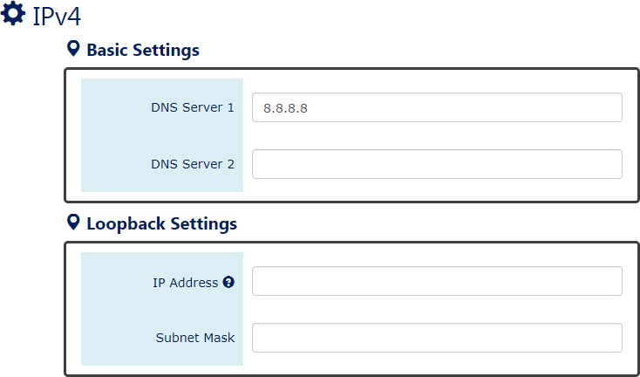

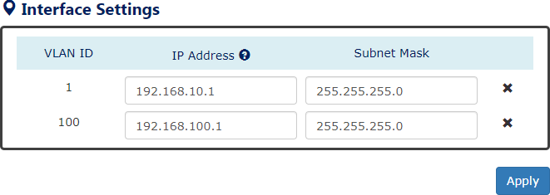

DNS Server 1 / 2
Specifies the IP address of the DNS Server so that the users can connect to another device based on the URL instead of the IP address.
The default DNS Server 1 is "8.8.8.8". It is provided by Google. The default DNS Server 2 is BLANK.

Loopback Settings
- IP Address
Assign a unique static IP Address for Loopback Interface.
Note: the IP Address of Loopback must be different from the IP Addresses of Interfaces (VLANs).
- Subnet Mask
Define the type of network of Loopback Interface.

Interface Settings
- VLAN ID
Users must create VLAN in the VLAN Settings Page before configuring its IP Address.
- IP Address
Assign a unique static IP Address for the VLAN ID. The default IP Address for VLAN 1 is "192.168.10.1".
- Subnet Mask
Define the type of network, to which this device is connected to. The default Subnet Mask for VLAN 1 is "255.255.255.0".
• (Apply Button)
After configuring above fields, click "Apply" button to make the changes effective.

IPv6 (VLAN IP)

Internet Protocol Version 6 (IPv6) is a solution to deal with the address space limitation of IPv4 and it is the most recent version of Internet Protocol. It is intended to replace IPv4. IPv6 is a Layer 3 (Internet Layer) protocol, which is used on the packet-switched networks and with connectionless communication. There are 16 bytes (128 bits) for an IPv6 address, and the address space is up to 2¹²⁸ unique addresses. The IPv6 address is usually represented in hexadecimal digits, 8 groups of 4 digits, and each group is separated by a “:” (colon). For example, the DNS server address in IPv6 is “2001:4860:4860:0000:0000:0000:0000:8888”.
CONFIGURE IPV6 INFORMATION
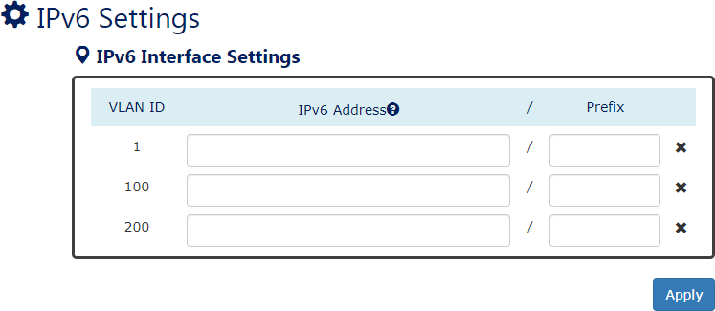
For more information, hover the mouse over the icon in the system.

VLAN ID
Users must create VLAN in the VLAN Settings Page before configuring its IP Address.

IPv6 Addresses
Enables the users to define an IPv6 addresses for each created VLAN.
The IPv6 address contains 2 section - IPv6 address and prefix. The default Prefix is 64-bit. : Click the remove icon to delete the IPv6 Address row.
• (Apply Button)
After configuring above fields, click "Apply" button to make the changes effective.

System Time

The System Time represents the date and time. The system uptime defines the passing time after the system boots up. There is no battery on the switch and hence the system time cannot be saved in the system. Users can configure the time zone and system time manually by synchronizing the time with the browser or by enabling the “NTP” service to get the time from a NTP Server.

NTP
Network Time Protocol (NTP) is a clock synchronization protocol, which is used to synchronize the system time with the NTP server. NTP is one of the oldest Internet Protocols in use from 1985 until now. It works based on a client-server model, but it can also be used in peer-to-peer relationships. The NTP application on the switch is follows the client-server model and the switch plays a role in the NTP Client.

CONFIGURE SYSTEM TIME INFORMATION
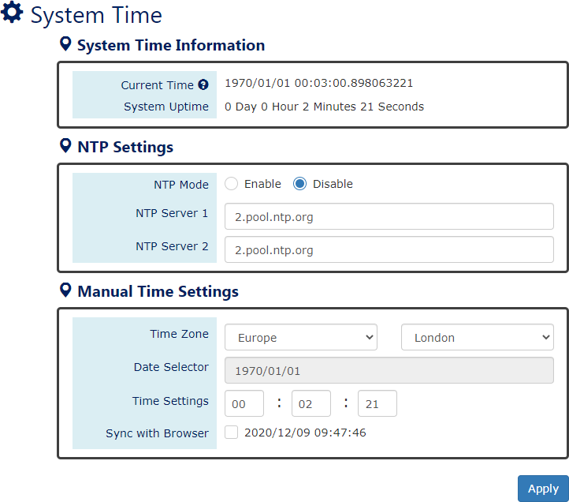

System Time Information
- Current Time: The current date time of the system.
Note: Time format: Year/Month/Day 24HR:Min:Sec.NanoSec
- System Uptime: The system boot up duration.

NTP Settings
- NTP Mode
"Enable" or "Disable" NTP Service. If NTP Mode is enabled, the system will sync time with NTP Server on an hourly basis.
- NTP Server 1 & 2
This field displays the URL or the IP address of the host that provides the NTP Service. There are 2 server configurations supported.

Manual Time Settings
- Time Zone
Select the Time Zone to define the local time offset from GMT.
- Date Selector
Select the system date manually. The format is "year/month/day".
- Time Setting
Define the system time manually. The format is "hour:minute:second".
- Sync with Browser
Select the checkbox to synchronize the system time with the browser time.
• (Apply Button)
After configuring above fields, click "Apply" button to make the changes effective.

Precision Time Protocol (PTP)

The Precision Time Protocol (PTP) is used to synchronize clocks and it is more accurate than NTP. PTP is majorly employed to synchronize the network devices that require precise timing like financial transactions. Synchronization and management of a PTP network is implemented by the exchange of messages across the communications devices.  PTP is working by a Master and Slave structure. There are three types of PTP clocks – Ordinary Clock, Boundary Clock, and Transparent Clock and currently we support  Ordinary Clock and Transparent Clock on the L2, Router, and L3 switches, and Boundary Clock on the Router and L3 switches. If the switch is an Ordinary Clock, it can be configured as role Master or Slave. For the Boundary Clock and Transparent Clock, they can be both Master and Salve at the same time to synchronize with  the Master and forward to Salves. | 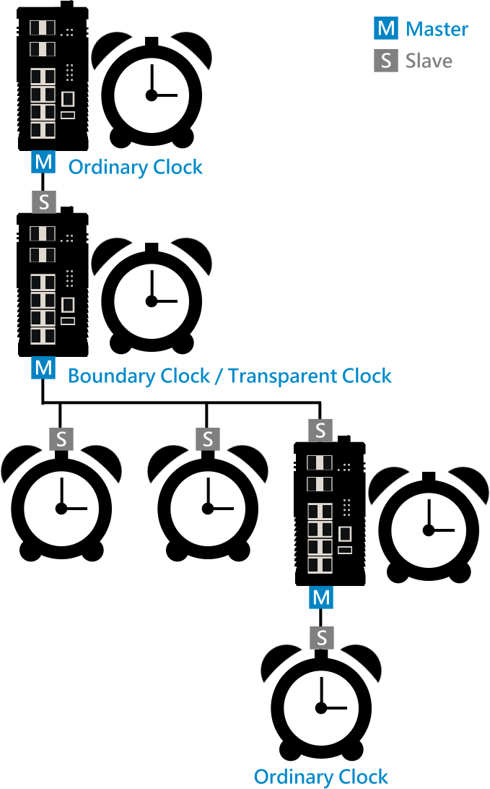

CONFIGURE PTP BASIC INFORMATION – ORDINARY CLOCK
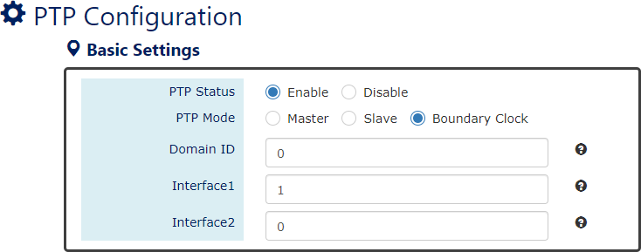
For more information, hover the mouse over the icon in the system.

PTP Status
"Enable" or "Disable" the PTP protocol.

Note: The PTP Slave and NTP Client are mutually incompatible, if users want to enable PTP mode with role Slave, please make sure the NTP Client is disabled.

PTP Mode
There are 3 roles of PTP that supported on the switch – Master, Slave, and Boundary Clock. The advanced settings of these modes are different, and the configurations are presented on the Configure PTP OC Master, Configure PTP OC Slave, and Configure PTP Boundary Clock sections.

Domain ID
The ID is the identifier of the PTP network. Only the nodes with the same Domain ID synchronize the time in the network.
The default value of Domain ID is 0
The range of Domain ID is from 0 to 127

Interface1
This field is to assign an interface for PTP function. It is the Master interface when PTP is running on Boundary Clock mode.
The default value of Interface1 is 1
The range of Interface1 is from 1 to 4094

Interface2
The field Interface2 is only supported on Boundary Clock mode. It is the Salve interface of Boundary Clock.
The default value of Interface2 is 0
The range of Interface2 is from 1 to 4094

CONFIGURE PTP ADVANCED SETTINGS
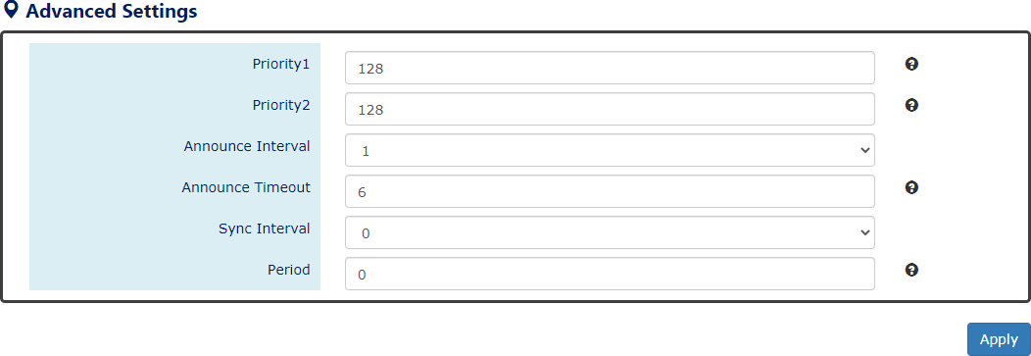
For more information, hover the mouse over the icon in the system.

Priority 1
The Priority is used to decide the Best Master when there are several Master nodes in the PTP network. If there are 2 or more Masters with the same Priority 1, the system will refer to the Priority 2.

The default value of Priority 1 is 128
The range of Priority 1 is from 0 to 248
Note: the lower the value the higher the priority

Priority 2
The Priority is used to decide the Best Master when there are several Master nodes with the same Priority 1 in the PTP network. If there are 2 or more Masters with the same Priority 2, the system will refer to the Clock Identity (MAC Address).
The default value of Priority 1 is 128
The range of Priority 1 is from 0 to 248
Note: the lower the value the higher the priority

Announce Interval
The Announce Interval is the period to send Announce Message.
The range of Announce Interval is from -1 to 7

Announce Timeout
The Announce Timeout is the timer for announcing timeout message.
The default value of Announce Timeout is 6
The range of Announce Timeout is from 2 to 255
  - Sync Interval
The Sync Interval is the period to send Sync Message.
The range of Sync Interval is from -7 to 7
The mapping for Announce Interval and Sync Interval to second(s) is as following table:
Interval | 0 | 1 | 2 | 3 | 4 | 5 | 6 | 7
Seconds | 1s | 2s | 4s | 8s | 16s | 32s | 64s | 128s
Interval |  | -1 | -2 | -3 | -4 | -5 | -6 | -7
Seconds |  | 512ms | 256ms | 128ms | 64ms | 32ms | 16ms | 8ms

Period
The Period is a timeout period. The Slave node will wait n (Period Value) times that announce receipt timeout before resetting.
The default value of Period is 0
The range of Period is from 0 to 20
• (Apply Button)
After configuring above fields, click "Apply" button to make the changes effective.

PTP STATUS – MASTER
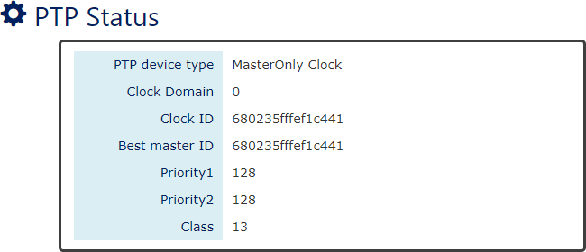

PTP Device Type
This field is the type/role of switch that in a PTP network. The switch can be “Master Only”
or “Slave Only” currently because we only support Ordinary Clock now.

Clock Domain
This field shows the Domain ID that the system is in now.

Clock ID
This field is the identity of the switch in the PTP network. The Clock Identity is configured to the MAC Address of the switch by default.

Best Master ID
The Best Master ID is the Clock Identity of the Best Master in a PTP network. If there are several Master in the PTP network, users can understand which one is the Best Master through this field.

Priority 1
This field is the value of Priority 1 that is configured.

Priority 2
This field is the value of Priority 2 that is configured.

Class
The Class field is usually named colckClass. The values of PTP clock classes are based on the traditional quality levels from SSM/ESMC.
PTP STATUS – SLAVE
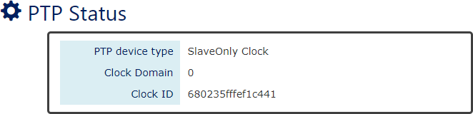

PTP Device Type
This field is the type/role of switch that in a PTP network. The switch can be “Master Only”
or “Slave Only” currently because we only support Ordinary Clock now.

Clock Domain
This field shows the Domain ID that the system is in now.

Clock ID
This field is the identity of the switch in the PTP network. The Clock Identity is configured to the MAC Address of the switch by default.

CONFIGURE PTP BASIC INFORMATION – TRANSPARENT CLOCK
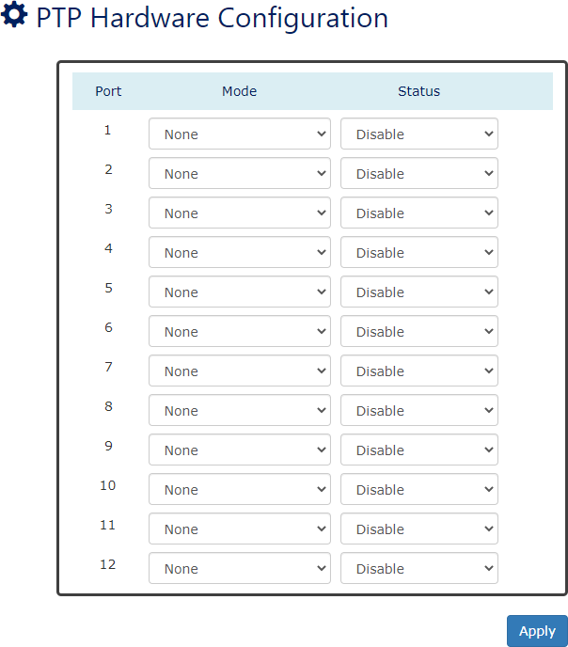

Known Limitations:
The Transparent Clock is only supported on the following conditions:
- VLAN untagged mode
- L2 management switches
- Copper ports and 1G SFP Slots
- One-step Mode
- End-to-End delay mechanism
  - Port
Port 1 to Port N, where N is based on the total port number.

Mode
Select Transparent Mode or Normal Mode (None) on the designated port.

Status
“Enable” or “Disable” selected mode on the designated port.
• (Apply Button)
After configuring above fields, click "Apply" button to make the changes effective.

Spanning Tree

The Spanning-Tree Protocol is a standard protocol that is defined in IEEE 802.1D. It is used to build a logical loop-free topology for layer-2 Networks. The basic function of the protocol is to prevent loops and broadcast flooding around the switches. STP allows spare links in the network design to provide backup paths when the active link fails and requires a convergence time of 30-50 seconds to recover the topology when the topology is changed. This prompted the use of Rapid Spanning-Tree Protocol as it provides a faster convergence when the topology is changed.
RSTP was introduced by IEEE as 802.1w. It can respond within 3 x "Hello Time" when a topology is changed. The "Hello Time" is a configurable value, and it is important for RSTP. The default RSTP value is 2 seconds and typically, the convergence time for RSTP is under 6 seconds. RSTP is much faster than STP. RSTP should be used instead of STP.
The Multiple Spanning-Tree Protocol defined in the IEEE 802.1s is an extension to RSTP for Virtual LANs. MSTP provides a better alternate path than STP/RSTP for different VLANs. It can make a group of VLANs more systemized in the topology.

CONFIGURE RSTP/CIST BASIC INFORMATION
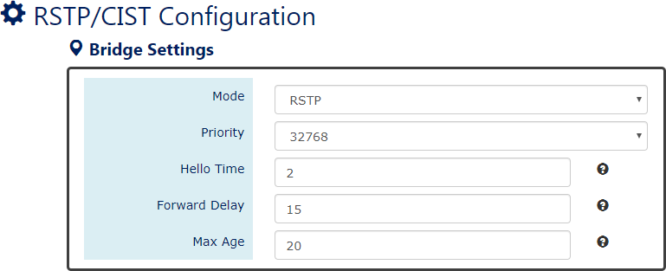
For more information, hover the mouse over the icon in the system.

System Time Information
RSTP: Enable STP and run "RSTP" for redundancy.
MSTP: Enable STP and run "MSTP" for redundancy.
Disable: Disable STP. Users must enable another protocol to prevent from loop.

Root Priority
It is used to define the "Root Bridge". The bridge with the lowest Root Priority is the "Root Bridge". If all the bridges are set to the same Root Priority value, the system will select the Root Bridge based on the MAC Addresses.

The range of Root Priority is from 0 to 61440 (multiple of 4096). The default Root Priority is 32768.

Hello Time
It is important and used to determine the interval to send BPDU (management frame) to check the RSTP topology and status.
The range of Hello Time is from 1 to 10 second(s). The default Hello Time is 2 seconds.

Forward Delay
A delay/timer is used to determine when to change the Path State from Learning/Listening to Forwarding.
The range of Forward Delay is from 4 to 30 seconds. The default Forward Delay is 15 seconds.

Maximum Age
A timer that is used to wait for the Hello BPDU from the Root Bridge. If this device receives the BPDU before the timer expires, the timer will be reset. Else, the device will send the topology changed BPDU to notify other devices.
The range of Maximum Age is from 6 to 40 seconds. The default Maximum Age is 20 seconds
The relationship between "Hello Time", "Forward Delay", and "Maximum Age" is:

2 x (Forward Delay - 1 sec) >= Max Age >= 2 x (Hello Time + 1 sec)

CONFIGURE RSTP PORT INFORMATION
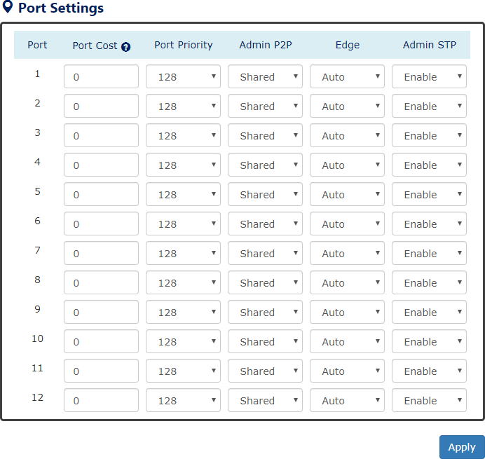

Port
For more information, hover the mouse over the icon in the system.

Port 1 to Port N, where N is based on the total port number.

Path Cost
The cost from the current node to another device. The range of Path Cost is from 0 to 200000000.
The default Path Cost is 0. This implies that the Path Cost is decided by the system.

Port Priority
Used to decide the port to be blocked in the Ring topology.
The range of Root Priority is from 0 to 240 and are in multiple of 16. The default Root Priority is 128.

Admin P2P
The Admin P2P is the link-type for each port.
P2P: It is a full-duplex link.
Shared: It is a half-duplex link.

Edge
A port that can connect to a non-STP device is called an Edge port. Users can manually fix a port to non-Edge or Edge.
Auto: The system automatically identifies an Edge or Non-Edge.
Edge: The port is forced to be an Edge port. An edge port will directly be transitioned to the "Forwarding" state and is not required to wait for the "Forward Delay". If a port is directly connected to a non-STP device, users can manually set it to "Edge" and enable it to transmit faster.
Non-Edge: The port is forced to be a Non-Edge port. This implies that the port will go through Learning/Listening to Forwarding state even though it is connected to an end device or not.

Admin STP
"Enable" or "Disable" the Spanning-tree protocol that is running on the specific port.
• (Apply Button)
After configuring above fields, click "Apply" button to make the changes effective.
RSTP/CIST STATUS
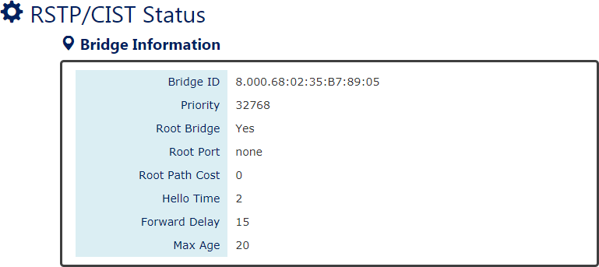

Bridge ID
This field shows the unique identity of this node when it is part of a network. It contains 8 bytes - the first 2 bytes are for Bridge Priority (configurable) and the remaining 6 bytes are for the MAC Address (unique).

Root Bridge

It is elected from the switches in the STP topology via several STP messages (BPDU). The Root Bridge is the node with the lowest Root Priority. If all the nodes are with the same Root Priority, the Root Bridge will be selected based on their MAC Addresses.

Root Priority
It is used to define the "Root Bridge". The bridge with the lowest Root Priority is the "Root Bridge". If all bridges are set to the same Root Priority value, the system will select the Root Bridge based on the MAC Addresses.

Root Port
It is the port that is connected to the Root Bridge and with the lowest cost. If the Root Port shows "none", it implies this node is the Root Bridge.

Root Path Cost
It is the cost from the current node to the Root Bridge.

Hello Time
It is used to determine the interval to send BPDU (management frame) to check the RSTP topology and status.

Forward Delay
It is used to determine when to change the Path State from Learning/Listening to Forwarding.

Max Age
It is used during waiting for Hello BPDU from the Root Bridge.
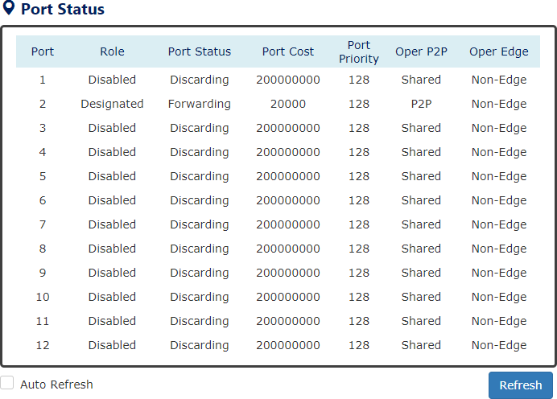

Port
Port 1 to Port N, N is based on the total port number.

Role
This field shows the role of the STP port.
Root: This is the root port, which is connected to the Root Bridge with the lowest cost.
Designated: This is the designated port, which can send the best BPDU on the segment to other connected nodes.
Alternate: This is the alternate port, which is blocked. This port can still receive useful BPDU from another bridge. When it receives a useful BPDU, it will help to forward it on the segment.
Backup: This is the backup port, which is blocked. It corresponds with “Alternate Port” to the blocking state. This port also receives useful BPDU, but the BPDU is from the same bridge. When it receives a useful BPDU, it will help to forward it on the segment.
Disabled: The port is not linked up.

Path State
This field shows the path state of this STP port.
Discarding: The port state can be “Disabled”, “Blocking”, or “Listening”. The incoming frames are dropped, and learning MAC addresses are stopped.
Learning: The port is learning MAC addresses, but the incoming frames are dropped.
Forwarding: The port in the forwarding state forwards the incoming frames based on the learned MAC address table.

Port Cost
This is the cost from the port to the Root Bridge. Spanning-tree Protocol assumes the path cost is determined by the access speeds of the links. The default RSTP path cost is shown in the following table:
Speed | RSTP Path Cost | Speed | RSTP Path Cost
4 Mbps | 5,000,000 | 1000 Mbps (1Gbps) | 20,000
10 Mbps | 2,000,000 | 2000 Mbps (2 Gbps) | 10,000
16 Mbps | 1,250,000 | 10000 Mbps (10 Gbps) | 2,000
100 Mbps | 200,000

Port Priority
The Port Priority is used to determine the Root Port on a non-root bridge. The port with the lowest Port Priority value gets the higher priority.

Oper. P2P
This field shows the link-type of the STP port. P2P means “point-to-point” and Shared means “point-to-multiple”.

Oper. Edge
This field shows the edge state of this STP port.

CONFIGURE MSTI INFORMATION
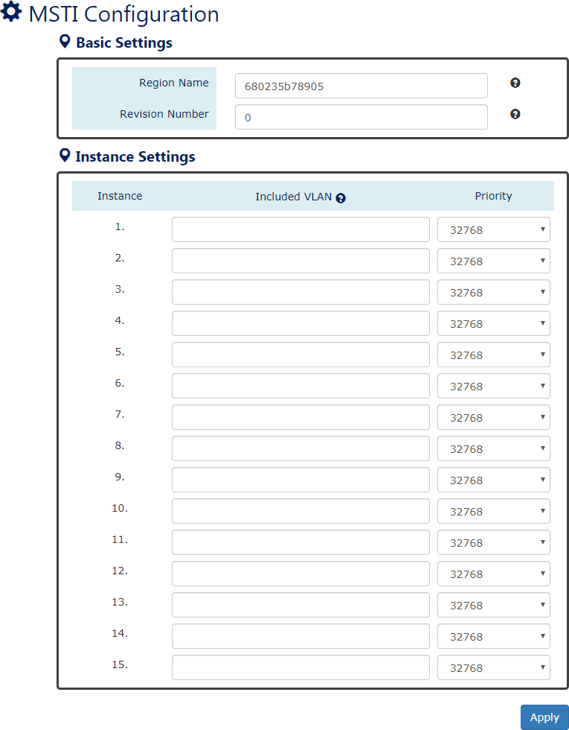
For more information, hover the mouse over the icon in the system.

Basic Settings
- Region Name
The Region Name is the name of the MST Region. The switches in the same MST Region must be set to the same Region Name.
The max. length for the Region Name is 32 characters. Note: #, \, ', ", ? are invalid characters.
- Revision Number
The Revision Number is the level of the MST Revision. The switches in the same MST Region must be set to the same Revision Number.

The range of the Revision Number is from 0 to 65535.
The default Revision Number is 0.

Instance Settings
- Instance
The Instance is from 1 to 15.
- Included VLAN
The configured VLANs are involved in the specific Instance.
The format is: 10, 20, 30…. “Comma” is used to separate VLAN IDs.
- Priority
The priority is used to define the “Root Bridge” that is used to communicate with other MSTI Region.
The range of the Root Priority is from 0 to 61440 (multiple of 4096). The default Root Priority is 32768.
• (Apply Button)
After configuring above fields, click "Apply" button to make the changes effective.
CONFIGURE MSTI PORT INFORMATION
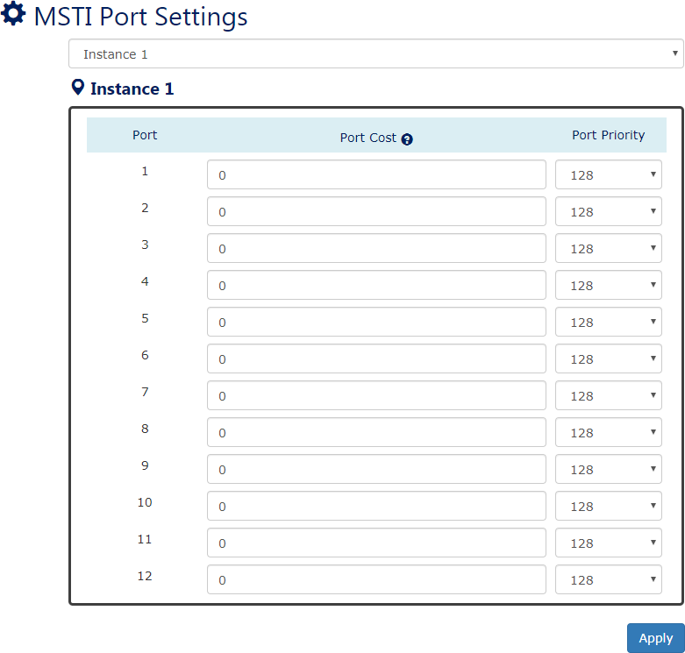
For more information, hover the mouse over the icon in the system.

Instance Selector
Select the instance to configure the ports. The Instance No. is from 1 to 15.

Port
Port1 to PortN, where N is based on the total port number.

Path Cost
The Path Cost is the cost from the current node to another device. The range of the Path Cost is from 0 to 200000000.
The default Path Cost is 0. This implies that the Path Cost is decided by the system.

Port Priority
This is used to identify the port to be blocked in the Ring topology.
The range of the Root Priority is from 0 to 240 and is in multiples of 16. The default Root Priority is 128.
• (Apply Button)
After configuring above fields, click "Apply" button to make the changes effective.

ERPS

Ethernet Ring Protection Switching (ERPS) applies the protection switching mechanism for Ethernet traffic in a ring topology. This mechanism is defined in ITU-T G8032. You can have a protection switching and avoid the possible loops in a network by implementing the ERPS function. This is done by blocking the flow of traffic to the Ring Protection Link (RPL) there by protecting the entire Ethernet ring.
When an ERPS is implemented in a ring topology, only one switch is allocated as the owner. This switch oversees blocking the traffic in the RPL to avoid loops. The switch adjacent to the RPL owner is called the RPL neighbor node and it is responsible for blocking the end of the RPL during normal condition. The participating switches that are adjacent to the RPL owner or neighbor in a ring are called the members or RPL next-neighbor nodes. The primary function of these switches is to forward the received traffic.
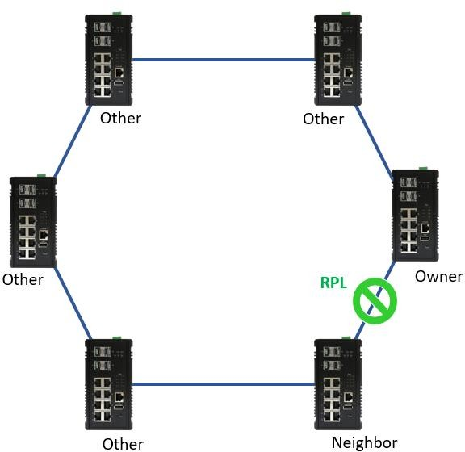

The benefit of the ERPS ring protection switching architecture are:

- Protection switching on Ethernet layer
- Preventing loop by blocking mechanism
- VLAN based protection
- Sub-50msec protection switching
- Support administration command
- 250 switches and links in singled ring tested

To make sure that a ring is up and loop-free, Ring Automatic Protection Switching message is sent regularly as control messages by nodes on the ring. The RPL owner identifies a signal failure (SF) in a ring when the RPL owner misses the poll packets or reads from the fault detection packets. When the fault is identified, the RPL owner unblocks the ring protection link (RPL) and permits the protected VLAN traffic through.
ERPS, like STP, provides a loop-free network by using polling packets to detect faults. If a fault occurs, ERPS restores itself by sending traffic over a protected reverse path rather than making a calculation to identify the forwarding path. The fault detection mechanism in the ERPS enables the ERPS to join in less than 50 milliseconds and recovers quickly to forward traffic. In a real test case, the protection switching time is 15ms in 250 devices single ring topology.
In the new ERPS version, G.8032 v2, it supports multiple ring or ladder topology. Rings can conjoin by one or more interconnection nodes. The major ring controls a full physical ring. Sub ring does not constitute a closed ring. It is connected to a major ring at the interconnection nodes.

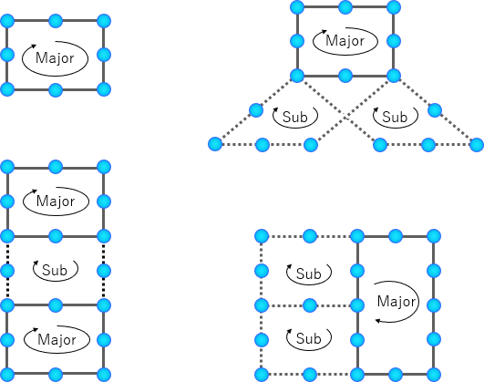

Using major ring and sub ring can design multiple ring or ladder topology. With these topologies, ERPS can append to variance application with different level of ring network. For example, core ring and branch ring architecture has application in campus and the area with central control node. Ladder topology has lots of case for tunnel and train application. The benefit of small ring is less effect nodes if ring caused of recovery.

CONFIGURE ERPS INFORMATION
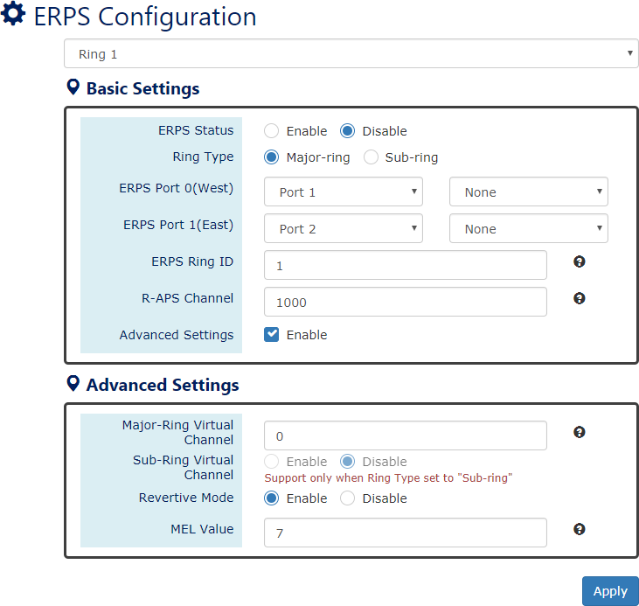
For more information, hover the mouse over the icon in the system.

ERPS Ring
There are three rings supported on a device. Using the dropdown select to change the ERPS Rings.

Basic Settings
- ERPS Status
“Enable” or “Disable” ERPS protocol running on the switch. By default, the ERPS protocol is disabled.
- Ring Type
Major-ring: controls a full physical ring.
Sub-ring: connected to another ring. It does not constitute a closed ring.
- ERPS Port 0
The ERPS Port 0 is also called “West Port”. Select one of the switch ports to be the Port 0 of ERPS and decide the role of the port.
- ERPS Port 1
The ERPS Port 1 is also called “East Port”. Select one of the switch ports to be the Port 1 of ERPS and decide the role of the port.

Note: Only One of the switch ports can be configured as ERPS Port 0 or ERPS Port 1.
Role | Description
Owner | There is only one “Owner” in the ERPS ring topology. The Owner is responsible for blocking the traffic in RPL and protects one side of  the RPL.
Neighbor | There is only one “Neighbor” in the ERPS ring topology. The Neighbor is the port connected with the Owner port and protects  another side of the RPL.
Interconnection | The Interconnection port connects a major-ring and a sub-ring. If one of the ports on the switch is set to “Interconnection” role, the  other port will be set to “Disabled” automatically.
None | The “None” implies that the port is other than an Owner or a  Neighbor.
- ERPS Ring ID
The ID is the identifier of the ring. The members in the same ring must be set to the same ERPS Ring ID.
The range of the ERPS Ring ID is from 1 to 239.
The default ERPS Ring ID is 1.
。 R-APS Channel
The R-APS Channel is used to forward ERPS information and is mapped to the VLAN IDs. These VLAN IDs cannot be set as traffic VLAN ID. The members in the same ring must be set to the same R-APS Channel.
The range of the R-APS Channel is from 1 to 4094.
The default R-APS Channel is 1000.

Advanced Settings
The Advanced Settings field is only displayed when the “Advanced Settings” checkbox is selected in the Basic Settings.
- Major-Ring Virtual Channel
This field is used to configure the specific virtual channel for transmitting the management packets of the sub-ring through the major-ring.
- Sub-Ring Virtual Channel
“Enable” or “Disable” using virtual channel in the sub-ring. When the Sub-Ring Virtual Channel is enabled, ERPS protocol will transmit management packets by the configured virtual channel.
- Revertive Mode
“Enable” or “Disable” the ERPS Revertive Mode. If the Revertive Mode is enabled, the blocked link will revert to the RPL link after the failed link is recovered.
By default, the ERPS Revertive Mode is enabled.
- MEL Value

MEL field is for the compliance with other devices which are running ITU-T G.8031 from third-party. The MEL implies the MEG Level. It is a field in the R-APS PDU. A large MEL value involves more devices. For example, level 7 contains levels 0 to 6.
The range of the MEL Value is from 0 to 7.
The default MEL Value is 7.
• (Apply Button)
After configuring above fields, click "Apply" button to make the changes effective.
ERPS STATUS
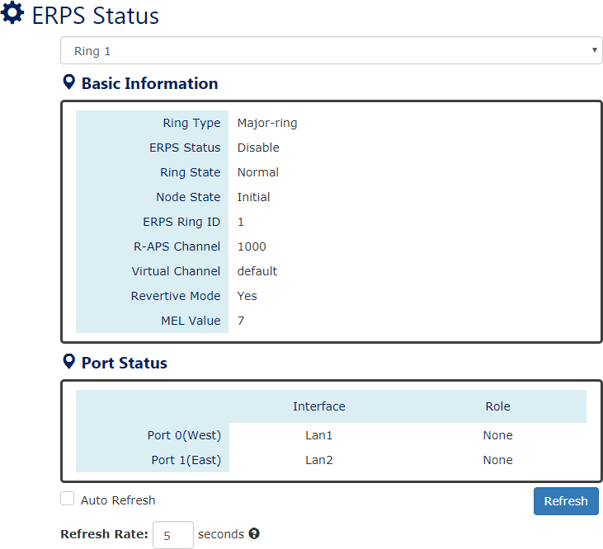

ERPS Ring
There are three rings supported on a device. Using the dropdown select to change the ERPS Rings.

Basic Information
- Ring Type
The type of the selected ERPS Ring shows “Major-ring”, “Sub-ring with virtual channel”, or “Sub-ring without virtual channel”.
- ERPS Status
The status of ERPS is “Enable” or “Disable” in the selected ERPS Ring.
- Ring State

There are two states for ERPS Rings: Normal and Abnormal.
- Node State
There are three states for ERPS Nodes: Initial, Idle, Pending, and Protection.
State | Description
Initial | The ERPS protocol is disabled in the selected ring.
Idle | The ERPS protocol is enabled in the selected ring and the ERPS ring  is under control by the RPL Owner.
Pending | The ERPS protocol is enabled in the selected ring. The ERPS ring is recovery from Protection state and is waiting for the wtr timer  expired.
Protection | The ERPS protocol is enabled in the selected ring but one of the links in the ring is broken. The RPL changes to forward to keep the  ring working.
- ERPS Ring ID
The ID is the identity for the selected ERPS Ring.
- R-APS Channel
This field shows the configured R-APS Channel.
- Virtual Channel
This field shows the virtual channel of sub-ring. If the field shows “default” implies the virtual channel follows the R-APS Channel.
- Revertive Mode
Show the Revertive Mode is enabled (Yes) or disabled (No).
- MEL Value
The field is the configured MEL value.

Port Status
- Interface
The configured port presents the ERPS port 0/1 in the ERPS protocol.
- Role
Display the configured role for the configured port.

MRP

MRP function is only supported on the CP-0804X
Media Redundancy Protocol (MRP) is an IEC standard protocol to prevent the ring topology from loop, and it is defined as IEC 62439-2. The recovery time of MRP is much faster than STP and even than RSTP, so it is suitable in most Industrial Ethernet applications.
In the ring topology with MRP, the manager is called Media Redundancy Manager (MRM), and the clients are called Media Redundancy Clients (MRC). The MRM send test packets from both of its ring ports periodically to confirm the health of ring topology.
There are three states for MRP Ring Ports – Disabled, Blocked, and Forwarding. When the MRP ring is under normal operation, the network works in the Ring-Closed state. In the closed state, one of the MRM Ring Ports is blocked and the other one is forwarding, while both ring ports of MRCs are forwarding. Due to the blocked port, the topology is a logical stub, and the loops are avoided. If one of the forwarding links is failed, the ring topology goes to open state, and the blocked port of MRM will be forwarding state to insure the transmission in the ring.
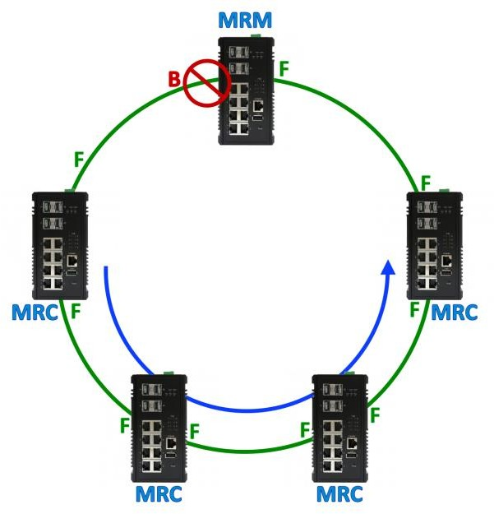 | 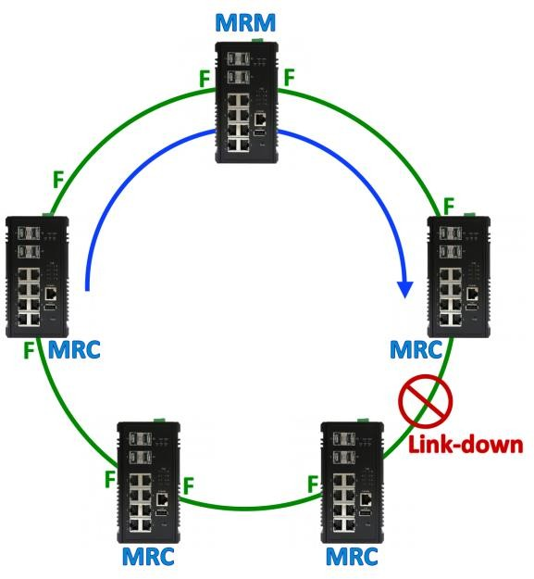
Ring Topology Closed | Ring Topology Open
If the MRC detects a link down at one of the ring ports, it can notify this event to the MRM initiatively. In Advanced Mode, the MRM can activate the blocked ring port to speed-up recovery rather than wait till sufficient loss of test packets.
MRP standard guarantees the recovery time in the specifications. The recovery time are 500ms, 200ms, 30ms with maximum 50 switches, and 10ms with up to 14 switches in a ring. Currently, we support the recovery delay of 500ms and 200ms.

CONFIGURE MRP INFORMATION

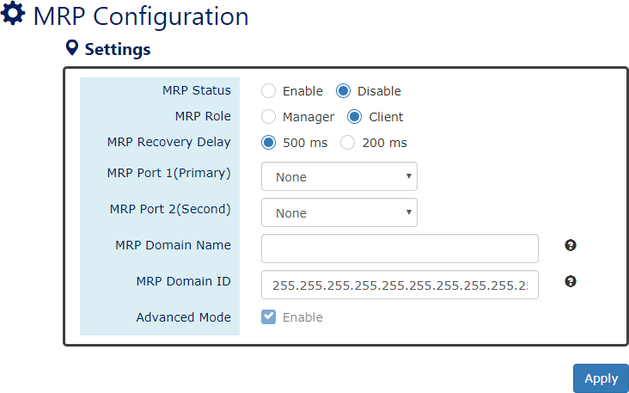

For more information, hover the mouse over the icon in the system.

MRP Status
“Enable” or “Disable” MRP protocol running on the switch. By default, the MRP protocol is
disabled.
  - MRP Role
Configure the role of the switch when running MRP protocol. The “Manager” item implies MRM, and the “Client” item implies MRC.

MRP Recovery Delay
The MRP Recovery Delay implies to the number of lost packets. The IEC 62439-2 standard defines 4 recovery delays – 500ms, 200ms, 30ms, and 10ms. Currently, we only support 500ms and 200ms.

MRP Port 1 (Primary)
The MRP Port 1 is the primary port of MRP. Select one of the switch ports to be the primary port of MRP. The Primary port is default configured to be forwarding when the Ring is closed.

MRP Port 2 (Second)
The MRP Port 2 is the secondary port of MRP. Select one of the switch ports to be the secondary port of MRP. The secondary port is default configured to be blocking when the Ring is closed.

MRP Domain Name
The MRP Domain Name is a unique string for the MRP domain to identify MRP domains

MRP Domain ID
The MRP Domain ID is the key attribute to define the members in the same MRP ring. The default MRP Domain ID is
255.255.255.255.255.255.255.255.255.255.255.255.255.255.255.255.
  - Advanced Mode
The Advanced Mode is supported only when the MRP Role is configured to “Manager”. If the Advanced Mode is checked, it implies the Advanced Mode is enabled. Under the advanced mode, when the MRM received a link-down signal, the MRM actives the backup port immediately rather than waiting for the sufficient loss of test packets.
MRP STATUS – BASIC & CONFIGURE INFORMATION
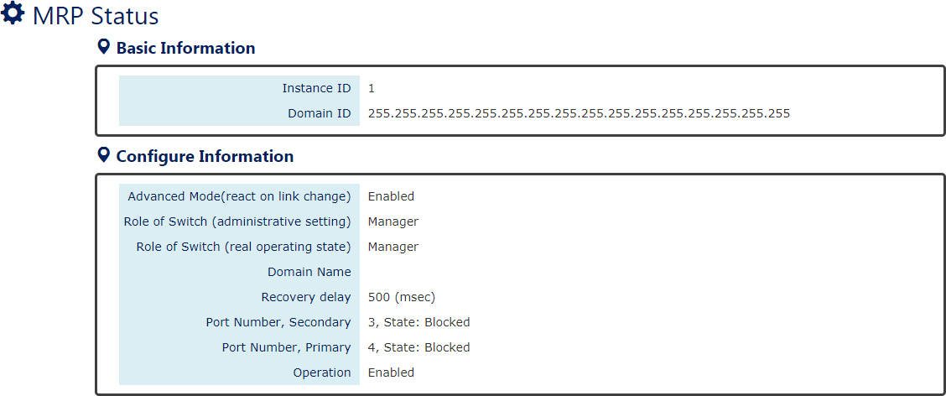

Basic Information
- Instance ID
The Instance ID is the Ring ID. We only support one ring currently, so the Instance ID displays always 1.
- Domain ID
The Domain ID is the identity of current MRP ring. Only the members with the same Domain ID will be regarded as working in the same ring.

Configured Information
- Advanced Mode
The field shows the status of Advanced Mode. Advanced Mode is only supported when the switch is configured as an MRM (Manager).
- Role of Switch
There are 2 roles of switches in the MRP – Manager and Client Administrative Setting: the role that users configured for the switch. Real Operating State: the role that the switch is working as.
- Domain Name
This field shows the configured name of this MRP Domain.

- Recovery Delay
This field shows current operating Recovery Delay. It may be 500 or 200 (msec).
- Port Number, Secondary
- Port Number, Primary
These two fields shows two parts of information. The first one is the switch port number configured as Primary / Secondary Port, and the other one is the state of this port. There are 3 states for MRP ports when the MRP is enabled: Forwarding, Blocked, and Disabled. If the MRP is disabled, the state shows “N/A”.
- Operation
This field shows current Operation State – Enabled or Disabled.

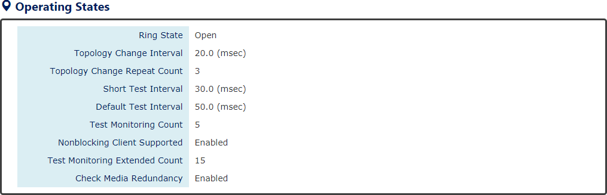

Operating States (Master)
。 Ring State
The Ring State displays the actual ring sate of MRP, and the state may be
Open: some of the links in the MRP ring are down or MRC failure.
Closed: the MRP ring is closed and under normal operation without error.
- Topology Change Interval
The interval is the period to send MRP_TopologyChange frames.
- Topology Change Repeat Count
The count is the repeat times to transmit MRP_TopologyChange frames.
- Short Test Interval
This interval is a timer used after link changes to send MRP_Test frames on the MRP ring ports.
- Default Test Interval
The interval is the default period to send MRP_Test frames on the MRP ring ports.
- Test Monitoring Count
This field is the interval count for monitoring the reception of MRP_Test frames.
- Non-blocking Client Supported
This field displays the ability of the MRM to support MRCs without BLOCKED port state support in the ring.
- Test Monitoring Extended Count
This field is an optional parameter. It is an extended interval count for monitoring

the reception of MRP_Test frames.
- Check Media Redundancy
Check the current state of MRM. The state may be “Enabled” or “Disabled”.
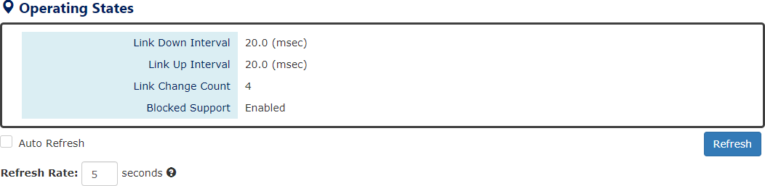

Operating States (Client)
- Link Down Interval
The Link-down Interval shows the period that MRP Link-down frames sent on the ring port. The default value of Link-down Interval is 20ms.
- Link Up Interval
The Link-up Interval shows the period that MRP Link-up frames sent on the ring port. The default value of Link-up Interval is 20ms.
- Link Change Count
The Link-change Count controls the repeated times to transmit MRP Link-Change frames. The default Link-change Count is 4 times.
- Blocked Support
The Blocked Support is default enabled. The MRM with Blocked Support will block the secondary port when there is no Blocked Port in the MRM ring topology to avoid loops.

SNMP

Simple Network Management Protocol (SNMP) is a standard for collecting and structuring information on the managed devices of the IP network. It can also modify some of the information to change the behavior of the devices. SNMP is usually used in monitoring the network. The users can remotely query the information provided by the devices running SNMP.
The switches support SNMP v1, v2c, and v3. SNMP v1 and v2c authenticates with a community string for “read-only” or “read-write” permission. The SNMP v3 authentication requires to select an authentication level (MD5 or SHA) and supports data encryption to make the data safer.
For the SNMP version and authentication method relationship, refer to the table below:
Version | Web Setting | Authentication | Encryption | Method
v1 &  v2c | Read Only Community | Community String | No | String match for authentication
v1 &  v2c | Read-Write Community | Community String | No | String match for authentication
v3 | Security Level –  No Authentication, No Privacy | No | No | Access by an account (admin or user)
v3 | Security Level – Authentication, No Privacy | MD5 / SHA | No | Access by an account (admin or user) and password with more than 8 characters, which is based  on MD5 or SHA
v3 | Security Level –  Authentication, Privacy | MD5 / SHA | Yes  AES / DES | Access by an account (admin or user) and password more than 8 characters, which is based on MD5 or SHA. The data encryption is based on AES or DES and the  key requires 8 to 32 characters.

CONFIGURE SNMP SERVER INFORMATION
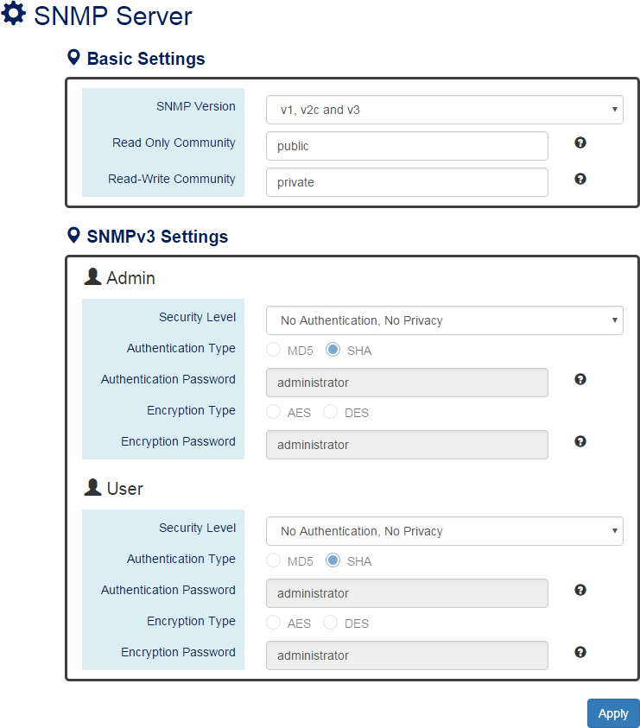
For more information, hover the mouse over the icon in the system.

Basic Settings
- SNMP Version
The system enables the SNMP “v1, v2c and v3” authentication by default. The users can enable the SNMP server on only “v1 and v2c” or “v3”. “None” refers to disabling the SNMP server.
- Read Only Community
The community used to access the SNMP server with the “read-only” privilege.
The max. length for the Read Only Community is 32 characters. Note: #, \, ', ", ? are invalid characters.

- Read-Write Community
The community used to access the SNMP server with the “read-write” privilege.
The max. length for the Read-Write Community is 32 characters. Note: #, \, ', ", ? are invalid characters.

SNMPv3 Settings
This section is displayed only when the SNMP Version is set to “v3” or “v1, v2c and v3”. Two accounts are provided – Admin and User to access the SNMP agent. The users can set different levels for the 2 accounts.
- Security Level
No Authentication, No Privacy: Access by an account “admin” or “user”.
Authentication, No Privacy: Access by an account “admin” or “user” with password. Authentication, Privacy: Access by an account “admin” or “user” with password and the data will be encrypted.
- Authentication Type
Two algorithms are provided - MD5 and SHA for authentication password.
- Authentication Password
A string/key is used to authenticate the SNMP Server and obtain the access permission. It will be hashed by MD5 or SHA before authentication.
The min. length for the Read-Write Community is 8 characters. The max. length for the Read-Write Community is 32 characters. Note: #, \, ', ", ? are invalid characters.
- Encryption Type
Two algorithms are provided - AES and DES for data encryption.
- Encryption Password
A string/key is used to encrypt the data that is sent to the SNMP server.
The min. length for the Read-Write Community is 8 characters. The max. length for the Read-Write Community is 32 characters. Note: #, \, ', ", ? are invalid characters.
• (Apply Button)
After configuring above fields, click "Apply" button to make the changes effective.

CONFIGURE SNMP TRAP INFORMATION
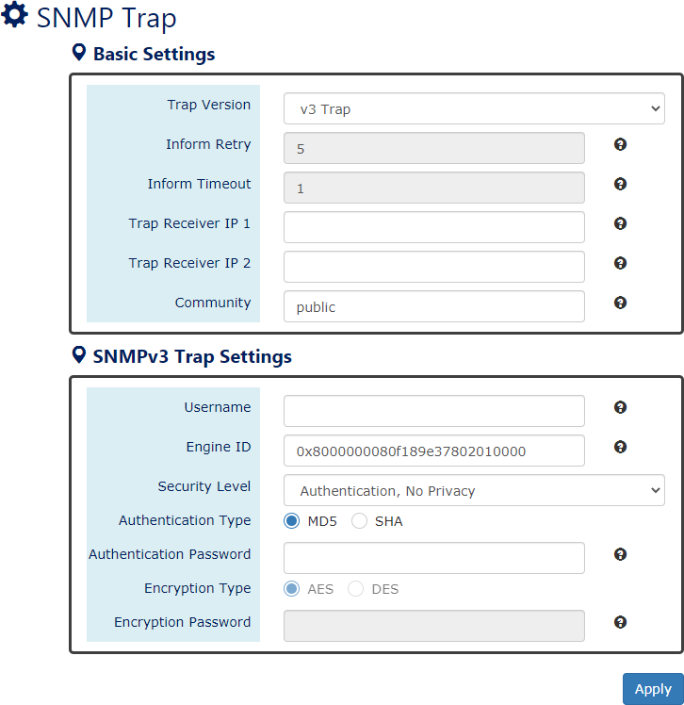
For more information, hover the mouse over the icon in the system.

Basic Settings
- Trap Mode
The system enables the SNMP “v1, v2c and v3” authentication by default. Users can enable the SNMP server only on “v1 and v2c” or “v3”. “None” indicates disabling the SNMP server.
- Inform Retry
The SNMP trap will send “Retry” times when the trap set to “v2 Inform” or “v3 Inform” mode.
The range of the Inform Retry is from 1 to 100. The default Inform Retry is 5.
- Inform Timeout
The interval is used to send trap when the trap set to “v2 Inform” or “v3 Inform” mode.
The range of the Inform Retry is from 1 to 300 second(s).

The default Inform Retry is 1 second.
- Trap Receiver IP 1 & 2
The IP address is the IP address of the trap server to receive the trap information. The system supports both IPv4 and IPv6 addresses for the receiver. There are 2 Trap Receiver IP supported.
- Community
The string in the SNMP trap is the identity of the device.
The max. length for the Community is 32 characters. Note: #, \, ', ", ? are invalid characters.

SNMPv3 Trap/Inform Settings
This section is displayed only when Trap Mode are set to “v3 Trap” or “v3 Inform”.
- Username
Specify the username for authentication with the SNMP trap server.
- Engine ID
The Engine ID is the identifier for the given SNMP application.
- Security Level
No Authentication, No Privacy: Access using the username assigned to the users. Authentication, No Privacy: Access using the username assigned to the users with password.
Authentication, Privacy: Access using the username assigned to the users with password and the data will be encrypted.
- Authentication Type
Two algorithms are provided - MD5 and SHA for authentication password.
- Authentication Password
A string/key is used to authenticate the SNMP trap server and obtain the permission. It will be hashed by MD5 or SHA before authentication.
The min. length for the Read-Write Community is 8 characters. The max. length for the Read-Write Community is 32 characters. Note: #, \, ', ", ? are invalid characters.
- Encryption Type
Two algorithms are provided - AES and DES for data encryption.
- Encryption Password
A string/key is used to encrypt the data sent to the SNMP trap server.
The min. length for the Read-Write Community is 8 characters. The max. length for the Read-Write Community is 32 characters. Note: #, \, ', ", ? are invalid characters.
• (Apply Button)
After configuring above fields, click "Apply" button to make the changes effective.

DHCP

DHCP SERVER/CLIENT
DHCP, Dynamic Host Configuration Protocol, is a standardized protocol used in the IP networks. The DHCP Server holds an IP address pool and when a DHCP Client request for an IP address, the DHCP Server picks an IP address from the pool and assigns it to the client. DHCP Server also manages other IP information such as Default Gateway and DNS Server. DHCP is particularly useful to configure the IP information for several devices. Only the administrator can enable the DHCP Client for each device and setup the DHCP Server. The clients will then obtain a unique IP address and other IP settings to connect to the network.
DHCP SERVER BINDING
Apart from dynamically allocating an IP address to a DHCP Client, the DHCP Server also provides a function to manually assign a static IP address to the device with a specific MAC Address. This is called as DHCP Server Binding.
DHCP RELAY/OPTION82
In a large network, there might be several subnets existed and the DHCP Client is not able to serve by DHCP Servers directly. In this case, we need a relay agent to help to transmit the request frames to the DHCP Servers. When a relay agent receives the broadcast request frame from a DHCP Client, the relay agent will transmit the frame to the DHCP Servers, which are in the same subnet by unicast.
Option 82 is an information option to identify the clients by Circuit ID and Remote ID. The Circuit ID is an identity containing the interface name and/or VLAN information, and the Remote ID is to identify the remote host (the relay agent). The DHCP Server can distribute an IP address to the DHCP Client according to Option 82 information and make the IP addresses more controllable.
The frame format for the Circuit ID is as below:
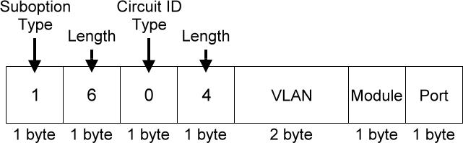

VLAN
The VLAN field is for the management VLAN ID, which is natively set to 1.

Module
The stack number for the device sending the DHCP request is on. For industrial switches, this byte is always filled as 0.

Port
The port number identifies the incoming DHCP request frame/DHCP Client.

The frame format for the Remote ID is as below:
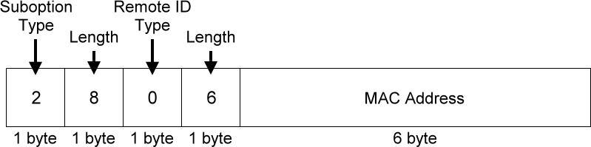

MAC Address
By default, the MAC address is set to the MAC address of DHCP relay agent.
CONFIGURE DHCP CLIENT
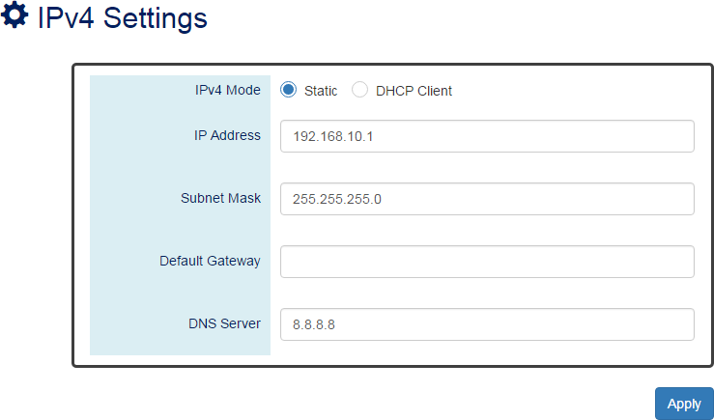

IPv4 Mode
Set the IPv4 Mode to “DHCP Client” to enable the DHCP Client. The system sends a
discovery frame to the network and tires to obtain an IP address from the DHCP Server. After enabling the DHCP Client, users need to connect to the Console Port to get the IP address by using “show ip address” on the CLI.

  - (Apply Button)

After configuring above fields, click "Apply" button to make the changes effective.
CONFIGURE DHCP SERVER INFORMATION
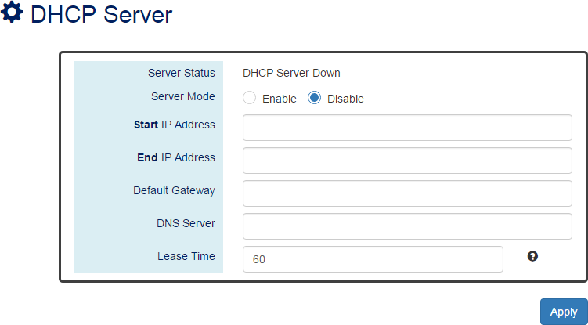
For more information, hover the mouse over the icon in the system.

Server Status
Shows the status of the DHCP server: Down or Up.

Server Mode
“Enable” or “Disable” the DHCP Server function.

Start IP Address
Set the range of the IP pool. The “Start IP Address” is the starting.
“Start IP Address” must be in the same subnet as that of the switch itself.

End IP Address
Set the range of IP pool. The “End IP Address” is the end.
“End IP Address” must be in the same subnet as that of the switch itself.

Default Gateway
Set the Default Gateway for the DHCP Clients to make them connect to the WAN.
“Default Gateway” must be in the same subnet as that of the switch itself.

DNS Server
Set the DNS Server for the DHCP Clients to make them connect to another device based on the URL instead of IP address.

Lease Time
DHCP Server leases an IP address to a device for a period. When the lease time expires, the DHCP server may assign a different IP address in the pool to the device.
• (Apply Button)
After configuring above fields, click "Apply" button to make the changes effective.
DHCP LEASED TABLE
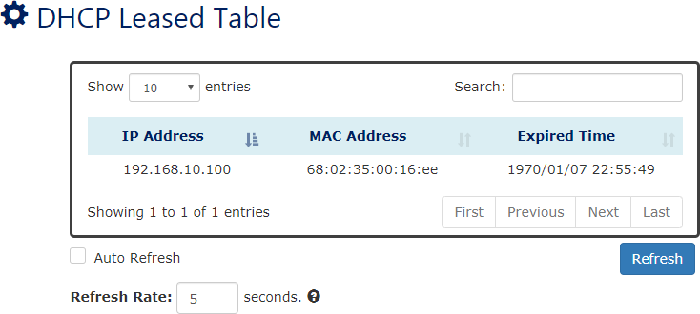

IP Address
This field implies the IP Address that this device acquired from DHCP Server.

MAC Address
The MAC Address of the device that acquired mapped IP Address. Administrators can use MAC Address to map to the device’s IP Address.

Expired Time
The Expired Time implies the deadline of designated IP Address that leased from DHCP Server. After Expired Time, the DHCP Client must communicate with DHCP Server and ask for the IP Address again.
CONFIGURE DHCP SERVER BINDING INFORMATION
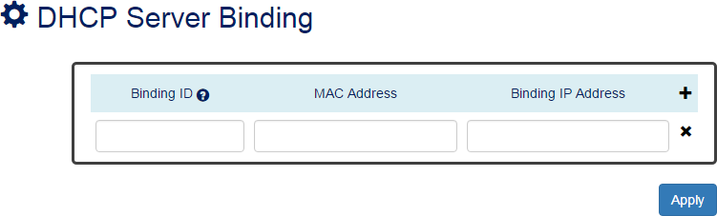
For more information, hover the mouse over the icon in the system.

Binding ID
An ID used to identify the binding.
The range of the Binding ID is from 1 to 32.

MAC Address
The device with the specified MAC Address will be assigned to the static Binding IP Address.

Binding IP Address
A static IP Address will be assigned to the specified MAC Address.
• : Click the plus icon to add a DHCP Binding row.
• : Click the remove icon to delete the DHCP Binding row.
• (Apply Button)
After configuring above fields, click "Apply" button to make the changes effective.

CONFIGURE DHCP RELAY INFORMATION
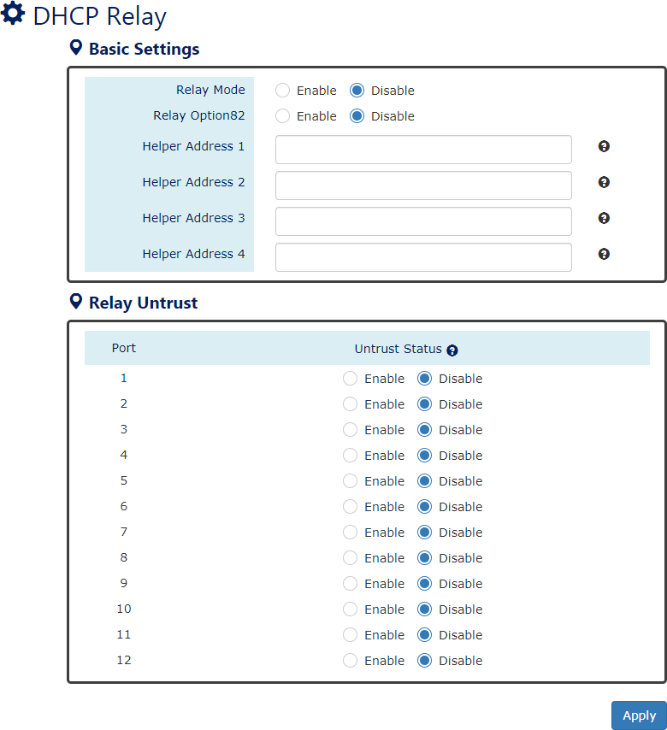
For more information, hover the mouse over the icon in the system.

Relay Basic Settings
- Relay Mode
“Enable” or “Disable” the DHCP Relay function.
- Relay Option82
“Enable” or “Disable” the DHCP Relay with Option82 tag.
- Helper Address 1 - 4
The IP Addresses of the DHCP Servers provide IP addresses to the DHCP Clients. A backup of Four Helper Addresses are available during breakdown.

Relay Untrust
- Port
Port1 to Port N, where N is based on the total port number.
- Untrust Status
“Enable” or “Disable” to untrust the specific port. If the untrusted status is enabled on a port, the system will drop the DHCP management frames on the port.
• (Apply Button)
After configuring above fields, click "Apply" button to make the changes effective.

PoE (PoE Model Only)

The PoE, or Power over Ethernet, allows switches to provide electric power along with data on the twisted pair Ethernet cables. The Power over Ethernet defined in IEEE 802.3af provides up to
15.4 W and IEEE 802.3at provides up to 25.5 W. It requires category 5 cables or better to support high power levels. PoE is helpful when the AC power is not available or is available with high cost. It is usually used in surveillance IP cameras, I/O sensors, wireless access points, and IP telephones.
POWER DE-RATING PROTECTION
Due to the power supply is designed inside the devices for some models, so the power budget will decrease by the operating temperature. To ensure the functionality of PoE, we do the protection by software in the background and adjust the budget as temperature rises. Please refer to the Hardware User Manual for the detail of the relationship of power budget and temperature.
POE DEBUG CODE
We provide PoE Debug Command on the “CLI” for troubleshooting. When users find that the PoE functions work abnormal, users can use the command to acquire the error code. The error codes are mapping to different situations, users can understand the error codes from the following table:
Code | Description
0x00 | PoE port is on.
0x01 | PoE port is on.
0x02 | PoE port is on.
0x03 | PoE port is on.
0x04 | PoE port is on.
0x06 | PoE port is off. Mains voltage is higher than maximum voltage limitation.
0x07 | PoE port is off. Mains voltage is lower than minimum voltage limitation.
0x11 | PoE port is not defined yet, please check the PoE power input.
0x20 | PoE port is off because of power budget exceeded.
0x1F | PoE port is off because of over-load state according to 802.3AF/AT.
0x43 | PoE port is off because of class error.
0x81 | 802.3BT - compliant PD was detected using BT Port (30w)
0x85 | 802.3BT - SSPD was detected using BT Port (60w/95w) and operates as BT Port  (30w) if requested class =< 4.
0x86 | 802.3BT - SSPD was detected using BT Port (60w|95w) and operates as BT Port  (60w/95w) if requested class > 4.
0x90 | BT Port (30w) and delivers power due to force power command.

0x91 | BT Port (60w/95w) and delivers power due to force power command.
0x1B | PoE port is off because detection is in process.
0xA8 | PoE port is not connected.
Others | Please contact your system administrator!!

CONFIGURE POWER OVER ETHERNET (POE)
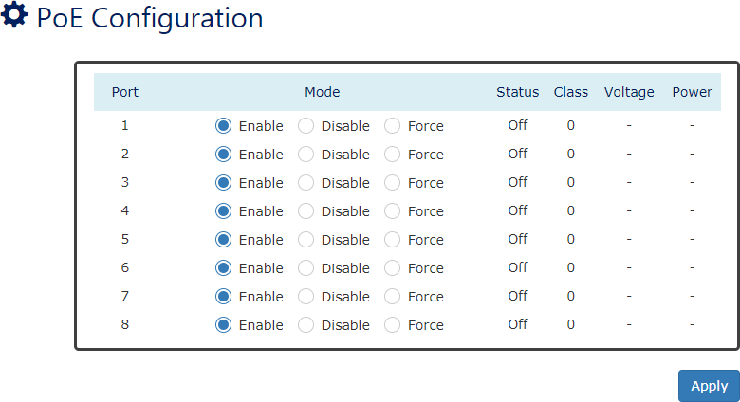

Port
Port1 to PortN, where N is based on the total PoE port number.

Mode
“Enable”, “Disable”, or “Force” PoE function on the specific port. If the mode is configured to “Force”, the system will provide power forcedly on the specific port even there is no device connected to this port.

Status
The field shows the PoE status of the specific port.
On: PoE is enabled or configured to force on the port and power is delivered on the port. Off: PoE is enabled on the port but no Powered Device (PD) is connected.
Disabled: PoE is disabled on the port.

Class
The field shows the class followed by the PD. The acceptable power of the class is defined in the IEEE 802.3af/at.

Voltage
This field shows the output voltage that PSE provided. The power output of the boost switch will be boosted to 53V.

Power
The Consumption field contains provided power in watts. The PSE can provide up to 30Watts and the PDs can receive up to 25.5Watts.

- (Apply Button)

After configuring above fields, click "Apply" button to make the changes effective.
CONFIGURE POE KEEP ALIVE
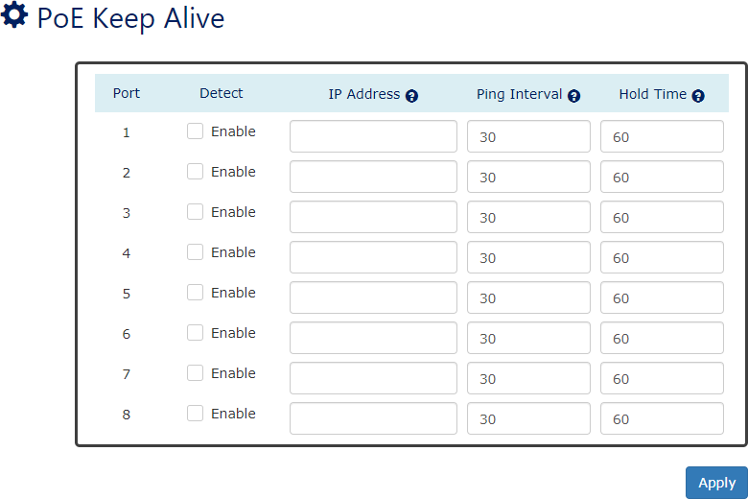

Port
For more information, hover the mouse over the icon in the system.

Port1 to PortN, where N is based on the total PoE port number.

Detect
“Enable” or “Disable” to detect the Powered Device (PD) on the specific port. When the detection is enabled, the system pings the configured IP Address on every Ping Interval.

IP Address
The field is the IP Address of the Powered Device (PD).

Ping Interval
The Ping Interval is the duration to ping the Powered Device (PD). The range of the Ping Interval is from 1 to 65535 seconds.
The default Ping Interval is 30 seconds.

Hold Time
The Hold Time is used when the ping fails. The system will wait for the Hold Time to expire and then try to ping the PD again.
The range of the Hold Time is from 1 to 65535 seconds.
The default Hold Time is 60 seconds.

- (Apply Button)

After configuring above fields, click "Apply" button to make the changes effective.
CONFIGURE POE SCHEDULE
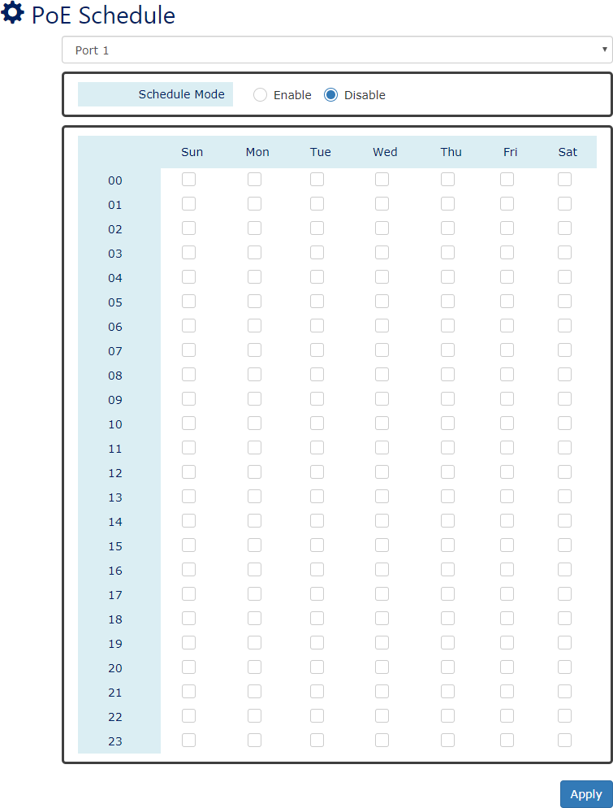

Port Selector
Select the port number to configure the PoE Schedule.
Port1 to PortN, where N is based on the total PoE port number.

Schedule Mode
“Enable” or “Disable” to provide power by the schedule on the specific port.
- Enable (for each day)
The week is from Sunday to Saturday.
- Week (The x-ray of the table)

The week is from Sunday to Saturday.
- Hour (The y-ray of the table)
The hour is from 00 (00:00) to 23 (23:00).
Users can select the checkbox with the Week and Hour in the table to enable the PoE Schedule on the specific time. For example, if the user wants the PoE to be enabled only on Monday from 6:00 to 7:00 and on Wednesday from 13:00 to 15:00, the following checkboxes must be selected – “Mon-06”, “Mon-07”, “Wed-13”, “Wed-14”, and “Wed-15”.
• (Apply Button)
After configuring above fields, click "Apply" button to make the changes effective.
CONFIGURE POE PRIORITY
From v1.1.48, we remove “Priority Mode” and “Power Limit” for each port configurations in the PoE Priority Page because of the support of the PoE chipset.
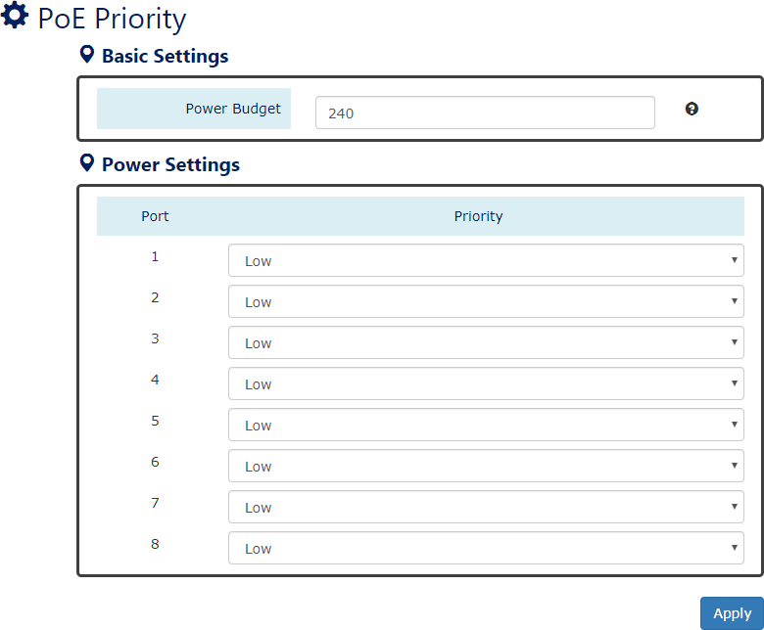
From v1.1.77, all PoE Models (including MP/MT/MH/MQ/CP/CT/CH/CQ) support PoE Priority function including 60W/95W 802.3bt switches.
For more information, hover the mouse over the icon in the system.

Basic Setting
  - Power Budget
This field defines the maximum power that can provide to all the connected PDs. The range of Power Budget is from 1 to 240 Watt.

The default Power Budget is 240 Watt.

Power Settings
  - Port
Port1 to PortN, where N is based on the total PoE port number.
  - Priority
Assign the PoE priority to high, middle, or low for the specific port.
• (Apply Button)
After configuring above fields, click "Apply" button to make the changes effective.

Industrial Protocols

There are three industrial protocols provided in the switch – EtherNet/IP, PROFINET, and
Modbus/TCP.
EtherNet/IP is an industrial network protocol that linked up the Common Industrial Protocol (CIP) with standard Ethernet. EtherNet/IP takes advantage of both Internet Protocol suite and IEEE 802 standard, which are the most widely deployed collections of Ethernet standards, to define the features and functions for its transportation, networking, data link and physical layers. CIP makes use of object-oriented design to provide EtherNet/IP with the services and device profiles needed for real-time control applications. The object-oriented design of the CIP is also used to promote consistent implementation of automation functions into a diverse ecosystem of products. EtherNet/IP defines how to organize the data in a TCP/UDP packet and transfers the packet in the application layer.
Modbus is a popular communication protocol used for the industrial serial devices. It is usually working as “master-slave” architecture and working with programmable logic controllers which are also called PLCs. The Modbus/TCP implies to provide Modbus Messaging service on the TCP/IP, so that the devices which are running Modbus can communicate with each other with Modbus messages. The Modbus messages are encapsulated with an Ethernet TCP/IP wrapper based on the standard. During the transmission, the switches can only acquire the encapsulated information when the Modbus/TCP is enabled. If users would like to understand the real content of Modbus message, users must install other utilities such as “ModScan”. Our switches implement the Modbus/TCP registers including system information, firmware information, port information, and packet information. The details refer to the “Modbus Data Mapping Information” section.
PROFINET is a technical standard for automation data communication over Industrial Ethernet. It is designed for collecting data and controlling devices in industrial systems. PROFINET is maintained and supported by PROFIBUS & PROFINET International (PI). It defines entire data exchange not only IO-controllers and IO-devices but also parameter setting and diagnosis. PROFINET is useful for production and process automation, safety applications, and all range of drive technology while these applications are implemented.

MODBUS DATA FORMAT AND FUNCTION CODE
The primary four types of Modbus/TCP data format are as following:
Data Access Type |  | Function Code | Function Name
Bit Access | Physical Discrete Inputs | 2 | Read Discrete Inputs
Bit Access | Internal Bits or Physical Coils | 1 | Read Coils
Word Access  (16-bit Access) | Physical Input Registers | 4 | Read Input Registers
Word Access  (16-bit Access) | Physical Output Registers | 3 | Read Holding Registers

MODBUS DATA MAPPING INFORMATION
In the following tables, we assume the total port number is 28.
The following table is for Function Code 3 (Holding Registers) / Function Code 6.
Address Offset | Data Type | Interpretation | Description
System Information
0x0000 to 0x0008 | 1 word | HEX | Port 1 to Port 8 Status Configuration
0x0000 to 0x0008 | 1 word | HEX | 0x0000: | Disable
0x0000 to 0x0008 | 1 word | HEX | 0x0001: | Enable
The following table is for Function Code 4 (Input Registers). The data map addresses in the following table starts from Modbus address 30001. For example, the address offset 0x0000H equals Modbus address 30001, and the address offset 0x0030H equals Modbus address 30049. All the information read from our switches is in the HEX mode and users can refer to the ASCII table for the translation (e.g., 0x4B=’K’, 0x74=’t’).
Address Offset | Data Type | Interpretation | Description
System Information
0x0030 | 20 words | ASCII | Product Name = “MT-0804G”
0x0030 | 20 words | ASCII | Word 0 Hi byte = |  | ‘M’
0x0030 | 20 words | ASCII | Word 0 Lo byte = |  | ‘T’
0x0030 | 20 words | ASCII | Word 1 Hi byte = |  | ‘-‘
0x0030 | 20 words | ASCII | Word 1 Lo byte = |  | ‘0’
0x0030 | 20 words | ASCII | Word 2 Hi byte = |  | ‘8’
0x0030 | 20 words | ASCII | Word 2 Lo byte = |  | ‘0’
0x0030 | 20 words | ASCII | Word 3 Hi byte = |  | ‘4’
0x0030 | 20 words | ASCII | Word 3 Lo byte = |  | ‘G’
0x0050 | 1 word |  | Product Serial Number
0x0051 | 2 words | HEX | Firmware Version  For example:
0x0051 | 2 words | HEX | Word 0 = | 0x0103
0x0051 | 2 words | HEX | Word 1 = | 0x0200

 |  |  | Firmware version is 1.3.2
0x0053 | 2 words | HEX | Firmware Release Date  For example:
0x0053 | 2 words | HEX | Word 0 = |  | 0x1719
0x0053 | 2 words | HEX | Word 1 = |  | 0x1506
0x0053 | 2 words | HEX | Firmware was released on 2015-06-17 at  19 o’clock
0x0056 | 3 words | HEX | Ethernet MAC Address  Ex: MAC = 01:02:03:0A:0B:0C
0x0056 | 3 words | HEX | Word 0 Hi byte = |  |  | 0x01
0x0056 | 3 words | HEX | Word 0 Lo byte = |  |  | 0x02
0x0056 | 3 words | HEX | Word 1 Hi byte = |  |  | 0x03
0x0056 | 3 words | HEX | Word 1 Lo byte = |  |  | 0x0A
0x0056 | 3 words | HEX | Word 2 Hi byte = |  |  | 0x0B
0x0056 | 3 words | HEX | Word 2 Lo byte = |  |  | 0x0C
0x0059 | 1 word | HEX | Power 1
0x0059 | 1 word | HEX | 0x0000: | Off
0x0059 | 1 word | HEX | 0x0001: | On
0x005A | 1 word | HEX | Power 2
0x005A | 1 word | HEX | 0x0000: | Off
0x005A | 1 word | HEX | 0x0001: | On
0x005B | 1 word | HEX | Fault LED Status
0x005B | 1 word | HEX | 0x0000: | Boot error
0x005B | 1 word | HEX | 0x0001: | Normal
0x005B | 1 word | HEX | 0x0002: | Fault
0x0082 | 1 word | HEX | DO1
0x0082 | 1 word | HEX | 0x0000: | Off
0x0082 | 1 word | HEX | 0x0001: | On
Port Information
0x1000 to 0x1008 | 1 word | HEX | Port 1 to Port 8 Status
0x1000 to 0x1008 | 1 word | HEX | 0x0000: | Link down
0x1000 to 0x1008 | 1 word | HEX | 0x0001: | Link up
0x1000 to 0x1008 | 1 word | HEX | 0x0002: | Disable
0x1000 to 0x1008 | 1 word | HEX | 0xFFFF: | No port
0x1100 to 0x1108 | 1 word | HEX | Port 1 to Port 8 Speed
0x1100 to 0x1108 | 1 word | HEX | 0x0000: | 10M-Half
0x1100 to 0x1108 | 1 word | HEX | 0x0001: | 10M-Full
0x1100 to 0x1108 | 1 word | HEX | 0x0002: | 100M-Half
0x1100 to 0x1108 | 1 word | HEX | 0x0003: | 100M-Full

 |  |  | 0xFFFF: | No port
0x1200 to 0x1208 | 1 word | HEX | Port 1 to Port 8 Flow Ctrl
0x1200 to 0x1208 | 1 word | HEX | 0x0000: | Off
0x1200 to 0x1208 | 1 word | HEX | 0x0001: | On
0x1200 to 0x1208 | 1 word | HEX | 0xFFFF: | No port
0x1300 to  0x1313 (Port 1)  0x1314 to  0x1327 (Port 2)  …  0x138C to  0x139F (Port 8) | 20 words | ASCII | Port 1 to Port 8 Description  Port Description = “100Tx,RJ45.”
 | 20 words | ASCII | Word 0 Hi byte = |  | ‘1’
 | 20 words | ASCII | Word 0 Lo byte = |  | ‘0’
 | 20 words | ASCII | Word 1 Hi byte = |  | ‘0’
 | 20 words | ASCII | Word 1 Lo byte = |  | ‘T’
 | 20 words | ASCII | …
 | 20 words | ASCII | Word 4 Hi byte = |  | ‘4’
 | 20 words | ASCII | Word 4 Lo byte = |  | ‘5’
 | 20 words | ASCII | Word 5 Hi byte = |  | ‘.’
 | 20 words | ASCII | Word 5 Lo byte = |  | ‘\0’
0x1500 to 0x1508 | 1 Word | HEX | Port 1 to Port 8 PoE Status  0x0000: PoE Off 0x0001: PoE On
0x1600 to  0x1608 | 1 Word | HEX | Port 1 to Port 8 PoE Power in Watt
Packet Information
0x2000 to 0x200F | 2 words | HEX | Port 1 to Port 8 Tx Packets  Ex: port 1 Tx Packet Amount = 13248635 Received Modbus response:  0x13248635
0x2000 to 0x200F | 2 words | HEX | Word 0 = | 1324
0x2000 to 0x200F | 2 words | HEX | Word 1 = | 8635
0x2080 to 0x208F | 2 words | HEX | Port 1 to Port 8 Tx Bytes  Ex: port 1 Tx Bytes Amount = 13248635 Received Modbus response:  0x13248635
0x2080 to 0x208F | 2 words | HEX | Word 0 = | 1324
0x2080 to 0x208F | 2 words | HEX | Word 1 = | 8635
0x2100 to  0x21(YY*2-1) | 2 words | HEX | Port 1 to YY Rx Packets  Ex: port 1 Rx Packet Amount = 13248635 Received Modbus response:  0x13248635
0x2100 to  0x21(YY*2-1) | 2 words | HEX | Word 0 = | 1324
0x2100 to  0x21(YY*2-1) | 2 words | HEX | Word 1 = | 8635
0x2180 to 0x218F | 2 words | HEX | Port 1 to Port 8 Rx Bytes  Ex: port 1 Rx Bytes Amount = 13248635 Received Modbus response:  0x13248635

 |  |  | Word 0 = | 1324
 |  |  | Word 1 = | 8635

ETHERNET/IP CIP OBJECT MAPPING INFORMATION
The following communication objects that defined in Common Industrial Protocol (CIP) are supported in switches for PLCs and SCADA systems to monitor:
- Identity Object
- TCP/IP Interface Object
- Ethernet Link Object
- Proprietary Object
The following tables introduce the supported attributes, including access rules for each attribute, and services for the above objects. Users can also refer to the official documents of CIP introduction (Vol. 1) and the Ethernet/IP Adaption of CIP (Vol. 2) to understand the details of each attribute of the standard objects.
Identity Object
The Class code of Identity object is defined in CIP Vol 1, 5-2 and the value is 0x01. Class Attribute List
Addr  ID | Access  Rule | Name | Data Type | Description
1 | Get | Revision | UINT (16) | Revision of this object
2 | Get | Max Instance | UINT (16) | Maximum instance number of an object currently created in this class  level of the device
3 | Get | Number of Instances | UINT (16) | Number of object instances currently  created in this class level of the device.
6 | Get | Maximum ID Number Class Attributes | UINT (16) | The attribute ID number of the last class attribute of the class definition  implemented in the device
7 | Get | Maximum ID Number Instance Attributes | UINT (16) | The attribute ID number of the last instance attribute of the class  definition implemented in the device
Instance Attribute List
Addr  ID | Access  Rule | Name | (Struct.) | Data Type | Description
1 | Get | Vendor ID |  | UINT (16) | The vendor ID of company
2 | Get | Device Type |  | UINT (16) | 0x0, “Managed Ethernet Switch”

3 | Get | Product Code |  | UINT (16) | N/A
4 | Get | Revision |  | (Struct.) | The version of the Identity object
4 | Get | Revision | Major | USINT (8) | The structure member, major
4 | Get | Revision | Minor | USINT (8) | The structure member, minor
5 | Get | Status |  | WORD (16) | Not used
7 | Get | Product Name |  | SHORT_  STRING | The product name in  human-readable format
101 | Get | Serial Number |  | UDINT (32) | The serial number of each device
Common Service List
Service  Code | Implementation |  | Service Name | Description
Service  Code | Class | Instance | Service Name | Description
0x01 | ✓ | ✓ | Get_Atributes_All | Return the contents of all attributes of  the class
0x0E | ✓ | ✓ | Get_Atributes_Single | Used to read an object instance attribute
0x10 |  | ✓ | Set_Atributes_Single | Used to write an object instance attribute
0x05 |  | ✓ | Reset | Invokes the reset service for the device
TCP/IP Interface Object
The Class code of TCP/IP Interface object is defined in CIP Vol 2, 5-3 and the value is 0xf5. Class Attribute List
Addr  ID | Access  Rule | Name | Data Type | Description
1 | Get | Revision | UINT (16) | Revision of this object
2 | Get | Max Instance | UINT (16) | Maximum instance number of an object currently created in this class  level of the device
3 | Get | Number of Instances | UINT (16) | Number of object instances currently created in this class level of the device.
6 | Get | Maximum ID Number Class Attributes | UINT (16) | The attribute ID number of the last class attribute of the class definition  implemented in the device
7 | Get | Maximum ID Number Instance Attributes | UINT (16) | The attribute ID number of the last instance attribute of the class  definition implemented in the device
Instance Attribute List
Addr  ID | Access  Rule | Name | (Struct.) | Data Type | Description
1 | Get | Status |  | DWORD | Interface status

 |  |  |  | (32) | 0 = The Interface Configuration attribute has not been configured.  1 = The Interface Configuration  attribute contains valid configuration obtained from BOOTP, DHCP or non-volatile  storage
2 | Get | Configuration Capability |  | DWORD (32) | Interface capability flags Bit map of capability flags:  Bit 0: BOOTP Client Bit 1: DNS Client  Bit 2: DHCP Client  Bit 3: DHCP-DNS Update  Bit 4: Configuration Settable
3 | Get/Set | Configuration Control |  | DWORD (32) | Interface control flags Bit map of control flags:  Bit 0 to 3: Startup Configuration  0 = The device shall use the  interface configuration values previously stored (for  example,  in non-volatile memory or via hardware witches).  1 = The device shall obtain its interface configuration values via BOOTP.  2 = The device shall obtain its interface configuration values via DHCP upon start-up.  3 to15 = Reserved.
4 | Get | Physical Link Object |  | (Struct.) | Path to physical link object
4 | Get | Physical Link Object | Path Size | UINT (16) | Size of Path
4 | Get | Physical Link Object | Path | Padded  EPATH | Logical segments identifying the  physical link object
5 | Get/Set | Interface Configuration |  | (Struct.) | TCP/IP network interface  configuration
5 | Get/Set | Interface Configuration | IP Address | UDINT (32) | The device’s IP address

 |  |  | Network  Mask | UDINT (32) | The device’s network mask
 |  |  | Gateway  Address | UDINT (32) | Default gateway address
 |  |  | Name  Server | UDINT (32) | Primary name server
 |  |  | Name  Server 2 | UDINT (32) | Secondary name server
 |  |  | Domain  Name | STRING | Default domain name
6 | Get/Set | Host Name |  | UDINT (32) | Host name
Common Service List
Service  Code | Implementation |  | Service Name | Description
Service  Code | Class | Instance | Service Name | Description
0x01 | ✓ | ✓ | Get_Atributes_All | Return the contents of all attributes of  the class
0x0E | ✓ | ✓ | Get_Atributes_Single | Used to read an object instance attribute
0x10 |  | ✓ | Set_Atributes_Single | Used to write an object instance attribute
Ethernet Link Object
The Class code of TCP/IP Interface object is defined in CIP Vol 2, 5-4 and the value is 0xf6. There is an instance for each switch port, and mapping as the following table:
Instance Number | Mapping to
0 | Ethernet Link class
1 | 1st switch port
2 | 2nd switch port
3 | 3rd switch port
… | N^{th} switch port
Class Attribute List
Addr  ID | Access  Rule | Name | Data Type | Description
1 | Get | Revision | UINT (16) | Revision of this object
2 | Get | Max Instance | UINT (16) | Maximum instance number of an object currently created in this class  level of the device
3 | Get | Number of Instances | UINT (16) | Number of object instances currently  created in this class level of the device.
6 | Get | Maximum ID Number | UINT (16) | The attribute ID number of the last

 |  | Class Attributes |  | class attribute of the class definition  implemented in the device
7 | Get | Maximum ID Number Instance Attributes | UINT (16) | The attribute ID number of the last instance attribute of the class  definition implemented in the device
Instance Attribute List
Addr  ID | Access  Rule | Name | (Struct.) | Data Type | Description
1 | Get | Interface Speed |  | UDINT (32) | Interface speed currently in use (Speed in Mbps, e.g., 0, 10, 100,  1000, 10000, etc.)
2 | Get | Interface  Flags |  | DWORD  (32) | Refer to the Interface Flags table
3 | Get | Physical  Address |  | ARRAY of 6  USINT (8) | MAC layer address (The System  MAC address)
4 | Get | Interface Counters |  | (Struct.) | Counters relevant to the receipt of  packets
4 | Get | Interface Counters | In Octets | UDINT (32) | Octets received on the interface.
4 | Get | Interface Counters | In Ucast  Packets | UDINT (32) | Unicast packets received on  the interface
4 | Get | Interface Counters | In NUcast  Packets | UDINT (32) | Non-unicast packets received on the  interface
4 | Get | Interface Counters | In Discards | UDINT (32) | Inbound packets received on  the interface but are discarded
4 | Get | Interface Counters | In Errors | UDINT (32) | Inbound packets that contain Errors (does not include In  Discards)
4 | Get | Interface Counters | In Unknown  Protos | UDINT (32) | Inbound packets with unknown  protocol
4 | Get | Interface Counters | Out Octets | UDINT (32) | Octets sent on the interface
4 | Get | Interface Counters | Out Ucast  Packets | UDINT (32) | Unicast packets sent on the  interface
4 | Get | Interface Counters | Out NUcast  Packets | UDINT (32) | Non-unicast packets sent on  the interface
4 | Get | Interface Counters | Out  Discards | UDINT (32) | Discarded outbound packets
4 | Get | Interface Counters | Out Errors | UDINT (32) | Outbound packets that contain  errors
6 | Get/Set | Interface |  | (Struct.) | Configuration for physical interface

 |  | Control | Control Bits | WORD (16) | Bit 0: Auto-Negotiate  Value 0: Force  Value 1: Auto-Nego Bit 1: Half/Full Duplex Value 0: half duplex Value 1: full duplex  Bit 2 to 15: Reserved, all zero
 |  | Control | Forced Interface  Speed | UINT (16) | Speed at which the interface shall be forced to operate
7 | Get | Interface Type |  | USINT | Value 0: Unknown interface type. Value 1: The interface is internal to the device, for example, in the case of an embedded switch.  Value 2: Twisted-pair (e.g.,  10Base-T, 100Base-TX, 1000Base-T,  etc.)  Value 3: Optical fiber (e.g., 100Base-FX)  Value 4 to 256: Reserved
8 | Get | Interface State |  | USINT | Value 0: Unknown interface state Value 1: The interface is enabled and is ready to send and receive data  Value 2: The interface is disabled Value 3: The interface is testing  Value 4 to 256: Reserved
9 | Get | Admin State |  | USINT | Value 0: Reserved  Value 1: Enable the interface  Value 2: Disable the interface. If this is the only CIP communications  interface, a request to disable the interface shall result in an error (status code 0x09).  Value 3 to 256: Reserved
10 | Get | Interface  Label |  | SHORT_  STRING | Human readable identification
101 | Get | PoE  Status |  | USINT (8) | Value 1: PoE On  Value 2: PoE Off

102 | Get | PoE  Power |  | UDINT (32) | PoE Power in Watt
103 | Get/Set | PoE Mode |  | UDINT (32) | Value 0: Unknown  Value 1: Enable  Value 2: Disable  Value 3: Force
Interface Flags
Bit(s) | Called | Definition
0 | Link Status | - indicates an inactive link.  - indicates an active link.
1 | Half/Full Duplex | - indicates half duplex.  - indicates full duplex.
2-4 | Negotiation Status | Indicates the status of link auto-negotiation 0 = Auto-negotiation in progress.  1 = Auto-negotiation and speed detection failed. Using default values for speed and duplex. Default values are product-dependent; recommended defaults are 10Mbps and half duplex.  2 = Auto negotiation failed but detected speed. Duplex was defaulted. Default value is product-dependent.  recommended default is half duplex.  3 = Successfully negotiated speed and duplex.  4 = Auto-negotiation not attempted. Forced speed and duplex.
5 | Manual Setting Requires Reset | 0 indicates the interface can activate changes to link parameters (auto-negotiate, duplex mode, interface speed) automatically. 1 indicates the device requires a Reset service be issued to its Identity Object for the changes to  take effect.
6 | Local Hardware Fault | 0 indicates the interface detects no local hardware fault; 1  indicates a local hardware fault is detected. The meaning of this is product-specific. For example, an AUI/MII interface might detect no transceiver attached, or a radio modem  might detect no antenna attached. In contrast to the soft, possibly self-correcting nature of the Link Status being  inactive, this is assumed a hard-fault requiring user  intervention.
7-31 | Reserved | Shall be set to zero
Common Service List

Service  Code | Implementation |  | Service Name | Description
Service  Code | Class | Instance | Service Name | Description
0x0E | ✓ | ✓ | Get_Atributes_Single | Used to read an object instance attribute
0x10 |  | ✓ | Set_Atributes_Single | Used to write an object instance attribute

Proprietary Object
The Class code of Proprietary object is defined by vendor, and the value is 0x1C1. Class Attribute List
Addr ID | Access Rule | Name | Data Type | Description
1 | Get | Power 1 | USINT (8) | Power 1 status.  Value 1: On  Value 0: Off
2 | Get | Power 2 | USINT (8) | Power 2 status.  Value 1: On  Value 0: Off
3 | Get | Alarm Relay | USINT (8) | Alarm Relay status. Value 1: On  Value 0: Off
4 | Get | Digital Input | USINT (8) | Digital Input status. Value 1: High  Value 0: Low
5 | Get | System Time | UDINT (32) | System Time encodes as Unix time.
6 | Get | All Interface Speed | ARRAY of 28  UDINT(32) | Array list of all interface speed  currently in use
7 | Get | All Interface Flags | ARRAY of 28  DWORD(32) | Array list of all interface flags. Refer  to the Interface Flags table
8 | Get | All Interface States | UDINT (32) | Bitwise of all current interface states. Bit 0: Port 1  Value 0: Link down Value 1: Link up  Bit 1: Port 2, and so on
ETHERNET/IP ELECTRONIC DATA SHEET (EDS) FILE
The EDS (Electronic Data Sheet) file includes electronic descriptions of all relevant communication parameters and objects of an EtherNet/IP device. It is required for I/O controllers to recognize switch and its CIP capability.
The list includes the sections which are described in our EDS file.
- [File]

- [Device]
- [Device Classification]
- [Port]
- Icon should be 32 * 32 in pixel.

PROFINET PARAMETERS MAPPING INFORMATION
There are three categories of parameters – Device Parameters, Device Status, and Port Parameters.
- r/w: Read and Write
- ro: Read Only

Device Parameters

Byte | Name | Access | Value | Description | Default Value
0 | Status Alarm | rw | 0 | Do not send any alarms | 0: No Alarms
0 | Status Alarm | rw | 1 | Send alarm if any status change | 0: No Alarms
1 | Power Alarm 1 | rw | 0 | Do not send power failed alarms | 0: No Alarms
1 | Power Alarm 1 | rw | 1 | Send alarm if power supply 1 fails | 0: No Alarms
2 | Power Alarm 2 | rw | 0 | Do not send power failed alarms | 0: No Alarms
2 | Power Alarm 2 | rw | 1 | Send alarm if power supply 2 fails | 0: No Alarms
Device Status

Byte | Name | Access | Value | Description
0 | Overall Device Status | ro | 0 | Unavailable
0 | Overall Device Status | ro | 1 | OK
0 | Overall Device Status | ro | 2 | Device Error
1 | Fault Status | ro | 0 | Unavailable
1 | Fault Status | ro | 1 | OK
1 | Fault Status | ro | 2 | Device Detect Fault
2 | Power 1 Status | ro | 0 | Unavailable
2 | Power 1 Status | ro | 1 | OK
2 | Power 1 Status | ro | 2 | Power 1 Fails
3 | Power 2 Status | ro | 0 | Unavailable
3 | Power 2 Status | ro | 1 | OK
3 | Power 2 Status | ro | 2 | Power 2 Fails
4 | Relay 1 | ro | 0 | Unavailable
4 | Relay 1 | ro | 1 | Closed

 |  |  | 2 | Open
5 | Relay 2 | ro | 0 | Unavailable
5 | Relay 2 | ro | 1 | Closed
5 | Relay 2 | ro | 2 | Open
6 | Redundant Mode | ro | 0 | Unavailable
6 | Redundant Mode | ro | 1 | RSTP
6 | Redundant Mode | ro | 2 | ERPS
6 | Redundant Mode | ro | 3 | ERPS Sub-ring 1
6 | Redundant Mode | ro | 4 | ERPS Sub-ring 2
7 | Ring Status | ro | 0 | Unavailable
7 | Ring Status | ro | 1 | Healthy
7 | Ring Status | ro | 2 | Break
8 | Redundant Port 1 Status | ro | 0 | Unavailable
8 | Redundant Port 1 Status | ro | 1 | Forwarding
8 | Redundant Port 1 Status | ro | 2 | Blocking
8 | Redundant Port 1 Status | ro | 3 | Link Down
9 | Redundant Port 2 Status | ro | 0 | Unavailable
9 | Redundant Port 2 Status | ro | 1 | Forwarding
9 | Redundant Port 2 Status | ro | 2 | Blocking
9 | Redundant Port 2 Status | ro | 3 | Link Down
10 | Sub-ring Mode | ro | 0 | Unavailable
10 | Sub-ring Mode | ro | 1 | Healthy
10 | Sub-ring Mode | ro | 2 | Break
11 | Sub-ring Port 1 Status | ro | 0 | Unavailable
11 | Sub-ring Port 1 Status | ro | 1 | Forwarding
11 | Sub-ring Port 1 Status | ro | 2 | Blocking
11 | Sub-ring Port 1 Status | ro | 3 | Link Down
12 | Sub-ring Port 2 Status | ro | 0 | Unavailable
12 | Sub-ring Port 2 Status | ro | 1 | Forwarding
12 | Sub-ring Port 2 Status | ro | 2 | Blocking
12 | Sub-ring Port 2 Status | ro | 3 | Link Down
13 | Connection | ro | 0 | Unavailable
13 | Connection | ro | 1 | OK
13 | Connection | ro | 2 | Connection Failure

Port Parameters

Byte | Name | Access | Value | Description
0 | Port Alarm | rw | 0 | Off, do net send alarm

 |  |  | 1 | On, send alarm when port link down
1 | Port Admin State | rw | 0 | Unavailable
1 | Port Admin State | rw | 1 | Off, inactive
1 | Port Admin State | rw | 2 | On, active
2 | Port Link State | ro | 0 | Unavailable
2 | Port Link State | ro | 1 | Link is down
2 | Port Link State | ro | 2 | Link is up
3 | Port Speed | ro | 0 | Unavailable
3 | Port Speed | ro | 1 | Unknown
3 | Port Speed | ro | 2 | 10M
3 | Port Speed | ro | 3 | 100M
3 | Port Speed | ro | 4 | 1G
3 | Port Speed | ro | 5 | 10G
4 | Port Duplex | ro | 0 | Unavailable
4 | Port Duplex | ro | 1 | Half
4 | Port Duplex | ro | 2 | Full
5 | Port Auto-negotiation | ro | 0 | Unavailable
5 | Port Auto-negotiation | ro | 1 | Off
5 | Port Auto-negotiation | ro | 2 | On
6 | Port Flow Control | ro | 0 | Unavailable
6 | Port Flow Control | ro | 1 | Off
6 | Port Flow Control | ro | 2 | On
7 | Port MDI/MDIX | ro | 0 | Unavailable
7 | Port MDI/MDIX | ro | 1 | MDI
7 | Port MDI/MDIX | ro | 2 | MDIX

CONFIGURE INDUSTRIAL PROTOCOLS INFORMATION
Note: For PoE models, the system will take around 10 seconds to read PoE status.
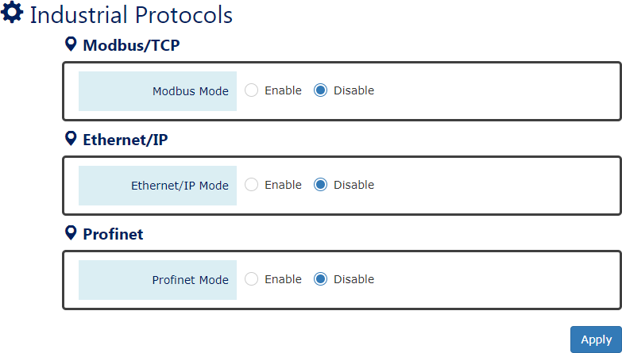

Modbus Mode
“Enable” or “Disable” the Modbus/TCP function.

Ethernet/IP Mode
“Enable” or “Disable” the Ethernet/IP function.

PROFINET Mode
“Enable” or “Disable” the PROFINET function.
• (Apply Button)
After configuring above fields, click "Apply" button to make the changes effective.

UPnP

UPnP is Universal Plug and Play, a set of networking protocols that permit the network devices to seamlessly discover each other in the networks. It is promoted by the UPnP Forum, but since 2016, all UPnP efforts are managed by the Open Connectivity Foundation.
UPnP extends “plug and play” to connect to a network device without configuration. When an UPnP device such as printer, Wi-Fi AP, or mobile device connects to a network, it will automatically establish the working configurations with another devices.
CONFIGURE UPNP INFORMATION
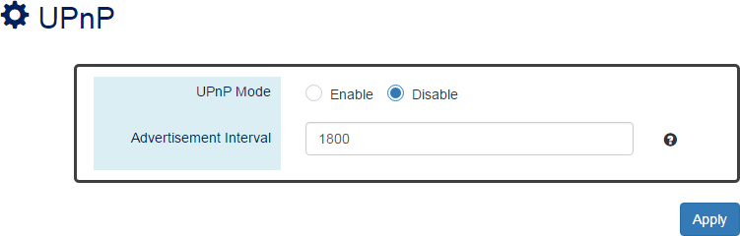
For more information, hover the mouse over the icon in the system.

UPnP Mode
“Enable” or “Disable” the UPnP function.

Advertisement Interval
A period used to send the UPnP advertisement frame.
The range of the Advertisement Interval is from 300 to 86400 seconds.
The default Advertisement Interval is 1800 seconds.
• (Apply Button)
After configuring above fields, click "Apply" button to make the changes effective.

Port Management

Port Management contains a “Description” field that is used to describe the port, “Enable” or “Disable” option to turn on or turn off a specific port, configure the speed-duplex for the port, and Flow Control on the port. In the Port Status page, the users can obtain information such as Link Status, Speed, Duplex, Flow Control, Tx and Rx in Bytes, and PoE status. These are helpful for the administrator to manage the interfaces on the switch.

CONFIGURE PORT INFORMATION
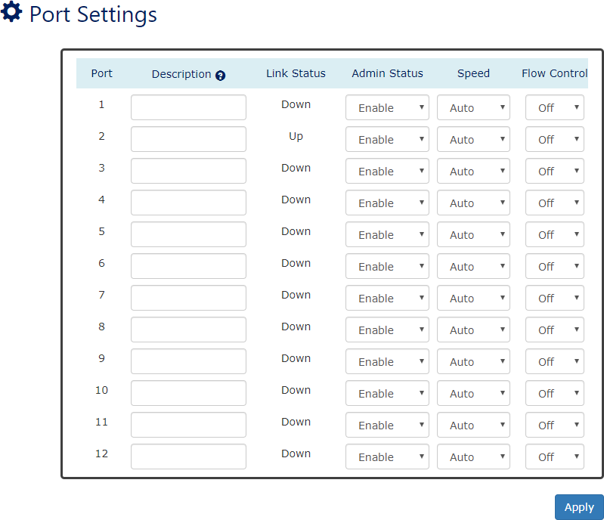

Port
For more information, hover the mouse over the icon in the system.

Port1 to PortN, where N is based on the total port number.

Description
The description for the port is helpful for the administrator to identify the difference between the ports.
The max. length for the Description is 32 characters.

Note: #, \, ', ", ? are invalid characters.

Link Status
Link Status shows “Up”, “Down”, or “Disable” to reflect the link status of the port.

Admin Status
“Enable” or “Disable” the Admin Status of the port to restrict the transmission on the port. Note: Administrator can turn off the un-used port to secure the network with unexpected device.

Speed
The users can manually fix the speed and duplex or automatically run auto-negotiation to determine the speed and duplex for copper ports.
  - Auto: The port follows IEEE 802.3 protocol to auto-negotiate with connected device.
  - 100M-Full: The port transmits frames with 100Mbits per second speed and full duplex.
  - 100M-Half: The port transmits frames with 100Mbits per second speed and half duplex.
  - 10M-Full: The port transmits frames with 10Mbits per second speed and full duplex.
  - 10M-Half: The port transmits frames with 10Mbits per second speed and half duplex.
The users must manually configure SFP ports to fix the speed and duplex. The default setting is the highest speed for the SFP slot.
  - Auto: The port follows IEEE 802.3 protocol to auto-negotiate with connected device.
  - 10G-Full (Only supported on 10G models)
The port transmits frames with 10Gbits per second speed and full duplex.
  - 1G-Full: The port transmits frames with 1Gbits per second speed and full duplex.
  - 100M-Full (Only supported on dual speed SFP ports)
The port transmits frames with 100Mbits per second speed and full duplex.
  - Copper-Full: Select Copper-Full when using copper SFP module.
Note: Configure the port speed to "1G-Full" if users need the VDSL2 SFP supported.
Configure the port speed to “Auto” if the connected device is unmanaged.
For Copper SFP Module, please refer to the following instructions to configure the correct speed:
Copper SFP Module Type | Speed Config | Note
SGMII (10/100/1000M) | Copper-Full | Only support transmitting on 1000M
Multi-Speed (1G/10G) | 10G-Full | Depends on the connected speed
10G | 10G-Full
1G / VDSL2 | 1G-Full

Flow Control
“Enable” or “Disable” the Flow Control when the speed is set to “Auto”. Enabling the Flow Control helps to prevent the traffic from losing when the network is in congestion.
• (Apply Button)
After configuring above fields, click "Apply" button to make the changes effective.

SFP DDM STATUS
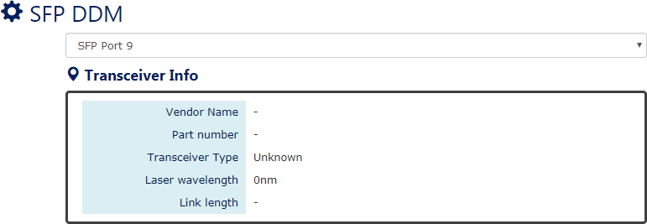

SFP Port Selector
Select the SFP port number to display SFP DDM information.

Transceiver Info
If there is no SFP module inserted or the information cannot be read, the field will show “-“.
  - Vendor Name
This field shows the brand or vendor name of the SFP module.
  - Part Number
This field shows the model name (part number) of the SFP module.
  - Transceiver Type
This field shows the transceiver type of the SFP module including transmitting speed and the type of fiber. If there is no SFP module inserted or the transceiver type cannot be read, the field will show “Unknown“.
  - Laser Wavelength
This field shows the laser operating wavelength of the SFP module.
  - Link Length
This field shows the maximum link length of the SFP module.

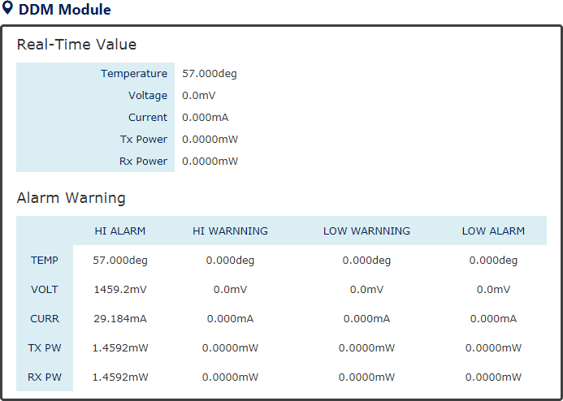

DDM Module
This section only shows when the SFP DDM is supported on the inserted SFP module.
  - Real Time Value
The current operating information including temperature, voltage, current, Tx power, and Rx power.
  - Alarm Warning
The default configured threshold for triggering the alarm and system warning. There are 5 types of information (temperature, voltage, current, Tx power, and Rx power) and 4 levels of alarm and warning (high alarm/warning, low alarm/warning).

DETAILED PORT STATUS
There are two methods to link to detailed port status (RMON). One is from menu and the other is from the front panel picture. Uses can directly click the port on the front panel and then the page will redirect to the detailed port status page of the specific port. The RMON is a set of standard Simple Network Management Protocol (SNMP) and it is useful to monitor and manage the incoming and outgoing traffic.
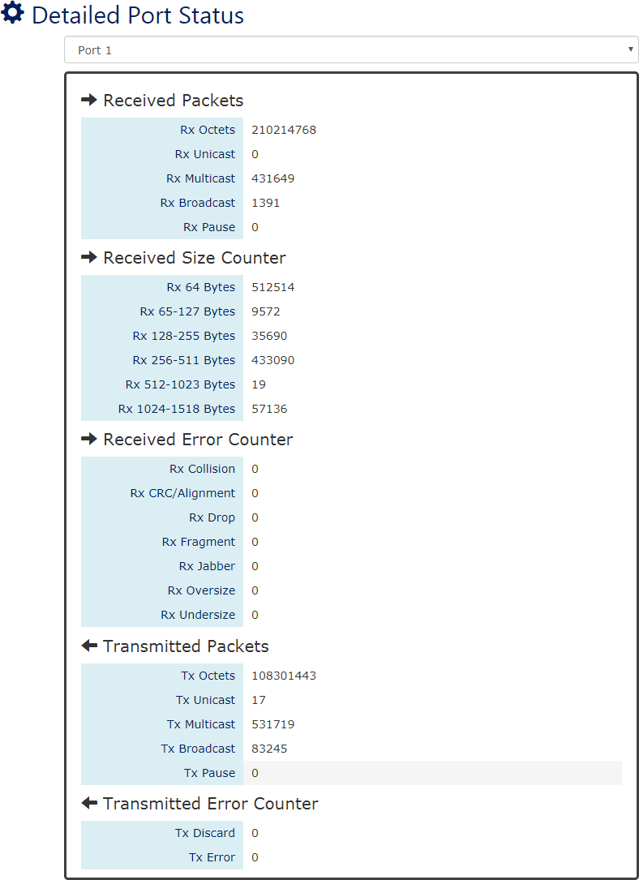

Port Selector
Select the port number to monitor the RMON information. Port 1 to N, where N is based on the total port number.

Received Packets
  - Rx Octets: the total received traffic in bytes
  - Rx Unicast: the number of received unicast packets
  - Rx Multicast: the number of received multicast packets
  - Rx Broadcast: the number of received broadcast packets
  - Rx Pause: the number of MAC Control packets received on the specific interface with an opcode indicating the PAUSE operation.

Received Size Counter
  - Rx 64 Bytes: the number of received packets that were 64 octets
  - Rx 65-127 Bytes: the number of received packets that were from 65 to 127 octets
  - Rx 128-255 Bytes: the number of received packets that were from 128 to 255 octets
  - Rx 256-511 Bytes: the number of received packets that were from 256 to 511 octets
  - Rx 512-1023 Bytes: the number of received packets that were from 512 to 1023 octets
  - Rx 1024-1518 Bytes: the number of received packets that were from 1024 to 1518 octets

Received Error Counter
  - Rx Collision: the total number of collisions on the Ethernet segment.
  - Rx CRC/Alignment: the total number of received packets that have either a bad Frame Check Sequence (FCS) with an integral number of octets (FCS Error) or a bad FCS with a non-integral number of octets (Alignment Error).
  - Rx Drop: the total number of dropped packets due to lack of resources.
  - Rx Fragment: the total number of received packets that are less than 64 octets and had either a bad Frame Check Sequence (FCS) with an integral number of octets (FCS Error) or a bad FCS with a non-integral number of octets (Alignment Error).
  - Rx Jabber: the total number of received packets that are longer than 1518 octets and had either a bad Frame Check Sequence (FCS) with an integral number of octets (FCS Error) or a bad FCS with a non-integral number of octets (Alignment Error).
  - Rx Oversize: the total number of received packets that are longer than 1518 octets.
  - Rx Undersize: the total number of received packets that are less than 64 octets.

Transmitted Packets
  - Tx Octets: the total transmitted traffic in bytes.
  - Tx Unicast: the number of transmitted unicast packets
  - Tx Multicast: the number of transmitted multicast packets
  - Tx Broadcast: the number of transmitted broadcast packets
  - Tx Pause: the number of MAC Control packets transmitted on the specific interface with an opcode indicating the PAUSE operation.

Transmitted Error Counter

  - Tx Discard: the number of outbound packets which are chosen to be discarded even though no errors had been detected. One possible reason for discarding such a packet could be to free up buffer space.
  - Tx Error: the number of outbound packets that could not be transmitted because of errors.
EEE STATUS
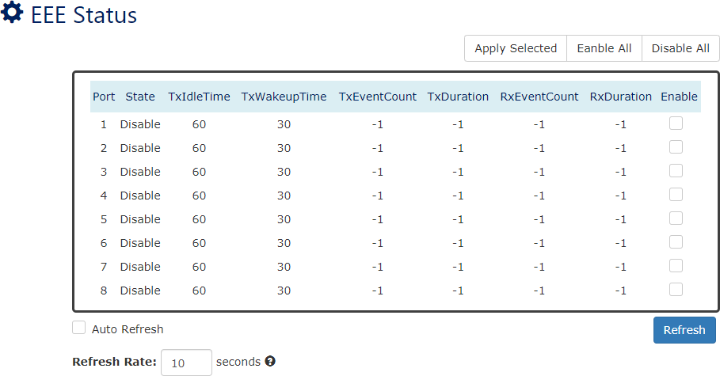
Energy-Efficient Ethernet (EEE) is a feature to save power when the link is idle, which means the port is linked up but there is no traffic on the link. The EEE function can be enabled or disabled by port.

Port
Port 1 to N, where N is based on the total port number.

State
Display the state, Enable or Disable, of EEE function.

TxIdleTime
The TxIdleTime is the required time to enter the EEE low-power mode.

TxWakeupTime
The TxWakeupTime is the required time to exit the EEE low-power mode.

TxEventCount
The TxEventCount is the EEE Low Power Idle (LPI) event counter of Tx. This counter implies the number of times that the LPI mode has been enforced by EEE function on the transmitting side.

TxDuration
The TxDuration is an LPI event duration on the transmitting path which is updated if the port is in the EEE LPI mode.

RxEventCount
The RxEventCount is the EEE LPI event counter of Rx. This counter implies the number of times that the LPI mode has been enforced by EEE function on the receiving side.

RxDuration
The RxDuration is an LPI event duration on the receiving path which is updated if the port is in the EEE LPI mode.

Enable
Select the specific ports or deselect the selected ports and then click the “Apply Selected” button to enable or disable the EEE function. Directly click “Enable All” to enable EEE function on all ports or “Disable All” to disable EEE function on all ports.

PORT STATUS
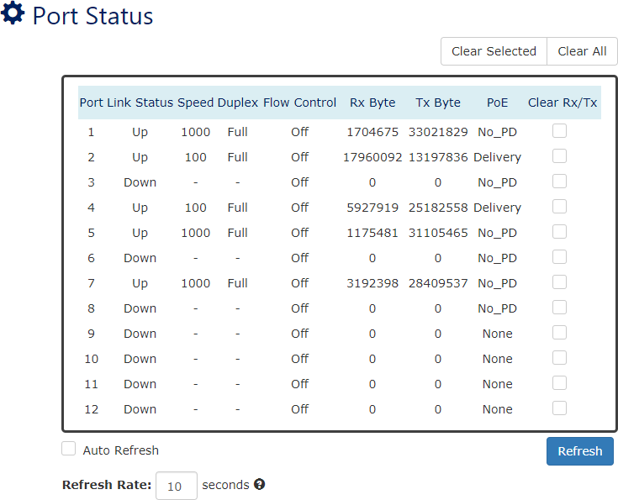

Port
Port 1 to N, where N is based on the total port number.

Link Status
Link Status displays the link state (“Up” or “Down”) of the port. If the port is disabled, it displays “Disabled”.

Speed
Speed displays the access speed in bit per second of the port. If the port is linked down, it displays “-“.

Duplex
Duplex displays the link-type (Full or Half) of the port. If the port is linked down, it displays “-“.

Flow Control
It is the state (On or Off) of the Flow Control.

Rx Byte
This is the total received frames formatted in byte.

Tx Byte
This is the total transmitted frames formatted in byte.
- PoE (PoE Model Only)
PoE displays the PoE state (Delivery, No PD, Disabled, None) of the port. If the port does not support PoE function, it displays “None”.
Note: This information is displayed on the system that supports the PoE function.

Clear Rx/Tx
Select the specific ports and click the “Click Selected” button to clear the Tx/Rx Byte information or click “Click All” button to clear all ports’ Tx/Rx Byte information.

IGMP Snooping

Internet Group Management Protocol (IGMP) is used in communicating among hosts and establishing a multicast group membership on the IPv4 networks (Layer 3). IGMP provides the ability to prune multicast traffic to those who need this kind of traffic and reduce the amount of traffic on the network. However, switches work on the MAC Layer (Layer 2) and are unable to obtain IGMP information. IGMP Snooping allows the switch to listen to the IGMP communication between hosts and routers and maintains a table of multicast IPs and group members. IGMP Snooping can prevent the hosts on the LAN from receiving traffic from a non-joined multicast group and save bandwidth of the network.
CONFIGURE IGMP SNOOPING INFORMATION
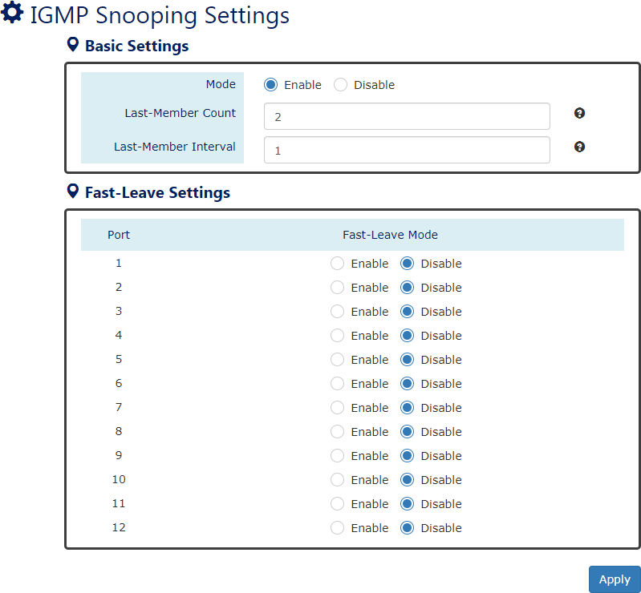
For more information, hover the mouse over the icon in the system.

Basic Setting
  - Mode
“Enable” or “Disable” the IGMP Snooping function.
  - Last-Member Count

The count is the number of times that the router sends IGMP query messages to receive the leave message.
The range of the Last-Member Count is from 2 to 10.
The default Last-Member Count Interval is 2.
。 Last-Member Interval
The interval is the period to send IGMP query messages.
The range of the Last-Member Interval is from 1 to 25 seconds.
The default Last-Member Interval is 1 second.

Fast-Leave Setting
  - Port
Port 1 to N, where N is based on the total port number.
  - Fast-Leave Mode
“Enable” or “Disable” the fast-leave function on the specific port. If the fast-leave mode is enabled on the port, the switch will close the multicast stream when receiving a leave message on this port without further action.
• (Apply Button)
After configuring above fields, click "Apply" button to make the changes effective.
CONFIGURE IGMP SNOOPING QUERIER INFORMATION
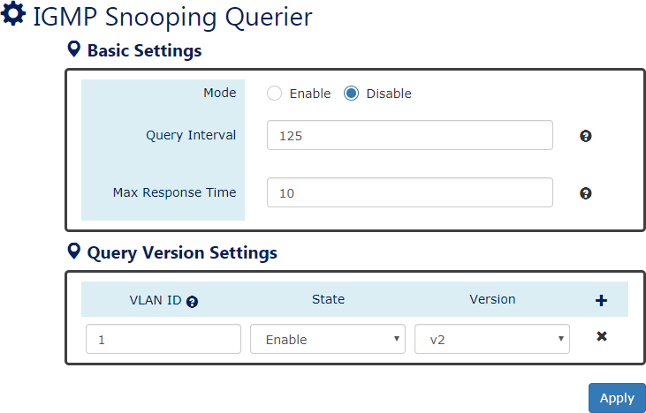
For more information, hover the mouse over the icon in the system.

Basic Settings
  - Mode
“Enable” or “Disable” the IGMP Snooping Querier function. If it is enabled, the system sends IGMP snooping version 1 and 2 queries.

  - Querier Interval
This period is the interval to send the IGMP snooping queries. The range of the Querier Interval is from 1 to 3600 seconds. The default Querier Interval is 125 seconds.
  - Query Max Response Time
This is a timer to wait for the member response of the IGMP groups. It is used in
removing the information of the IGMP groups if no member responds to the query.

Query Version Settings
The Query Version Settings is configured for per-VLAN query.
  - VLAN ID
The field is to fill in the VLAN ID to configure the IGMP Snooping query version.
  - State
“Enable” or “Disable” the IGMP Snooping query on the configured VLAN ID.
  - Version
Set the IGMP Snooping version (v1, v2c, v3) on the specific VLAN.
• (Apply Button)
After configuring above fields, click "Apply" button to make the changes effective.
CONFIGURE UNKNOWN MULTICAST INFORMATION
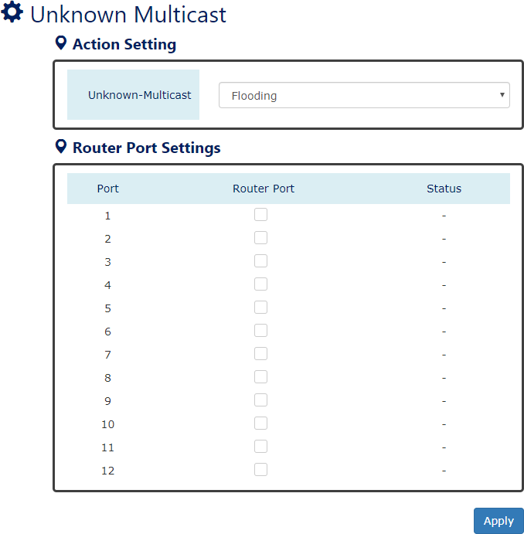

Action Settings
  - Unknown-Multicast
Configure the action when the system receives an unknown-multicast packet.
Flooding: flood the unknown-multicast packet to all other ports.
Discarding: discard the unknown-multicast packet.
Router: forward the unknown-multicast packet to the router port.

Router Port Settings
  - No.
Port 1 to N, where N is based on the total port number.
  - Router Port
Set the specific port to router port or not.
  - Status
The status field shows the port’s status which “-“ implies not a router port and “static” implies set to router port.
IGMP SNOOPING TABLE
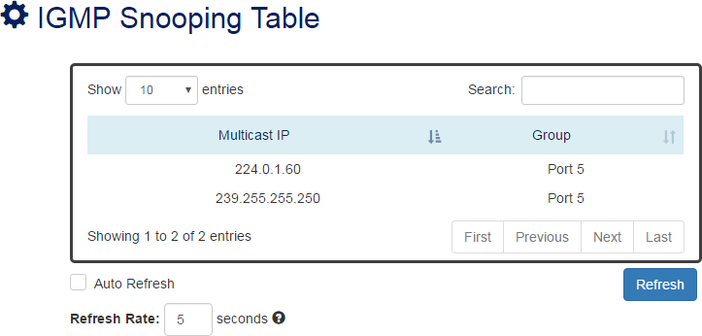

Multicast IP
The Multicast IP is the IP address of the multicast group.

Group
The group shows the port number, which joined the group.

802.1Q VLAN

Q VLAN
Virtual Local Area Network (VLAN) is a structure that can ease Network planning. The devices in a VLAN can be located anywhere without the restriction of physical connections but work like they are on the same physical segment.
IEEE 802.1Q defines VLAN tagging conception for the Ethernet frames. VLAN tagging supports frames in the different VLAN groups transmitting on a link (called VLAN trunk). The maximum number of VLANs on the Ethernet network is 4096. The VLAN 0 and VLAN 4095 are for specific use and hence the usable VLAN number is 4094.

VLAN Q-IN-Q
VLAN Q-in-Q, also called Stacked VLAN, is an extension for 802.1Q VLAN. It supports a maximum of 4096*4096 VLAN groups. VLAN Q-in-Q can apply a port to a provider, customer, or tunnel for different applications. The header of the stacked VLAN frame contains two 802.1Q Headers with different Ethertype (TPID). The TPID “0x88A8” is the outer tag by default and the TPID “0x8100” is the inner tag for 802.1Q VLAN. Customized ethertype called Specific Provider Ethertype are supported if one or more ports are set to “Specific Provider”.
CONFIGURE 802.1Q VLAN INFORMATION
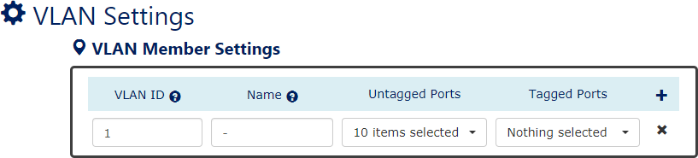
For more information, hover the mouse over the icon in the system.

VLAN Member Settings
      - VLAN ID
Assigns a unique VLAN ID to this VLAN group. The range of the VLAN ID is from 1 to 4094.
      - Name
Assigns a name to this VLAN group to identify the different VLANs.
The max. length for the Name is 32 characters. Note: #, \, ', ", ? are invalid characters.
      - Untagged Ports

Sets the untagged ports for this VLAN group. The system removes the VLAN tag before transmitting from the port that is set to “untagged”. Usually, this port is connected to the end device that belongs to this VLAN.
      - Tagged Ports
Sets the tagged ports for this VLAN group. The system keeps the VLAN tag when transmitting from the port that is set to “tagged”. Usually, this port is connected to another switch and uses the VLAN tag to transfer the VLAN information.
。 : Click the plus icon to add a VLAN Member row.
。 : Click the remove icon to delete the VLAN Member row.
  - Q VLAN TABLE
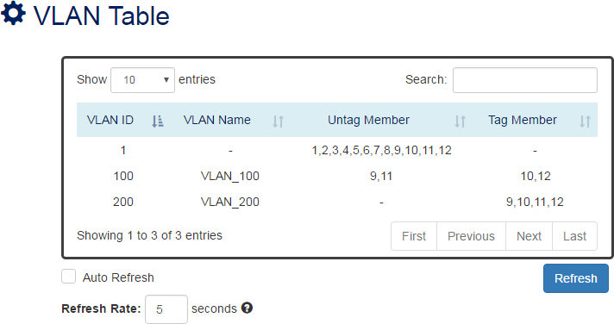

VLAN ID
This is the assigned unique VLAN ID for this VLAN group.

VLAN Name
This is the assigned VLAN Name for this VLAN group.

Untag Member
These ports are assigned as VLAN untagged ports.

Tag Member
These ports are assigned as VLAN tagged ports.
CONFIGURE 802.1Q VLAN PVID & ACCEPT TYPE

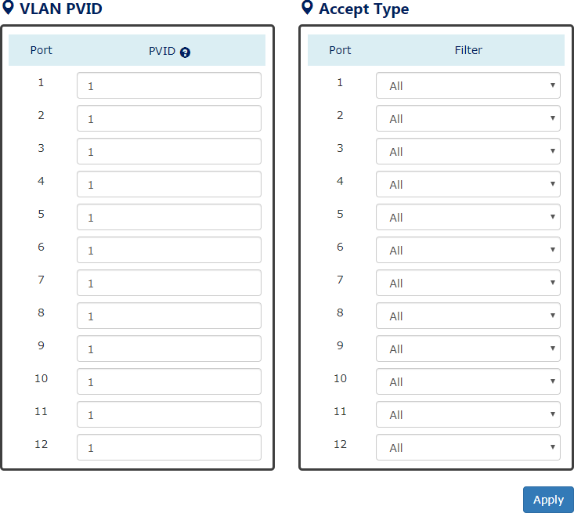
For more information, hover the mouse over the icon in the system.

VLAN PVID
      - Port
Port1 to PortN, where N is based on the total port number.
      - PVID
Assign a VLAN ID to the frames without a VLAN tag that come into the specific port.

Accept Type
      - No.
Port1 to PortN, where N is based on the total port number.
      - Filter
Three types of filters are provided: All, Tagged Only, Untagged Only.
All: Accept both tagged and untagged frames that come into the port.
Tagged Only: Accept only tagged frames that come into the port.
Untagged Only: Accept only untagged frames that come into the port.
• (Apply Button)
After configuring the above fields, click "Apply" button to make it effective.

CONFIGURE VLAN Q-IN-Q
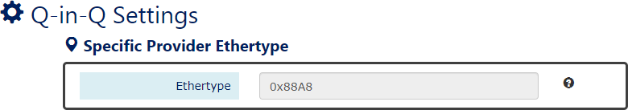
For more information, hover the mouse over the icon in the system.

Specific Provider Ethertype
This is a global configuration and an Ethertype is assigned for all ports, which are configured as “Specific Provider”. This field is locked (disabled) until at least one port is configured to the “Specific Provider” in the “Q-in-Q Port Settings” section.
The range of the Provider Ethertype is from 0x0000 to 0xFFFF, but 0x8100 is invalid.
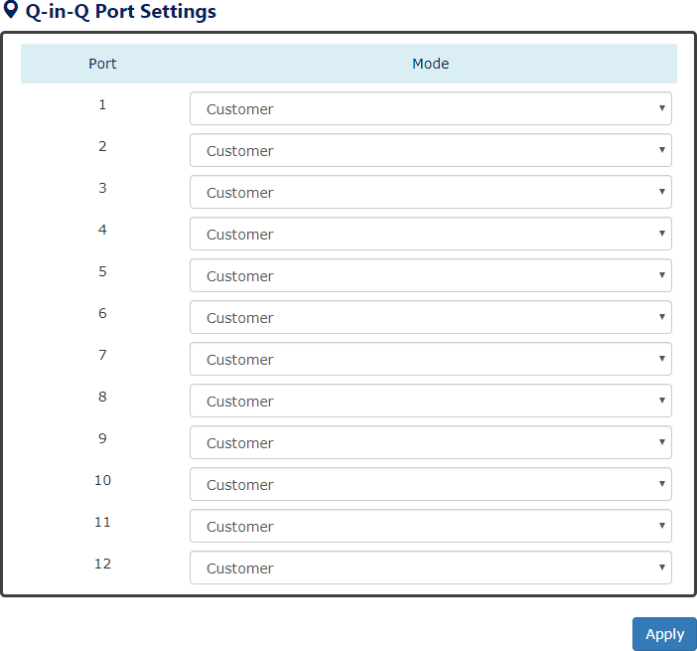
The default Provider Ethertype is 0x88A8.

Q-in-Q Port Settings
      - Port
Port1 to PortN, where N is based on the total port number.
      - Mode
Set the port to one of the Q-in-Q modes.

The Egress is dependent on the connected device and hence the egress action is skipped.
Mode | Ingress
Q-in-Q Tunnel | Untagged Frames: Add TPID:0x88A8 tag and forward.  Tagged Frames:  - TPID:0x8100: Add TPID:0x88A8 tag and forward.  - TPID:0x88A8: Forward the frames.
Mode | Ingress
Customer | A port set to “Customer” runs typically 802.1Q VLAN. Untagged Frames: Add TPID:0x8100 tag and forward. Tagged Frames:  1. TPID:0x8100:  - Same VLAN ID: Forward the frames.  - Different VLAN ID: Discard the frames.  2. TPID:0x88A8: Discard the frames.
Provider | Untagged Frames: Add TPID:0x88A8 tag and forward.  Tagged Frames:  - TPID:0x8100: Discard the frames.  - TPID:0x88A8:  - Same VLAN ID: Forward the frames.  - Different VLAN ID: Discard the frames.
Specific Provider | Users define the Ethertype for the Provider service. Untagged Frames: Add the user-defined TPID tag and forward.  Tagged Frames:  - TPID:0x8100: Discard the frames.  - TPID:0x88A8: Discard the frames.  - TPID: [user-defined]:  - Same VLAN ID: Forward the frames.  - Different VLAN ID: Discard the frames.
• (Apply Button)
After configuring above fields, click "Apply" button to make the changes effective.

Quality of Service

Quality of Service which known as QoS provides a stable and predictable transmitting service. It is useful to manage the bandwidth more efficiently based on the requirement of applications. Users can set different priorities for different traffics to satisfy the services which need a fixed bandwidth and have more sensitive of delay. Quality of Service can also optimize the restrict bandwidth resource and control the network traffic of the switches.

CONFIGURE QOS INFORMATION
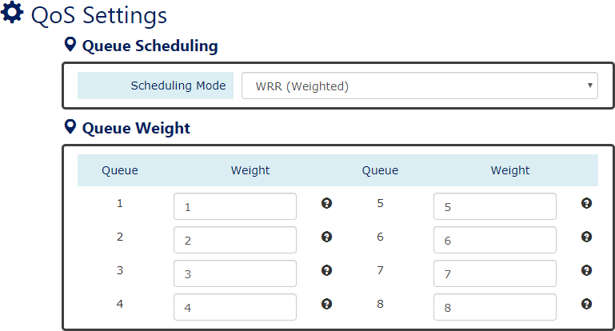
For more information, hover the mouse over the icon in the system.

Queue Scheduling
      - Scheduling Mode
Select the scheduling mode for the Quality of Service.
WRR: Weighted Round Robin. WRR ensures that every queue takes turns to transmit the traffic by its weight.
Strict: Strict Priority Queue. The traffic is transmitted based on the priority, which is from highest to lowest.

Queue Weight
      - Queue
Eight queues from queue 0 to queue 7 are supported.
      - Weight
Enables you to configure a specific weight for the port.
The range of the Weight is from 1 to 100. There is no need to sum all queues to 100. The default Weight for each queue is displayed in the table:

Queue | 0 | 1 | 2 | 3 | 4 | 5 | 6 | 7
Weight | 1 | 2 | 3 | 4 | 5 | 6 | 7 | 8

CONFIGURE QOS TRUST MODE AND DEFAULT COS
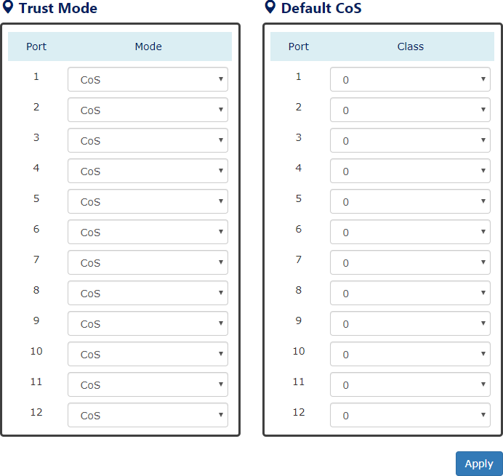

Trust Mode
      - Port
Port1 to PortN, where N is based on the total port number.
      - Mode
CoS: Class of Service. Use the 3-bit “PRI” field in the VLAN tag. It enables you to assign traffic to 8 different classes from 0 to 7.
DSCP: Use 6-bit field “DSCP” in the Type of Service (ToS) tag. It enables you to assign traffic to 64 different types from 0 to 63.

Default CoS
      - Port
Port1 to PortN, where N is based on the total port number.
      - Class
You can assign a default class to the port. The system follows the assigned CoS classes to transmit frames if there is no VLAN tag in the frame header.

The default Class for each port is 0.
• (Apply Button)
After configuring above fields, click "Apply" button to make the changes effective.
CONFIGURE COS MAPPING
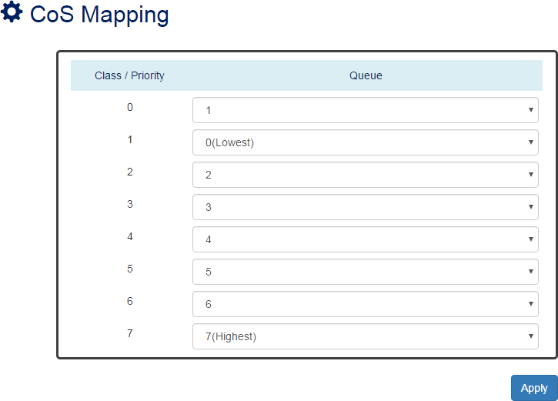

Class / Priority
There are 3 bits for the “Class of Service” field called “PRI” in the VLAN tag and there are 8 classes from 0 to 7.

Queue
The chipset supports 8 queues from queue 0 to queue 7. The queue 0 is the lowest priority queue and the queue 7 is the highest priority queue.
The default Queue for each class is displayed in the table:
Class | 0 | 1 | 2 | 3 | 4 | 5 | 6 | 7
Queue | 1 | 0 | 2 | 3 | 4 | 5 | 6 | 7

CONFIGURE TOS MAPPING

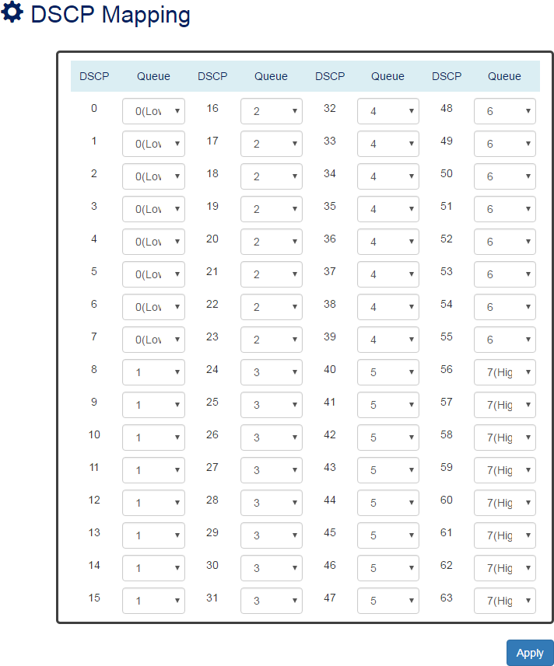

DSCP
There are 6 bits for the “DSCP” in ToS tag and hence there are 64 classes from 0 to 63.

Queue
The chipset supports 8 queues from queue 0 to queue 7. The queue 0 is the least priority queue and the queue 7 is the highest priority queue.
The default Queue for each type is displayed in the table:
Type | 0-7 | 8-15 | 16-23 | 24-31 | 32-39 | 40-47 | 48-55 | 56-63
Queue | 0 | 1 | 2 | 3 | 4 | 5 | 6 | 7
• (Apply Button)
After configuring above fields, click "Apply" button to make the changes effective.

Port Trunk

Port Trunk is also known as Link Aggregation, and it is a protocol to group links to a trunk. A total of 8 trunk groups are provided. It is a good method to reach load balance and link backup. For example, when port 1 to port 4 are combined to trunk 1 and all ports support 100Tx and set to full-duplex, the bandwidth of the trunk will be 800Mbps. The traffic transmitting on the trunk is distributed to one of the links by the source MAC address to reach the load balance. When the trunk mode is set to LACP and when one of the links is broken, the traffic will transmit on another link on the group.

CONFIGURE PORT TRUNK INFORMATION
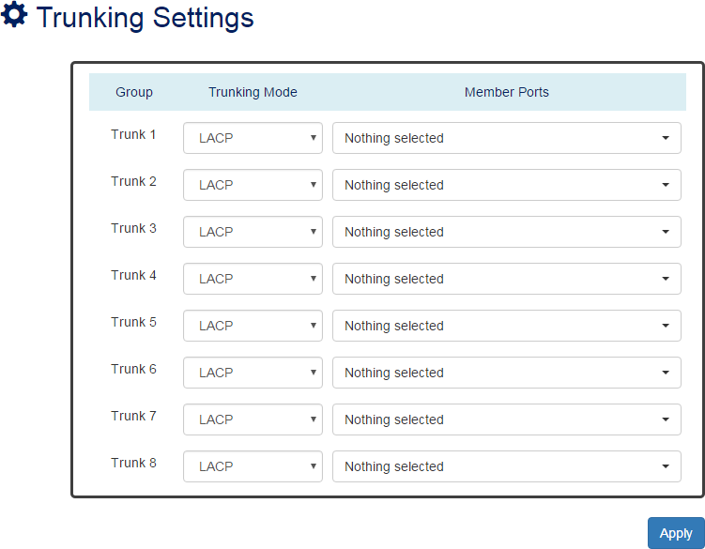

Group
Eight trunk groups from Trunk 1 to Trunk 8 are supported.

Trunking Mode
Two trunking modes are available: “LACP” and “Static”.
Static: The traffic is transmitted on one of the links in the group. The link is determined by the MAC Address in the frame header. If the link is broken, the traffic cannot transmit on the other links in the group.

LACP: It is also known as “Dynamic” trunking. If the current transmitting link is broken, the traffic can be transmitted on another link in the group.

Member Ports
Select member ports to be joined in the specified Trunk group. A port can only be in one of the Trunk group. Each Trunk group supports maximum 8 member per ports.
• (Apply Button)
After configuring above fields, click "Apply" button to make the changes effective.

PORT TRUNK STATUS
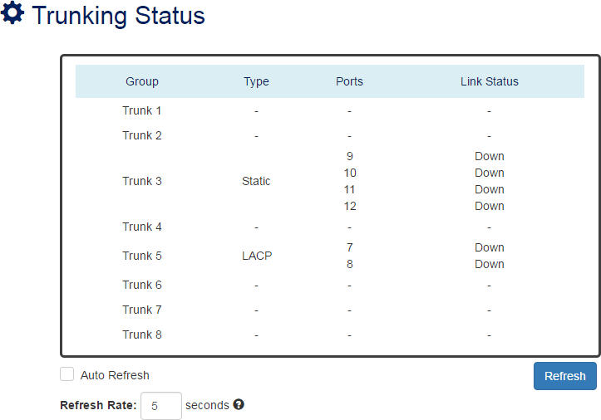

Group
The supported trunk groups are from Trunk 1 to Trunk 8.

Type
The trunk mode set for this group may be “LACP” or “Static”. This field displays “-“ if no members are in the group.

Ports
The selected member ports in the group will be displayed in this column.

Link Status
This field displays the link state (Up or Down) for the specific port.

Static Route

Static Route is the most basic routing method. Users have to manually-configure routing entries into routing table. Static Route is fixed and unchanged if the Network is changed. Static Route is good to be configured at a gateway of last resorts. The Network administrator has the full control over the static routing behavior, so the administrator must have enough background knowledge to handle it.
CONFIGURE IPV4 STATIC ROUTE INFORMATION
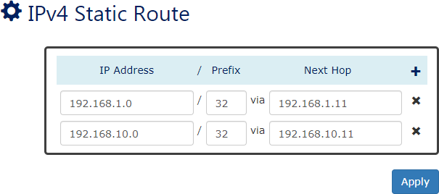

IP Address
Assign the IP Address to configure the static routing path.

Netmask
The Netmask is a number mapping to the Subnet Mask. For example, users configure the Netmask to 24 implies to configure the Subnet Mask to 255.255.255.0.

Next Hop
The Next Hop is an IP Address for a VLAN ID. The Next Hop implies the next node that the packet will be transferred to.
• (Apply Button)
After configuring above fields, click "Apply" button to make the changes effective.

CONFIGURE IPV6 STATIC ROUTE INFORMATION
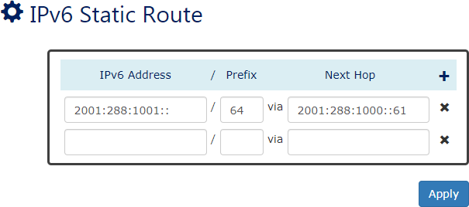

IPv6 Address
Assign the IPv6 Address to configure the static routing path.

Prefix
The Prefix defines the segment of the IPv6 address.

Next Hop
The Next Hop is an IPv6 Address for a VLAN ID. The Next Hop implies the next node that the packet will be transferred to.
• (Apply Button)
After configuring above fields, click "Apply" button to make the changes effective.

IPV4 STATIC ROUTE EXAMPLE
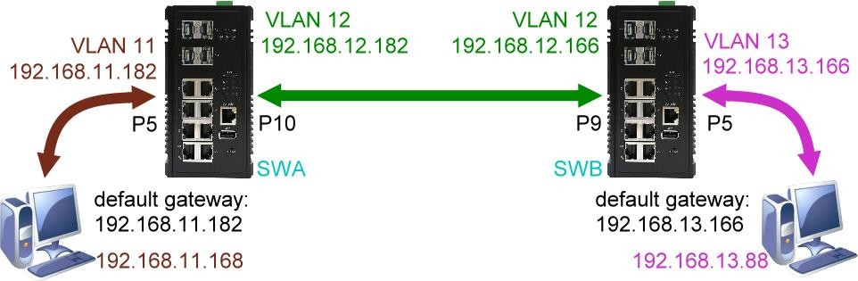
In the following diagram, we are going to configure a topology with Static Route for the system.

Configurations for SWA
- Configure VLAN for different subnets
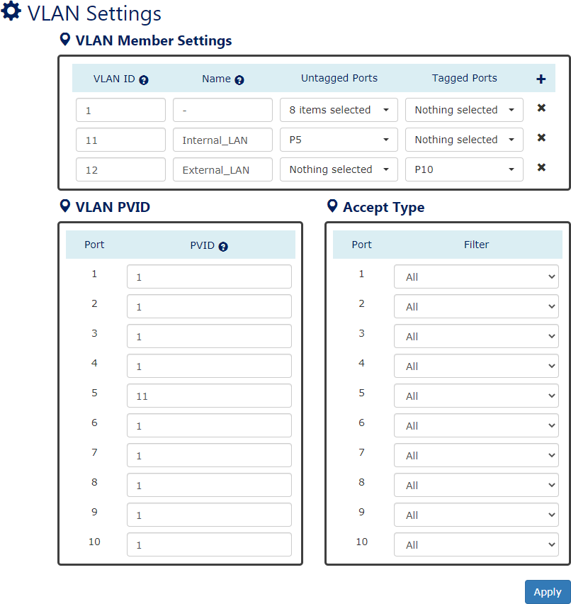
Add VLAN 11 with untagged member port 5 and VLAN 12 with tagged member port 10 Configure PVID to 11 on port 5 because the end device (PC) has no ability to deal with the VLAN tag.

- Configure IP Address for different VLANs (Subnets)
The IP Address of VLAN 11 is 192.168.11.182 and the Subnet Mask is 255.255.255.0 The IP Address of VLAN 12 is 192.168.12.182 and the Subnet Mask is 255.255.255.0
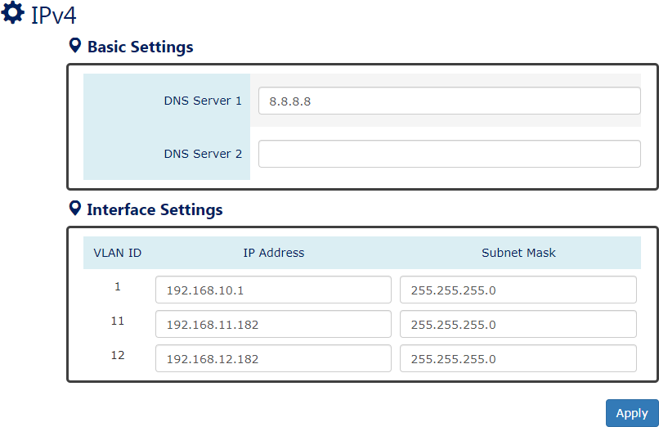

- Configure Static Routing Rule
To connect to the internal LAN on SWB, users must configure the path on SWA
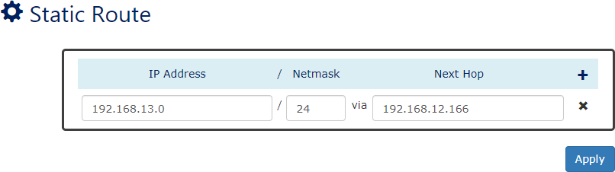
The Subnet of internal LAN on SWB is 192.168.13.0/24, and the IP Address of SWB’s external LAN is 192.168.12.166.

Configurations for SWB

- Configure VLAN for different subnets
Add VLAN 11 with untagged member port 5 and VLAN 12 with tagged member port 10 Configure PVID to 11 on port 5 because the end device (PC) has no ability to deal with the VLAN tag.

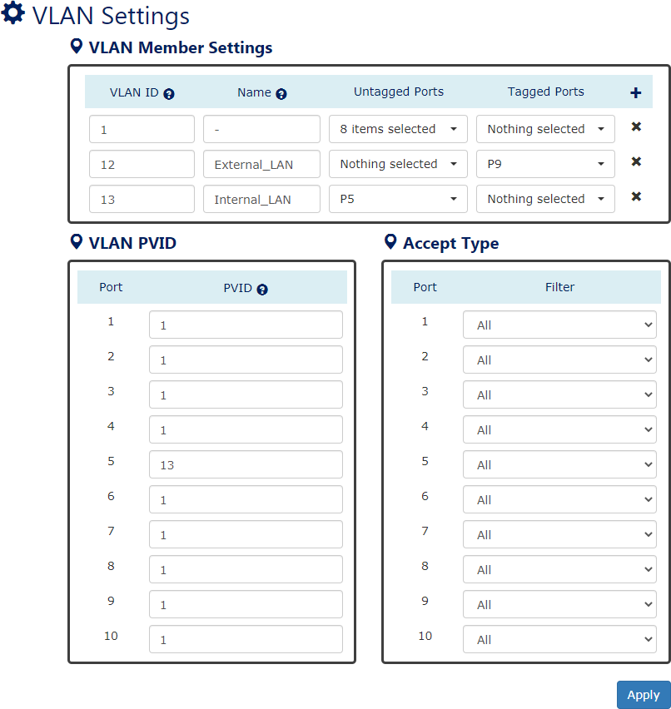

- Configure IP Address for different VLANs (Subnets)
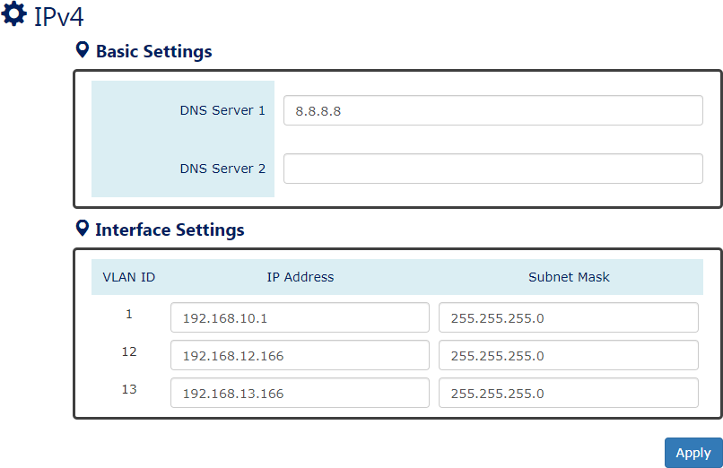
The IP Address of VLAN 11 is 192.168.11.182 and the Subnet Mask is 255.255.255.0 The IP Address of VLAN 12 is 192.168.12.182 and the Subnet Mask is 255.255.255.0

- Configure Static Routing Rule
To connect to the internal LAN on SWA, users must configure the path on SWB
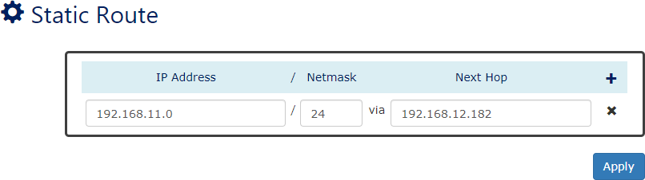
The Subnet of internal LAN on SWA is 192.168.11.0/24, and the IP Address of SWA’s external LAN is 192.168.12.182.

Note: Remember clicking “Apply” button to make the changes effective in each step.

OSPFv2

Open Shortest Path First (OSPF) is one of the dynamic routing protocols and OSPFv2 is for IPv4 Networks. OSPF is the most widely used interior Gateway Protocol (IGP) and it is designed for medium-and-large-scale enterprise networks. OSPF nodes exchange neighbors’ information by Link-State and calculate the shortest path with their Cost to transmit packets. OSPF is operating under a hierarchical system and divide the system to several Areas by different Area IDs. OSPF nodes only exchange information with the nodes in the same Area.
CONFIGURE OSPFV2 INFORMATION
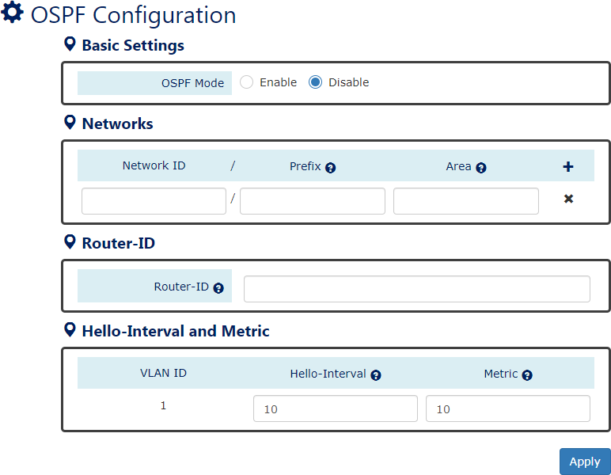
For more information, hover the mouse over the icon in the system.

OSPF Mode
“Enable” or “Disable” OSPFv2 Function. The OSPFv2 function is default disabled. Please make sure the status of RIP is Disabled before Enable OSPFv2 function.

Networks
      - Network ID
The Networks ID implies the first IP Address of the subnet that will join the OSPF routing.

      - Prefix
The Prefix is a number mapping to the Subnet Mask. For example, users configure the Prefix to 24 implies to configure the Subnet Mask to 255.255.255.0.
The range of Prefix is from 0 to 32.
      - Area
The Area is an identity and only the nodes in the same area will exchange the OSPF information with each other. The Area 0 is a special area and called Backbone Area. All other areas must connect to the backbone area.
The range of Area is from 0 to 4294967295. : Click the plus icon to add an OSPF entry.
: Click the remove icon to delete the OSPF entry.

Router-ID
The Router-ID implies the identity for the working OSPFv2. The format of Router-ID is A.B.C.D.

Hello Interval
The Hello Interval is the period to send “Hello Message” to OSPF neighbors.
The range of Hello Interval is from 1 to 65535 second(s).
The default Hello Interval is 10 seconds.

Metric
The Metric is the total cost of the path from source device to destination device.
The range of Metric is from 1 to 65535.
The default Metric is 10.
• (Apply Button)
After configuring above fields, click "Apply" button to make the changes effective.

OSPFV2 STATUS
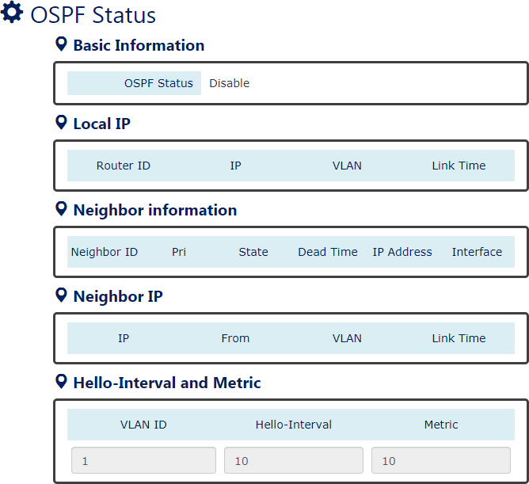

OSPF Mode
Display the state (“Enable” or “Disable”) of OSPF function.

Local IP
Display the information that configured on the localhost for OSPFv2.

Neighbor Information
Display the status of the neighborhood.

Neighbor IP
Display the information that learned from OSPF neighbors.

Hello Interval
Display the Hello Interval value of designated VLAN.

Metric
Display the Metric of designated VLAN.

OSPFV2 EXAMPLE
In the following diagram, we are going to configure a topology with Dynamic Routing – OSPFv2 for the system. Use the following commands or view OSPF Status page to check the link state after configurations are completed:
- show router ospf
- show router ospf neighbor
- show ip route
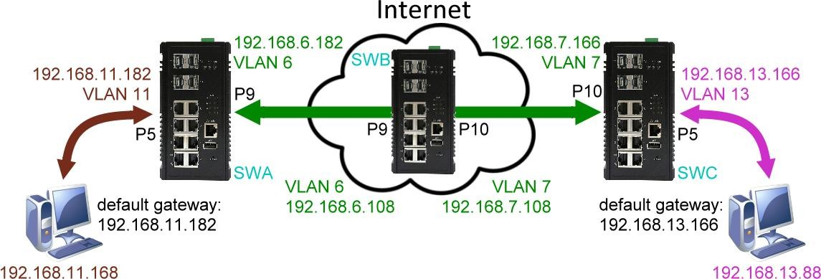
*Simulation Internet by through SWB.*

Configurations for SWA

- Configure VLAN for different subnets
Add VLAN 6 with tagged member port 9and VLAN 11 with untagged member port 5 Configure PVID to 11 on port 5 because the end device (PC) has no ability to deal with the VLAN tag.
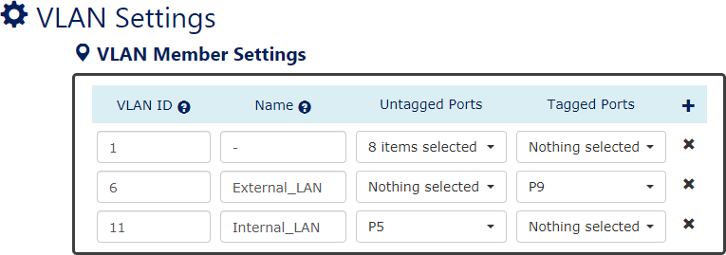

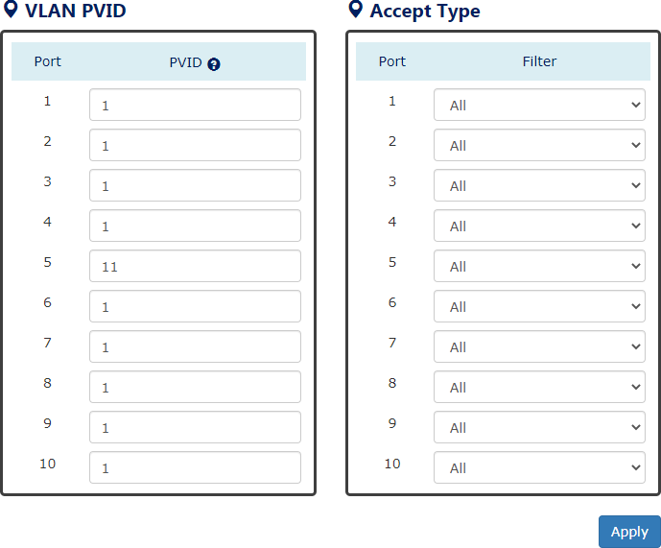

- Configure IP Address for different VLANs (Subnets)
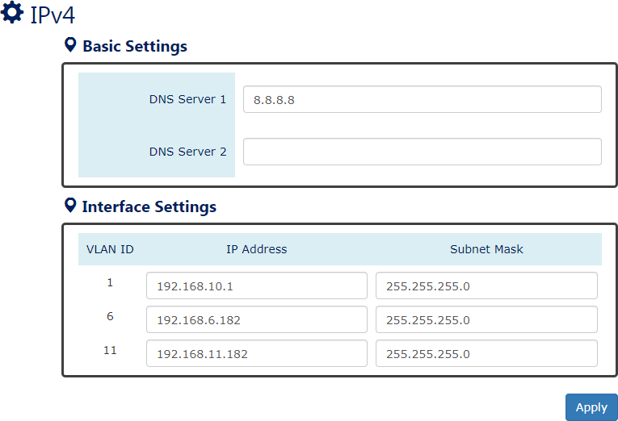
The IP Address of VLAN 6 is 192.168.6.182 and the Subnet Mask is 255.255.255.0 The IP Address of VLAN 11 is 192.168.11.182 and the Subnet Mask is 255.255.255.0

- Configure OSPF rules
Set Router ID to 0.0.0.1 for SWA
Configure subnet 192.168.6.0/24 to join OSPF network area 0

Configure subnet 192.168.11.0/24 to join OSPF network area 0
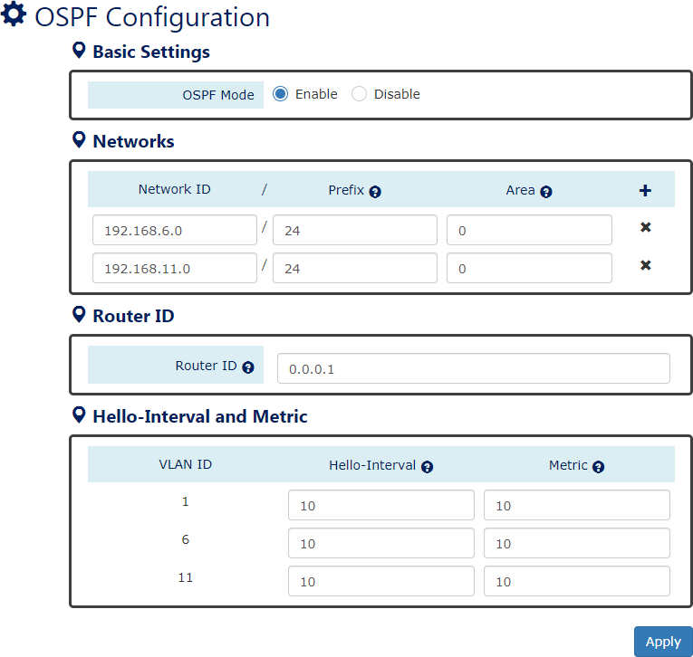
Enable OSPFv2 function on SWA

Configurations for SWB

- Configure VLAN for different subnets
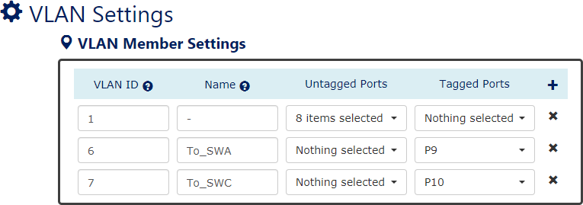
Add VLAN 6 with tagged member port 9 and VLAN 7 with tagged member port 10 Both port 9 and port 10 are tagged members, so there is no need to configure PVID.

- Configure IP Address for different VLANs (Subnets)
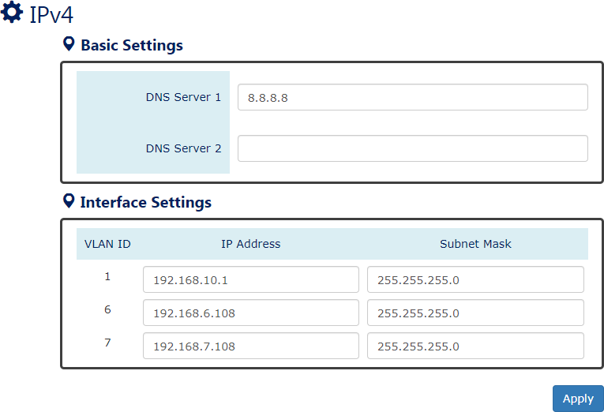
The IP Address of VLAN 6 is 192.168.6.108 and the Subnet Mask is 255.255.255.0 The IP Address of VLAN 7 is 192.168.7.108 and the Subnet Mask is 255.255.255.0

- Configure OSPF rules
Set Router ID to 0.0.0.2 for SWB
Configure subnet 192.168.6.0/24 to join OSPF network area 0 Configure subnet 192.168.7.0/24 to join OSPF network area 0
Enable OSPFv2 function on SWB
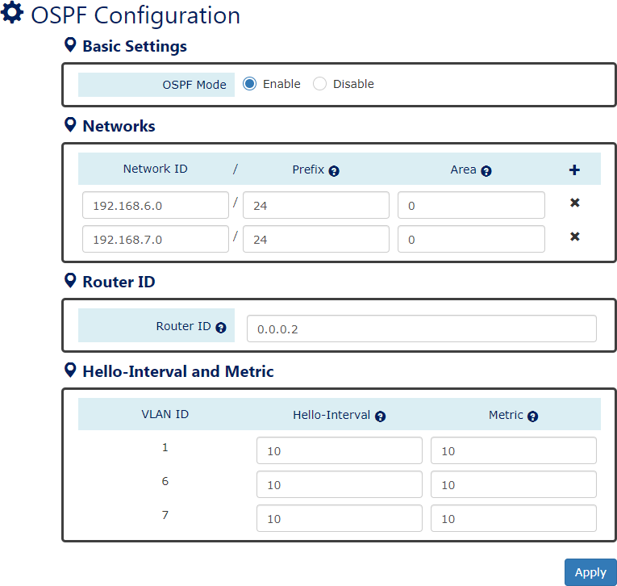

Configurations for SWC

- Configure VLAN for different subnets
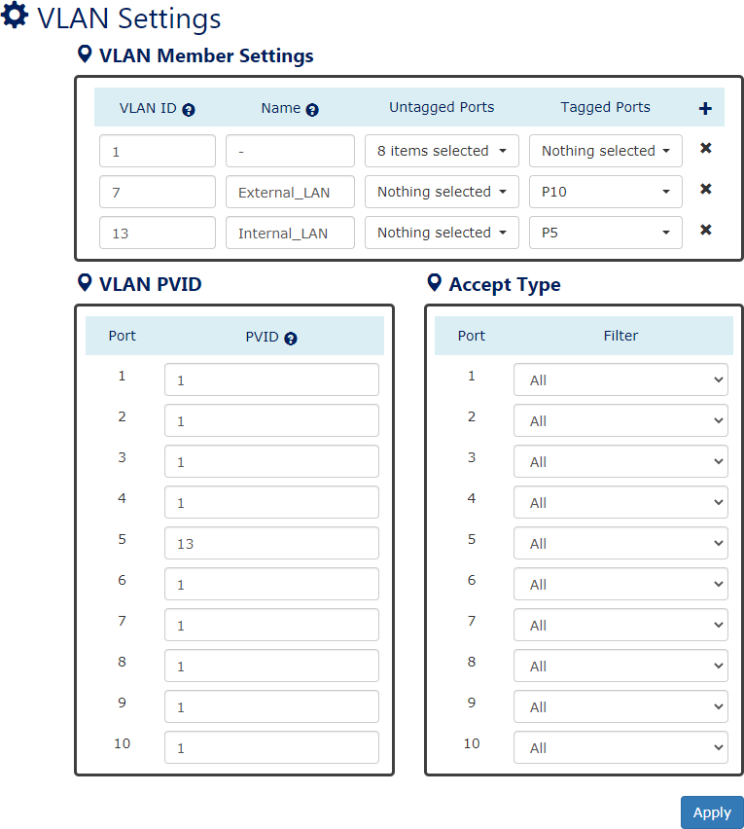
Add VLAN 7 with tagged member port 10 and VLAN 13 with untagged member port 5 Configure PVID to 13 on port 5 because the end device (PC) has no ability to deal with the VLAN tag.
- Configure IP Address for different VLANs (Subnets)
The IP Address of VLAN 7 is 192.168.7.166 and the Subnet Mask is 255.255.255.0 The IP Address of VLAN 13 is 192.168.13.166 and the Subnet Mask is 255.255.255.0

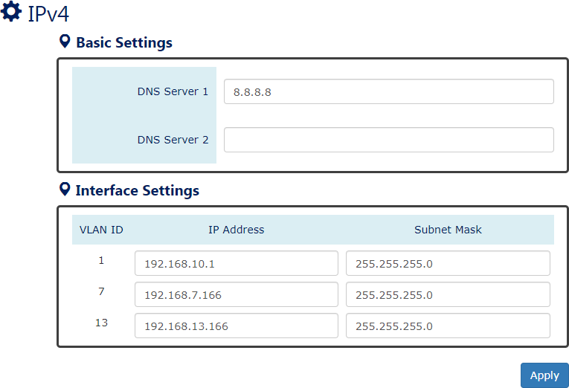

- Configure OSPF rules
Set Router ID to 0.0.0.3 for SWC
Configure subnet 192.168.7.0/24 to join OSPF network area 0 Configure subnet 192.168.13.0/24 to join OSPF network area 0
Enable OSPFv2 function on SWB
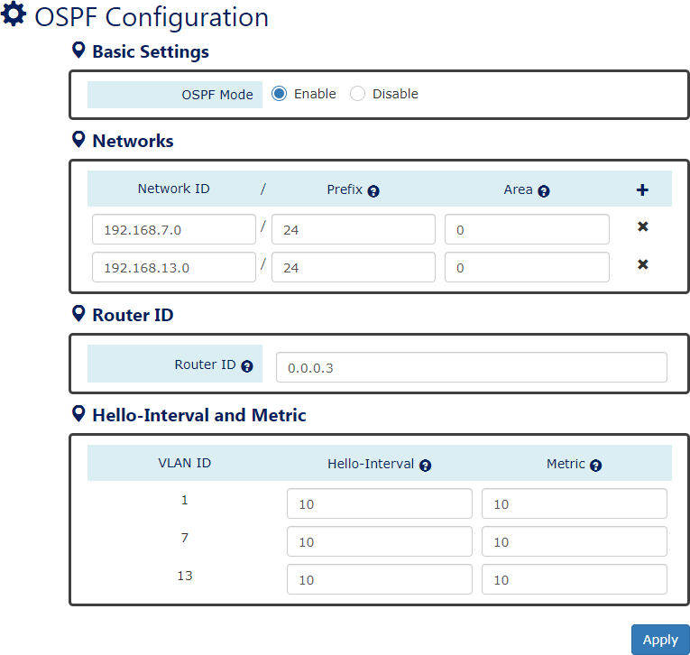

Note: Remember clicking “Apply” button to make the changes effective in each step.

OSPFv3

Continued from previous chapter, OSPFv3 is an extension of OSPFv2 which can support both
IPv4 and IPv6 Networks.
There is no necessary to explicitly create a routing process for each subnet in OSPFv3. The routing process will be triggered by assigning an interface, which implies VLAN, to the OSPFv3 configurations. Users can configure several IPv6 address prefixes on a VLAN interface, so all prefixes on the VLAN interface will be included by default.
CONFIGURE OSPFV3 INFORMATION
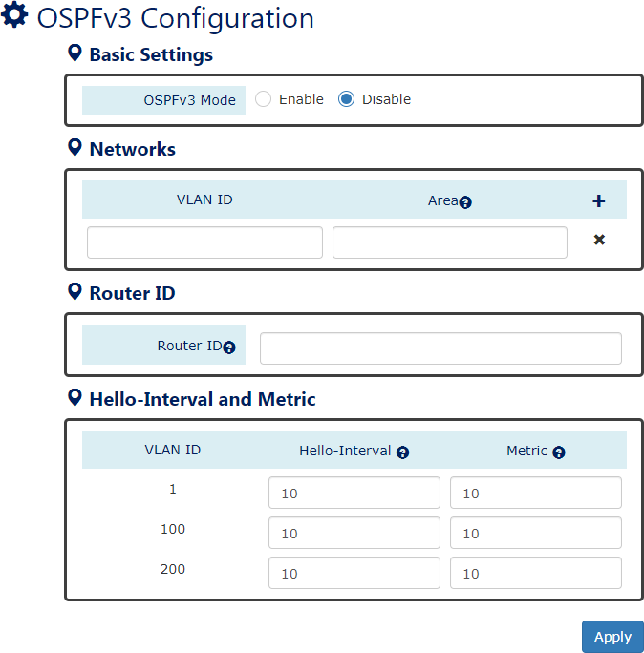
For more information, hover the mouse over the icon in the system.

OSPFv3 Mode
“Enable” or “Disable” OSPFv3 Function. The OSPFv3 function is default disabled. Please make sure the status of RIP is Disabled before Enable OSPFv3 function.

Networks

      - VLAN ID
Assign the designated VLAN interface to join OSPFv3 routing process.
      - Area
The Area is an identity and only the nodes in the same area will exchange the OSPF information with each other. The Area 0 is a special area and called Backbone Area. All other areas must connect to the backbone area.
The range of Area is from 0 to 4294967295. : Click the plus icon to add an OSPF entry.
: Click the remove icon to delete the OSPF entry.

Router-ID
The Router-ID implies the identity for the working OSPFv3. The format of Router-ID is A.B.C.D.

Hello Interval
The Hello Interval is the period to send “Hello Message” to OSPF neighbors.
The range of Hello Interval is from 1 to 65535 second(s).
The default Hello Interval is 10 seconds.

Metric
The Metric is the total cost of the path from source device to destination device.
The range of Metric is from 1 to 65535.
The default Metric is 10.
• (Apply Button)
After configuring above fields, click "Apply" button to make the changes effective.

OSPFV3 STATUS
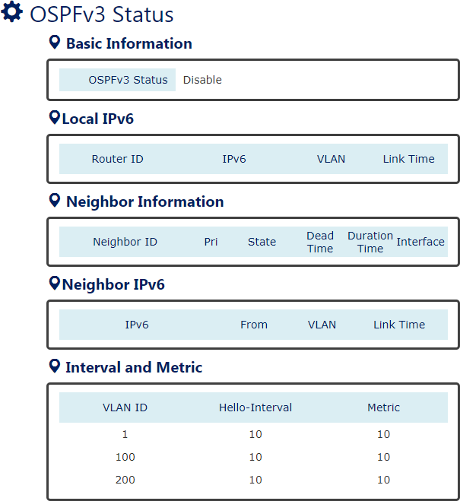

OSPF Mode
Display the state (“Enable” or “Disable”) of OSPF function.

Local IPv6
Display the information that configured on the localhost for OSPFv3.

Neighbor Information
Display the status of the neighborhood.

Neighbor IPv6
Display the information that learned from OSPF neighbors.

Hello Interval
Display the Hello Interval value of designated VLAN.

Metric
Display the Metric of designated VLAN.

RIPv1/v2

Routing Information Protocol (RIP) is another dynamic routing protocol for a small-scale Network. RIP uses Distance Vector to determine the routing path. The best path for RIP is the least hops during transmission. This is also the weakness of RIP because the path with least hops might not be the fastest path.
The RIP members broadcast their routing table to each other every 30 seconds to synchronize the Network and maintain the routing paths to be the least hops. The max number of hops that can be transferred between two nodes (routers) is 15. Therefore, the RIP function is only suitable for a small Network.
CONFIGURE RIPV1/V2 INFORMATION
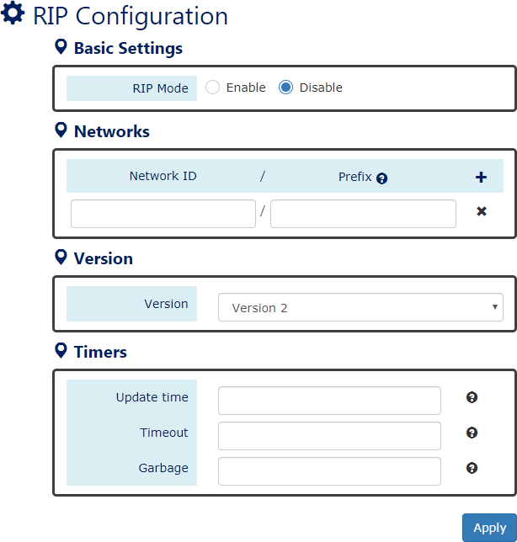
For more information, hover the mouse over the icon in the system.

RIP Mode
“Enable” or “Disable” RIP Function. The RIP function is default disabled.

Please make sure the status of OSPFv2 is Disabled before Enable RIP function.

Networks
      - Network ID
The Networks ID implies the first IP Address of the subnet that will join the RIP routing.
      - Prefix
The Prefix is a number mapping to the Subnet Mask. For example, users configure the Prefix to 24 implies to configure the Subnet Mask to 255.255.255.0.
The range of Prefix is from 0 to 32.

Version
Configure the Version of RIP. We support RIPv2 by default, but users can configure the version to support RIPv1.
    - Timers
      - Update Time
The Update Time is the interval to send broadcast for updating routing table with other routers in the same RIP Network.
The range of Update Time is from 5 to 2147483647.
The default Update Time is 30 seconds.
。 Timeout
The Timeout value is also called Aging Time. It will be count down from configured value until 0. If the system received a packet with the same RIP path, the Aging Time will be reset to the initial configured value and count down again. If the Aging Time is counting down to 0, the routing entry will be deleted from the routing table.
The range of Timeout is from 5 to 2147483647.
The default Timeout is 180 seconds.
。 Garbage
The Garbage-Collection Timer is used for a newly created routing path. When a new routing path is built, the timer creates and counts down. The routing path will be discarded if the timer is 0.
The range of Garbage is from 5 to 2147483647.
The default Garbage is 120 seconds.
• (Apply Button)
After configuring above fields, click "Apply" button to make the changes effective.

RIPV1/V2 STATUS
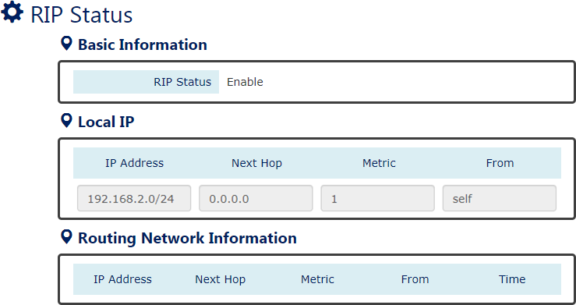

RIP Status
Display the state (“Enable” or “Disable”) of RIP function.

Local IP
Display the information that configured on the localhost for RIP.

Routing Network Information
Display the routing information that exchanges with other routers.
RIP EXAMPLE
In the following diagram, we are going to configure a topology with Dynamic Routing – RIP for the system. Use the following commands or view RIPv1/v2 Status page to check the link state after configurations are completed:
- show router rip status
- show router rip state
- show ip route
*Simulation Internet by through SWB.*

Configurations for SWA

- Configure VLAN for different subnets
Add VLAN 6 with tagged member port 9and VLAN 11 with untagged member port 5 Configure PVID to 11 on port 5 because the end device (PC) has no ability to deal with the VLAN tag.
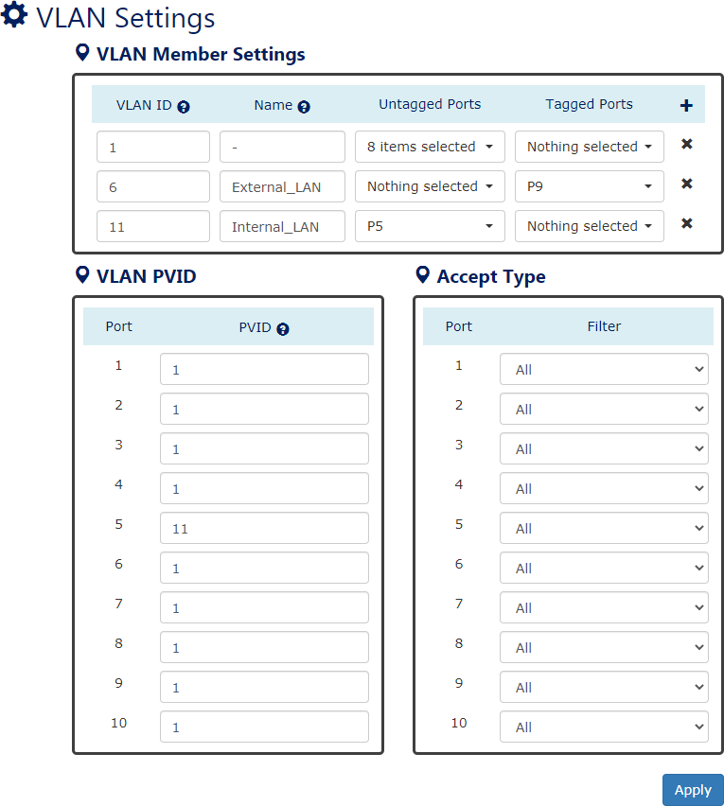

- Configure IP Address for different VLANs (Subnets)
The IP Address of VLAN 6 is 192.168.6.182 and the Subnet Mask is 255.255.255.0 The IP Address of VLAN 11 is 192.168.11.182 and the Subnet Mask is 255.255.255.0

- Configure RIP rules
Configure subnet 192.168.6.0/24 to join RIP network Configure subnet 192.168.11.0/24 to join RIP network
Enable RIP function on SWA, the default RIP is running version 2.
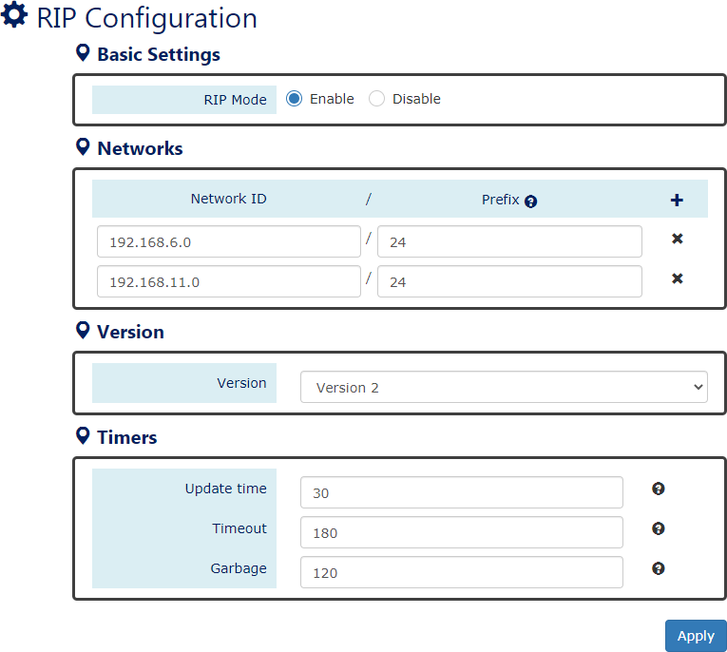

Configurations for SWB

- Configure VLAN for different subnets
Add VLAN 6 with tagged member port 9 and VLAN 7 with tagged member port 10 Both port 9 and port 10 are tagged members, so there is no need to configure PVID.

- Configure IP Address for different VLANs (Subnets)
The IP Address of VLAN 6 is 192.168.6.108 and the Subnet Mask is 255.255.255.0 The IP Address of VLAN 7 is 192.168.7.108 and the Subnet Mask is 255.255.255.0

- Configure RIP rules
Configure subnet 192.168.6.0/24 to join RIP network Configure subnet 192.168.7.0/24 to join RIP network
Enable RIP function on SWB, the default RIP is running version 2.
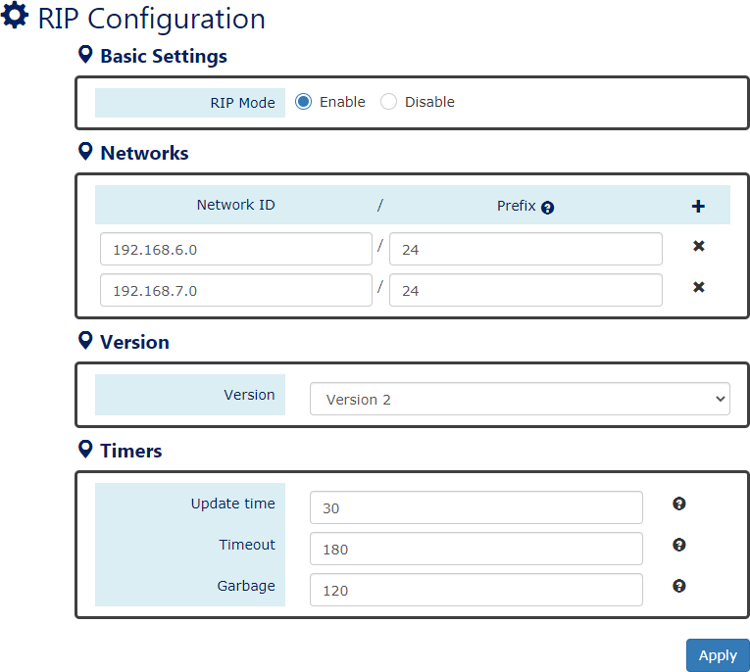

Configurations for SWC

- Configure VLAN for different subnets
Add VLAN 7 with tagged member port 10 and VLAN 13 with untagged member port 5 Configure PVID to 13 on port 5 because the end device (PC) has no ability to deal with the VLAN tag.
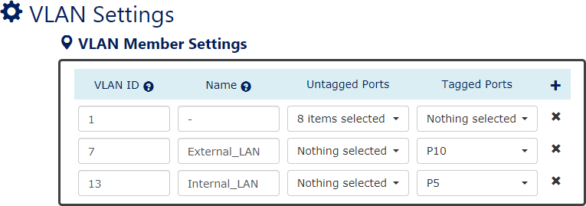

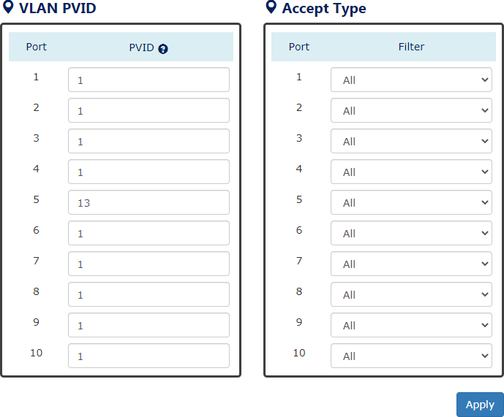

- Configure IP Address for different VLANs (Subnets)
The IP Address of VLAN 7 is 192.168.7.166 and the Subnet Mask is 255.255.255.0 The IP Address of VLAN 13 is 192.168.13.166 and the Subnet Mask is 255.255.255.0

- Configure RIP rules
Configure subnet 192.168.7.0/24 to join RIP network Configure subnet 192.168.13.0/24 to join RIP network
Enable RIP function on SWC, the default RIP is running version 2.

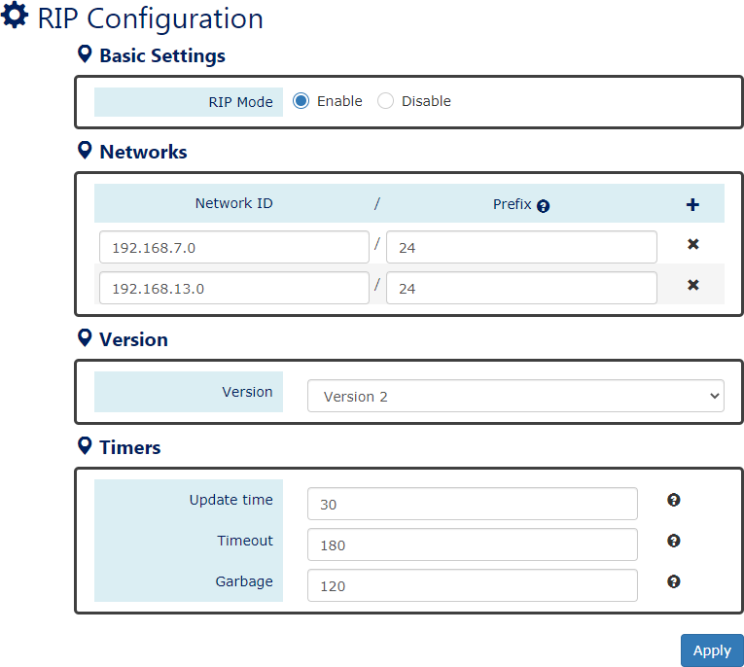

Note: Remember clicking “Apply” button to make the changes effective in each step.

RIPng

RIP next generation (RIPng) is an extension of RIPv2 to support IPv6. The following are the differences between RIPng and RIPv2. Although RIPng is the next generation of RIPv2, the RIPng does not support RIPv1. The operation of RIPng is to assign a set of route entries into a specific next-hop rather than record next-hops for each route entry on RIPv2. The multicast group of RIPng is FF02::9 but for RIPv2, it uses 224.0.0.9.
The max number of hops that can be transferred between two nodes is also 15 for RIPng. It is a
limitation for using on a large-scale network topology.

CONFIGURE RIPNG INFORMATION
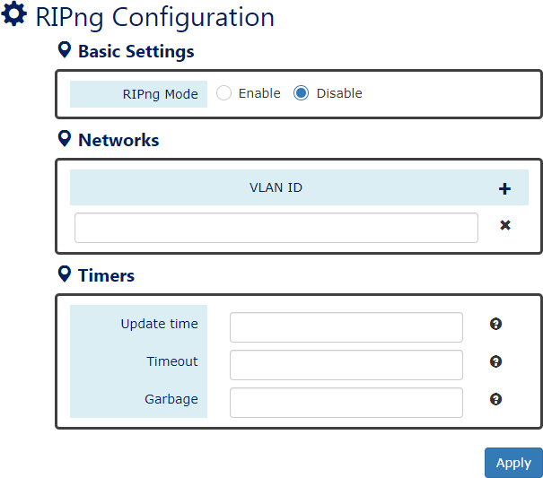
For more information, hover the mouse over the icon in the system.

RIP Mode
“Enable” or “Disable” RIPng Function. The RIP function is default disabled.
Please make sure the status of OSPF is Disabled before Enable RIPng function.

Networks
      - VLAN ID
The VLAN ID implies the VLAN interface that will join the RIP routing.

    - Timers
      - Update Time
The Update Time is the interval to send broadcast for updating routing table with other routers in the same RIP Network.
The range of Update Time is from 5 to 2147483647.
The default Update Time is 30 seconds.
。 Timeout
The Timeout value is also called Aging Time. It will be count down from configured value until 0. If the system received a packet with the same RIP path, the Aging Time will be reset to the initial configured value and count down again. If the Aging Time is counting down to 0, the routing entry will be deleted from the routing table.
The range of Timeout is from 5 to 2147483647.
The default Timeout is 180 seconds.
。 Garbage
The Garbage-Collection Timer is used for a newly created routing path. When a new routing path is built, the timer creates and counts down. The routing path will be discarded if the timer is 0.
The range of Garbage is from 5 to 2147483647.
The default Garbage is 120 seconds.
• (Apply Button)
After configuring above fields, click "Apply" button to make the changes effective.

RIPNG STATUS
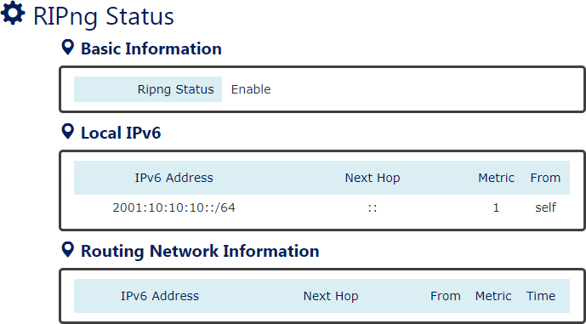

RIPng Status
Display the state (“Enable” or “Disable”) of RIPng function.

Local IPv6
Display the information that configured on the localhost for RIPng.

Routing Network Information
Display the routing information that exchanges with other routers.

VRRP

Virtual Router Redundancy Protocol (VRRP) is a function to avoid single point of failure in the static default routed environment. There are two or more routers in a VRRP group to backup each other. They share the same virtual IP address in the Network and one of them called Master provides routing services for other devices. Others in the same VRRP group are Backup routers. When the Master router is broken, the Backup routers will replace the original Master router based on their Priority value. The router with the highest Priority value will be the next Master, so that the routing can be uninterrupted.
CONFIGURE VRRP INFORMATION
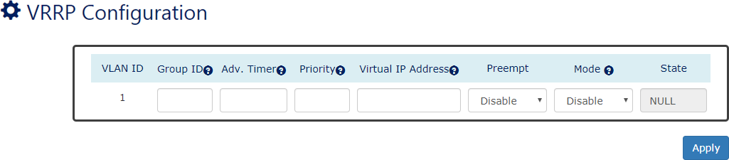
For more information, hover the mouse over the icon in the system.

VLAN ID
Display the current VLAN ID that is configured with members and IP Address.

Group ID
The Group ID is the identity for the VRRP Group. All routers in the same VRRP group MUST be configured with the same Group ID.
The range of Group ID is from 1 to 255

Adv. Timer
The timer is the period to send Advertisement to make sure the Master is still alive. The Master route will be changed if other Backup routers miss Advertisement message after the timer expired to make sure the continuous services.
The range of Adv. Timer is from 1 to 60 seconds

Priority
The Priority is used to decide the Master in the VRRP group.
The range of Priority is from 1 to 254
Note: the higher the value the higher the priority

Virtual IP Address
The Virtual IP Address is a public IP Address in the Network. All routers in the same VRRP group are configured with the same Virtual IP Address.
Note: The Virtual IP Address must be configured different from VLAN IP Addresses.

Preempt
“Enable” or “Disable” Preempt Mode. When the Preempt Mode is disabled, other VRRP routers are not allowed to preempt the Master role.

Mode
“Enable” or “Disable” VRRP function on this VLAN.
Note: Users must configure all VRRP parameters before enable VRRP function.

State
There are four states for the VRRP
Master: This is a major router that provides services in the VRRP group.
Backup: This is a backup router in the VRRP group. When the VRRP Master is broken, the backup router will provide services.
Init: VRRP function is under initialization. NULL: VRRP function is disabled.
VRRP EXAMPLE
In the following diagram, we are going to configure a topology with VRRP for router backup.

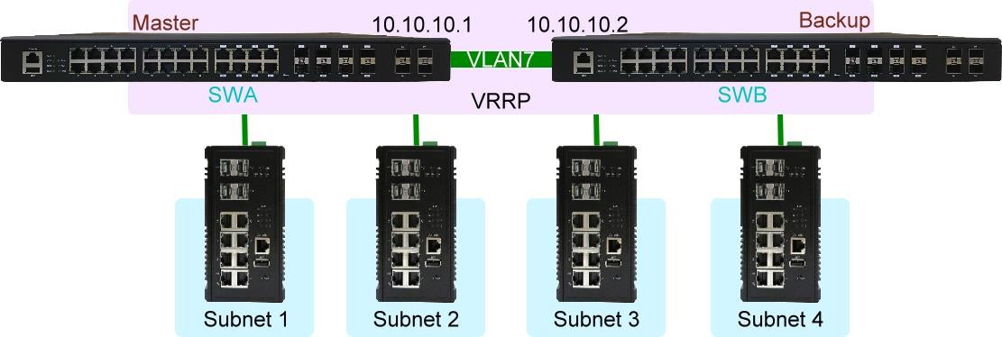

Configurations for SWA

- Configure VLAN 7 on SWA for VRRP interface and assign IP Address to the VLAN
- Configure VRRP information for SWA (Master Router)
Set Group ID to 1, Advertisement Timer to 10 seconds, Priority to 100, and Virtual IP Address to 10.10.10.5. Make sure the Mode is configured to “Enable”.
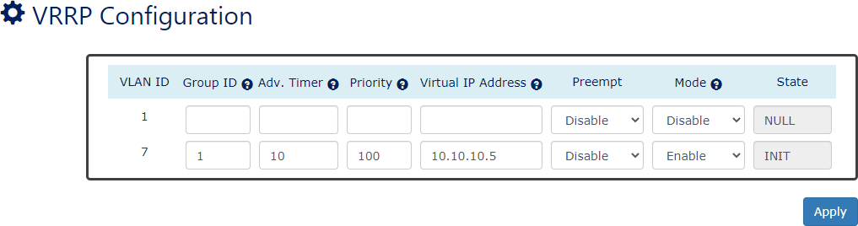

Configurations for SWB

- Configure VLAN 7 on SWB for VRRP interface and assign IP Address to the VLAN
- Configure VRRP information for SWB (Backup Router)
Set Group ID to 1, Advertisement Timer to 10 seconds, Priority to 50, and Virtual IP Address to 10.10.10.5. Make sure the Mode is configured to “Enable”.
Because SWB is the Backup Router, the Priority value must be below the Priority value of SWA.
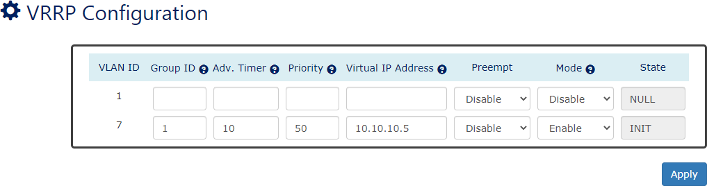
Note: The Group ID and Virtual IP Address should be the same on all VRRP members. Note: Remember clicking “Apply” button to make the changes effective in each step.

Storm Control

A traffic storm happens when there is excessive packets flood to the LAN and decreases the performance. The Storm Control function is used to prevent the system from breaking down by the broadcast, multicast, or unknown unicast traffic storm. When the Storm Control is enabled on the specific traffic type, the system will monitor the incoming traffic. If the traffic is more than the configured level, the traffic will be dropped to avoid the storm.

CONFIGURE STORM CONTROL INFORMATION
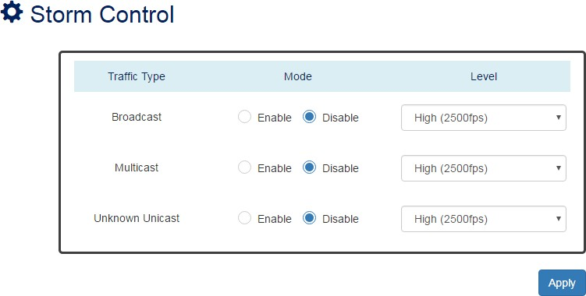

Traffic Type
Three types of traffics are supported in the Storm Control: Broadcast, Multicast, and
Unknown Unicast.
    - Mode
“Enable” or “Disable” Storm Control function in the specific traffic type.

Level
Three frame levels are available: High, Middle, and Low. If the frames of specific traffic type are more than the set level, the system will drop the type of frames to prevent the system from breaking down.
High: More than 2500 frame per second.
Mid: More than 1000 frame per second.
Low: More than 500 frame per second.
• (Apply Button)
After configuring above fields, click "Apply" button to make the changes effective.

802.1X Settings

802.1X is an IEEE standard defined Port-based Network Access Control. It provides a more secured authentication mechanism for the devices, which would like to connect to a LAN or a WAN. The Port-based Network Access Control protocol is a convenient method for the users because the authentication is per-port and once the port passes the authentication, it is not required to authenticate again when changing to another device, i.e., without security. Therefore, MAC-based access control is provided. It is a more secure, but less convenient method for authentication. Only the device with the MAC Address that has passed the authentication can be added to the networks. These two methods are optional on each port and the users can select one of them on different ports.
CONFIGURE 802.1X BASIC INFORMATION
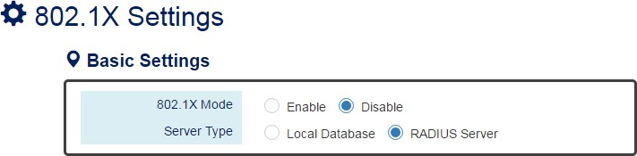

For more information, hover the mouse over the icon in the system.

Basic Settings
      - 802.1X Mode
“Enable” or “Disable” 802.1X function on the switch.
      - Server Type
Select the 802.1X server type to “Local Database” or “RADIUS Server”.
Local Database: The database is maintained in a table stored in the switch. The client must send the username and password to authenticate with the switch’s database.
RADIUS Server: The database is maintained in other devices running RADIUS service. The authentication follows the RADIUS protocol including communication and encryption.

CONFIGURE 802.1X PORT INFORMATION
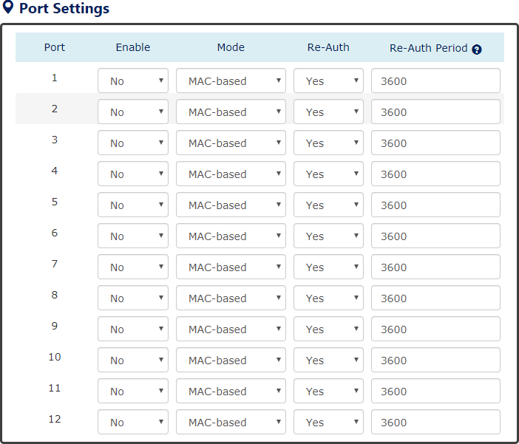
For more information, hover the mouse over the icon in the system.

Port Settings
      - Port
Port1 to PortN, where N is based on the total port number.
      - Enable
“Enable” or “Disable” 802.1X function on the port. “Yes” means 802.1X is enabled on the port and the port is locked until it passes the authentication.
      - Mode
Select the 802.1X mode to “Mac-based” or “Port-based”.
Mac-based: Only the MAC Address, which passed the authentication can connect to the networks.
Port-based: If the port had passed the authentication, every device connected to the port can connect to the networks.

- Re-Auth
“Enable” or “Disable” re-authentication on the port. “Yes” means re-authentication is enabled on the port and the port must re-authenticate with the server every re-auth period.
- Re-Auth Period
This is a time interval, which is used in re-authenticating the server.
• (Apply Button)
After configuring above fields, click "Apply" button to make the changes effective.
CONFIGURE LOCAL DATABASE INFORMATION
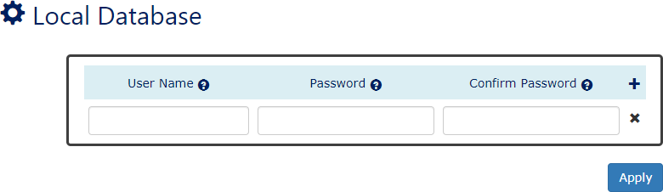
For more information, hover the mouse over the icon in the system.

User Name
The User Name is used in authentication.
The max. length for the User Name is 32 characters. Note: #, \, ', ", ? are invalid characters.

Password
The Password is used in authentication.
The max. length for the Password is 20 characters. Note: #, \, ', ", ? are invalid characters.

Confirm Password
The Confirm Password field must be the same as Password field.
• : Click the plus icon to add a Username/Password row.
• : Click the remove icon to delete the Username/Password row.
• (Apply Button)
After configuring above fields, click "Apply" button to make the changes effective.

CONFIGURE RADIUS SERVER INFORMATION
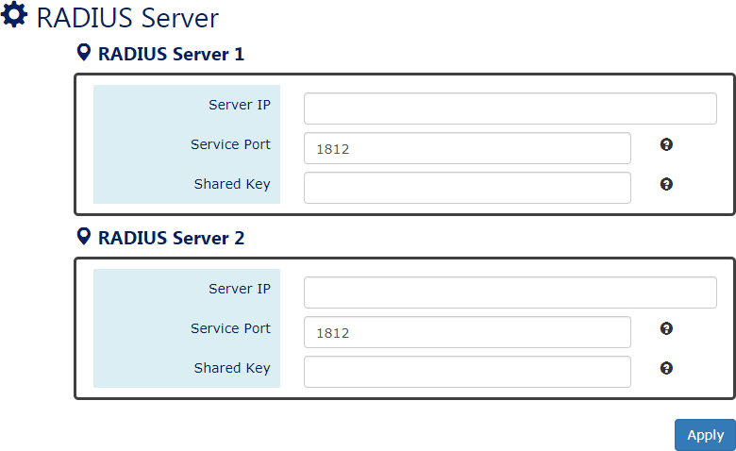
For more information, hover the mouse over the icon in the system.

Server IP
The Server IP is the IP address of the server.

Service Port
The Service Port is the listening port on the RADIUS server.

Shared Key
The key is used in establishing the connection between the server and the authenticator before authentication.
• (Apply Button)
After configuring above fields, click "Apply" button to make the changes effective.

Service Control

We provide 5 types of interface which are HTTP, HTTPS, SSH, Telnet, and Console Port to access the management interface of the switch. Users can configure the authority for each type of service to be enabled or disabled. Reset Button is another method to reboot or reset factory default. We also provide the configuration for the Reset Button to enable or disable its function. All the services are enabled by default and users can disable unused service to make the system more secure.

CONFIGURE SERVICE CONTROL INFORMATION
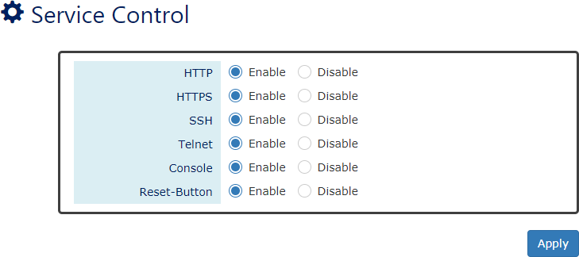

HTTP
Enable or Disable to access management interface by HTTP which is the foundation of data communication for the World Wide Web (WWW).

HTTPS
Enable or Disable to access management interface by HTTPS which is an adaptation of HTTP for security. The communication will be encrypted in HTTPS.

SSH
Enable or Disable to access management interface by SSH, which is a cryptographic network protocol. SSH provides a secure channel over an unsecured network in the client-server architecture. The switch plays the role of SSH server and hosts plays the role of SSH client.

Telnet
Enable or Disable to access management interface by Telnet which is a text-oriented virtual terminal connection. It is less secure than SSH because it does not encrypt any data even password when the data is transmitting.

Console
Enable or Disable to access management interface by Serial Console Port. Disable the Console Port can avoid the misconfiguration by someone who can access the device on-site.

Reset Button
Enable or Disable to react when users press the Reset Button. The Reset Button provides different functions including reboot and reset factory default. Disable Reset Button is a protection from mistaking the button to reboot the system or restore the system to default state.
• (Apply Button)
After configuring above fields, click "Apply" button to make the changes effective.

Access Control List

An access control list provides rules to apply all network ports. The inbound traffic checked the entries in the ACL table. Each entry can be the MAC entry for layer 2 address and IP entry for the
layer 3 address. And it can check the source address or destination address. User can adjust the address mask to provide the group setting in one entry. Entry have two actions that can permit or deny network packet transmitting to another port.

CONFIGURE ACCESS CONTROL LIST

Index
Entry number in the ACL table. Traffic packet will be checked with the index sequence.
The range of the Index is from VLAN 1 to 128

Action
Drop: Packet will be discarded if it hit the address rule.
Permit: Packet will be forwarded if it hit the address rule.

Address Type
Src: Address rule bases on the source address
Dst: Address rule bases on the destination address

Address
MAC address with byte colon format. For example: 00:80:C2:01:23:45 IP Address with decimal dot format. For example: 192.168.1.123

Address Mask
Bit mask for MAC address with byte colon. Bit 1 is checking in rule. Otherwise bit 0 is exclude in checking rule.
Subnet mask for IP address with decimal dot. To decide the type of network.

ACCESS CONTROL LIST EXAMPLE
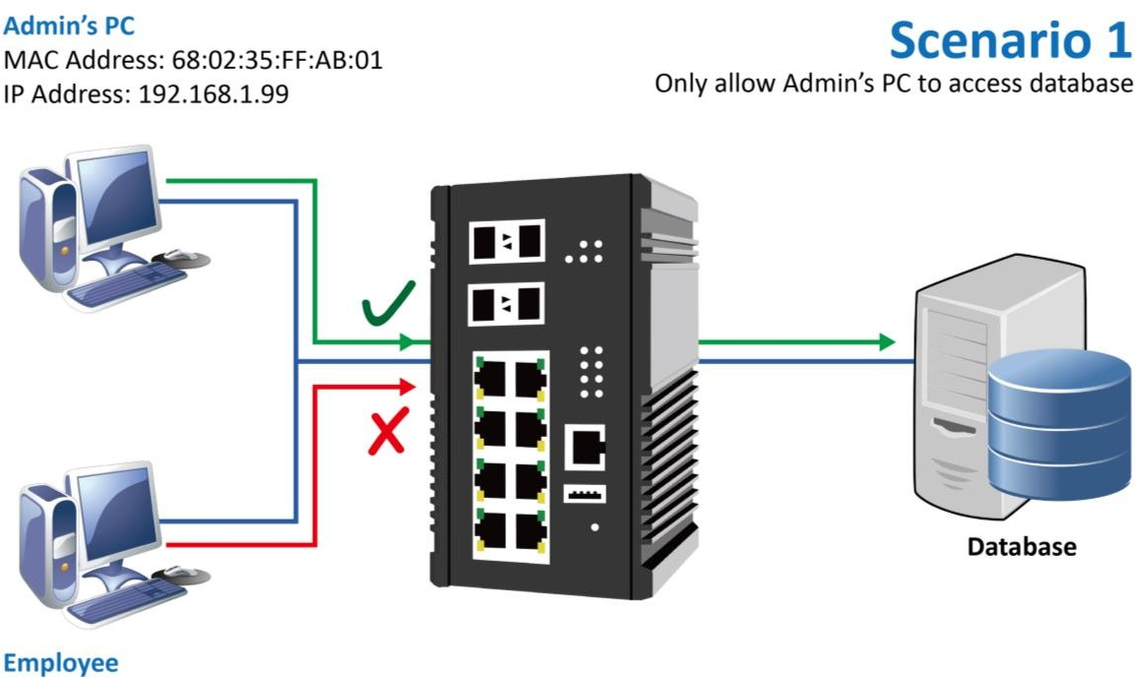

Configure Permission by MAC Address
- Login Command Line Interface (CLI) with username and password which are admin/admin by default.
- Configure ACL rule for the MAC Address of Admin’s PC by issuing:
acl mac 1 permit src 68:02:35:FF:AB:01 ff:ff:ff:ff:ff:ff
Note: the index ID is from 1 to 128
Configure Permission by IP Address
- Login Command Line Interface (CLI) with username and password which are admin/admin by default.
- Configure ACL rule for the IP Address of Admin’s PC by issuing:
acl ip 1 permit src 192.168.1.99 255.255.255.0
Note: the index ID is from 1 to 128

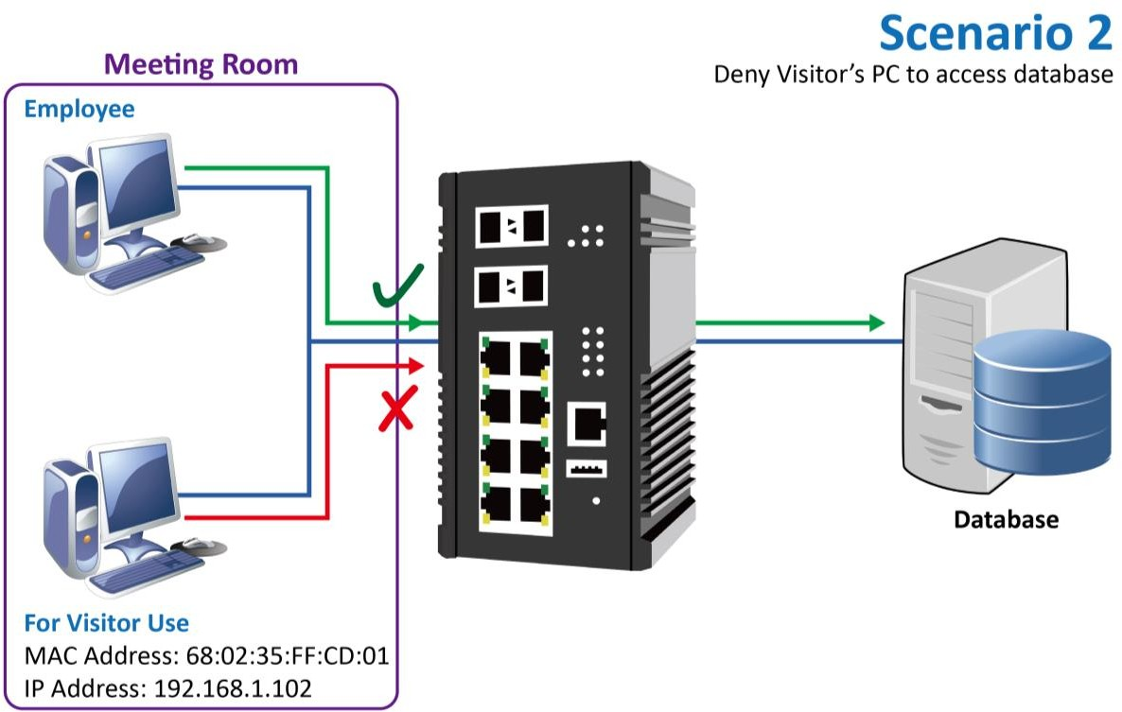

Configure Deny by MAC Address
- Login Command Line Interface (CLI) with username and password which are admin/admin by default.
- Configure ACL rule for the MAC Address of Visitor’s PC by issuing:
acl mac 1 drop src 68:02:35:FF:CD:01 ff:ff:ff:ff:ff:ff
Note: the index ID is from 1 to 128
Configure Deny by IP Address
- Login Command Line Interface (CLI) with username and password which are admin/admin by default.
- Configure ACL rule for the IP Address of Visitor’s PC by issuing:
acl ip 1 drop src 192.168.1.102 255.255.255.0
Note: the index ID is from 1 to 128

SSH

To reduce the steps for login the system via SSH connection, the public/private key pair is a good choice for users. The pair of keys is created on the local device and users must provide the public key to the target device, for example, the Ethernet switch. When users connect to the target device, the system creates a safe connection by SSH. The localhost and target device authenticates each other with the public and private keys to make sure the security.

BACKUP HOST KEY FILE
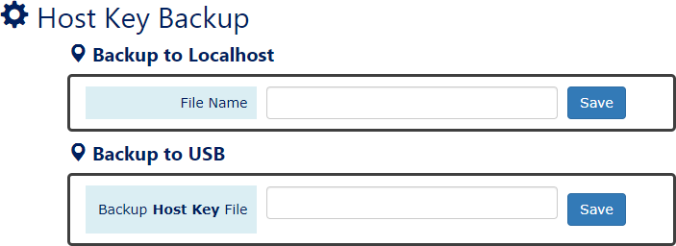

Backup to Localhost
      - File Name
Specify the File Name for the SSH Host Key file, which will be saved to the localhost.

Backup to USB
Ensure there is a USB stick inserted into the USB port.
      - Backup Host Key File
Specify the File Name for the saved SSH Host Key file, which will be saved to the USB.
Note: The file system of USB must be FAT32.
•  (Save Button)
Click the "Save" button to save the configuration file to the Localhost or USB.

RESTORE HOST KEY FILE
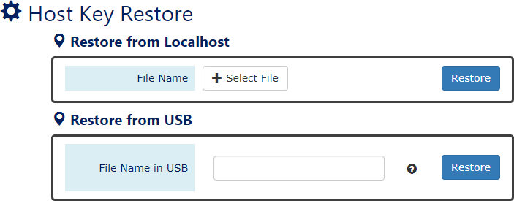

Restore from Localhost
      - File Name
Select the SSH Host Key file, which is saved in the Localhost.

Restore from USB
Please ensure there is a USB stick inserted into the USB port.
      - File Name in USB
The File Name of the saved SSH Host Key file, which is saved to the USB. If the configuration file is saved in the directory, please specify the full path.
Note: The file system of USB must be FAT32.
•  (Restore Button)
Click the "Restore" button to restore the SSH Host Key from the Localhost or USB.

HOST KEY INFORMATION
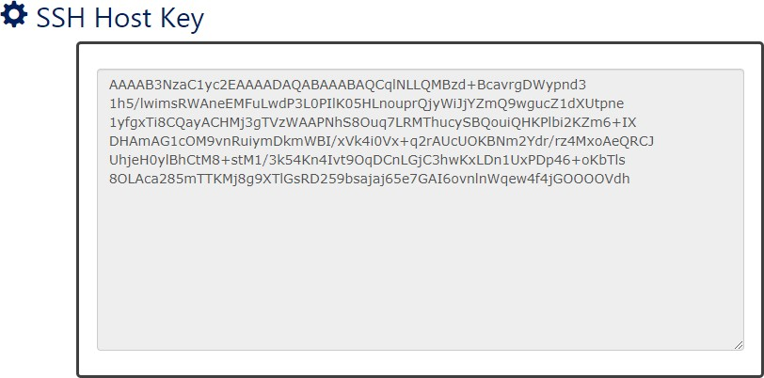
The current SSH Host Key is displayed in the “SSH Host Key” page. The system only accept one SSH Host Key, once users restore another Host Key, the current Host Key will be replaced.

Port Mirroring

Port Mirroring is a feature that copies the incoming or outgoing packets on one or more ports to another destination port. It is especially useful to monitor the network traffic and analyze the copied traffic. Port Mirroring helps network management to keep a close eye on the network and debug when some issues arise.

CONFIGURE PORT MIRRORING INFORMATION
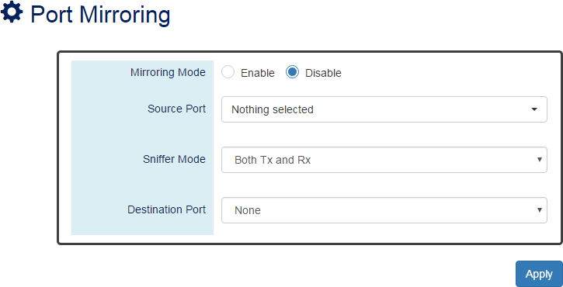

Mirroring Mode
“Enable” or “Disable” the Port Mirroring function. If the user enables Port Mirroring function, the system will transmit the traffic of the specific “Sniffer Mode” from “Source Port” to “Destination Port”.

Source Port
The traffic on the Source Ports will be sniffed to the Destination Port.

Sniffer Mode
Both Tx and Rx: Sniffs both transmitting and receiving traffics. Tx Only: Sniffs only the transmitting traffic.
Rx Only: Sniffs only the receiving traffic.

Destination Port
The traffic will sniff to the Destination Port. This port is usually connected to a host running the software to observe the packets.
• (Apply Button)
After configuring above fields, click "Apply" button to make the changes effective.

Remote SPAN (RSPAN)

Switch port Analyzer (SPAN) provides efficient and high-performance traffic monitoring. It duplicated network traffic from a configured interface to another designated interface on the switch. SPAN is used for connectivity troubleshooting and for network performance utilization.
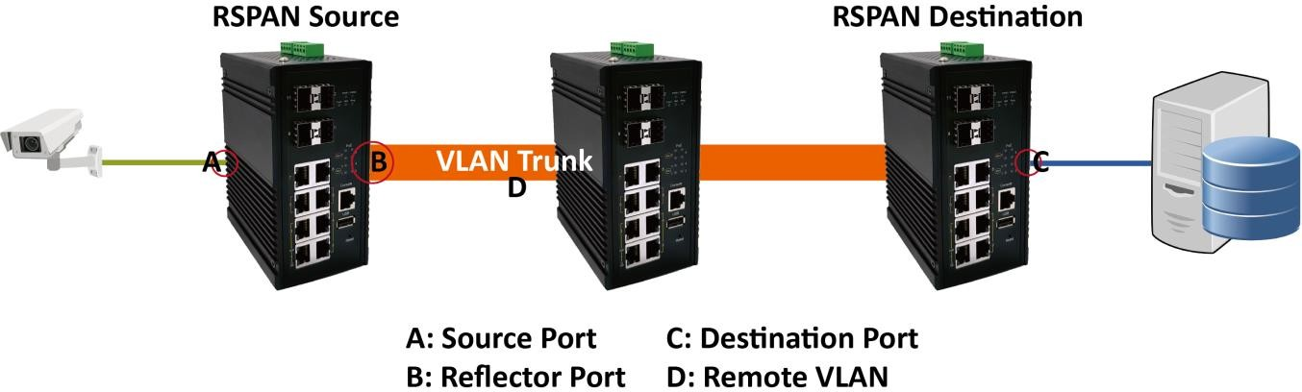
An extension of SPAN called Remote SPAN or RSPAN allows users to monitor traffic from source ports distributed over multiple switches. In other words, users can centralize the network capture devices. RSPAN operates by mirroring the traffic from a source port of an RSPAN session on a VLAN. The VLAN is connected to other switches via trunked mode, allowing the traffic on the RSPAN session to be transported across multiple switches. On the switch that contains the destination port for the RSPAN session, the traffic from the VLAN of RSPAN session is simply mirrored out the destination port.

CONFIGURE REMOTE SPAN INFORMATION
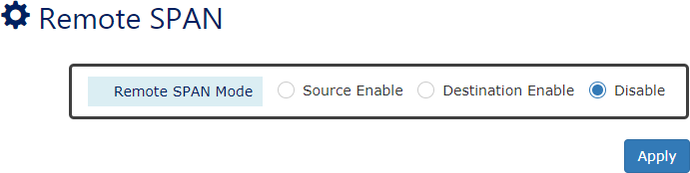
The RSPN is default disabled. The switch provides Source Mode and Destination Mode. Users can select the mode according to their application.

Remote SPAN Mode
“Enable” RSPAN on the Source Mode or Destination Mode or “Disable” RSPAN function.

CONFIGURE REMOTE SPAN SOURCE MODE
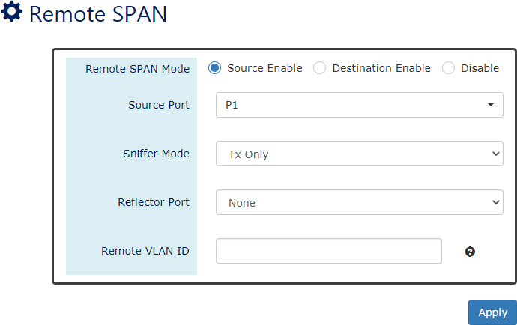
For more information, hover the mouse over the icon in the system.

Source Port
The traffic through the Source Port will be mirrored to remote devices.

Sniffer Mode
Select the traffic type, Tx or Rx, to mirror.

Reflector Port
To optimize the utilization of switch interfaces, the Reflector Port on our switches is designed to copy packets from the RSPAN Source Port and forward the copied packets out like an uplink port.

Remote VLAN ID
The configured Remote VLAN ID will be the RSPAN session and used to transmit RSPAN traffic. The Remote VLAN ID configured on the RSPAN Source and Destination must be the same one.
The range of the Remote VLAN ID is from VLAN 2 to 1001 and VLAN 1006 to 4094. VLAN 1 and VLAN 1002 to 1005 are reserved VLANs.

CONFIGURE REMOTE SPAN DESTINATION MODE
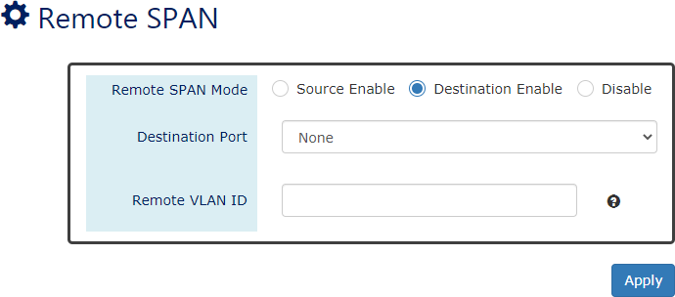
For more information, hover the mouse over the icon in the system.

Destination Port
The copied traffic will be forwarded to this Destination Port.

Remote VLAN ID
The configured Remote VLAN ID will be the RSPAN session and used to transmit RSPAN traffic. The Remote VLAN ID configured on the RSPAN Source and Destination must be the same one.
The range of the Remote VLAN ID is from VLAN 2 to 1001 and VLAN 1006 to 4094. VLAN 1 and VLAN 1002 to 1005 are reserved VLANs.
CONFIGURATION EXAMPLE FOR RSPAN
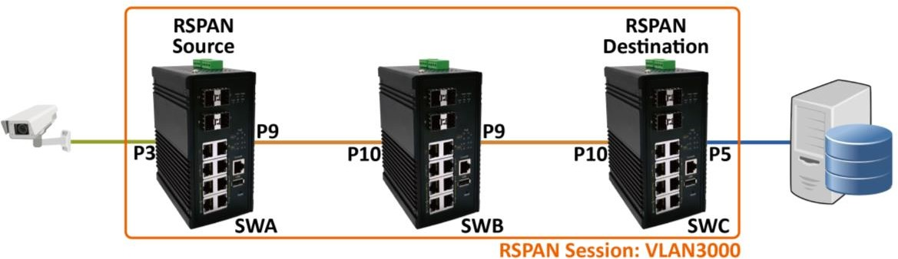
In the following diagram, the SWA is the RSPAN Source, and the SWC is the RSPAN Destination. Between SWA and SWC, there is a SWB which is a normal switch. We are going to monitor the traffic from the IP Camera on the left side to the Server on the right side.

Step-by-step Configuration
- Login Web Console and click menu “Diagnostics” -> “Remote SPAN”
- Configure for SWA
  - Click “Source Enable” and there will show other related configuration items.
  - Select the Source Port (Port 3) that will be monitored.

  - Select the Sniffer Mode, normally called traffic type. For this example, we want to monitor the traffic from the IP Camera, so we must select “Rx”.
  - Select the Reflector Port which will forward the copied traffic to the destination. On the SWA, Port 9 is the Uplink and Reflector Port.
  - Decide the Remote VLAN ID for RSPAN Session; the copied traffic will be transmitted through this VLAN trunk. We use VLAN 3000 on this example.
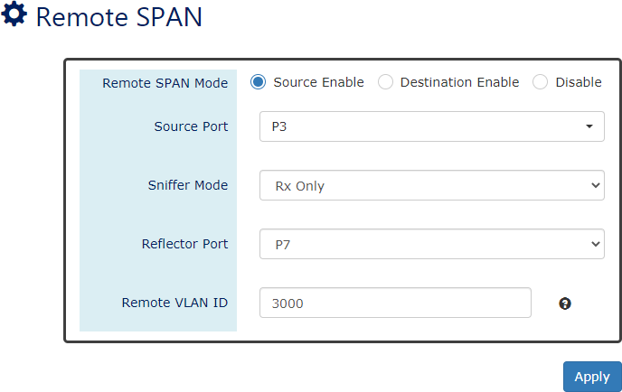
  - Click “Apply” button to effect RSPAN configurations.
  - Configure uplink port (Port 9) to tagged member on VLAN 3000.
  - Click “Apply” button on the bottom of the page to make the VLAN effective.
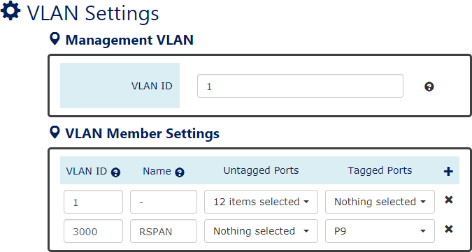
- Configure for SWB
  - Configure the ports (Port 9 and Port 10) connected with SWA and SWC to tagged members on VLAN 3000.
  - Click “Apply” button on the bottom of the page to make the VLAN effective.

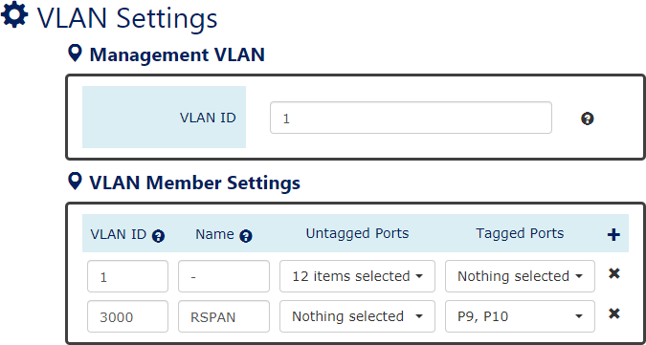
- Configure for SWC
  - Click “Destination Enable” and there will show other related configuration items.
  - Select the Destination Port (Port 5) that the copied traffic will be transmitted to.
  - Configure the Remote VLAN ID to VLAN 3000 for RSPAN Session.
  - Click “Apply” button to effect RSPAN configurations.
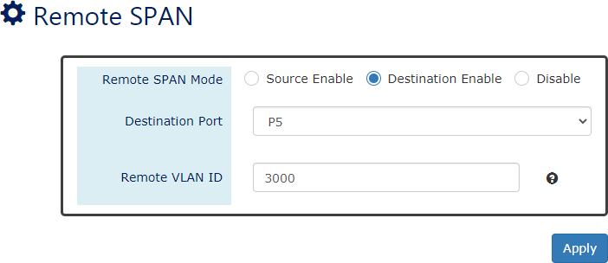
  - Configure uplink port (Port 10) to tagged member on VLAN 3000.
  - Click “Apply” button on the bottom of the page to make the VLAN effective.
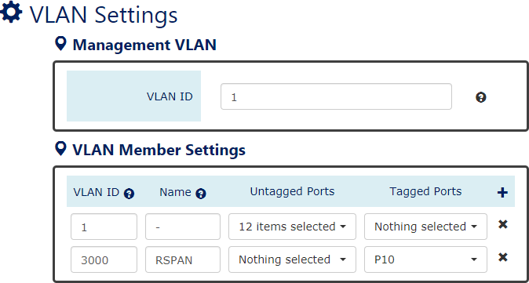

Ping

Ping is a tool used to test the reachability of a device on the IP network. Ping is enabled by sending Internet Control Message Protocol (ICMP) request to the target device and waits for the response packet from the target device to check the connection.
PING ANOTHER DEVICE WITH IPV4/IPV6
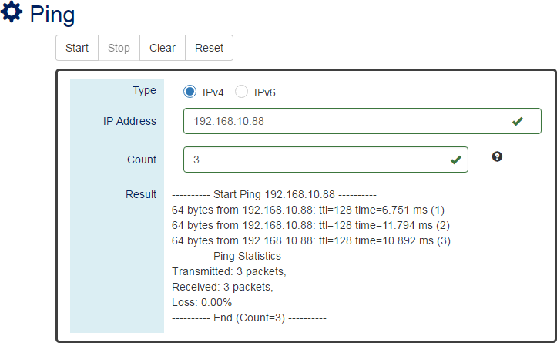

Type
For more information, hover the mouse over the icon in the system.

Ping a connected device with “IPv4” or “IPv6” protocol.

IP Address
The IP address of the connected device is verified based on the type.

Count
Sets the count times. The system will send “Count” number ICMP packets to the specific IP address and wait for the response.
The range of the Count is from 3 to 50. The default Count is 3.

Result
The result of the ping shows the response from the specific IP address. If the specific IP address does not respond, it displays No Response.

“Start” Button
Click the “Start” Button to start the ping to the IP address.

“Stop” Button
Click the “Stop” Button to stop the ping to the IP address before the count is completed.

“Clear” Button
Click the “Clear” Button to clear the “Result”.

“Reset” Button
Click the “Reset” Button to clear the “Result” and reset the “IP Address” and “Count”
number.

Cable Diagnostic

This command can check the status of copper cables with the time domain reflectometer (TDR) technology. It can detect a cable fault by sending a detect signal and read the reflecting back. With this test, it can help to identify and narrow down the physical level issue.

DISPLAY CABLE DIAGNOSTIC
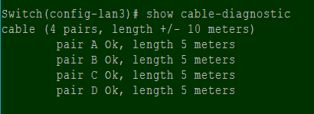

Port Selector
Select the port number to test.
Port 1 to N, where N is based on the total port number.

Cable status
The status of cable. It contains the number of pairs in the cable and the error amount.
Usually there are 4 pair in the CAT-5E cable for Gigabit Ethernet link.

Pair status
The status of each pair of port. ‘Ok’ status means cable is connected to another node. ‘Open’
status means cable does not connect to any device.

Length
The length of each pair of port in meters. Please note the error amount is around 10 meters due to the TDR technology. The short cable less than the error amount might be untastable.

LLDP

LLDP is Link Layer Discovery Protocol and it is a vendor-neutral layer 2 protocol that is defined by IEEE 802.1AB. LLDP is used in advertising identity of the devices, capabilities and neighbors on the LAN. The information from the neighbors enables the switch to quickly identify the devices and interoperate with each other more smoothly and efficiently. The neighbor table shows the information about the device that is next to the port. The LLDP can only get information from the device that is close to it. If the users want to know the topology of the LAN, they can collect all information from the device and analysis the neighbor table.
CONFIGURE LLDP INFORMATION
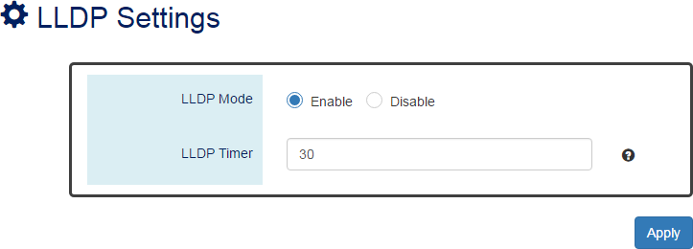
For more information, hover the mouse over the icon in the system.

LLDP Mode
“Enable” or “Disable” the LLDP function.

LLDP Timer
The LLDP Timer is a time interval to send LLDP messages. The range of the LLDP Timer is from 5 to 32767 seconds. The default LLDP Timer is 30 seconds.
• (Apply Button)
After configuring above fields, click "Apply" button to make the changes effective.

LLDP NEIGHBOR TABLE
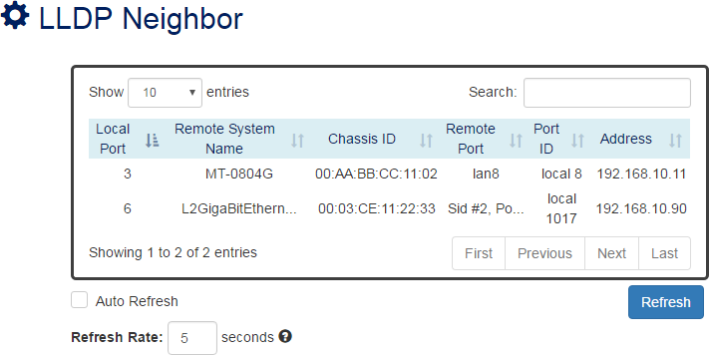

Local Port
The port connected to the LLDP neighbor on the local switch.

Remote System Name
This is the system name of the LLDP neighbor. This value is set and provided by the remote device.

Chassis ID
The Chassis ID defines the MAC Address of the LLDP neighbor.

Remote Port
This field displays the port information received from the LLDP neighbor.

Port ID
The Port ID displays the port identity of the connected port on the LLDP neighbor.

Address
The Address displays the IP address of the LLDP neighbor.

System Warning

System Warning contains “System Event Log”, “SMTP Settings”, and “Event Selection” for different types of services such as “Fault Alarm”, “System Log”, “SMTP”, and “SNMP Trap”. These logs are especially useful for the administrator to manage and debug the system. When the system is powered off or when someone tries to login the system or the system reboots abnormally, or when some of the interfaces are linked down, the system sends log messages to notify specific users and record the events on the server or assigned platform. Users can also connect an alarm buzzer to the relay alarm pins. When the configured “Fault Alarm” events are triggered, the alarm buzzer will ring to notify the users.

CONFIGURE SYSTEM WARNING INFORMATION
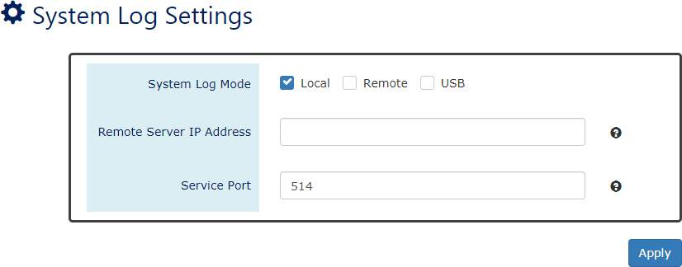
For more information, hover the mouse over the icon in the system.

System Log Mode
    - Select the checkbox to send system log to Local (Switch), Remote, or USB when events happened.

Remote Server IP Address
The field contains the IP Address of the remote server. If the “Remote” mode is enabled, users must assign this IP Address to receive the system logs. The system supports both IPv4 and IPv6 addresses for the remote server.

Service Port
The port is used to listen to the system log packets on the remote server.
The range of the Service Port is from 1 to 65535. The default Service Port is 514.
• (Apply Button)
After configuring above fields, click "Apply" button to make the changes effective.

SYSTEM EVENT LOG
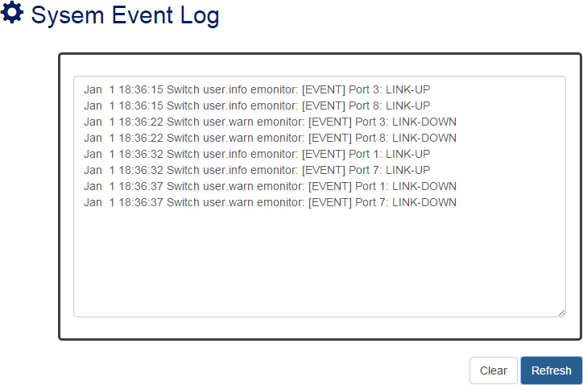

Log Text Area
The system event information displays if the “Local” system log mode is enabled and the configured events are triggered.
• 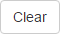 (Clear Button)
Click the “Clear” button to clear the system event log in the text area.
• (Refresh Button)
Click the “Refresh” button to refresh the system event log in the text area.

CONFIGURE SMTP INFORMATION
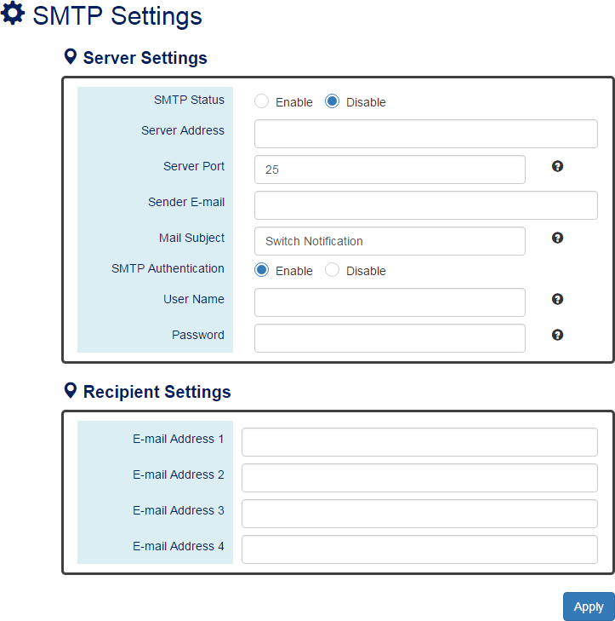
For more information, hover the mouse over the icon in the system.

Server Settings
      - SMTP Status
“Enable” or “Disable” the SMTP function.
      - Server Address
This is the IP address or URL of the SMTP Server. For example, the SMTP server address provided by Google is “smtp.gmail.com”.
      - Server Port
This field is the port listening on the server for the SMTP request. For security, we suggest users configure the server port to 465 for SSL or 587 for TLS.
The range of the Service Port is from 1 to 65535.
The default Service Port is 25. Port 25 is the default port for e-mail server.
- Sender E-mail
The Sender E-mail is the e-mail address used to send the notifications to Recipients.
- Mail Subject

The Mail Subject is a string that is displayed in the E-mail title.
Note: #, \, ', ", ? are invalid characters.
- SMTP Authentication
“Enable” or “Disable” to authenticate the SMTP server with the configured username and password.
- User Name
The username is used in authentication with the SMTP server.
The max. length for the User Name is 32 characters. Note: #, \, ', ", ? are invalid characters.
- Password
The password is used in authentication with the SMTP server.
The max. length for the Password is 32 characters. Note: #, \, ', ", ? are invalid characters.

Recipient Settings
      - E-mail Address 1-4
The configured e-mail address will receive the notifications if the SMTP is enabled and the events set on “Event Selection” are triggered.
• (Apply Button)
After configuring above fields, click "Apply" button to make the changes effective.

CONFIGURE SYSTEM EVENT SELECTIONS
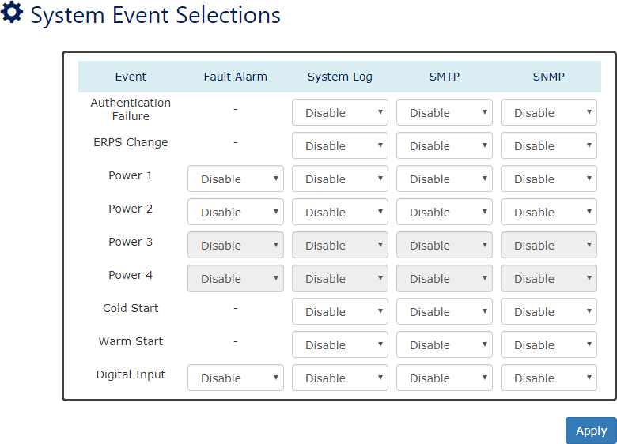

Event
There are 5 events on the System Events.
Authentication Failure: Login failed on the web console or CLI. It may be caused due to incorrect username or password.
ERPS Change: The ERPS function is working and the topology is changed. Power 1 - 4: The power 1 to 4 is powered off.
Cold Start: The system reboots due to interruption of power supply.
Warm Start: The system reboots by issuing “reboot” command on CLI or clicking the “reboot icon” on the web console.
Digital Input: The signal from the digital input is changed from high to low or low to high.
• (Apply Button)
After configuring above fields, click "Apply" button to make the changes effective.

CONFIGURE INTERFACE EVENT SELECTIONS
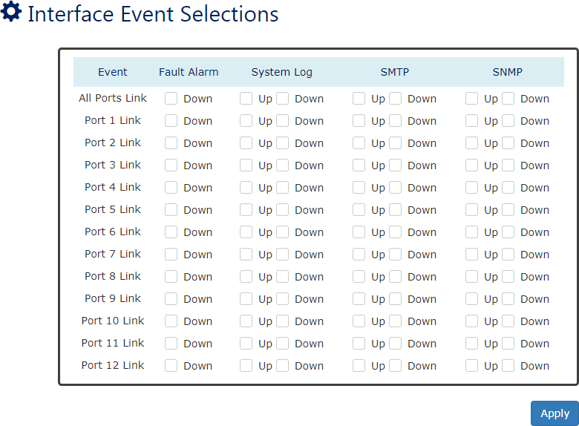

Event
The events on the “Interface Events” display the link status for each port. Fault Alarm is triggered only during link down and other system log types support both link up and link down.

Fault Alarm

The Fault LED will turn on red and relay will turn ON, if the configured events are triggered. By default, the Fault LED is green, and relay is turned OFF in the normal situation,

System Log
When the configured events are triggered, the logs will be displayed in the “System Event Log” page, remote server, or saved to a USB file named “message”. This is based on the settings of the “System Log Mode” in the “System Log Settings” page.
Note: The file system of USB must be FAT32.

SMTP
If the SMTP is enabled and the configured events are triggered, the system will send an e-mail notification to the e-mail addresses of the assigned recipient set in the “SNMP Settings” page.

SNMP
If the SNMP Trap is enabled and the configured events are triggered, the system will send event information to the assigned “Trap Receiver IP”, which is set in the “SNMP Trap” page.
• (Apply Button)
After configuring above fields, click "Apply" button to make the changes effective.
CONFIGURE SFP DDM EVENT SELECTIONS
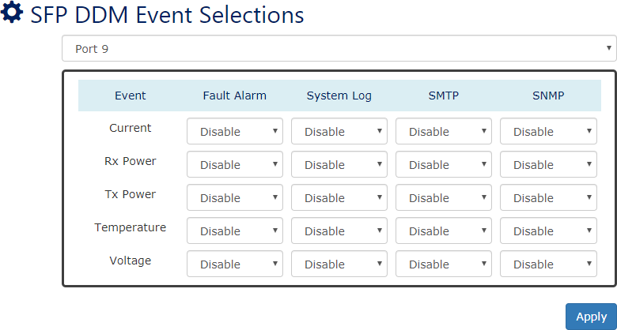

Event
There are 5 events on the “SFP DDM Events”: Current, Rx Power, Tx Power, Temperature, and Voltage. Enable or Disable the event fault alarm or system warning when the value is higher than the high alarm/warning threshold or the value is lower than the low alarm/warning threshold.

Data Collection

The health of switch system is particularly important in the real application. For most switches, they provide basic real-time traffic and PoE status, but users need the long-time records to analyze and statistic for the system. For this purpose, we implement the Data Collection function to collect traffic and PoE status periodically and save the collected data to the USB device. In addition to this, we also provide charts to display the collected data. Users can easily recognize the situation of the switch system and find the unusual points from the charts.
To ensure the accuracy of the data, the NTP service must be turned on before enable Data Collect function, so that when users find an abnormal record, they can trace it by the recording time. And there is no worry for the size of system storage because the data is saved in the USB. The data even can be move to other devices to display or users can use the collected raw data to do other application.

CONFIGURE DATA COLLECTION SETTINGS
USB and NTP are essential before users enable the Data Collection functions. Please check if there is an USB inserted and the NTP service is also enabled. The file system of USB must be FAT32.
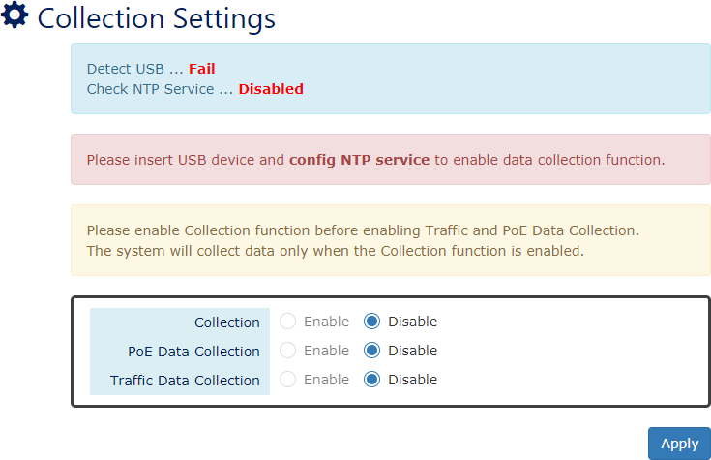

Collection
“Enable” or “Disable” Data Collection Function on the switch. The Traffic and PoE Data Collection can be enabled only when the Collection is enabled.
    - PoE Data Collection (PoE Models Only)
“Enable” or “Disable” PoE Data Collection function on the switch.

Traffic Data Collection
“Enable” or “Disable” Traffic Data Collection function on the switch.

RESET COLLECTED DATA
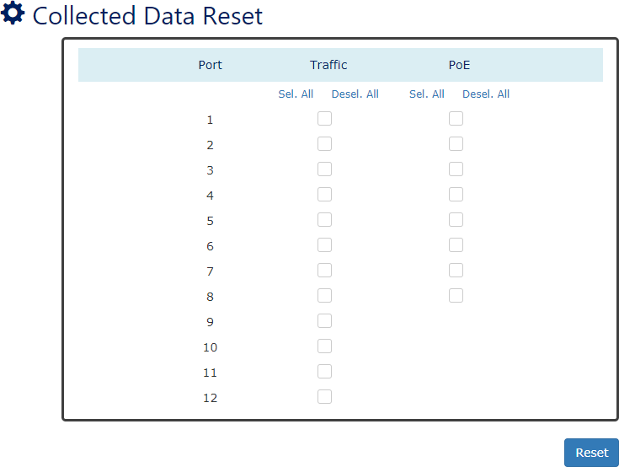

Port
Port 1 to Port N, N is based on the total port number.

Traffic
Check the checkbox to reset the data for the designated port. After reset, the collected data will be removed from the USB.
Note: It cannot undo after reset, please make sure you want to reset the file.
    - PoE (PoE Models Only)
Port 1 to Port N, N is based on the total port number.

POE STATUS CHARTS (PoE Models Only)
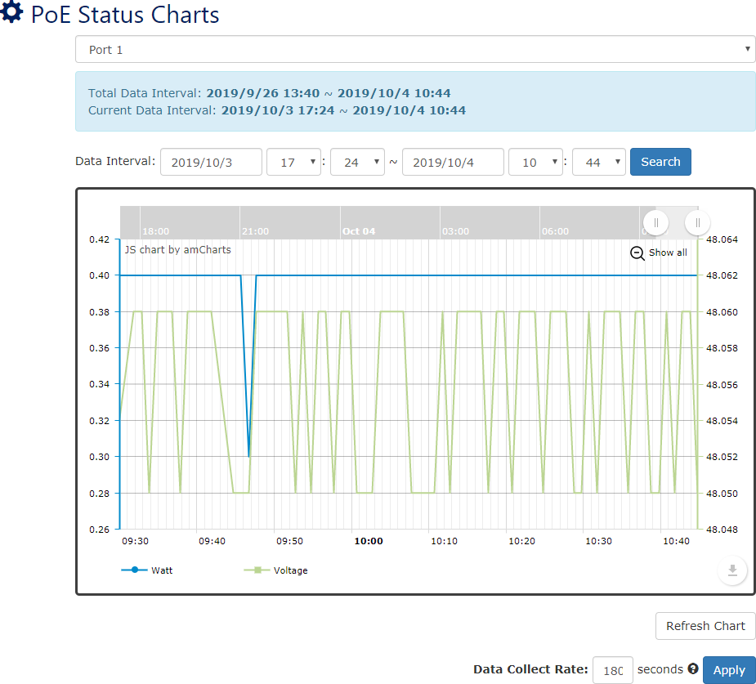
For more information, hover the mouse over the icon in the system.

Port (Drop-down Selector)
Port1 to PortN, where N is based on the total PoE port number. The PoE Status Chart is displayed by port.

Total Data Interval
The interval is the date time from first data to last data that collected in the USB.

Current Data Interval
The interval is the date time from first data to last data that displayed on the current chart.

Data Interval (Drop-down Selector)
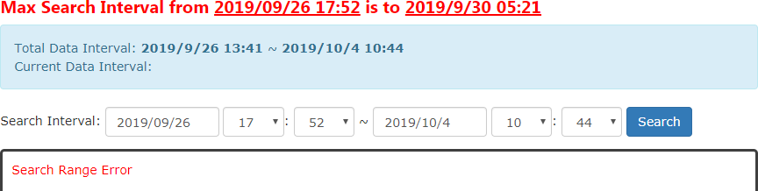
Select an interval to search data. The returned data will be displayed on the chart. The number of data is limited by the system, if the selected interval is larger than the limitation, the system will return an acceptable interval (Shown as the following screenshot).

Note: After configuring “Data Interval”, click "Search" button to get data in the interval.

Chart
The chart displays both watts (blue line) and voltage (green line) data.

Refresh Chart (Button)
Press the Refresh Chart button to refresh the chart and get the updated data.

Data Collect Rate
The field is the period to collect data. The system will get the real-time data periodically according to the configured Data Collect Rate.
Note: PoE Status Charts and Interface Traffic Charts are shared the same Data Collect Rate.
The range of the Data Collect Rate is from 60 to 600 seconds. The default Data Collect Rate is 180 seconds.
Note: After configuring “Data Collect Rate”, click "Apply" button to make the changes effective.

INTERFACE TRAFFIC CHARTS
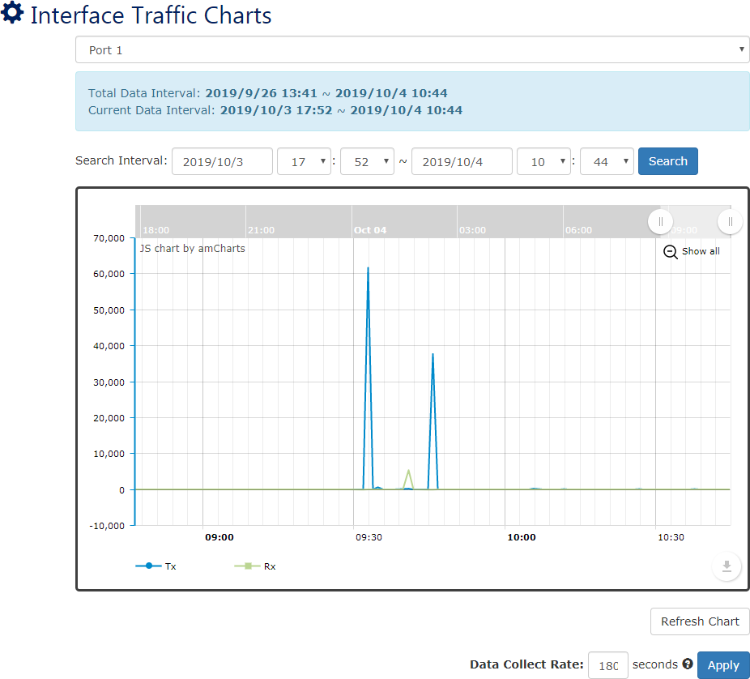
For more information, hover the mouse over the icon in the system.

Port (Drop-down Selector)
Port1 to PortN, where N is based on the total switch port number. The Interface Traffic Chart is displayed by port.

Total Data Interval
The interval is the date time from first data to last data that collected in the USB.

Current Data Interval
The interval is the date time from first data to last data that displayed on the current chart.

Data Interval (Drop-down Selector)
Select an interval to search data. The returned data will be displayed on the chart. The number of data is limited by the system, if the selected interval is larger than the limitation, the system will return an acceptable interval (Shown as the following screenshot).
Note: After configuring “Data Interval”, click "Search" button to get data in the interval.

Chart
The chart displays transmitted bytes (blue line) and received bytes (green line) data.

Refresh Chart (Button)
Press the Refresh Chart button to refresh the chart and get the updated data.

Data Collect Rate
The field is the period to collect data. The system will get the real-time data periodically according to the configured Data Collect Rate.
Note: Interface Traffic Charts and PoE Status Charts are shared the same Data Collect Rate.
The range of the Data Collect Rate is from 60 to 600 seconds. The default Data Collect Rate is 180 seconds.
Note: After configuring “Data Collect Rate”, click "Apply" button to make the changes effective.

MAC Table

MAC address is Media Access Control address, which is used in layer 2 switching. A MAC Address table is maintained by the switch to transmit frames more efficiently. When the switch receives a frame, the system will check the MAC table and forward the frame to the corresponding port. The MAC Address table is built dynamically by the received frames and when the system receives a frame with an unknown MAC address, it floods the frame to all LAN ports in the same VLAN. When the destination device replies the system identifies the MAC Address and the target port.
The MAC Address for the switch is designed as per-port-per-MAC, which implies each port has its own MAC Address. This is for MAC sensitive protocols such as Spanning-tree protocol. The MAC Address display on the right side of WEB GUI is the MAC Address for whole system and the MAC Addresses for the ports are increasing by 1 from port 1 to last port.
For example, the MAC Address of the system is 68:02:35:FF:FF:05, and there are 8-port on the switch. The MAC Address for each port will be:
Port | MAC Address | Port | MAC Address
Port 1 | 68:02:35:FF:FF:06 | Port 5 | 68:02:35:FF:FF:0A
Port 2 | 68:02:35:FF:FF:07 | Port 6 | 68:02:35:FF:FF:0B
Port 3 | 68:02:35:FF:FF:08 | Port 7 | 68:02:35:FF:FF:0C
Port 4 | 68:02:35:FF:FF:09 | Port 8 | 68:02:35:FF:FF:0D
Note: The MAC Address is hex format, so the number after “09” is “0A”.

CONFIGURE STATIC MAC ADDRESS INFORMATION
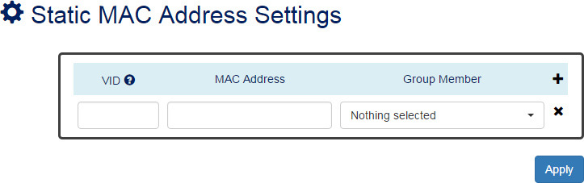

VID
For more information, hover the mouse over the icon in the system.

The VID is the VLAN group ID, which contains the configured MAC Address .
The range of the VID is from 1 to 4094.

MAC Address
This field is the static MAC Address of the configured member ports in the VLAN group.

Group Member
The Group Member is the port(s) in the VLAN group, to which the configured MAC Address belongs.
• : Click the plus icon to add a static MAC Address row.
• : Click the remove icon to delete the static MAC Address row.
• (Apply Button)
After configuring above fields, click "Apply" button to make the changes effective.
MAC ADDRESS TABLE
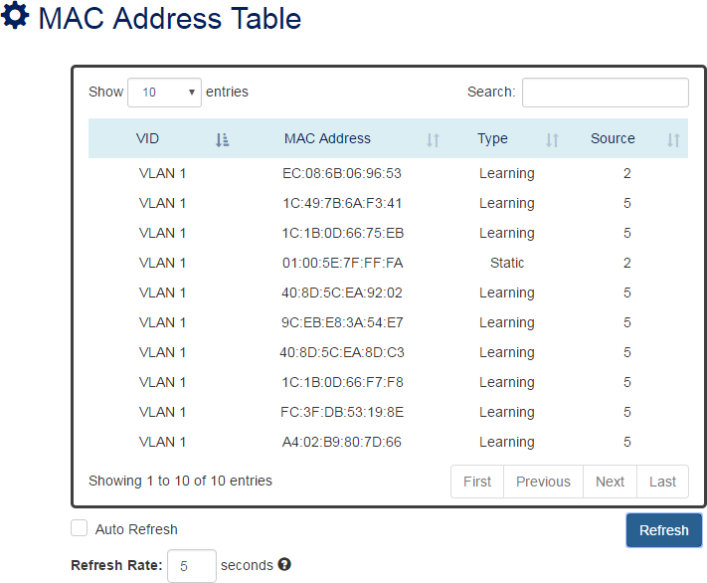

VID
The VID is the VLAN group ID, which contains the configured MAC Address.

MAC Address
The MAC Address column displays the learnt or configured MAC Addresses.

Type
The Type column displays the type (Learning or Static) of the MAC Address. Learning: The MAC address is learnt from the transmitting frames.
Static: The MAC Address is configured by the users or the system.

Source
The Source column displays the port(s) to which the MAC Address belong.

Authorization

The "Username" and "Password" are important information both in the "Command Line Interface" or "Web Console". Users have to login into the system before doing any configuration. We strongly suggest the users to change at least the password for security when they are going to use this device.
We also provide authentication with RADIUS/TACACS+ server from software version 1.0.3. Users can maintain the login information in their own RADIUS/TACACS+ database and allow several usernames/passwords to login the system.

CONFIGURE LOGIN INFORMATION
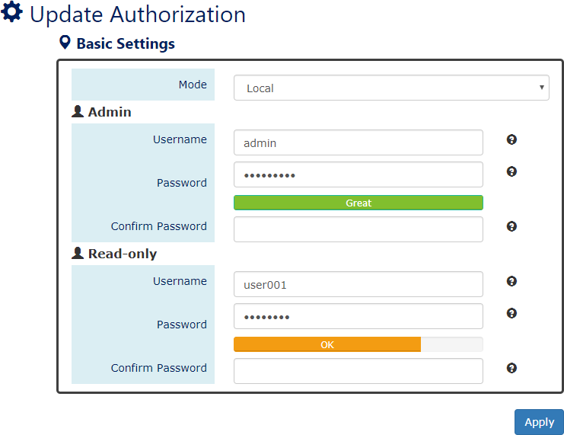

Mode
For more information, hover the mouse over the icon in the system.

There are three modes for login authentication.
Local: The username and password are defined in the system. Currently we support two-level users – Admin and Read-only user. The Admin can access any page and configure the system but the read-only user can only access status pages.
Radius: The username and password are defined in the RADIUS server and when user’s login the system, the system will authenticate with the RADIUS server to get the login permission. The password will be encrypted during the transmitting.

Tacacs+: The username and password are defined in the TACACS+ server and when users login the system, the system will authenticate with the TACACS+ server to get the login permission. The whole payload and password will be encrypted during the transmitting.

Username
The account used to login to the system.
The maximum length of the Username is 32 characters Only alphabet (A-Z, a-z) and numbers (0-9) are allowed. The default Username is admin.

Password
The password used to login to the system. We provide password strength bar for reference. There are 3 levels - Weak, OK, and Great. We strongly recommend users configuring the password to “Great” level for security.
The maximum length of the Password is 32 characters.
Only alphabet (A-Z, a-z), numbers (0-9), and chars (!,@,%,^,*,(,)) are allowed. The default Password is admin.

Confirm Password
It is used to confirm the value specified by the users in the "Password" field. The value of the field must be the same as "Password".
• (Apply Button)
After configuring above fields, click "Apply" button to make the changes effective.
CONFIGURE RADIUS SERVER INFORMATION
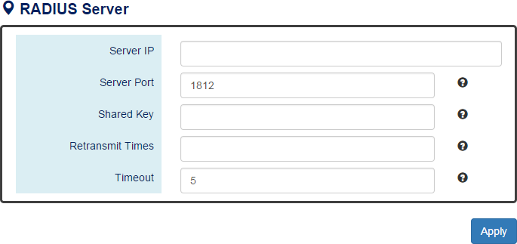
This section only display when the mode in the Basic Settings is set to “Radius”.
For more information, hover the mouse over the icon in the system.

Server IP
The IP address of the RADIUS server must in the same subnet as the IP address of the switch.

Server Port

The port is listening to the RADIUS service on the RADIUS server. The range of the Server Port is from 1 to 65535.
The default Server Port is 1812.

Shared Key
The Shared Key is a string that used to build the connection with the RADIUS server. It must be the same as the string/secret set in the RADIUS server.
The maximum length of the Shared Key is 32 characters.

Retransmit Times
The password used to login to the system.
The range of the Retransmit Times is from 1 to 1000.

Timeout
The time interval is used to waiting for the response from the RADIUS server. The range of the Timeout is from 1 to 1000 seconds.
The default Timeout is 5 seconds.
• (Apply Button)
After configuring above fields, click "Apply" button to make the changes effective.
CONFIGURE TACACS+ SERVER INFORMATION
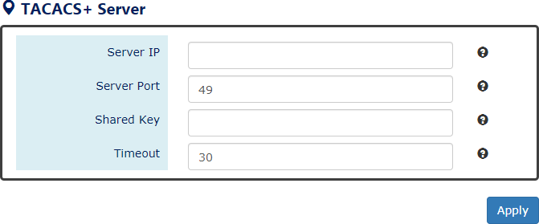
This section only display when the mode in the Basic Settings is set to “Tacacs+”.
For more information, hover the mouse over the icon in the system.

Server IP
The IP address of the TACSCS+ server must in the same subnet as the IP address of the switch. The system supports both IPv4 and IPv6 addresses for the TACACS+ server.

Server Port
The port is listening to the TACSCS+ service on the TACSCS+ server. The range of the Server Port is from 1 to 65535.
The default Server Port is 49.

Shared Key

The Shared Key is a string that used to build the connection with the TACSCS+ server. It must be the same as the string/secret set in the TACSCS+ server.
The maximum length of the Shared Key is 32 characters.

Timeout
The time interval is used to waiting for the response from the TACSCS+ server. The range of the Timeout is from 1 to 1000 seconds.
The default Timeout is 30 seconds.
• (Apply Button)
After configuring above fields, click "Apply" button to make the changes effective.

Firmware Upgrade

For a better performance and wider industrial applications, we constantly develop new features and revise the issues from the users. We suggest the users to upgrade the system to the newest firmware version to have a better user experience.
We provide 2 ways to upgrade the firmware from the Web Console, - one is saving the firmware file in the USB stick and another one is saving the firmware file on the PC. If the firmware file is on the PC, the users will have to only select the file and click Apply button, for the system to upgrade it automatically.

UPGRADE FIRMWARE VERSION - UPLOAD FIRMWARE FILE
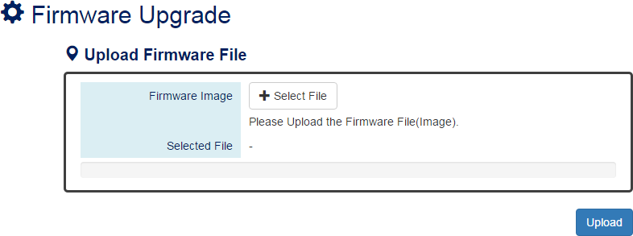

Firmware Image
Click the "Select File" button to select the firmware image provided by the sales or support. The Firmware Version displayed on the system can be customized by the file name. For example, if you want the version to be called as 1.2.3, you only need to modify the file name to XXX-v1.2.3 (XXX is the original file name).

Selected File
After selecting a firmware image to be uploaded, the selected file name will be displayed in this field.
•  (Upload Button)
After selecting the firmware image, click "Upload" button to upload it.

UPGRADE FIRMWARE PROCESS - UPLOADING FIRMWARE FILE
The following steps are performed when the system starts to upgrade after the "Apply" button is clicked:
- Uploading the firmware image
The progress bar displays the uploading percentage.
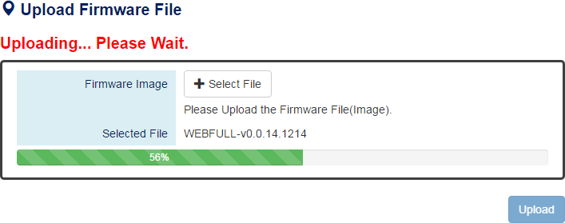
- Verifying the uploaded file
When the file is 100% uploaded, the system starts to verify the uploaded file to make sure it is valid. By default, the firmware image is encrypted to prevent the attack on man-in-the-middle. Optionally, higher encryption methodology is also provided.
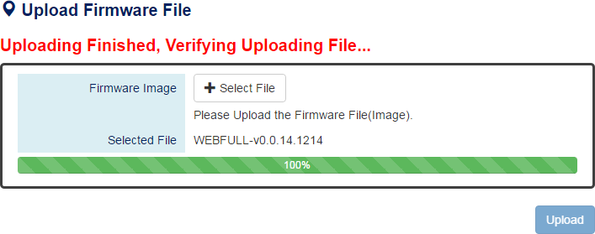
- Installing the uploaded firmware image
The new firmware will install after the system validates it.
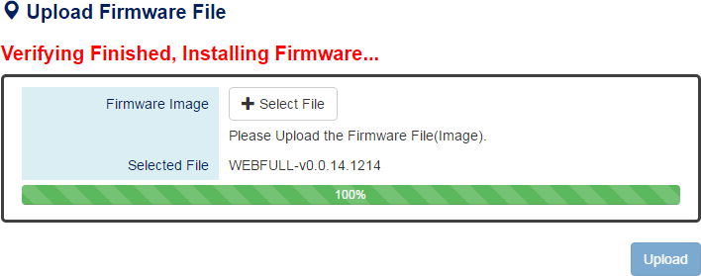

- Rebooting the system
The system will reboot automatically if the firmware is upgraded without any issue. The progress bar displays the rebooting progress.


UPGRADE FIRMWARE VERSION - COPY FIRMWARE FILE FROM USB
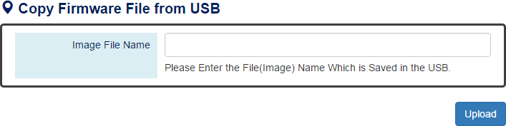

Image File Name
Enter the name of the firmware image in the USB. The system will try to identify the file with specified file name to upload it to the system.
Note: The file system of USB must be FAT32.
• (Upload Button)
After entering the firmware image name, click "Upload" button to copy it from the USB to the system.
UPGRADE FIRMWARE PROCESS - COPY FIRMWARE FILE FROM USB
- Copying the firmware image from USB to switch
The system will also check if the USB is inserted and file exists.
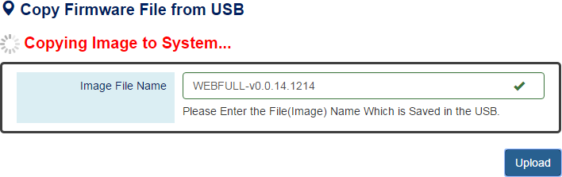

- Verifying the uploaded file
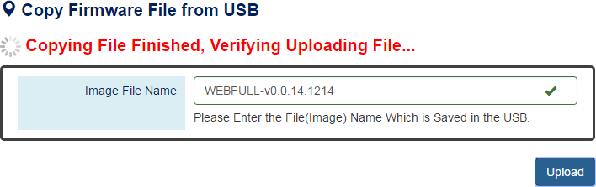
After copying the firmware file to switch, the system starts to verify the uploaded file to make sure it is valid. By default, the firmware image is encrypted to prevent the attack on man-in-the-middle. Optionally, higher encryption methodology is also provided.
- Installing the uploaded firmware image
The new firmware will install after the system makes sure it is valid.
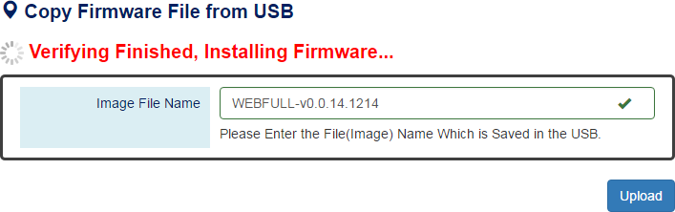
- Rebooting the system
The system will reboot automatically if the firmware is upgraded without any issue. The progress bar displays the rebooting progress.

Config Backup

In the normal application, there are several switches in the Network, and they might be configured to the same features. To facilitate this, the users can configure one of the switches and save the configuration file to localhost (for example: users' PC) or USB sticks and then restore the configurations on another switch via "Config Restore" function. Configuration file in the USB can also have a way to fast replace the device when it is damage.

BACKUP CONFIGURATION FILE
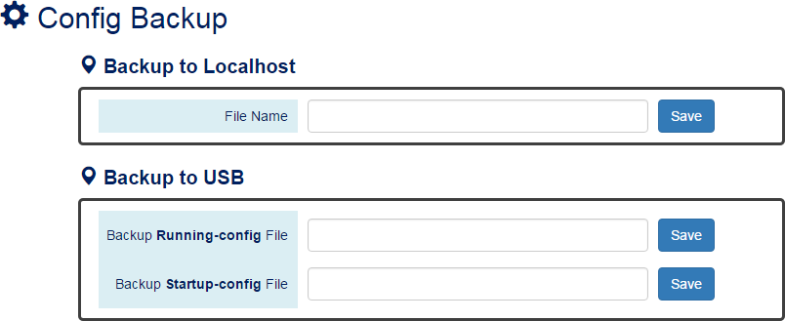

Backup to Localhost
  - File Name
Specify the File Name for the Startup-config file, which will be saved to the localhost.

Backup to USB
Ensure there is a USB stick inserted into the USB port.
  - Backup Running-config File
Specify the File Name for the saved Running-config file, which will be saved to the USB.
  - Backup Startup-config File
Specify the File Name for the saved Startup-config file, which will be saved to the USB.
Note: The file system of USB must be FAT32.
The “space” is not allowed in the File Name.
• (Save Button)
Click the "Save" button to save the configuration file to the Localhost or USB.
NOTE: If the File Name filed is empty, the system assigns the default name: config-[datetime].cfg

Config Restore

We suggest users to save/backup the configurations after a series of settings. If another device needs the same configurations, users can use the Config Restore function to restore it.

RESTORE CONFIGURATION FILE
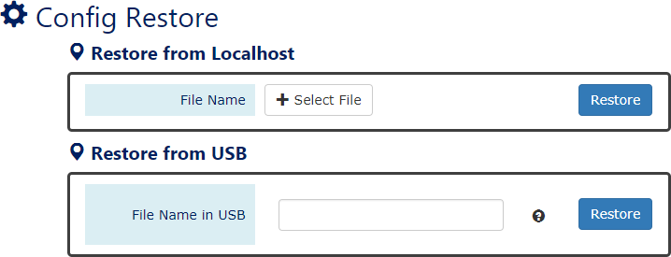

Restore from Localhost
  - File Name
Select the configuration file, which is saved in the Localhost.

Restore from USB
Please ensure there is a USB stick inserted into the USB port.
  - File Name in USB
The File Name of the saved configuration file, which is saved to the USB. If the configuration file is saved in the directory, please specify the full path.
Note: The file system of USB must be FAT32.
The “space” is not allowed in the File Name.
• (Restore Button)
Click the "Restore" button to restore the configurations from the Localhost or USB.

USB Auto-Load & Auto-Backup

CONFIGURE USB AUTO-LOAD AND AUTO-BACKUP
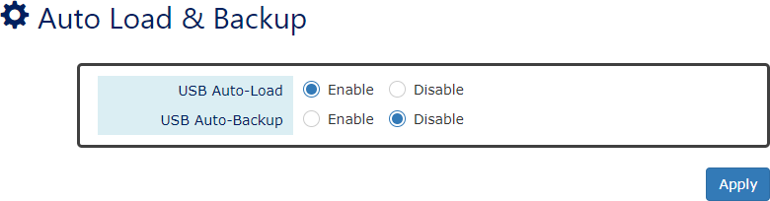

USB Auto-Load
“Enable” or “Disable” the USB Auto-Load function. If “USB Auto-Load” is enabled, the system will search the configuration file named “startup-config” in the USB and load it when rebooting.
Note: The file system of USB must be FAT32.

USB Auto-Backup
“Enable” or “Disable” USB Auto-Backup function. If “USB-Auto-Backup” is enabled, the system will save the configurations to a file named “running-config” in the USB when users modify the configurations.
Note: The file system of USB must be FAT32.
• (Apply Button)
After configuring above fields, click "Apply" button to make the changes effective.

SFTP File Access

CONFIGURE SFTP CONFIGURATION UPLOAD
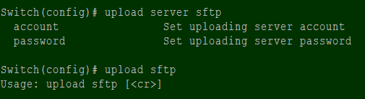
- Config IP address of SFTP server
Switch(config)# upload server ip [SERVER_IP]
- Config login account name of SFTP server
Switch(config)# upload sftp server account [SERVER_ACCOUNT]
- Config login account password of SFTP server
Switch(config)# upload sftp server password [SERVER_PASSWORD]
- Action to do the SFTP upload
Switch(config)# upload sftp
CONFIGURE SFTP CONFIGURATION DOWNLOAD
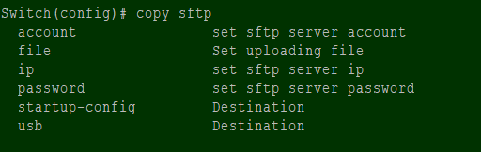
- Config IP address of SFTP server
Switch(config)# copy sftp ip [SERVER_IP]
- Config login account name for SFTP server
Switch(config)# copy sftp account [SERVER_ACCOUNT]
- Config login account password for SFTP server
Switch(config)# copy sftp password [SERVER_PASSWORD]
- Config login account password for SFTP server
Switch(config)# copy sftp file name [FILE_NAME]
- Action to do the SFTP download to the startup configuration
Switch(config)# copy sftp startup-config
Note: After copy to the startup configuration, system will reboot automatically.
- Action to do the SFTP download to the USB storage
Switch(config)# copy sftp USB
Note: The file system of USB must be FAT32.

Command Line Interface

Command Line Interface is usually called CLI. It allows the users to configure, monitor, and maintain the switch by executing commands directly.
CONNECT TO CLI VIA CONSOLE PORT
Before starting the connection to the Console Port, ensure that you have a utility (such as “Putty”, “Tera Term”, “HyperTerminal”, “SecureCRT”, etc.) to do that. The following example is operating on Windows 7 and connected by “Putty”.
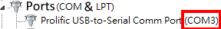
- Connect the Console Port to your PC or Laptop and check the port number in the “Device Manager” on the PC.
- Configure the Serial Information with the COM port number and Speed (Baud Rate: 115200). By default, the Data bits and Parity are 8 and 1. Then click “Open” to connect to the CLI.
Note: The complete parameters are COMX/115200/8/1.
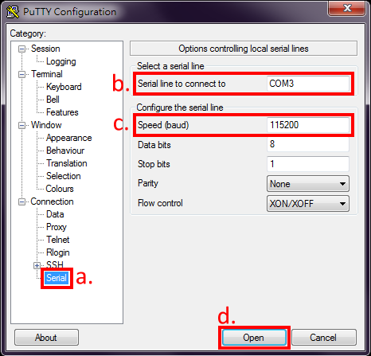

- Enter the username and password to login to the system. The default username and password is admin/admin.
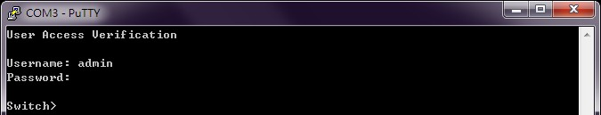
- When you see “Switch>”, it refers that you have logged in to the system. You can then start to configure the system on the CLI mode.
CONNECT TO CLI VIA TELNET
The following example is operating on Windows 7. If the system shows the information as the picture below, please enable the “Telnet Client” before using telnet function.
- Click Windows “Start” button and enter “cmd” on the search box to open the “Command Prompt”.
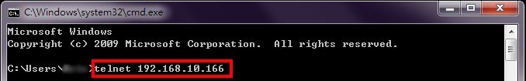
- Enter “telnet [IP_ADDRESS]” on the CMD window. For example, the IP address of the switch is “192.168.10.166”, so enter “telnet 192.168.10.166” and then press the “Enter” key.
- Enter the username and password to login the system. The default username and password is
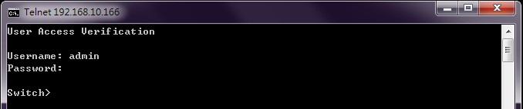
admin/admin.
- When “Switch>” is displayed, it refers that you have logged in to the system. You can then start to configure the system on the CLI mode.
CONFIGURE SYSTEM UNDER DIFFERENT MODES
After login to CLI, users must enter the Privileged Mode for “show” commands. If users want to configure the system via CLI, they must enter Configuration Mode.
The command to enter Privileged Mode is “enable”. After entering Privileged Mode, issue “configure terminal” to enter Configuration Mode. When “Switch(config)#” is displayed, users can start configuring the system with all commands under Configuration Mode. In the Command Group section, the mode of each command will be marked in the last column of the commands table.

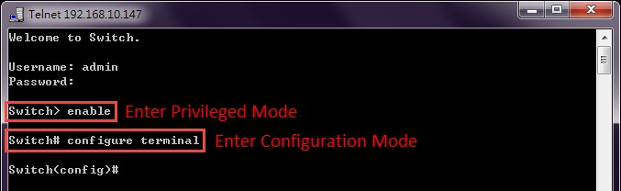
There are different modes under Configuration Mode, such as Interface Mode, VLAN Mode, ERPS Mode, and MRP Mode. If the command that users are preparing to issue is under these modes, they must enter the designated mode first. Users can issue “exit” to leave current mode. In the following table, we list the commands to enter different modes.
Mode | Command | Description
Interface | interface lanX | X implies the port number
VLAN | vlan X | X implies the VLAN ID
ERPS | ethernet redundancy erps-ring X | X implies the Ring number, from 1 to 3
MRP | ethernet redundancy mrp instance-mode 1 | Only support single ring currently

ENABLE TELNET CLIENT ON WIDOWS 7
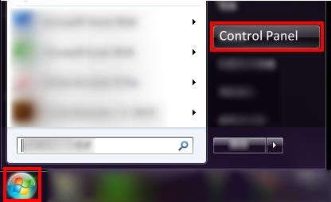
- Click the Windows “Start” button and click “Control Panel” item.
- Click the “Programs” item.
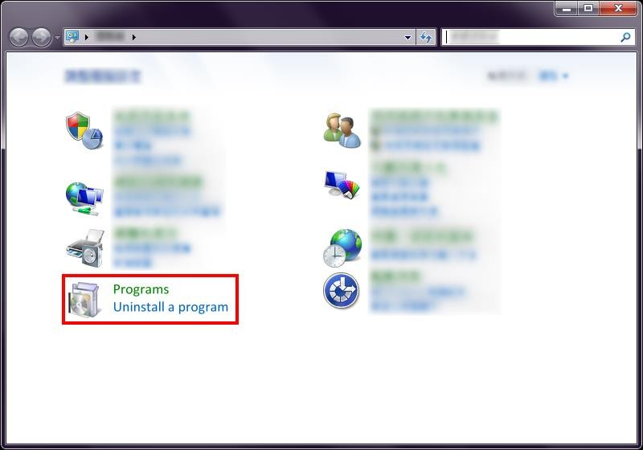

- Click the “Turn Windows features on or off” item.
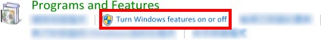
- Select the checkbox of “Telnet Client” and then click “OK” to enable telnet function.
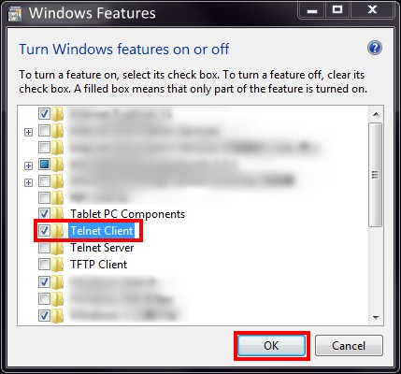
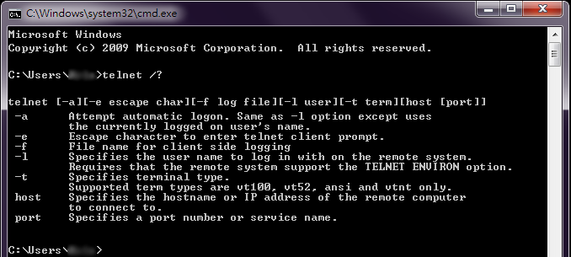
- Click Windows “Start” button and enter “cmd” on the search box to open the “Command Prompt” to test the telnet function.
FIRMWARE UPGRADE VIA CLI
Users can upgrade the system with a new firmware on both the web console and CLI mode. To upgrade on the web console, a high interactivity web GUI is provided for the users. Please refer to
Firmware Upgrade section. To upgrade on the CLI mode, there are 3 methods: TFTP, wget (HTTP), and USB. The following sections explain how to upgrade the firmware using the 3 methods.

FIRMWARE UPGRADE VIA CLI – TFTP
If the users are planning to upgrade the firmware via CLI mode with TFTP, a TFTP server is needed before upgrading. You can download the free TFTP server from tftpd official website.
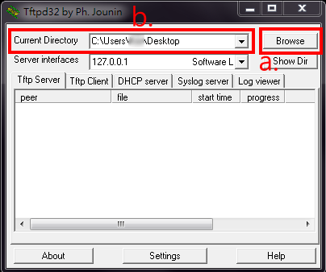
- Open the TFTP Server and browser the file directory path. For example, if the firmware file is saved on the desktop, the path to the desktop should be specified in the “Current Directory” field.
- Make sure the link between the switch and the host (PC or laptop) is connected. To verify it, ping the IP address of the switch IP address from the host to check it.
- Assign the firmware file name by issuing the “upload file name [FILE_NAME]“. The default file name is “WEBFULL”.
- Assign the TFTP Server IP address by issuing “upload server ip [SERVER_IP]”. The server IP address is the IP address of the host, which is running the TFTP server.
The commands for assigning the filename and server IP are in the Configure mode, so before configuring, specify “configure terminal” to enter the Configure mode.
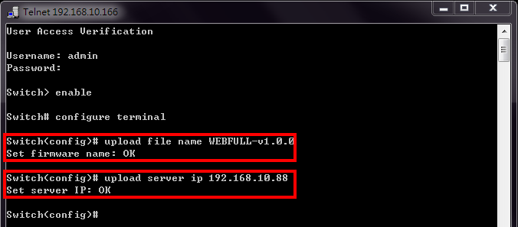
If the command is completely configured, the system will display “OK”.

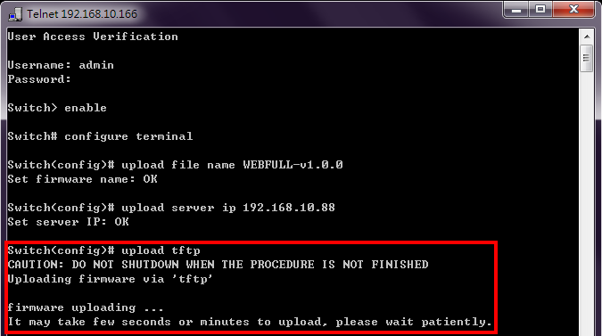
- Start to upgrade the firmware file by specifying “upload tftp”. The system starts to upload the assigned file by the TFTP. This takes a few minutes.
- After uploading, the system will verify the uploaded file. If the verification passes, the new firmware file will be installed. Ensure the system is powered on and the system will reboot automatically after the firmware is completely installed.
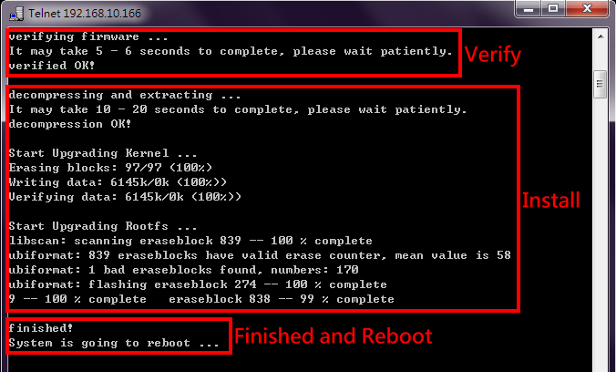

FIRMWARE UPGRADE VIA CLI – WGET
“Wget” uses the HTTP to transmit the file to the switch. Users must establish a HTTP Server
such as “Apache” and upload the firmware file to the HTTP Server.
- Assume there is a HTTP Server existed whose IP address is “192.168.1.9” and the firmware file named WEBFULL-v1.0.0 is uploaded.
- Make sure the link between the switch and the server is connected. We can ping the IP address of the server from the switch by using the command “ip ping [IP_ADDRESS]”.
- Assign the firmware file name by using “upload file name WEBFULL-v1.0.0“.
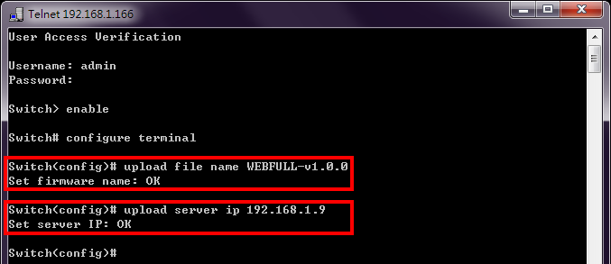
- Assign the Wget Server IP address by using “upload server ip 192.168.1.9”. If the command is completely configured, the system will display “OK”.
- Start to upgrade the firmware file by using “upload wget”. The system starts to upload the assigned file by HTTP. This takes a few seconds or minutes.
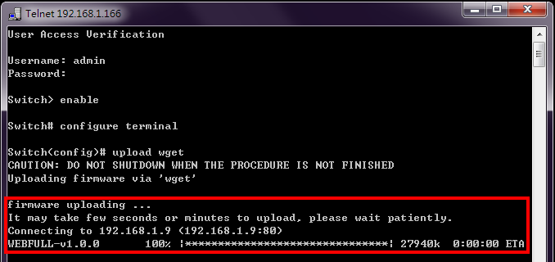

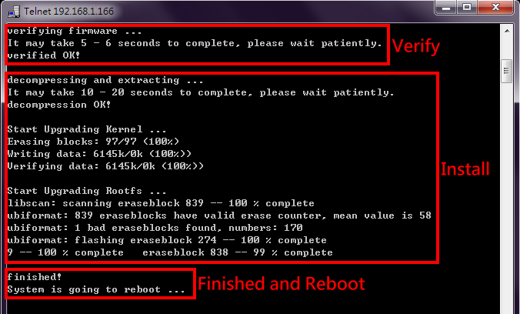
- Once the uploading is complete, the system will verify the uploaded file. If the verification passes, the new firmware file will be installed. Ensure to keep the system powered on and the system will reboot automatically after the firmware is completely installed.

FIRMWARE UPGRADE VIA CLI – USB
Check if the firmware file is saved in the USB and the USB stick is inserted in the USB part of the switch before upgrading the firmware file.
- Save the firmware file to the USB device and insert the USB stick to the USB port.
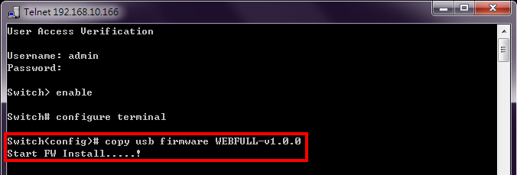
- Use “copy usb firmware [FILE_NAME]” to upgrade the system via USB.
- After the installation is complete, the system will reboot automatically.
Note: The file system of USB must be FAT32.

COMMAND GROUPS
The following are the commands that the users can use in the CLI mode. Please check if the
mode is correct before issuing the command.

AUTHENTICATION GROUP

Command | Explanation | Mode
login authentication [tacacs+ | radius] | Set login authentication method | Configure
logout | Disconnect | Configure
radius-server host [IP_ADDR] | Set IP address of RADIUS server | Configure
radius-server key [SHARED_KEY] | Set specific characters for authentication  verification | Configure
radius-server port [1-65535] | Set communication port of RADIUS server | Configure
radius-server retransmit [1-1000] | Set the number of times a request re-sending to RADIUS server | Configure
radius-server timeout [1-1000] | Set the timeout period to wait for RADIUS server  response | Configure
tacacs-server host [IP_ADDR] | Set IP address of TACASC+ server | Configure
tacacs-server key [SHARED_KEY] | Set specific characters for authentication  verification | Configure
tacacs-server port [1-65535] | Set communication port of TACASC+ server | Configure
tacacs-server timeout [1-1000] | Set the timeout period to wait for TACASC+  server response | Configure
username [USER_ID] [PASSWORD] | Configure username and password | Configure
username-ro [USER_ID] [PASSWORD] | Configure read only username and password | Configure
show login authentication | Display login authentication method | Configure
show radius-server host | Display IP address of RADIUS server | Configure
show radius-server key | Display specific characters for authentication  verification | Configure
show radius-server port | Display communication port of RADIUS server | Configure
show radius-server retransmit | Display the number of times a request is resent | Configure
show radius-server timeout | Display the timeout period to wait for RADIUS server response | Configure
show tacacs-server host | Display IP address of the server | Configure
show tacacs-server key | Display specific characters for authentication  verification | Configure
show tacacs-server port | Display communication port of the server | Configure
show tacacs-server timeout | Display the timeout period to wait for the server  response | Configure
show username | Display admin ID | Configure
show username-ro | Display read only user ID | Configure
no login authentication | Default Login authentication method | Configure
no radius-server host | Default IP address of the server | Configure

no radius-server key | Default specific characters for authentication verification | Configure
no radius-server port | Default communication port of the server | Configure
no radius-server retransmit | Default the number of times a request is resent | Configure
no radius-server timeout | Default the timeout period to wait for the server  response | Configure
no tacacs-server host | Default IP address of TACACS+ server | Configure
no tacacs-server key | Default specific characters for authentication  verification | Configure
no tacacs-server port | Default communication port of TACACS+ server | Configure
no tacacs-server timeout | Default the timeout period to wait for TACACS+  server response | Configure
no username | Default username and password | Configure
no username-ro | Default read only username and password | Configure

SSH GROUP

Command | Explanation | Mode
copy host-key-config usb [FILE_NAME] | Backup SSH host key to USB | Configure
copy usb host-key-config [file] | Upload SSH host key config from USB | Configure
download file name [FILE_NAME] | Set downloading file name, default name  is host_key.cfg | Configure
download host-key-config | Download current SSH host key config | Configure
download server account [SERVER_ACCOUNT] | Set downloading server account | Configure
download server ip [SERVER_IP] | Set downloading server IP Address | Configure
download server password  [SERVER_PASSWORD] | Set downloading server password | Configure
upload host-key-config wget [file] | Upload SSH host key config from Localhost | Configure
show ssh host-key | Display SSH host key | Configure

SYSTEM GROUP

Command | Explanation | Mode
erase startup-config | Reset to factory default and reboot | Configure
erase startup-config keep-ip | Reset to factory default except IP | Configure
erase startup-config keep-ip-user | Reset to factory default except IP and USER | Configure
erase startup-config keep-user | Reset to factory default except USER ID/PASS | Configure
exec-timeout [MINUTE] [SECOND] | Set idle timeout [MINUTE] [SECOND] | Configure
hostname [HOSTNAME] | Set Switch Host Name | Configure
reboot | Reboot the switch | Configure
system contact [CONTACT] | Set system contact | Configure
system description [SYS_DESCRIPTION] | Set device description | Configure
system location [LOCATION] | Set device location | Configure

show exec-timeout | Display idle timeout | Configure
show hostname | Display Switch Host Name | Configure
show environment power [1|2] | Display power 1/2 status | Configure
show event status relay | Display relay status | Configure
show system contact | Display system contact | Configure
show system description | Display system description | Configure
show system firmware-date | Display system release time | Configure
show system location | Display system location | Configure
show system mac | Display system MAC address | Configure
show system uptime | Display system uptime | Configure
show system version firmware | Display system version | Configure
show transceiver ddm | Display transceiver DDM information | Interface
show transceiver info | Display transceiver information | Interface
show transceiver raw | Display transceiver raw data | Interface
show username | Display admin ID | Configure
no exec-timeout | Default idle timeout | Configure
no hostname | Default Switch Host Name | Configure
no system contact | Clear system contact | Configure
no system description | Clear device description | Configure
no system location | Clear device location | Configure
no username | Default username and password | Configure

SERVICE CONTROL GROUP

Command | Explanation | Mode
service [http | https | ssh | telnet | console |  reset-button] enable | Enable service http, https, ssh, telnet,  console port, or reset button | Configure
show service [http | https | ssh | telnet | console | reset-button] | Display service http, https, ssh, telnet, console port, or reset button state | Configure
no service [http | https | ssh | telnet |  console | reset-button] | Disable service http, https, ssh, telnet,  console port, or reset button | Configure
IPV4 GROUP

Command | Explanation | Mode
ip address [IP_ADDR] [MASK] | Set IPv4 address and netmask | VLAN
ip loopback-address [IP_ADDR] [NETMASK] | Set Loopback Address | Configure
ip name-server [NAME_SERVER_IP] | Set Domain Name-Server | Configure
ip ping [IPV4_ADDR] [<size PKG_SIZ> |  <repeat PKG_CNT>] | Issue an IPv4 ping command | Configure
show ip address | Display Host address of IPv4 | VLAN
show ip loopback-address | Display Loopback address of IPv4 | Configure
show ip name-server | Display Domain Name-Server | Configure

no ip address | Delete IPv4 address | VLAN
no ip loopback-address | Delete Loopback Address | Configure
no ip name-server | Clear the domain name-server | Configure

IPV6 GROUP

Command | Explanation | Mode
ipv6 address [X:X::X:X</PREFIX_LEN>] | Set VLAN IPv6 Address | VLAN
ipv6 enable | Enable IPv6 protocol | Configure
ipv6 ping [IPV6_ADDR] [<size PKG_SIZ> |  <repeat PKG_CNT>] | Issue an IPv6 ping command | Configure
show ipv6 | Display IPv6 protocol state | Configure
show vlan ipv6 | Display VLAN IPv4 Address Table | Configure
no ipv6 | Disable IPv6 protocol | Configure
no ipv6 address [IPV6_ADDR/PREFIX_LEN] | Delete IPv6 address | VLAN

TIME GROUP

Command | Explanation | Mode
clock time [hh:mm:ss] [day] [month] [year] | Configure time | Configure
clock timezone [AREA] [CITY] | Configure time zone | Configure
ntp client sync [minute | hour | day | month  | year] [NUMBER] | Configure NTP client sync | Configure
ntp client timeserver1 [SERVER_IP/URL] | Configure NTP client time server 1 | Configure
ntp client timeserver2 [SERVER_IP/URL] | Configure NTP client time server 2 | Configure
ntp time update | Configure NTP time update | Configure
show clock time | Show time | Configure
show clock timezone | Show timezone | Configure
show ntp client sync | Show sync time | Configure
show ntp client timeserver1 | Show NTP server 1 configuration | Configure
show ntp client timeserver2 | Show NTP server 2 configuration | Configure
no clock timezone | Remove timezone | Configure
no ntp client sync | Remove NTP sync time | Configure
no ntp client timeserver1 | Remove NTP time server 1 configuration | Configure
no ntp client timeserver2 | Remove NTP time server 2 configuration | Configure
PTP GROUP

Command | Explanation | Mode
ptp announce interval [-1 to 7] | Set PTP announce interval, the interval is  expressed as log 2. i.e. -1 is 0.5s, 0 is 1s. | Configure
ptp announce timeout [2-255] | Set PTP announce timeout | Configure
ptp disable | Disable PTP | Configure

ptp domain [0-127] | Set PTP domain number | Configure
ptp enable | Enable PTP | Configure
ptp interface1 | Set the interface to master of boundary  clock mode | Configure
ptp interface2 | Set the interface to slave of boundary  clock mode | Configure
ptp mode [m(master) | s(slave) | b(boundary clock)] | Set PTP mode
ptp period [0-20] | Set PTP timeout periods | Configure
ptp priority1 [0-248] | Set PTP priority1 | Configure
ptp priority2 [0-248] | Set PTP priority2 | Configure
ptp sync interval [-7 to 7] | Set PTP sync interval, the interval is expressed as log 2. i.e. -1 is 0.5s, 0 is 1s. | Configure
show ptp announce interval | Display PTP announce interval | Configure
show ptp announce timeout | Display PTP announce timeout | Configure
show ptp clock | Display PTP sync information | Configure
show ptp domain | Display PTP domain number | Configure
show ptp enable | Display PTP status | Configure
show ptp interface1 | Display PTP interface1 | Configure
show ptp interface2 | Display PTP interface2 | Configure
show ptp mode | Display PTP mode | Configure
show ptp period | Display PTP timeout periods | Configure
show ptp priority1 | Display PTP priority1 | Configure
show ptp priority2 | Display PTP priority2 | Configure
show ptp sync interval | Display PTP sync interval | Configure
no ptp announce interval | Default PTP announce interval | Configure
no ptp announce timeout | Default PTP announce timeout | Configure
no ptp domain | Default PTP domain number | Configure
no ptp interface1 | Default PTP interface1 | Configure
no ptp interface2 | Default PTP interface2 | Configure
no ptp mode | Default PTP mode | Configure
no ptp period | Default PTP timeout periods | Configure
no ptp priority1 | Default PTP priority1 | Configure
no ptp priority2 | Default PTP priority2 | Configure
no ptp sync interval | Default PTP sync interval | Configure

STP GROUP

Command | Explanation | Mode
spanning-tree forward-time [4-30] | Set STP forward time | Configure
spanning-tree hello-time [1-10] | Set STP hello time | Configure
spanning-tree max-age [6-40] | Set max age | Configure

spanning-tree mode [rstp] | Set STP mode as [RSTP] | Configure
spanning-tree mst instance [1-15] vlan  [VLAN_LIST] | Set vlan group for specific MSTP instance | Configure
spanning-tree mst name [NAME] | Set MSTP name | Configure
spanning-tree mst revision [0-65535] | Set MSTP revision | Configure
spanning-tree mst [1-15] priority [0-61440] | Set priority for specific MSTP instance | Configure
spanning-tree priority [0-61440] | Set STP priority | Configure
spanning-tree cost [0-200000000] | Configure STP cost | Interface
spanning-tree edge  [admin-edge|admin-non-edge] | Configure STP edge | Interface
spanning-tree link-type  [point-to-multiple|point-to-point] | Configure STP link type on port | Interface
spanning-tree mst [1-15] cost [0-  200000000] | Configure port cost for specific MSTP instance | Interface
spanning-tree mst [1-15] port-priority [0-  200000000] | Configure port priority for specific MSTP  instance | Interface
spanning-tree port-priority [0-240] | Configure STP port priority | Interface
spanning-tree stp disable | Disable Spanning Tree Protocol (STP) on port | Interface
show spanning-tree forward-time | Show STP forward time | Configure
show spanning-tree hello-time | Show STP hello time | Configure
show spanning-tree max-age | Show STP max age | Configure
show spanning-tree mode | Show Spanning Tree mode (RSTP or disable) | Configure
show spanning-tree mst instance [1-15]  vlan | Show vlan group for specific MSTP instance | Configure
show spanning-tree mst name | Show MSTP name | Configure
show spanning-tree mst revision | Show MSTP revision | Configure
show spanning-tree mst [1-15] priority | Show priority for specific MSTP instance | Configure
show spanning-tree mst [1-15] status | Show bridge status for specific MSTP instance | Configure
show spanning-tree priority | Show STP priority | Configure
show spanning-tree rstp-status | Show Spanning Tree rstp status | Configure
show spanning-tree cost | Show STP cost | Interface
show spanning-tree edge | Show STP auto edge | Interface
show spanning-tree link-type | Show STP link type | Interface
show spanning-tree mst [1-15] cost | Show port cost for specific MSTP instance | Interface
show spanning-tree mst [1-15]  port-priority | Show port priority for specific MSTP instance | Interface
show spanning-tree port-priority | Show STP port priority | Interface
show spanning-tree stp | Show STP activated status on port | Interface
no spanning-tree forward-time | Remove STP forward time configuration | Configure
no spanning-tree hello-time | Remove STP hello time configuration | Configure
no spanning-tree max-age | Remove STP max age configuration | Configure
no spanning-tree mode | Disable STP configuration | Configure
no spanning-tree priority | Remove STP priority configuration | Configure

no spanning-tree cost | Remove STP cost configuration | Interface
no spanning-tree edge | Remove auto edge configuration | Interface
no spanning-tree link-type | Remove link type configuration | Interface
no spanning-tree mst [1-15] cost | Remove port cost for specific MSTP instance | Interface
no spanning-tree mst [1-15] port-priority | Remove port priority for specific MSTP  instance | Interface
no spanning-tree port-priority | Remove STP port priority configuration | Interface
no spanning-tree stp | Enable STP on port | Interface

ERPS GROUP

Command | Explanation | Mode
ethernet redundancy erps-ring [ 1 | 2 | 3 ] | Ethernet Ring Protection Switching (ERPS) mode | Configure
aps-channel [1 - 4094] | Set APS channel | ERPS
disable | Disable ERPS function | ERPS
enable | Enable ERPS function | ERPS
erps-ring [ 1 | 2 | 3 ] | Change to Other ERPS Ring | ERPS
ext-command clear | Extended ERPS command - Clear | ERPS
ext-command fs | Extended ERPS command – Forced Switch | ERPS
ext-command ms | Extended ERPS command – Manual Switch | ERPS
id [1 - 239] | Set Ring ID | ERPS
mel [0 - 7] | ERPS mel | ERPS
revertive | Set as revertive mode | ERPS
ring-port 0 [1(lan1) - N(lanN)] | Mapping ERPS ring port0 to switch port | ERPS
ring-port 1 [1(lan1) - N(lanN)] | Mapping ERPS ring port1 to switch port | ERPS
role port0 [o(owner) | n(neigh) | i(interconn)] | Set role on ring port0 | ERPS
role port1 [o(owner) | n(neigh) | i(interconn)] | Set role on ring port1 | ERPS
timer guard [10 - 2000] | Set guard timer interval | ERPS
timer hold-off [0 - 10000] | Set hold-off timer interval | ERPS
timer wtr [1 - 12] | Set WTR timer interval | ERPS
type [m(major-ring) | s(sub-ring)] | Set type as Major-Ring or Sub-Ring | ERPS
virtual-channel major-ring channel-id [1-4094] | Set virtual channel for ERPS Ring | ERPS
virtual-channel sub-ring set | Set virtual channel for ERPS Sub-ring | ERPS
show config | Displays ERPS configuration | ERPS
show port status | Displays ERPS ring port status | ERPS
show status | Displays ERPS status | ERPS
no aps-channel | Default ERPS aps-channel | ERPS
no id | Default Ring ID as default | ERPS
no revertive | Default mode non-revertive | ERPS
no ring-port 0 | Default ring port0 as lan1 | ERPS
no ring-port 1 | Default ring port1 as lan2 | ERPS

no role port0 | Default role of ring port0 as none | ERPS
no role port1 | Default role of ring port1 as none | ERPS
no timer guard | Default guard timer | ERPS
no timer hold-off | Default hold-off timer | ERPS
no timer wtr | Default wtr timer | ERPS
no type | Default ring type as Major-Ring | ERPS
no virtual-channel major-ring channel-id | Default virtual channel as ERPS Major  Ring's aps-channel | ERPS
no virtual-channel sub-ring set | Default virtual channel for ERPS Sub-ring  as None | ERPS

MRP GROUP

Command | Explanation | Mode
ethernet redundancy mrp instance-mode [1] | Media Redundancy Protocol (MRP) mode | Configure
advanced-mode [enable | disable] | Enable/Disable MRP Advanced Mode | MRP
domain-id [DOMAIN_ID] | Set MRP Domain-id, the format is 16 bytes in decimal notation | MRP
name [DOMAIN_NAME] | Set MRP Domain Name | MRP
operation [enable | disable] | Enable/Disable MRP Protocol | MRP
port 1 [1(lan1) - N(lanN)] | Set MRP ring-port 1 ID | MRP
port 2 [1(lan1) - N(lanN)] | Set MRP ring-port 2 ID | MRP
recovery-delay [500 | 200] | Set MRP Recovery Delay (unit: ms) | MRP
role [m(manager) | c(client)] | Set MRP Role to MRM(manager) or  MRC(client) | MRP
show advanced-mode | Display MRP Advanced-mode | MRP
show config | Display MRP Domain Config | MRP
show domain-id | Display MRP Domain ID | MRP
show name | Display MRP Domain Name | MRP
show operation | Display MRP Operation Status | MRP
show port [1 | 2] | Display MRP ring-port [1 | 2] ID | MRP
show recovery-delay | Display MRP Recovery Delay | MRP
show role | Display MRP Domain Expected Role | MRP
show summary | Display MRP Domain Summary | MRP
no domain-id | Default MRP Domain ID | MRP
no name | Clear MRP Domain Name | MRP
no port [1 | 2] | Default MRP ring-port [1 | 2] ID | MRP
no recovery-delay | Default MRP Recovery Delay | MRP
no role | Default MRP Domain role | MRP
SNMP GROUP

Command | Explanation | Mode

snmp server community ro [COMMUNITY] | Set v1, v2c snmp server read-only community | Configure
snmp server community rw [COMMUNITY] | Set v1, v2c snmp server read-write  community | Configure
snmp server enable | Enable snmp server | Configure
snmp server enable v1-v2c-only | Enable snmp v1 and v2c | Configure
snmp server enable v3-only | Enable snmp v3 command only | Configure
snmp server v3 auth admin [md5| sha]  [PASSWORD] | Set SNMPv3 admin authentication type | Configure
snmp server v3 auth user [md5| sha]  [PASSWORD] | Set SNMPv3 user authentication type | Configure
snmp server v3 encryption admin [des| aes]  [PASSWORD] | Set SNMPv3 admin encryption type | Configure
snmp server v3 encryption user [des| aes]  [PASSWORD] | Set SNMPv3 user encryption type | Configure
snmp server v3 level admin [auth| noauth|  priv] | Set SNMPv3 admin security level | Configure
snmp server v3 level user [auth| noauth|  priv] | Set SNMPv3 user security level | Configure
snmp trap community [COMMUNITY] | Set v1, v2c snmp trap community | Configure
snmp trap host1 [TRAP_HOST_IP] | Set snmp trap host 1 IP address | Configure
snmp trap host2 [TRAP_HOST_IP] | Set snmp trap host 2 IP address | Configure
snmp trap inform retry [1-100] | Set snmp inform retry times | Configure
snmp trap inform timeout [1-300] | Set snmp inform timeout | Configure
snmp trap v3 auth [sha| md5] [PASSWORD] | Set SNMPv3 authentication type: md5 or sha | Configure
snmp trap v3 encryption [des| aes]  [PASSWORD] | Set SNMPv3 encryption type: des or aes | Configure
snmp trap v3 engine-ID [ENGINE_ID] | Set snmp trap engine ID | Configure
snmp trap v3 level [auth| noauth| priv] | Set SNMPv3 trap security level | Configure
snmp trap v3 user [USER_ID] | Set SNMPv3 trap user | Configure
snmp trap version [1| 2c trap| 2c inform| 3  trap| 3 inform] | Set snmp trap version and type | Configure
show snmp server | Display snmp server status | Configure
show snmp server community ro | Display snmp server read only community | Configure
show snmp server community rw | Display snmp server writable community | Configure
show snmp server v3 auth admin | Display SNMPv3 admin authentication type and passphrase | Configure
show snmp server v3 auth user | Display SNMPv3 user authentication type  and passphrase | Configure
show snmp server v3 encryption admin | Display SNMPv3 admin encryption type  and passphrase | Configure
show snmp server v3 encryption user | Display SNMPv3 user encryption type and  passphrase | Configure
show snmp server v3 level admin | Display SNMPv3 admin security level | Configure

show snmp server v3 level user | Display SNMPv3 user security level | Configure
show snmp trap community | Display snmp trap community | Configure
show snmp trap host1 | Display snmp trap host 1 | Configure
show snmp trap host2 | Display snmp trap host 2 | Configure
show snmp trap inform retry | Display snmp inform retry times | Configure
show snmp trap inform timeout | Display snmp inform timeout | Configure
show snmp trap v3 auth | Display SNMPv3 authentication type and passphrase | Configure
show snmp trap v3 encryption | Display SNMPv3 encryption type and passphrase | Configure
show snmp trap v3 engine-ID | Display snmp trap engine ID | Configure
show snmp trap v3 level | Display SNMPv3 trap security level | Configure
show snmp trap v3 user | Display SNMPv3 trap user | Configure
show snmp trap version | Display snmp trap version and type | Configure
no snmp server | Disable snmp server | Configure
no snmp server community ro | Default ro-community name | Configure
no snmp server community rw | Default rw-community name | Configure
no snmp server v3 auth admin | Default SNMPv3 admin authentication type | Configure
no snmp server v3 auth user | Default SNMPv3 user authentication type | Configure
no snmp server v3 encryption admin | Default SNMPv3 admin encryption type | Configure
no snmp server v3 encryption user | Default SNMPv3 user encryption type | Configure
no snmp server v3 level admin | Default SNMPv3 admin security level | Configure
no snmp server v3 level user | Default SNMPv3 user security level | Configure
no snmp trap community | Default snmp trap community | Configure
no snmp trap host1 | Default snmp trap host 1 | Configure
no snmp trap host2 | Default snmp trap host 2 | Configure
no snmp trap inform retry | Default snmp inform retry times | Configure
no snmp trap inform timeout | Default snmp inform timeout | Configure
no snmp trap v3 auth | Default SNMPv3 authentication type and passphrase | Configure
no snmp trap v3 encryption | Default SNMPv3 encryption type and passphrase | Configure
no snmp trap v3 engine-ID | Default snmp trap engine ID | Configure
no snmp trap v3 level | Default SNMPv3 trap security level | Configure
no snmp trap v3 user | Default SNMPv3 trap user | Configure
no snmp trap version | Default snmp trap version | Configure

DHCP GROUP

Command | Explanation | Mode
boot host dhcp | Directs the system to get an IP address | Configure

dhcp relay information option | Set DHCP-relay option | Configure
dhcp relay server [server_number: 1-4]  [server_IP] | Set DHCP-relay server [1-4] IP | Configure
dhcp relay untrust | Set DHCP-relay untrusted port | Interface
dhcp server binding [bind_ID: 1 - 32] [MAC]  [IP_TO_BIND] | Set binding IP and MAC of DHCP | Configure
dhcp server default-gateway [IP_ADDR] | Set default-gateway IP for DHCP client | Configure
dhcp server included-address [START_OF_IP]  [END_OF_IP] | Set IP range for its client | Configure
dhcp server lease-time [60-2592000] | Set DHCP server lease time | Configure
dhcp server name-server [IP_ADDR] | Set name-server address for DHCP client | Configure
dhcp service relay enable | Enable DHCP relay | Configure
dhcp service server enable | Enable DHCP server | Configure
show boot host dhcp | Display DHCP client state | Configure
show dhcp relay information option | Display DHCP relay option | Configure
show dhcp relay server [server_number: 1-4] | Display DHCP relay address | Configure
show dhcp relay untrust | Display DHCP untrusted port status | Interface
show dhcp server binding | Display all DHCP bounding entries | Configure
show dhcp server default-gateway | Display DHCP default-gateway IP | Configure
show dhcp server included-address | Display DHCP included IP range | Configure
show dhcp server lease | Display DHCP lease entries | Configure
show dhcp server lease-time | Display DHCP server lease time | Configure
show dhcp server name-server | Display DHCP name-server | Configure
show dhcp server status | Display DHCP server status | Configure
show dhcp service relay | Display DHCP relay agent status | Configure
show dhcp service server | Display DHCP server status | Configure
no boot host dhcp | Disable DHCP client | Configure
no dhcp relay information option | Disable DHCP relay option | Configure
no dhcp relay server [server_number: 1-4] | Remove DHCP relay server [1-4] IP | Configure
no dhcp relay untrust | Default port as trusted | Interface
no dhcp server binding [bind_ID: 1-32] | Remove DHCP bounding IP and MAC | Configure
no dhcp server default-gateway | Remove DHCP default-gateway IP | Configure
no dhcp server included-address | Remove DHCP included IP range | Configure
no dhcp server lease-time | Remove DHCP lease time | Configure
no dhcp server name-server | Remove DHCP name-server | Configure
no dhcp service relay | Disable DHCP relay | Configure
no dhcp service server | Disable DHCP server | Configure

INDUSTRIAL PROTOCOLS GROUP

Command | Explanation | Mode
ethernet-ip enable | Enable EtherNet/IP Protocol | Configure
modbus tcp enable | Enable Modbus/TCP Protocol | Configure
profinet enable | Enable PROFINET Protocol | Configure
show ethernet-ip | Show EtherNet/IP status | Configure
show modbus tcp | Show Modbus/TCP status | Configure
show profinet | Show PROFINET status | Configure
no ethernet-ip | Disable EtherNet/IP Protocol | Configure
no modbus tcp | Disable Modbus/TCP Protocol | Configure
no profinet | Disable PROFINET Protocol | Configure

UPNP GROUP

Command | Explanation | Mode
upnp advertisement interval [300-86400] | Set UPnP advertisement interval | Configure
upnp enable | Enable Universal Plug and Play (UPnP) | Configure
show upnp | Display Universal Plug and Play (UPnP) state | Configure
show upnp advertisement interval | Display UPnP advertisement interval | Configure
no upnp | Disable Universal Plug and Play (UPnP) | Configure
no upnp advertisement interval | Default UPnP advertisement interval | Configure

PORT GROUP

Command | Explanation | Mode
eee port-enable | 802.3az (EEE) port enable | Interface
flowcontrol [on | off] | Configure port's flow-control to response a pause  frame | Interface
name [PORT_NAME] | Set interface name | Interface
shutdown | Disable port | Interface
speed_duplex [10 | 100] [full | half] | Configure port's speed and duplex | Interface
show interface all link summary | To display interface link status globally | Configure
show administrate | To display port's admin state | Interface
show eee port-all | Display EEE port-all status | Configure
show eee-info | Display Port EEE statistic information | Interface
show flowcontrol | Display port's flow-control state | Interface
show link duplex | To display port's duplex | Interface
show link rx | To display port's Rx_Bytes | Interface
show link speed | To display port's speed | Interface
show link state | To display port's link state | Interface
show link summary | To display port's link summary | Interface

show link tx | To display port's Tx_Bytes | Interface
show name | To display port's name | Interface
show speed_duplex | To display port's speed and duplex | Interface
show transceiver | Transceiver information | Interface
no eee port-enable | 802.3az (EEE) port disable | Interface
no flowcontrol | Default flow-control as Auto mode | Interface
no name | Remove port's name | Interface
no shutdown | Enable port | Interface
no speed_duplex | Default port speed-duplex as Auto mode | Interface

POE GROUP (PoE Model Only)

Command | Explanation | Mode
power inline budget [1-240] | Power PoE budget | Configure
power inline mode-config disable | Disable PoE on port | Interface
power inline mode-config enable | Enable PoE on port | Interface
power inline mode-config force | Force PoE powered on port | Interface
power inline priority [1-3] | Set PoE port priority on port;  1:high, 2:middle, 3:low | Interface
keepalive enable | Enable PoE keepalive | Interface
keepalive hold-time | Configure PoE keepalive power cycle  hold-time | Interface
keepalive ip | Configure IP for PoE keepalive | Interface
keepalive time | Configure PoE keepalive cycle time | Interface
schedule enable | Enable one port PoE schedule | Interface
schedule [Sunday-Saturday] open-time  [time] | Configure PoE schedule open time on one  day | Interface
show power inline budget | Display PoE power budget | Configure
show power inline detail-code | Display PoE status code, refer to “PoE Debug  Code” for more explanation | Interface
show power inline operation | Display All PoE ports operation status | Configure
show power inline status | Display All PoE ports detail status | Configure
show power inline status | Display PoE status for specific port | Interface
show power inline temperature | Display temperature of PoE controller | Configure
show keepalive table | Display All PoE keepalive info | Configure
show power inline status | Display PoE status | Interface
show keepalive | Show PoE keepalive status | Interface
show keepalive hold-time | Show PoE keepalive hold-time | Interface
show keepalive ip | Show IP for PoE keepalive | Interface

show keepalive time | Show PoE keepalive cycle time | Interface
show schedule | Disable Universal Plug and Play (UPnP) | Interface
show schedule [Sunday-Saturday]  open-time | Show open time of POE schedule on one day | Interface
show schedule table | Show one port PoE schedule table | Interface
no power inline budget | Default PoE power budget | Configure
no power inline mode-config | Default PoE powered config on port | Interface
no power inline priority | Disable PoE port priority on port | Interface
no keepalive | Disable PoE keepalive | Interface
no keepalive hold-time | Default PoE keepalive power cycle hold-time | Interface
no keepalive ip | Remove IP for PoE keepalive | Interface
no keepalive time | Remove PoE keepalive cycle time | Interface
no schedule | Remove one port PoE schedule | Interface
no schedule [Sunday-Saturday] open-time | Remove PoE schedule on one day | Interface

IGMP SNOOPING GROUP

Command | Explanation | Mode
igmp snooping enable | Enable IGMP snooping | Configure
igmp snooping last-member count [2-10] | Set IGMP last-member-count | Configure
igmp snooping last-member interval [1-25] | Set IGMP last-member-interval | Configure
igmp snooping querier enable | Enable IGMP snooping querier | Configure
igmp snooping query interval [1-3600] | Set IGMP query interval | Configure
igmp snooping query max-respond-time [1-12] | Set IGMP max-query-respond time | Configure
igmp snooping query version [VLAN_ID]  [STATE:0|1] [VERSION:1|2|3] | Add IGMP query version entry by VLAN  ID. STATE 0: disable; STATE 1: enable | Configure
igmp snooping router-port [PORT_LIST] | Set router port list for multicast | Configure
igmp snooping unknown-multicast [f|d|r] | Set unknown-multicast action | Configure
show igmp snooping all | Display IGMP settings (summary) | Configure
show igmp snooping mdb | Display IGMP multicast database | Configure
show igmp snooping query-version | Display IGMP Query version by VLAN ID | Configure
show igmp snooping router-port | Display IGMP router port list | Configure
show igmp snooping unknown-multicast | Display unknown-multicast action | Configure
no igmp snooping | Disable IGMP snooping | Configure
no igmp snooping last-member count | Default IGMP Last-Member-Count | Configure
no igmp snooping last-member interval | Default IGMP Last-Member-Interval | Configure
no igmp snooping querier | Disable IGMP querier | Configure
no igmp snooping query interval | Default IGMP query interval | Configure
no igmp snooping query max-respond-time | Default IGMP max-respond-time | Configure

no igmp snooping router-port | Default IGMP router port | Configure
no igmp snooping unknown-multicast | Default unknown-multicast action | Configure

VLAN GROUP

Command | Explanation | Mode
provider ethertype [VALUE_IN_HEX (i.e.,  0x88A8)] | Setup EtherType in S-TAG for provider  port | Configure
member [untag PORT_LIST] [tag PORT_LIST] | Set VLAN member | VLAN
name [VLAN_NAME] | Set VLAN Name | VLAN
switchport accept [tagged | untagged] | Set VLAN acceptance of frame | Interface
switchport mode [d(dot1q-tunnel)| c(customer)| p(provider)| s(specific-provider)] | Configure port type as dot1q-tunnel, Customer, or Service Provider | Interface
switchport pvid [PVID: 1-4094] | Set port VLAN-Id | Interface
show provider ethertype | Display Service Provider EtherType | Configure
show vlan global | Display VLAN Global information | Configure
show member | Display port VLAN member | VLAN
show name | Display VLAN name | VLAN
show switchport accept | Display acceptance of VLAN frame | Interface
show switchport mode | Display VLAN interface port type | Interface
show switchport pvid | Display port VLAN-Id | Interface
no provider ethertype | Default EtherType as 0x88A8 in S-TAG for  provider port | Configure
no member | Default VLAN member | VLAN
no name | Default VLAN name | VLAN
no switchport accept | Default acceptance of VLAN frame | Interface
no switchport mode | Default port type as Customer | Interface
no switchport pvid | Default port VLAN-Id | Interface
QOS GROUP

Command | Explanation | Mode
qos fair-queue weight [W0] [W1] [W2]  [W3] [W4] [W5] [W6] [W7] | Set WRR Queue Weight | Configure
qos map cos [priority:0-7] to tx-queue  [0-7] | Set Cos queue mapping of priority [0-7] | Configure
qos map dscp [0-63] to tx-queue [0-7] | Set DSCP mapping queue | Configure
qos queue-schedule [strict | wrr] | Set QoS scheduling type | Configure
qos default cos [0-7] | Set Default Class of Service (COS) value | Interface

qos trust [cos | dscp] | Set trust of cos or dscp | Interface
show qos fair-queue weight | Display WRR Queue Weight | Configure
show qos map cos | Display global QoS queue mapping status | Configure
show qos map cos [0-7] | Display QoS queue mapping status of Priority  [0-7] | Configure
show qos map dscp | Display global DSCP queue mapping status | Configure
show qos map dscp [0-63] | Display DSCP queue mapping status of class [0-63] | Configure
show qos queue-schedule | Display queue scheduling type | Configure
show qos default cos | Display CoS default value | Interface
show qos trust | Display QoS trust | Interface
no qos fair-queue weight | Default WRR Queue Weight | Configure
no qos map cos [0-7] | Reset Cos queue mapping of priority [0-7] | Configure
no qos map dscp [0-63] | Reset DSCP mapping queue to default | Configure
no qos queue-schedule | Default scheduling type as WRR | Configure
no qos default cos | Reset default CoS to initial value | Interface
no qos trust | Default trust as CoS | Interface

PORT TRUNK GROUP

Command | Explanation | Mode
trunk group [1-8] [static | lacp] INTERFACES_LIST | Configure port aggregation group | Configure
show trunk group | Show all trunk groups | Configure
show trunk group [1-8] | Show trunk group [1-8] | Configure
no trunk group [1-8] | Remove trunk group [1-8] | Configure
STORM CONTROL GROUP

Command | Explanation | Mode
storm-control broadcast enable | Enable the broadcast storm control | Configure
storm-control broadcast level [low | mid |  high] | Set the broadcast storm control level | Configure
storm-control multicast enable | Enable the multicast storm control | Configure
storm-control multicast level [low | mid |  high] | Set the multicast storm control level | Configure
storm-control unknown-unicast enable | Enable the unknown-unicast storm control | Configure
storm-control unknown-unicast level [low |  mid | high] | Set the unknown-unicast storm control  level | Configure
show storm-control broadcast | Display the broadcast storm control status | Configure
show storm-control broadcast level | Display the broadcast storm control level | Configure
show storm-control multicast | Display the multicast storm control status | Configure

show storm-control multicast level | Display the multicast storm control level | Configure
show storm-control unknown-unicast | Display the unknown-unicast storm  control status | Configure
show storm-control unknown-unicast level | Display the unknown-unicast storm  control level | Configure
no storm-control broadcast | Disable the broadcast storm control | Configure
no storm-control broadcast level | Default the broadcast storm control to  level high | Configure
no storm-control multicast | Disable the multicast storm control | Configure
no storm-control multicast level | Default the multicast storm control to  level high | Configure
no storm-control unknown-unicast | Disable the unknown-unicast storm  control | Configure
no storm-control unknown-unicast level | Default the unknown-unicast storm  control to level high | Configure

STATIC ROUTE GROUP

Command | Explanation | Mode
ip route [IP_ADDR] [NETMASK:0-32] [NEXT_HOP] | Add static routing entry | Configure
ipv6 route [X:X::X:X/M] [X:X::X:X] | Set IPv6 Static Route | Configure
show ip route static | Display static routing entries | Configure
show ipv6 route | Display IPv6 Routing Table | Configure
show ipv6 route static | Display IPv6 Static Routing Table | Configure
no ip route [IP_ADDR] [NETMASK:0-32] | Delete a static routing entry | Configure
no ipv6 route [X:X::X:X/M] [X:X::X:X] | Remove an IPv6 Static Route entry | Configure
OSPFV2 GROUP

Command | Explanation | Mode
ip ospf authentication | Enable OSPF Authentication on this VLAN | VLAN
ip ospf authentication message-digest | Enable OSPF Authentication with MD5 on this  VLAN | VLAN
ip ospf authentication-key [AUTH_KEY] | Set OSPF Authentication Password (Key) | VLAN
ip ospf dead-interval [1-65535] | Set OSPF Dead Interval; The default OSPF  Dead Interval is 4 times hello interval | VLAN
ip ospf hello-interval [1-65535] | Set OSPF Hello Interval | VLAN
ip ospf message-digest-key [1-8] md5  [AUTH_KEY] | Set OSPF MD5 Authentication Password for  KEY ID [1-8] | VLAN
ip ospf metric [1-65535] | Set OSPF Metric | VLAN

router ospf authentication area [AREA_ID] | Enable OSPF Authentication | Configure
router ospf authentication message-digest  area [AREA_ID] | Enable MD5 Authentication on specific OSPF  Area | Configure
router ospf enable | Enable Global OSPF function | Configure
router ospf network [IP_ADDR]  [NETMASK:0-32] [AREA_ID] | Set OSPF Network Interface and Area | Configure
router ospf router-id [ROUTER_ID] | Set OSPF Router-ID | Configure
show ip ospf authentication | Display OSPF Authentication on this VLAN | VLAN
show ip ospf authentication-key | Display OSPF Authentication Password (Key) | VLAN
show ip ospf dead-interval | Display OSPF Dead Interval | VLAN
show ip ospf hello-interval | Display OSPF Hello Interval | VLAN
show ip ospf message-digest-key | Display OSPF MD5 Authentication Password  (Key) | VLAN
show ip ospf metric | Display OSPF Metric | VLAN
show router ospf | Display OSPF Routing Status | Configure
show router ospf authentication | Display OSPF Authentication Status | Configure
show router ospf mode | Display OSPF Enable/Disable | Configure
show router ospf neighbor | Display OSPF Routing Neighbor | Configure
show router ospf network | Display OSPF Network Interface and Area | Configure
show router ospf router-id | Display OSPF Router-ID | Configure
show router ospf vlan | Display OSPF Vlan Table | Configure
no ip ospf authentication | Disable OSPF Authentication on this VLAN | VLAN
no ip ospf authentication-key | Clear OSPF Authentication Password (Key) | VLAN
no ip ospf dead-interval | Clear OSPF Dead Interval | VLAN
no ip ospf hello-interval | Clear OSPF Hello Interval | VLAN
no ip ospf message-digest-key [1-8] | Remove OSPF MD5 Authentication Password  for KEY ID [1-8] | VLAN
no ip ospf metric | Clear OSPF Metric | VLAN
no router ospf | Remove OSPF Routing Protocol Configuration | Configure
no router ospf authentication area  [AREA_ID] | Disable OSPF Authentication on specific Area | Configure
no router ospf network [IP_ADDR]  [NETMASK:0-32] | Clear OSPF Network Interface | Configure
no router ospf router-id | Clear OSPF Router-ID | Configure

OSPFV3 GROUP

Command | Explanation | Mode
ipv6 ospf6 dead-interval [1-65535] | Set OSPFv3 Dead Interval; The default | VLAN

 | OSPF Dead Interval is 4 times hello interval
ipv6 ospf6 hello-interval [1-65535] | Set OSPFv3 Hello Interval | VLAN
ipv6 ospf6 metric [1-65535] | Set OSPFv3 Metric | VLAN
ipv6 ospf6 network [broadcast | point-to-point] | Set OSPFv3 Network-type | VLAN
ipv6 ospf6 priority [0-255] | Set OSPFv3 Priority | VLAN
router ospf6 area [AREA_ID] [X:X::X:X/M] | Set OSPFv3 Area | Configure
router ospf6 enable | Global OSPFv3 On | Configure
router ospf6 router-id [ROUTER_ID] | Set OSPFv3 Router-ID; OSPFv3 router-id is  in IP address format: A.B.C.D | Configure
router ospf6 vlan [VLAN_id] [AREA_ID] | Set OSPFv3 interface/Area | Configure
show ipv6 ospf6 interface | Display OSPFv3 Information | Configure
show ipv6 ospf6 dead-interval | Display OSPFv3 Dead Interval | VLAN
show ipv6 ospf6 hello-interval | Display OSPFv3 Hello Interval | VLAN
show ipv6 ospf6 metric | Display OSPFv3 Metric | VLAN
show router ospf6 | Display OSPFv3 Routing Status | Configure
show router ospf6 mode | Display OSPFv3 Enable/Disable | Configure
show router ospf6 neighbor | Display OSPFv3 neighbor | Configure
show router ospf6 router-id | Display OSPFv3 Router-ID | Configure
show router ospf6 vlan | Display OSPFv3 VLAN Table | Configure
no router ospf6 | Remove OSPFv3 Routing Protocol  Configuration | Configure
no router ospf6 vlan [VLAN_id] [AREA_ID] | Remove OSPFv3 interface/area | Configure

RIPV1/V2 GROUP

Command | Explanation | Mode
router rip enable | Enable Global RIP function | Configure
router rip neighbor [IP_ADDR] | Set RIP Neighbors | Configure
router rip network [IP_ADDR] [NETMASK:0-32] | Set RIP Network | Configure
router rip timers [Update] [Time-out] [Garbage] | Set Routing-Table Update, Time-Out, and Garbage Collection Timers  Default timer - update timer: 30s,  time-out: 180s , garbage: 120s | Configure
router rip version [1|2] | Set RIP Version | Configure
show router rip mode | Display RIP Enable/Disable | Configure
show router rip network | Show RIP Network Interface and Area | Configure
show router rip state | Show RIP Routing Table | Configure
show router rip status | Show RIP Status | Configure
no router rip | Remove RIP Configurations | Configure

no router rip neighbor | Clear RIP Router-ID | Configure
no router rip network [IP_ADDR]  [NETMASK:0-32] | Remove RIP Network Interface and Area | Configure
no router rip timers | Clear RIP Timers | Configure
no router rip version | Reset RIP Version | Configure

RIPNG GROUP

Command | Explanation | Mode
router ripng enable | Enable Global RIP function | Configure
router ripng timers [Update] [Time-out] [Garbage] | Set Routing-Table Update, Time-Out, and Garbage Collection Timers  Default timer - update timer: 30s, time-out:  180s , garbage: 120s | Configure
Router ripng vlan | Set RIPng Network | Configure
show router ripng mode | Display RIPng Enable/Disable | Configure
show router ripng state | Show RIPng Routing Table | Configure
show router ripng status | Show RIPng Status | Configure
no router ripng | Remove RIPng Routing Protocol Configurations | Configure
no router ripng vlan | Remove RIPng network-interface | Configure

VRRP GROUP

Command | Explanation | Mode
vrrp adv-timer [1-60] | Set Advertise Interval Timer of VRRP | VLAN
vrrp enable | Enable VRRP | VLAN
vrrp group-id [1-255] | Set Virtual Group ID of VRRP | VLAN
vrrp ip-address [Virtual IP address] | Set Virtual Server IP of VRRP | VLAN
vrrp preempt | Enable Preemption Mode of VRRP | VLAN
vrrp priority [1-254] | Set Priority of VRRP | VLAN
show vrrp-config |  | Configure
show vrrp adv-timer | Display Advertise Interval Timer of VRRP | VLAN
show vrrp all | Display All VRRP Configuration | VLAN
show vrrp group-id | Display Virtual Group ID of VRRP | VLAN
show vrrp ip-address | Display Virtual IP of VRRP | VLAN
show vrrp preempt | Display Preemption Mode of VRRP | VLAN
show vrrp priority | Display Priority of VRRP | VLAN
show vrrp state | Display State of VRRP | VLAN

no vrrp adv-timer | Disable VRRP and Remove Advertise Interval Timer  of VRRP | VLAN
no vrrp all | Disable VRRP and Remove All VRRP Configuration | VLAN
no vrrp group-id | Disable VRRP and Remove Virtual Group ID of VRRP | VLAN
no vrrp ip-address | Disable VRRP and Remove Virtual IP of VRRP | VLAN
no vrrp preempt | Disable Preemption Mode of VRRP | VLAN
no vrrp priority | Disable VRRP and Remove Priority of VRRP | VLAN
no vrrp state | Disable VRRP | VLAN

802.1X GROUP

Command | Explanation | Mode
dot1x authentication server [1|2] ip [IP] | Set 802.1X authentication server 1 or 2  address | Configure
dot1x authentication server [1|2] port [PORT] | Set 802.1X authentication server 1 or 2  port | Configure
dot1x authentication server [1|2] share-key  [KEY] | Set 802.1X authentication server 1 or 2  share-key | Configure
dot1x authentication server type  [local|radius] | Set 802.1X authentication server type | Configure
dot1x enable | Enable 802.1X protocol | Configure
dot1x local-db [USER] [PASSWORD] | Set 802.1X local user database | Configure
dot1x authenticator enable | Set 802.1X authenticator | Interface
dot1x mode [mac-based | port-based] | Set 802.1X mode as 1. MAC-based,  2.Port-based | Interface
dot1x reauthentication enable | Set 802.1X reauthentication | Interface
dot1x reauthentication period [60-65535] | Set 802.1X reauthentication period | Interface
show dot1x | Display 802.1X protocol state | Configure
show dot1x authentication server [1|2] ip | Display 802.1X authentication server 1 or 2  address | Configure
show dot1x authentication server [1|2] port | Display 802.1X authentication server 1 or 2  port | Configure
show dot1x authentication server [1|2]  share-key | Display 802.1X authentication server 1 or 2  key | Configure
show dot1x authentication server type | Display 802.1X authentication server type | Configure
show dot1x brief | Display 802.1X information | Configure
show dot1x local-db | Display 802.1X users and password in  database | Configure
show dot1x server brief | Display 802.1X RADIUS server | Configure

show dot1x authenticator | Display 802.1X authenticator state | Interface
show dot1x mode | Display 802.1X mode config | Interface
show dot1x reauthentication | Display 802.1X reauthentication state | Interface
show dot1x reauthentication period | Display 802.1X reauthentication period (in  sec.) | Interface
no dot1x | Disable 802.1X protocol | Configure
no dot1x authentication server [1|2] ip | Default 802.1X authentication server 1 or  2 address | Configure
no dot1x authentication server [1|2] port | Default 802.1X authentication server 1 or  2 port | Configure
no dot1x authentication server [1|2]  share-key | Default 802.1X authentication server 1 or  2 share-key | Configure
no dot1x authentication server type | Default 802.1X authentication server type | Configure
no dot1x local-db [USER] | Remove an entry in 802.1X local database | Configure
no dot1x authenticator | Disable 802.1X authenticator | Interface
no dot1x mode | Default 802.1X mode as MAC-based | Interface
no dot1x reauthentication | Disable 802.1X reauthentication | Interface
no dot1x reauthentication period | Default 802.1X reauthentication period | Interface

PORT MIRROR GROUP

Command | Explanation | Mode
mirror destination [DEST_PORT] | Set mirror interface of destination | Configure
mirror enable | Enable port mirror | Configure
mirror source [rx | tx | both] [PORT_LIST] | Set mirror interface of source | Configure
show mirror | Show port mirror enable/disable state | Configure
show mirror destination | Show port mirror destination configuration | Configure
show mirror source | Show port mirror source configuration | Configure
no mirror | Disable port mirror | Configure
no mirror destination | Delete port mirror Destination configuration | Configure
no mirror source | Delete port mirror Source configuration | Configure
REMOTE SPAN GROUP

Command | Explanation | Mode
rspan destination [DEST_PORT] | Set remote SPAN interface of destination | Configure
rspan mode source enable | Enable remote SPAN of source | Configure
rspan mode destination enable | Enable remote SPAN of destination | Configure
rspan reflector [REFLECTOR_PORT] | Set remote SPAN interface of reflector | Configure
rspan source [rx | tx] [PORT] | Set remote SPAN monitor traffic and interface of | Configure

 | source
rspan vlan-id [2 - 1001, 1006 - 4094] | Set remote SPAN VLAN-Id | Configure
show rspan | Show remote SPAN enable/disable state | Configure
show rspan destination | Show remote SPAN destination configuration | Configure
show rspan reflector | Show remote SPAN reflector configuration | Configure
show rspan source | Show remote SPAN source configuration | Configure
show rspan vlan-id | Show remote SPAN VLAN-Id configuration | Configure
no rspan | Disable remote SPAN | Configure
no rspan destination | Delete remote SPAN destination configuration | Configure
no rspan reflector | Delete remote SPAN reflector configuration | Configure
no rspan source | Delete remote SPAN source configuration | Configure
no rspan vlan-id | Delete remote SPAN VLAN-Id configuration | Configure

LLDP GROUP

Command | Explanation | Mode
lldp enable | Enable LLDP protocol | Configure
lldp timer [5-32767] | Set LLDP timer | Configure
show lldp neighbor | Display LLDP neighbor | Configure
show lldp neighbor detail | Display LLDP neighbors in detail | Configure
show lldp state | Display LLDP status | Configure
show lldp timer | Display LLDP timer | Configure
no lldp | Disable LLDP protocol | Configure
no lldp timer | Default LLDP timer | Configure

SYSLOG GROUP

Command | Explanation | Mode
syslog local enable | Enable logging to local | Configure
syslog log clear | Clear syslog log | Configure
syslog remote enable | Enable logging to remote | Configure
syslog remote port [PORT] | Set syslog remote server port | Configure
syslog remote server [ADDRESS] | Set syslog remote server address | Configure
syslog usb enable | Enable log to USB device | Configure
show syslog local | Display local logging state | Configure
show syslog log | Display syslog messages | Configure
show syslog remote | Display remote logging state | Configure
show syslog remote port | Display remote server port | Configure
show syslog remote server | Display remote server IP | Configure
show syslog usb | Display USB logging state | Configure

no syslog local | Disable logging to local | Configure
no syslog remote | Disable logging to remote | Configure
no syslog remote port | Default syslog remote server port | Configure
no syslog remote server | Clear syslog remote server address | Configure
no syslog usb | Disable logging to USB | Configure

SMTP GROUP

Command | Explanation | Mode
smtp authentication enable | Enable SMTP authentication | Configure
smtp authentication password [PASSWORD] | Set SMTP password | Configure
smtp authentication username [USER_NAME] | Set SMTP username | Configure
smtp enable | Enable SMTP | Configure
smtp receive [1-4] [RECEIVER_ADDRESS] | Set SMTP receiver [1-4] address | Configure
smtp sender [SMTP_SENDER_ADDRESS] | Set SMTP sender | Configure
smtp server address [SMTP_SERVER_ADDRESS] | Set SMTP server address | Configure
smtp server port [SMTP_SERVER_PORT] | Set SMTP server port | Configure
smtp subject [SUBJECT] | Set SMTP subject | Configure
show smtp authentication state | Display SMTP authentication status | Configure
show smtp authentication username | Display SMTP user name | Configure
show smtp receive [1-4] | Display SMTP receiver [1-4] | Configure
show smtp sender | Display SMTP sender | Configure
show smtp server address | Display SMTP server address | Configure
show smtp server port | Display SMTP server port | Configure
show smtp state | Display SMTP service | Configure
show smtp subject | Display SMTP subject | Configure
no smtp authentication | Disable SMTP authentication | Configure
no smtp authentication password | Clear SMTP password | Configure
no smtp authentication username | Clear SMTP user name | Configure
no smtp | Disable SMTP | Configure
no smtp receive [1-4] | Clear SMTP receiver [1-4] | Configure
no smtp sender | Clear SMTP sender | Configure
no smtp server address | Clear SMTP server | Configure
no smtp server port | Clear SMTP server port | Configure
no smtp subject | Clear SMTP subject | Configure

EVENT GROUP

Command | Explanation | Mode
event alarm ddm [lanX-lanY] [current | | Register a DDM event of current, Rx | Configure

rx_power | temperature | tx_power | voltage] | power, temperature, Tx power, or voltage
event alarm digital-input [high | low] | Register an event of digital-input | Configure
event alarm interface [lan1-lanN] down | Register an event of Interface DOWN | Configure
event alarm [power1|power2] | Register an event of power 1 or 2 failure | Configure
event smtp auth-failure | Register an event of authentication failure | Configure
event smtp cold-start | Register an event of cold-start | Configure
event smtp ddm [lanX-lanY] [current | rx_power | temperature | tx_power |  voltage] | Register a DDM event of current, Rx power, temperature, Tx power, or voltage | Configure
event smtp digital-input [high | low] | Register an event of digital-input | Configure
event smtp interface [lan1-lanN] down | Register an event of Interface DOWN | Configure
event smtp interface [lan1-lanN] up | Register an event of Interface UP | Configure
event smtp [power1|power2] | Register an event of power 1 or 2 failure | Configure
event smtp warm-start | Register an event of warm-start | Configure
event snmptrap auth-failure | Register an event of authentication failure | Configure
event snmptrap cold-start | Register an event of cold-start | Configure
event snmptrap ddm [lanX-lanY] [current |  rx_power | temperature | tx_power | voltage] | Register a DDM event of current, Rx power, temperature, Tx power, or voltage | Configure
event snmptrap digital-input [high | low] | Register an event of digital-input | Configure
event snmptrap interface [lan1-lanN] down | Register an event of Interface DOWN | Configure
event snmptrap interface [lan1-lanN] up | Register an event of Interface UP | Configure
event snmptrap [power1|power2] | Register an event of power 1 or 2 failure | Configure
event snmptrap warm-start | Register an event of warm-start | Configure
event syslog auth-failure | Register an event of authentication failure | Configure
event syslog cold-start | Register an event of cold-start | Configure
event syslog ddm [lanX-lanY] [current | rx_power | temperature | tx_power |  voltage] | Register a DDM event of current, Rx power, temperature, Tx power, or voltage | Configure
event syslog digital-input [high | low] | Register an event of digital-input | Configure
event syslog interface [lan1-lanN] down | Register an event of Interface DOWN | Configure
event syslog interface [lan1-lanN] up | Register an event of Interface UP | Configure
event syslog [power1|power2] | Register an event of power 1 or 2 failure | Configure
event syslog warm-start | Register an event of warm-start | Configure
show event alarm ddm [lanX-lanY] [current | rx_power | temperature | tx_power |  voltage] | Display current, Rx power, temperature, Tx power, or voltage event registration | Configure
show event alarm digital-input | Display digital-input event registration | Configure
show event alarm interface [lan1-lanN] down | Display interface DOWN event registration | Configure
show event alarm [power1|power2] | Display power 1 or 2 event registration | Configure

show event smtp auth-failure | Display authentication failure event  registration | Configure
show event smtp cold-start | Display cold-start event registration | Configure
show event smtp ddm [lanX-lanY] [current |  rx_power | temperature | tx_power | voltage] | Display current, Rx power, temperature, Tx power, or voltage event registration | Configure
show event smtp digital-input | Display digital-input event registration | Configure
show event smtp interface [lan1-lanN] down | Display interface DOWN event registration | Configure
show event smtp interface [lan1-lanN] up | Display interface UP event registration | Configure
show event smtp [power1|power2] | Display power 1 or 2 event registration | Configure
show event smtp warm-start | Display warm-start event registration | Configure
show event snmptrap auth-failure | Display authentication failure event  registration | Configure
show event snmptrap cold-start | Display cold-start event registration | Configure
show event snmptrap ddm [lanX-lanY] [current | rx_power | temperature | tx_power | voltage] | Display current, Rx power, temperature, Tx power, or voltage event registration | Configure
show event snmptrap digital-input | Display digital-input event registration | Configure
show event snmptrap interface [lan1-lanN]  down | Display interface DOWN event registration | Configure
show event snmptrap interface [lan1-lanN] up | Display interface UP event registration | Configure
show event snmptrap [power1|power2] | Display power 1 or 2 event registration | Configure
show event snmptrap warm-start | Display warm-start event registration | Configure
show event syslog auth-failure | Display authentication failure event  registration | Configure
show event syslog cold-start | Display cold-start event registration | Configure
show event syslog ddm [lanX-lanY] [current | rx_power | temperature | tx_power |  voltage] | Display current, Rx power, temperature, Tx power, or voltage event registration | Configure
show event syslog digital-input | Display digital-input event registration | Configure
show event syslog interface [lan1-lanN] down | Display interface DOWN event registration | Configure
show event syslog interface [lan1-lanN] up | Display interface UP event registration | Configure
show event syslog [power1|power2] | Display power 1 or 2 event registration | Configure
show event syslog warm-start | Display warm-start event registration | Configure
no event alarm ddm [lanX-lanY] [current | rx_power | temperature | tx_power |  voltage] | Unregister a DDM event of current, Rx power, temperature, Tx power, or voltage | Configure
no event alarm digital-input | Unregister an event of digital-input | Configure
no event alarm interface [lan1-lanN] down | Unregister an event of Interface DOWN | Configure
no event alarm [power1|power2] | Unregister an event of power 1 or 2 failure | Configure
no event smtp auth-failure | Unregister an event of authentication | Configure

 | failure
no event smtp cold-start | Unregister an event of cold-start | Configure
no event smtp ddm [lanX-lanY] [current |  rx_power | temperature | tx_power | voltage] | Unregister a DDM event of current, Rx power, temperature, Tx power, or voltage | Configure
no event smtp digital-input | Unregister an event of digital-input | Configure
no event smtp interface [lan1-lanN] down | Unregister an event of Interface DOWN | Configure
no event smtp interface [lan1-lanN] up | Unregister an event of Interface UP | Configure
no event smtp [power1|power2] | Unregister an event of power 1 or 2 failure | Configure
no event smtp warm-start | Unregister an event of warm-start | Configure
no event snmptrap auth-failure | Unregister an event of authentication  failure | Configure
no event snmptrap cold-start | Unregister an event of cold-start | Configure
no event snmptrap ddm [lanX-lanY] [current | rx_power | temperature | tx_power | voltage] | Unregister a DDM event of current, Rx power, temperature, Tx power, or voltage | Configure
no event snmptrap digital-input | Unregister an event of digital-input | Configure
no event snmptrap interface [lan1-lanN]  down | Unregister an event of Interface DOWN | Configure
no event snmptrap interface [lan1-lanN] up | Unregister an event of Interface UP | Configure
no event snmptrap [power1|power2] | Unregister an event of power 1 or 2 failure | Configure
no event snmptrap warm-start | Unregister an event of warm-start | Configure
no event syslog auth-failure | Unregister an event of authentication  failure | Configure
no event syslog cold-start | Unregister an event of cold-start | Configure
no event syslog ddm [lanX-lanY] [current | rx_power | temperature | tx_power |  voltage] | Unregister a DDM event of current, Rx power, temperature, Tx power, or voltage | Configure
no event syslog digital-input | Unregister an event of digital-input | Configure
no event syslog interface [lan1-lanN] down | Unregister an event of Interface DOWN | Configure
no event syslog interface [lan1-lanN] up | Unregister an event of Interface UP | Configure
no event syslog [power1|power2] | Unregister an event of power 1 or 2 failure | Configure
no event syslog warm-start | Unregister an event of warm-start | Configure

MAC ADDRESS TABLE GROUP

Command | Explanation | Mode
clear mac address-table dynamic | Flush dynamic MAC addresses in MAC  table | Configure
mac address add [VID: 1-4094] [MAC_ADDR]  [PORT] | Set a MAC address to MAC table | Configure

show mac address | Display MAC table | Configure
no mac address [VID: 1-4094] [MAC_ADDR] | Remove a MAC address from FDB | Configure

USB GROUP

Command | Explanation | Mode
usb auto-backup | Auto save to USB if running config is changed | Configure
usb auto-load | Auto load config from USB to switch | Configure
show usb auto-backup | Display USB auto backup activated status | Configure
show usb auto-load | Display USB auto load activated status | Configure
no usb auto-backup | Disable auto save | Configure
no usb auto-load | Disable auto load | Configure

FILE GROUP

Command | Explanation | Mode
copy running-config startup-config | Save running-config to startup-config | Configure
copy running-config usb [file] | Save running-config to USB | Configure
copy startup-config running-config | Restore from startup-config | Configure
copy usb firmware [file] | Upgrade firmware from USB | Configure
copy startup-config usb [file] | Save startup-config to USB | Configure
copy usb startup-config [file] | Restore startup-config from USB | Configure
upload file name [FILE_NAME] | Set uploading file name | Configure
upload server ip [SERVER_IP] | Set uploading server IP | Configure
upload tftp | Upload and update firmware via TFTP (slower) | Configure
upload wget | Upload and update firmware via HTTP (faster) | Configure
show upload file name | Display uploading file name | Configure
show upload server ip | Display uploading server IP | Configure
no upload file name | Default uploading file name | Configure
no upload server ip | Clear uploading server IP | Configure

