Using Industrial Ethernet with Fiber Optics

Achieving Security, Longer Distance and Superior Noise Immunity

Overview
The use of fiber optics in Industrial local area networks (LANs), such as Ethernet, has increased due to the inherent advantages of using fiber optic cabling. High data rates can be maintained without electromagnetic or radio frequency interference (EMI/RFI). Longer distances can be achieved versus copper wiring. For the industrial/commercial user, fiber offers high-voltage isolation (opto-isolation), intrinsic safety, and elimination of ground loops in geographically large installations. Ethernet will function with no difficulty over fiber optics if some simple rules are followed.

Cabling Basics
Optical fiber consists of three basic elements: core, cladding and the coating. The core constructed of either glass or plastic provides the basic means for transmitting the light energy down the cable. The cladding prevents the light from exiting the core and being absorbed by the cable itself. The coating provides protection to the fiber core while providing strength. Final protection is provided by an overall jacket that may consist of other strength and protective elements.
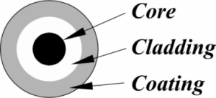

Figure 1 — A single fiber consists of three basic elements.

Fiber Size
Optical fibers are classified by their diameter in microns (1 micron = one-millionth of a meter). Frequently the core, cladding and coating are specified using slashes (/) to separate the values. For example, 50/125/250 means the core is 50 µm, the cladding is 125 µm and the coating is 250 µm. These dimensions all pertain to the concentric diameters of the various elements. A short form way of specifying the fiber is to only list the core and cladding sizes. In the above example, this fiber would be classified as 50/125. Core sizes range from as small as 5 µm to as high as 1000 µm. Depending upon the core size, either one or two modes of light transmission will be experienced. The two modes are called single-mode and multimode.
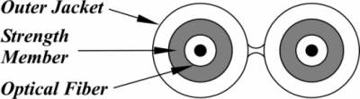

Figure 2 — Fiber optic cable is available as paired cable (duplex cable) with an appearance like "zip cord."
Single-Mode Operation
With small diameter fibers in the range of 5 to 10 µm, all light rays tend to propagate along the axis of the fiber. Since there is only one path for the light to take, the light is termed to be experiencing a single mode of operation. As the core diameter increases, the light rays have the option of traveling at an angle to the core axis while attempting to exit through the cladding. This second effect is called multimode operation.
Multimode Operation
With fiber core sizes of 50, 62.5 and above, multimode operation will be experienced. Not only will the light transfer down the axis of the fiber, but it will also travel away from the axis and toward the cladding. The cladding helps reflect the light rays back toward the fiber axis. The cladding provides this effect because it has a lower index of refraction than the core. The 50-micron fiber is used to support longer distances in Multi-mode fiber. The 62.5-micron fiber is standard for the shorter distance found in use with Multi-mode fiber.
Index of Refraction
The index of refraction of a material (n) is defined as the ratio of the speed of light in a vacuum compared to the speed of light in the material. When light passes from one material to another with a different density, part of the light will be reflected, and the remainder refracted. The angle of the refracted ray will be different from the incident wave and will obey Snell's Law:

n₁ sin Θ₁ = n₂ sin Θ₂

where n₁, and n₂ are the corresponding indexes of refraction and the two angles are measured relative to a perpendicular axis to the boundary of the two materials. At some angle called the critical angle, Θ₂ becomes 90°. For all values of Θ₁, greater than the critical angle, total internal reflection will occur. This is the fundamental principle of fiber optic communications. The light energy is constrained to the inner core. The cladding with its lower index of refraction provides the total internal reflection necessary for proper operation.
Multimode Signal Distortion
In multimode operation, light waves travel down the axis of the fiber as well as a zigzag course bouncing off the cladding. Since some of the light rays take a longer trip when they exit the far end of the core (due to its zigzag course), distortion of the original signal will occur as it recombines with the light ray that took the shorter path down the axis of the core. This results in pulse broadening at the receiver end. This distortion is called modal dispersion because the paths of the light rays are at different lengths. To counteract this multimode phenomenon, graded-index fiber was developed.
With graded-index fiber, the index of refraction is highest along the center axis of the fiber and gradually decreases from the axis to the circumference. Light travels slower with a higher index of refraction and faster with a lower index of refraction.
With this approach, the light that travels down the center axis is deliberately slowed to match the time required for light to travel a zigzag course nearer the circumference. The result is less distortion and higher bandwidth.
Bandwidth requirements are generally not an issue with Ethernet. Multimode fibers have bandwidth specifications in frequency-distance units (MHz-km) that depend upon the operating wavelength. Doubling the distance halves, the signaling rate; however, even at minimal bandwidth specifications (160 MHz-km or so), the attenuation limitations of increased fiber length will be met before the bandwidth limitations.
Lower bandwidth fiber exists with a 200 µm core diameter. This is step-index fiber meaning that only one index of refraction exists in the core and another in the cladding. This fiber is intended for shorter runs and is easier to connect and is more resilient to physical abuse due to its larger core size. This fiber is found in plant floor applications but is not recommended for Ethernet.
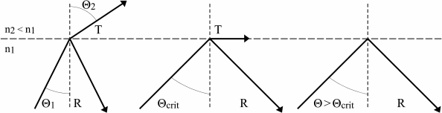

Figure 3 — Total internal reflection occurs when the incident angle exceeds the critical angle.
Operating Wavelengths
Fiber optic transmitters and receivers are generally classified to operate in either of three frequencies. These frequencies have been found to have the lowest attenuation across a band of frequencies. The regions of lowest attenuation are called windows. The frequencies the industry uses are 850 nm, 1310 nm, and 1550 nm. The two lower wavelengths offer cost/performance tradeoffs that are of interest in Ethernet applications. The 850 nm technology is readily available at the lowest cost. However, fiber optic cable attenuation is higher in the 850 nm band than in the 1310 nm band and the bandwidth is less. This attenuation is what limits the fiber optic segment lengths when using Ethernet. The 1310 nm receivers and transmitters are more costly but are recommended when long distances are to be encountered or high data rate operation is required. The 850 nm technology is generally used with multimode applications, while the 1310 nm technology is used with either single-mode or multimode operation.
NOTE: The use of 850 nanometer fiber optics over Multi-mode fiber is a common practice. However, in Industrial Ethernet deployment – it is better to use 1310 nanometer fiber optics over Multi-mode fiber. The reason? 850 nanometer fiber optics are LED (light emitting diode) and the 1310 nanometer fiber optics are laser based. Laser fiber optics have a wider temperature range: -40~+85C. LED fiber optics are limited to 0 ~70C
Fiber Optic Transmitters
Both 850 nm and 1310 nm fiber optic transmitters can be found in switches and network interface modules (NIMs) and the two technologies cannot be mixed. These transmitters are available with either LC, ST, SC, FC or MTP/MPO connectors. The ST connector operates like a small coaxial BNC connector. It prevents over-tightening and provides repeatable insertion loss. The SC connector is a low-cost, snap-in connector. Today we generally use LC (Lucent Connector) connectors.

SC Connector
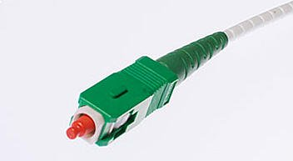
The SC was developed by the laboratories at Nippon Telegraph and Telephone (NTT) in the mid-eighties and was one of the first connectors to hit the market following the advent of ceramic ferrules. Sometimes referred to as the ‘square connector’ the SC has a push-pull coupling end face with a spring-loaded ceramic ferrule. Initially intended for Gigabit Ethernet networking, it was standardized into the telecommunications specification TIA-568-A in 1991 and slowly grew in popularity as manufacturing costs came down. Due to its excellent performance it dominated fiber optics for over a decade with only the ST rivalling it. Thirty years on, it remains the second most common connector for polarization maintaining applications. The SC is ideally suited for datacoms and telecoms applications including point to point and passive optical networking.

LC Connector
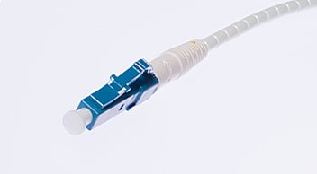
Considered by some to be the modern replacement of the SC connector; its introduction was less successful, in part due to initially high license fees from inventor Lucent Corporation. Also, a push-pull connector, the LC utilizes a latch as opposed to the SC locking tab and with a smaller ferrule it is known as a small form factor connector. Having half the footprint of the SC connector gives it huge popularity in datacoms and other high-density patch applications, as its combination of small size and latch feature make it ideal for densely populated racks/panels. With the introduction of LC compatible transceivers and active networking components, its steady growth in the FTTH arena is likely to continue. This is the best connector to use in terms of lowest insertion loss characteristics. It is commonly used today

FC Connector
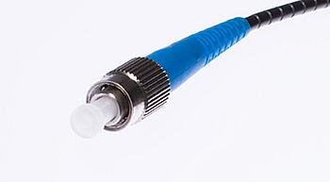
The FC was the first optical fiber connector to use a ceramic ferrule, but unlike the plastic bodied SC and LC, it utilizes a round screw-type fitment made from nickel-plated or stainless steel. The connector end face relies on an alignment key for correct insertion and is then tightened into the adaptor/jack using a threaded collet. Despite the additional complexity both in manufacturing and installation, it is still the connector of choice for precise measuring equipment such as OTDRs.
Initially intended for datacoms and telecoms applications, its use has reduced since the introduction of the SC and LC. These deliver similar performance to the FC, but both have less expensive components and are quicker to connect. However, the screw-on collet of the FC does make it particularly effective in high vibration environments, ensuring that the spring-loaded ferrule is firmly mated.

ST Connector
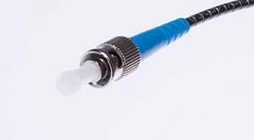
The ST connect was developed by AT&T shortly after the arrival of the FC. They can be mistaken for one another, but the ST uses a bayonet fitment rather than a screw thread. Usage has declined in recent decades, for the same reasons as the FC. Additionally, it cannot be terminated with an angled polish, which limits use in single mode fiber and FTTH applications.
Deployed predominately in multi-mode datacoms it is most common in network environments such as campuses, corporate networks and in military applications where the quick connecting bayonet had its advantages at the time. It is typically installed into infrastructures that were built at the turn of the century; when retrofitting, STs are typically swapped out for more cost-effective SC and LC connectors.

MTP/MPO connector
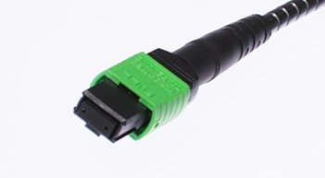
The MT ferrule connector is another of NTT’s inventions and has been around since the 1980s, although the technology has only recently become popular under branded versions of the Multiple Fiber Push-On/Pull-Off connector, such as MTP and MPO. It is larger than the other connectors but for good reason - it can support up to 24 fibers in a single ferrule.
Multi-fiber connectors are not currently designed for field-fit applications so must be lab terminated. In high density patch environments such as datacenters they are used extensively, both at single mode and multi-mode wavelengths. On a ‘per-fiber’ basis the costs are relatively inexpensive. However as might be expected, the attenuation loss can be higher than a single ceramic ferrule connector. It is possible to order ‘low loss’ MTP/MPO connectors which have comparable insertion loss performances. These are more expensive.
In fiber optic implementations, a separate transmitter and receiver are used instead of a transceiver. Fiber optic links use a duplex cable for NIM-to-hub and hub-to-hub connections. A transmitter at point A connects to a receiver at point B. Point B's transmitter attaches to point A's receiver. Therefore, a crossover function must be accomplished in the cabling. Transmitters and receivers may or may not be color-coded so care must be exercised to pair a transmitter to a receiver.
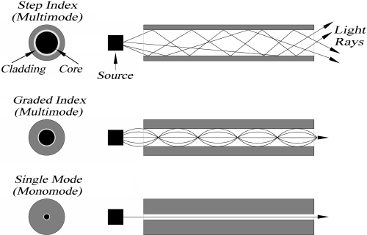

Figure 4 — Step-index fiber has the lowest bandwidth, while single-mode fiber offers the highest.
Transmitter Power
Transmitters are rated in dBm with 0 dBm corresponding to 1 milliwatt of power. Transmitter output can vary from device to device, so it is important to 100% test transmitters to ensure that none are shipped below the minimum specified in the Ethernet standard. Testing is usually accomplished by applying a square wave signal and measuring the average power with an optical power meter. Transmitter output also depends upon the fiber size. More energy is launched into larger fiber sizes; therefore, a power rating shown in a specification is based upon a core size.
Receiver Sensitivity
Receiver sensitivity is also rated in dBm and is based upon receiving the same square wave signal generated by the transmitter. Typically, only a maximum sensitivity rating is given which represents the weakest signal discernable by the receiving electronics. Separate receivers are required for 850 nm and 1310 nm operation. Receiver sensitivity is typically the same over a batch of receivers and does not exhibit the same variability as transmitters.
Optical Power Budget
When specifying a fiber optic installation, attention must be paid to the available optical power budget. The power budget is the difference between the light source strength minus receiver sensitivity expressed in dB. This value must be compared to the link loss that is the total attenuation due to optical cable and optical connectors. The link loss must be less than the power budget. The difference is called the power margin that provides an indication of system robustness.
Link Loss
To determine the link loss, all losses due to fiber length and cable connections must be summed. Fiber optic cable attenuation is usually specified by the cable manufacturer. Use this figure to determine the attenuation for a length of fiber cable. It is also necessary to include losses due to cable terminations. Connectors usually create a loss of from 0.5 to 1 dB for each connection. For example, assume a 1500-meter run of 62.5 µm cable which the cable manufacturer specifies as having a cable attenuation of 3.5 dB per 1000 meters. The cable loss would therefore be 5.25 dB. Assume there are two connector losses of 0.5 dB each for a total of 1 dB. The link loss would therefore total 6.25 dB. If the light source produced −20 dBm and the receiver sensitivity is −30.4 dBm, then the power budget would be 10.4 dB which is greater than the link loss by 4.15 dB. This difference would represent a high degree of margin since a 3 dB margin is what is typically recommended to account for aging. Recommendations on acceptable attenuation values can be found in TIA/EIA-568-A Commercial Building Telecommunications Cabling Standard.
Overdrive
Overdrive occurs when too little fiber optic cable is used resulting in insufficient attenuation; thereby, saturating the receiver. To correct this condition, a longer length of fiber optic cable must be installed between the transmitter and receiver. This is potentially a problem with larger core cable. Another solution is to have a receiver with a wide dynamic range. Over this range, the receiver will accept varying levels of signal without overload.
Delay Budget
People frequently assume that with fiber optics, signals propagate at the speed of light. This is not true. In fact, the propagation factor is 0.67c or 5 ns/m which is slower than an electrical signal over coaxial cable. The delay through cables and hubs is an issue for shared Ethernet systems that operate over half-duplex links and must obey the rules for collision detection. It is not an issue for full-duplex links which avoid collisions altogether.

Ethernet Standards
Ethernet standards are published in ISO/IEC 8802-3:2000 which is also known as IEEE Std 802.3, 2000 Edition. This is an evolving standard with information on 10, 100 and 1000 Mbps operation. This is an extraordinarily complex standard and is over 1500 pages long. From the standard we will review those portions dealing with fiber optics.
FOIRL
The Fiber Optic Inter-Repeater Link (FOIRL) was the original fiber optic specification. It was intended to link two repeaters together with a maximum of 1 km fiber optic cable while operating at 10 Mbps. This standard has been superseded by the 10BASE-FL specification.
10BASE-F
The 10BASE-F standard is actually a collection of fiber optic standards for 10 Mbps operation. It consists of three separate standards— 10BASE-FL, 10BASE-FB and 10BASE-FP. It is not sufficient to claim 10BASE-F compatibility because of these three specific implementations. The −FB and −FP standards are not popular and will not be discussed.
10BASE-FL
This standard is the most popular 10 Mbps fiber implementation. The standard calls for a maximum segment length of 2 km of multimode fiber optic cable and a minimum length of 0 km. This means that the transmitter cannot create an overdrive condition. A 10BASE-FL unit must be able to communicate with a FOIRL unit but be limited to 1 km. Connectors are the ST style and a segment consists of a pair of cables; thereby allowing for full-duplex communication. The operating wavelength of the receivers and transmitters are 850 nm allowing for the less expensive components. The minimum average transmit level is −20 dBm while the maximum is −12 dBm. The receiver must be able to distinguish a −32.5 dBm signal and not overload from a −12 dBm signal. That means that the receiver's dynamic range must be at least 20.5 dB and that the power budget must be 12.5 dB. The intention is to use 62.5/125 fiber optic cable. If a larger core is used, more energy will be launched which could cause overdrive on short runs. Manchester encoding is used just like 10BASE-T.
100BASE-X
Like 10BASE-F, 100BASE-X is not a unique physical layer but details the encoding for the two most popular Fast Ethernet physical layers— 100BASE-TX and 100BASE-FX. One physical layer is for copper and the other for fiber optics, yet the standard applies to both. Much of the 100BASE-X standard comes from the FDDI standard including the 4B/5B encoding.
4B/5B
Data transfers over the Medium Independent Interface (MII), defined for Fast Ethernet, are done with 4-bit nibbles that represent actual data. With 10BASE-FL, Manchester encoding is used which guarantees a transition within every bit cell regardless of logic state. This effectively creates a 20 Mbaud signal for a 10 Mbps data rate. If the same encoding were used for Fast Ethernet, a 200 Mbaud signal would result making it difficult to maintain the same 2 km maximum segment length due to bandwidth restrictions. A solution is the 4B/5B code where the 4-bit nibbles being transferred over the MII are encoded as five-bit symbols sent over the medium. The encoding efficiency is 80% and the baud rate increases to 125 Mbaud. This is still fast but not as fast as 200 Mbaud. The 4B/5B scheme is used for both the 100BASE-TX and 100BASE-FX physical layers.
100BASE-FX
The actual governing specification for 100BASE-FX is ISO/IEC 9314-3 which describes FDDI's Physical Layer Medium Dependent (PMD). The 100BASE-FX fiber optic physical layer is remarkably similar in performance to 10BASE-FL. Maximum segment length is 2km for both technologies; however, for 100BASE-FX this is only achieved on full-duplex links. On half-duplex links the segment length cannot exceed 412 m. Either SC, MIC or ST fiber optic connectors can be used, but SC is recommended. Multimode fiber optic cable (62.5/125) is what is normally used; however, larger cores can be substituted. Minimum transmitter power is −20 dBm and maximum receiver sensitivity is −31 dBm. The signaling on fiber optics is NRZI (non-return to zero inverted) since there is no concern for EMI on fiber optic links.
With 100BASE-TX, 1310 nm technology is used and since communication between 850 nm devices does not exist, there is no support for the Fast Ethernet Auto-negotiation scheme. For 100 Mbps operation, the fiber optic cable must have a minimum bandwidth of 500 MHz-km. This does not necessarily require a cable change since the same fiber optic cable used at 10 Mbps (160 MHz-km at 850 nm) will have the necessary bandwidth at 1300 nm. Therefore, the 2 km maximum segment length can be maintained.
It is interesting to note that both 10BASE-FL and 100BASE-FX only specify multimode cable. The use of single-mode cable is vendor specific. Therefore, it is best to match the same vendor equipment at each end of the single-mode link and observe maximum segment lengths. Distances of 15 km are common but full-duplex operation is a necessity.
100BASE-SX
Recently, the 100BASE-SX standard was released as a low-cost upgrade in performance from 10BASE-FL systems. It is basically the 100BASE-TX standard, but utilizes 850 nm devices and ST connectors. Segment lengths are limited to 300 m, but Auto-negotiation of data rates is possible with other 100BASE-SX compatible devices.

Conclusion
Robust Ethernet networks can be designed using fiber optics supporting the popular 1 Gigabit (1 GbE), 10 Gigabit, 10 GbE, 25 Gigabit (25 GbE) and 100 Gigabit (100 GbE) Speeds

bandwidth used to keep your Internet line open.
Length and type of media | Approximate size | 1Mbps | 5Mbps | 10Mbps | 20Mbps | 100Mbps | 1000Mbps (Gigabit)
4-minute song | 4 MB | 30s | 5s | 3s | 1.5s | 0.3s | 0.03s
5-minute video | 30 MB | 3m | 40s | 26s | 13s | 2.5s | 0.2s
9-hour audiobook | 110 MB | 10m | 2m | 1.5m | 46s | 9.2s | 0.9s
45-minute TV show | 200 MB | 20m | 5m | 3m | 1.5m | 16s | 1.7s
45-minute HDTV show | 600 MB | 1h | 15m | 8.5m | 4m | 50s | 5s
2-hour movie | 1.0-1.5 GB | 2h | 24m | 21.5m | 10.5m | 1.5m | 8s
2-hour HD movie | 3.0-4.5 GB | 6h | 72m | 60m | 32m | 4.5m | 25s
Misc. Archive | 10 GB | Forget it | Nope | Too long | Slow | Better | 1m 20s

