DATA SHEET

Security as a Service - SaaS // Cyber-Secure // BlueKey™

BW-BTE207 Traffic Enclosure Lock
Rugged, Military Grade, ZINC ALLOY & 304 Stainless Steel, Encrypted, Bluetooth Low Energy (BLE),
***High Security Traffic Enclosure Lock. Exact Replacement! Precision Cast – Lightweight & Stronger
No wires, No Batteries & No Maintenance.
America’s #1 Traffic Enclosure Lock. Waterproof and Dustproof – IP65 Ingress Protection. Full Audit Trail
5 Year Warranty – NIST Compliant – Patent Pending

Product ID: BW-BTE207

Replacement Lock

GENERAL
Dimensions & Weight | 130 x 80 x 90 mm | 340g / Precision Cast
Usage | Indoor / Outdoor / Hazardous Locations
Exact Replacement | Yes – Bolt for Bolt Interchangeable. No wiring, No drilling or door modifications
Build Material | 304 Stainless Steel | Bottom Cover: TPE Sealing Cap: Silicon
ENVIRONMENT
Temperature | -40 °C to +85 °C (Operation)
Relative Humidity (RH) | 0 to 95% (without condensation)
Ingress Protection | IP65
ELECTRONICS
Power Supply - None | Lock Powered by a USB Micro rechargeable USB Key Fob – Lithium Battery
Encryption | AES 256-bit
LOGIC
Accessible Keys | >2 Million
Encrypted Audit Trail | >60,000 Audit Events | >20,000 Cylinders
COMPATIBILITY
Keys | All Key Types / Rechargeable USB BLE 4
CERTIFICATIONS
CE / NIST / BLE / NEMA TS-2
WARRANTY
Warranty | 3 years
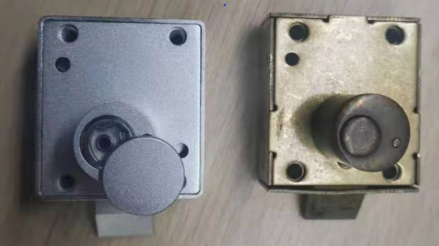

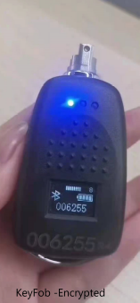


.347
.733"
1.234"
3.134 cm"
2.00"
5.08c
.383"
1.661"
1.734"
.5"
2.25"
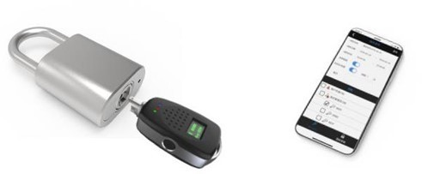
America’s #1 Security Lock

