BlueWARRIOR BlueKey™ Encrypted Bluetooth Smart Locks
Shape Selection
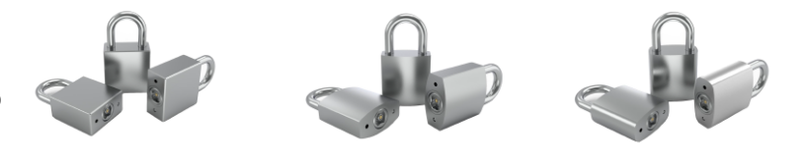 Square Shape Diamond Shape Round Shape
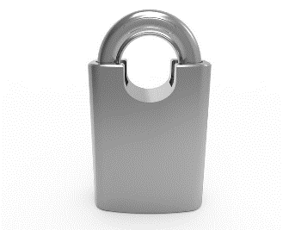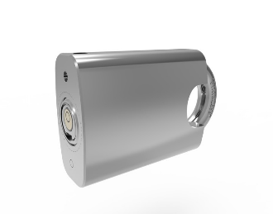
Shoulder Shape – Anti Bolt Cutter (ABC)

FREE Mobile APPLICATION for Android: BlueCloudLock
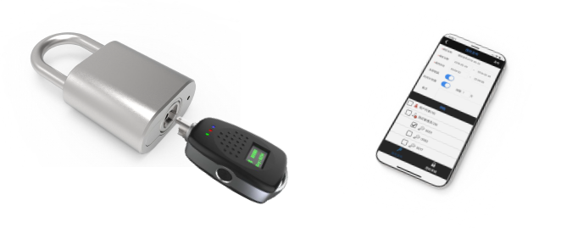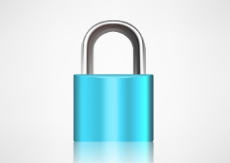

Dimension Selection
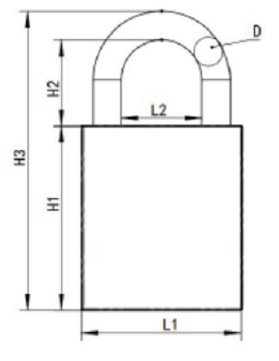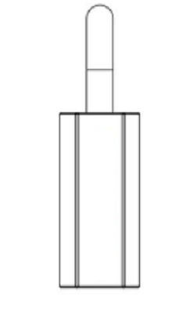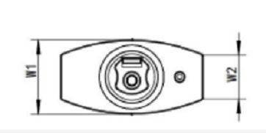
SERIES | Size | L1 | L2 | H1 | H2 | H3 | W1 | W2 | D | Remark
BW400-74/40mm DIAMOND | 40 | 40 | 20 | 42 | 24 | 74 | 21 | 13 | 7 | Diamond/Defaulted
BW500-130/60mm SQUARE | 60 | 60 | 28 | 47 | 77 | 130 | 21 | 21 | 11 | Square
BW500-77/40mm SQUARE | 40 | 40 | 20 | 42 | 24 | 77 | 20 | 20 | 7 | Square
BW400-64/35mm DIAMOND | 35 | 35 | 20 | 40 | 21 | 64 | 16 | 7 | 5 | Diamond
BW600-77/40mm ROUUND | 40 | 40 | 21 | 42 | 30 | 77 | 22 | / | 7 | Round
BW400-74/40mm DIAMOND | 40 | 40 | 21 | 42 | 30 | 77 | 22 | / | 7 | Diamond(Zinc Alloy)

Unit/mm; Main material / 304 stainless steel.
BlueWARRIOR Padlock SERIES Shapes
400 SERIES – DIAMOND
500 SERIES – SQUARE
600 SERIES – ROUND
700 SERIES – Anti-Bolt Cutter (Shouldered)

BlueKey™ Functions & Features:
- The padlock has no power supply and is maintenance-free.
- Smart chip, Bluetooth encrypted communication.
- Meets IP66 level protection.
- Records statistics management, individual lock open & close records.
- Authorization management and detailed statistical management.

BlueKey™ ENCRYPTION & Software Features

- Unique code: a unique identifier 64-bit coded ID.
- Communication Encryption: 64-bit digital password communication encryption, mutual opening rate is 0.
- Opening and closing records: distinguish status of unlocking and locking records.
- Unlocking Sequence: use the original mechanical key, the switch lock position is accurately inserted and then removed.
- Mobile Phone Application: Secure and easy to use phone application. Allows for control and a full audit trail / Update Authority – anywhere and everywhere.
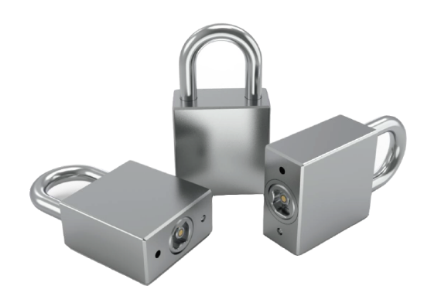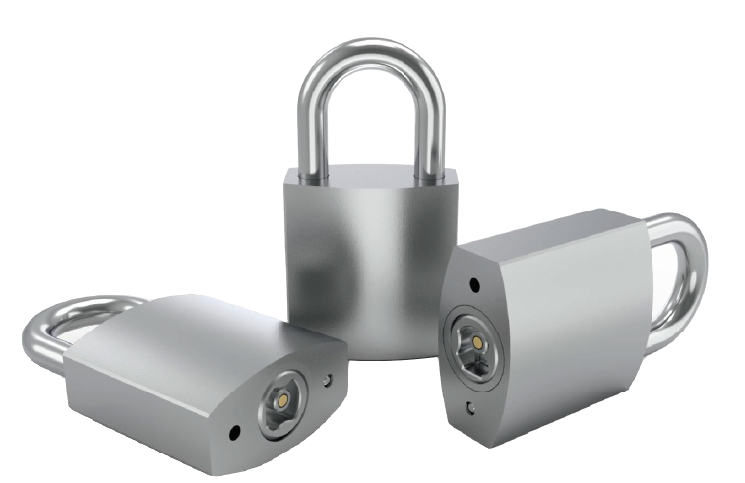

IV Secure Cloud Features

BlueWARRIOR BlueKey™ & IV for Security
IV has adopted security controls and practices for IV Cloud Services that are designed to protect the confidentiality, integrity, and availability of Your Content that is hosted by IV in your IV Cloud Services environment and to protect Your content from any unauthorized processing activities such as loss or unlawful destruction of data. IV continually works to strengthen and improve those security controls and practices.
Each BlueWARRIOR Cyber-Blue customer has their own secure cabinet that secures and isolates customer data and records. Totally encrypted transactions ensure the data integrity and safety of all records for each customer

- Monitoring and mitigation with Cloud Guard and Security Zones
- IV Cloud Infrastructure Identity and Access Management
- Key Management & Security
- Web Application Firewalls - Multiple
- Isolated Network Virtualization
- Root of Trust
- Secure Linux
- NIST Compliance
- Global Footprint with many Regions
- Government Cloud Availability

BlueWARRIOR has partnered with IV Cloud to offer a complete, state of the art, 21st Century, secure & encrypted security system.
America’s most affordable and secure security system!

Key Features
- Small, ruggedized electronic key made with 304 stainless steels for durability.
- Rechargeable Lithium battery – up to 6,000 openings per charge.
- Built-in FULL Encryption
- The BlueWARRIOR key fob contains all access and scheduling data
- Micro-USB connector for data and charging
- Secure Cloud Network, WEB, and mobile phone
- Data Screen, Colored LED’s & BEEP Indicators
- Onboard Encryption Chip
- Unique Encrypted ID – the key cannot be copied or forged
Padlock / Traffic Enclosure Lock Features
- Low Cost
- No wiring required - power is provided by the BlueWARRIOR Key Fob.
- Holds over 6000 Audit Events
- Variety of Padlocks in different shapes & sizes
  - Eliminates Rekeying and Lost keys
  - Full Audit Trail
  - Exact replacement – no modifications or drilling required
  - No Wiring / No Batteries / No Maintenance
  - Waterproof
- Outdoor or Indoor use – 304 stainless steels
- Anti-Bolt Cutter (ABC) Padlocks available
- Traffic Enclosure Lock
  - Eliminates the #2 Key in use in the US – and on eBay
  - Exact replacement – no modifications or drilling required
  - No Wiring / No Batteries / No Maintenance
  - Waterproof
- Padlocks & Traffic Enclosure Locks can work from same key
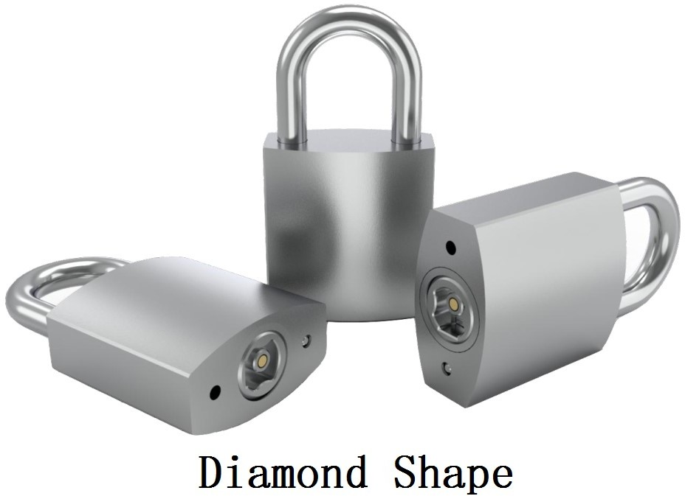
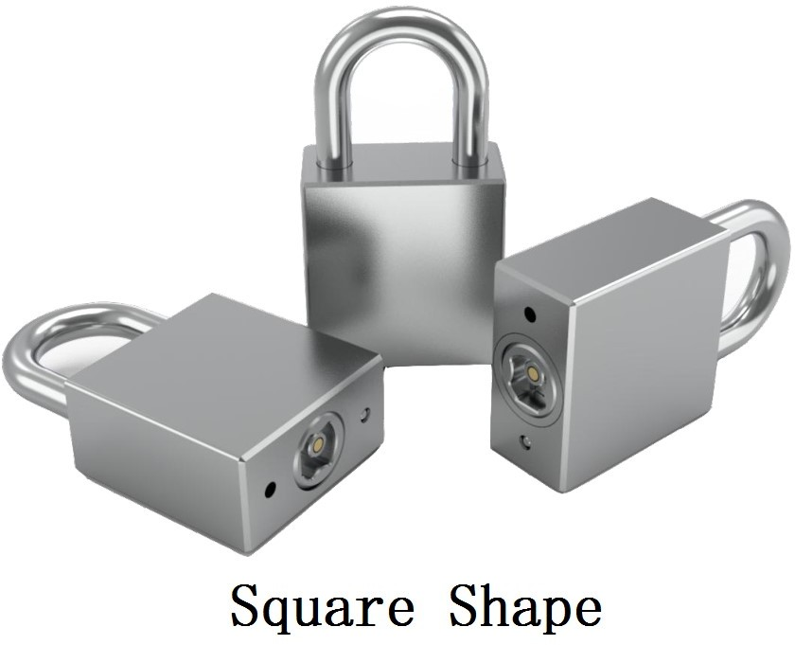

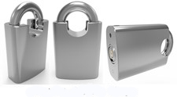
Anti-Bolt Cutter with Shoulders (ABC)
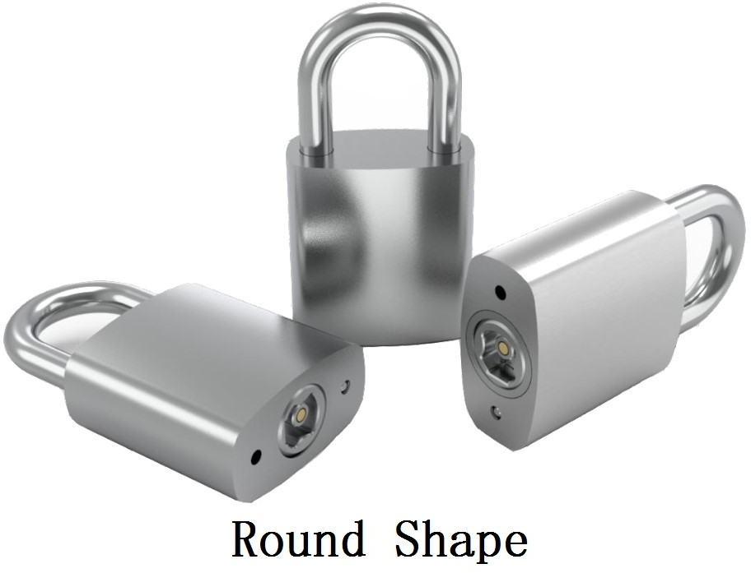

Encrypted – BlueWARRIOR Key Fob & Traffic Enclosure Lock
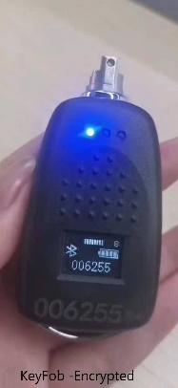

Internal Lock Description & Functions

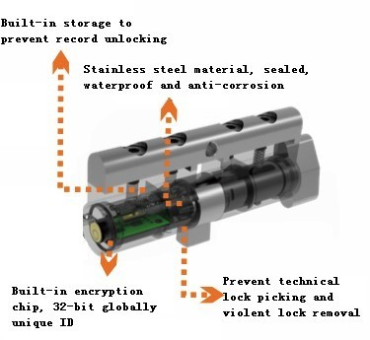

Figure 2-2 Schematic Diagram

Features / Quality Control

Material

The main body is made of Hardened 304 stainless steel.

Structure

The surface of the lock body is smooth and evenly coated. There should be no obvious deformation, cracks, fading, and there should be no defects such as burrs, bubbles, corrosion, scratches, or coating shedding. The interface of each part of the lock body should be exact, firm and reliable. Easily accepting the insertion and extraction of the key within exact tolerances.

Strength

After installation the padlock shell has sufficient mechanical strength and rigidity. After the impact strength of 2.65J and the static pressure test of 110N, no obvious deformation and damage should occur.
The lock beam of the padlock will not be damaged after bearing the axial static pressure of 3000N, and the padlock will still function normally.
When a static tension of 1600N and a torque of 50N·m are applied to the manual parts on the protective surface after being locked, the lock will not open, and the manual parts will not be deformed or damaged.

Torsional stress

The padlock can withstand the following torsional stress (including horizontal and vertical directions) during normal use without deformation or fracture. When the electronic key is turned on, the torsional stress transmitted by the key is 3N·m torque.

Durability

The padlock has been opened and closed for 5000 times under the condition of rated voltage and rated load current. After the test, there is no damage or failure of electrical or mechanical components, and it will be able to work normally.

Enclosure protection level

The enclosure protection level of the padlock meets the requirements of the IP65 Ingress Protection level

Anti-technology Unlocking

The normal working padlock does not appear to open under the action of a strong electric field of 50V/m.
The normal working padlock does not appear to open under the action of a strong magnetic field of 0.5T.

Environmental adaptability

The climatic environment of the padlock is suitable to meet the requirements of varying test conditions.
. See the table below for specific requirements.

Table 1 Environmental Adaptability

project | Test conditions (II)
project | Test requirements | Time  Interval | Status
High  temperature | temperature：70℃±2℃ | 4h | Working  status
Low  temperature | temperature：－25℃±3℃ | 4h | Working  status
Constant  heat & humidity | temperature：40℃±2℃ Relative humidity：93%±3% | 48h
Salt spray | Salt solution concentration：5%±0.1% temperature：35℃±2℃  Spray time：  Spray 15min every 45min Salt fog deposition：  1.0mL/(h·80cm²)~2.0mL/(h·80cm²) | 96h | Working status

Mechanical environment adaptability

The mechanical environmental adaptability of the padlock shall meet the following stringent testing requirements. That is, the mechanical environment adaptability test is carried out in accordance with the provisions of Table 2. Before the test, the padlock is in a normal locked state, after the test, there should be no opening phenomenon and should be able to work normally, the mechanical parts and components in the lock are not loose, and the outer shell is not deformed or damaged.

Table 2 Mechanical Environment Adaptability

Project | Test conditions | Status
Sinusoidal vibration | Frequency range: 10 Hz ~ 150 Hz Acceleration: 5 m/s²  Vibration direction: X, Y, Z three axes Scan rate: 1 oct/min  Number of scan cycles: 1 | Working status
Shock | Acceleration: 150 m/s² Pulse duration: 11ms  Shock pulse waveform: half sine  Number of impact axis: 6 Number of pulses on each axis: 3 | Working status
Free fall | Drop height: 1 m  Number of geometric faces: 6 Number of drops on each side: 1 time With or without packaging: With | Working  status

Stability Testing

The padlock should be energized continuously for 10 days under normal working conditions, and it should be opened and closed no less than 300 times per day. There should be no malfunctions, electrical failures or mechanical failures.

Electronic Lock Cylinder Certification

The Bluetooth key fob realizes the parameter setting and unlocking function of the padlock through the single-contact contact communication with the padlock. The single-point gold-plated current pin inside the lock shall make good contact with the gold-plated layer of the passive lock core to complete the power feed and data transmission. The key can only be removed and inserted at a specific position and angle.
Each lock cylinder has a unique 64-bit coded ID identification and a unique 64-bit communication password, which is used to distinguish different locks and effectively prevent cross-opening.
Table 3 Electrical Characteristics of the electronic lock cylinder

Parameter | Conditions | Min | Max | Unit
Operating  Voltage |  | 3.6 | 4.2 | V



Please Contact us at:
BlueWARRIOR.com
SecurityTransform.com
DYMEC.com
Address: Kansas City, Missouri, USA

Telephone: 816-988-7861

Email:
Sales@BlueWARRIOR.com (Commercial Sales)
Sales@DYMEC.com.cn (Domestic Sales)

Support@BlueWARRIOR.com (Technical & Account Support)
Support@DYMEC.com (Technical & Account Support)
Websites:
www.BlueWARRIOR.com
http://www.SecurityTransform.com
http://www.DYMEC.com

Sales Contacts:
Terry Shelton Thom Sherer
Email: terryshelton909@gmail.com Thom.Sherer@DYMEC.com
Telephone: (303) 229-7068 (713) 826-0739
Golden, Colorado Houston, Texas

Carl Johnson Tom West
Email: carl.johnson@dymec.com twest@dymec.com
Telephone: (512) 635-5630 (816) 214-1946
Dallas, Texas Kansas City, Missouri

