KY-MT1000G-M12 / DYMEC M-12 Series 10 Port, M12 Industrial, Managed PoE+, Super Booster Gigabit Ethernet Switch for Transportation, Railway & Trackside
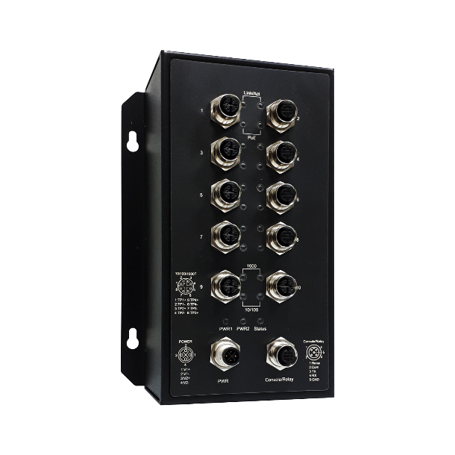 | - Certified EN50155  - 10x 10/100/1000T(x) M12 connector with 8x IEEE 802.3at PoE+  - Built for harsh environments and wide temperature range application  - RSTP, MSTP, ERPS, LACP for Network Redundancy  - QoS CoS/DSCP to increase determinism  - 5 Year / Limited Lifetime Warranty  - Supports IGMP Snooping v1/v2/v3, up to 1023 groups  - DHCP Relay Option 82 for policies IP address assignment  - SNMP v1/v2c/v3 for network management  - Supports Storm Protection  - Support industrial automation protocols Ethernet/IP and Modbus TCP  - Supports PoE PD Alive Check Function for PoE Device Power Recycle  - Superpower Boost for PoE+  




Specifications

Technology
Standards | IEEE 802.3 10BaseT  IEEE 802.3u 100BaseTX  IEEE 802.3ab 1000BaseT  IEEE 802.3x Flow Control  IEEE 802.3af Power over Ethernet  IEEE 802.3at PoE+  IEEE 802.3ad/802.1AX LACP  IEEE 802.1D Spanning Tree Protocol  IEEE 802.1w Rapid STP  IEEE 802.1s Multiple STP  ITU-T G.8032 / Y.1344 ERPS  IEEE 802.1Q VLAN Tagging  IEEE 802.1ad Stacked VLANs  IEEE 802.1p Class of Service  IEEE 802.1X Network Authentication  IEEE 802.1AB LLDP
Processing Type | Store and Forward
Switch Properties
Priority Queues | 8 Queues
Jumbo Frame | 12000bytes
MAC Table Size | 16K
VLAN Table Size | 4094
IGMP Group | 1023
Packet Buffer | 12Mbits
Software Features
Network Redundancy | RSTP, MSTP, G.8032 ERPSv2, Port Trunking with LACP
Security | 802.1X, RADIUS, TACACS+, SSL, SSH
Management | IPv4, IPv6, Web, Telnet, Serial Console, CLI, SNMP v1/v2c/v3, uPnP
Diagnostics | RMON, SNMP Inform/Trap, Syslog, SMTP, Port Mirroring, LLDP
Configuration | DHCP Server/Client, Relay Option 82, TFTP
Filter | 802.1Q VLAN, Q-in-Q, IGMP Snooping v1/v2/v3, IGMP Querier, Independent Vlan Learning
Time Sync. | NTP
QoS | CoS, DSCP, WRR/SPQ Queuing, Storm Protection
PoE | Powering Status, PoE Monitoring, Scheduling, PD Alive Check
Industrial Profiles | Ethernet/IP, Modbus TCP
Interface
Network Connector | 10 x 10/100/1000T(x) M12 Female X-coded 8-pole with 8x PoE+, auto negotiation speed duplex mode, auto MDI/MDI-X
LED Indicators | Per unit: PWR1, PWR2, Status  Ports: Link/Active with highest speed (Green), low speed (Amber)  PoE: Output Power
Alarm Contact | 1 x relay output with current carrying capacity of 1A @ 24 VDC
Serial Console | 1 x RS232 in M12 connector with console cable, 115.2Kbps, 8N1
Power Requirements
Operation Voltage | LV: 24-48 Volts DC, HV: 72-110 Volts DC, redundant dual inputs
Connection | M12 Male S-coded 4-pole
Power Consumption | <15 Watts without PDs' consumption
PoE Power Budget | Maximum 30 Watts per PoE port. Maximum total output power for PD: 190 Watts @24V input.
Protection | Overload Current Protected, Reverse Polarity Protected
Mechanical Construction
Enclosure | SECC
Protection Class | IP54
Dimensions | 143 x 209 x 77 mm (W x H x D)
Weight | 1.90 kg
Mounting | Wall Mounting Kits, Optional DIN-Rail Mounting
Environmental Limits
Operating Temperature | Extended: -40°C ~ 85°C (40°F ~ 176°F)
Storage Temperature | -40°C ~ 85°C (40°F ~ 185°F)
Ambient Relative Humidity | 5 to 95%, (Non-Condensing)
Regulatory Approvals
EMI | FCC Part 15 Subpart B Class A  CE EN 55032 Class A
EMS | IEC61000-4-2 (ESD)  IEC61000-4-3 (RS)  IEC61000-4-4 (EFT)  IEC61000-4-5 (Surge)  IEC61000-4-6 (CS)  IEC61000-4-8 (Magnetic Field)
Free Fall | IEC60068-2-32
Shock | IEC61373
Vibration | IEC61373
Green | RoHS Compliant
Certifications | EN 50155  EN 45545-2
MTBF | >100,000 Hours
Warranty | 5 Years / Limited Lifetime

Note from DYMEC Development
In a continuing effort of improvement and updated technology, product specifications are subject to change without notice.
Dimensions (unit = mm)
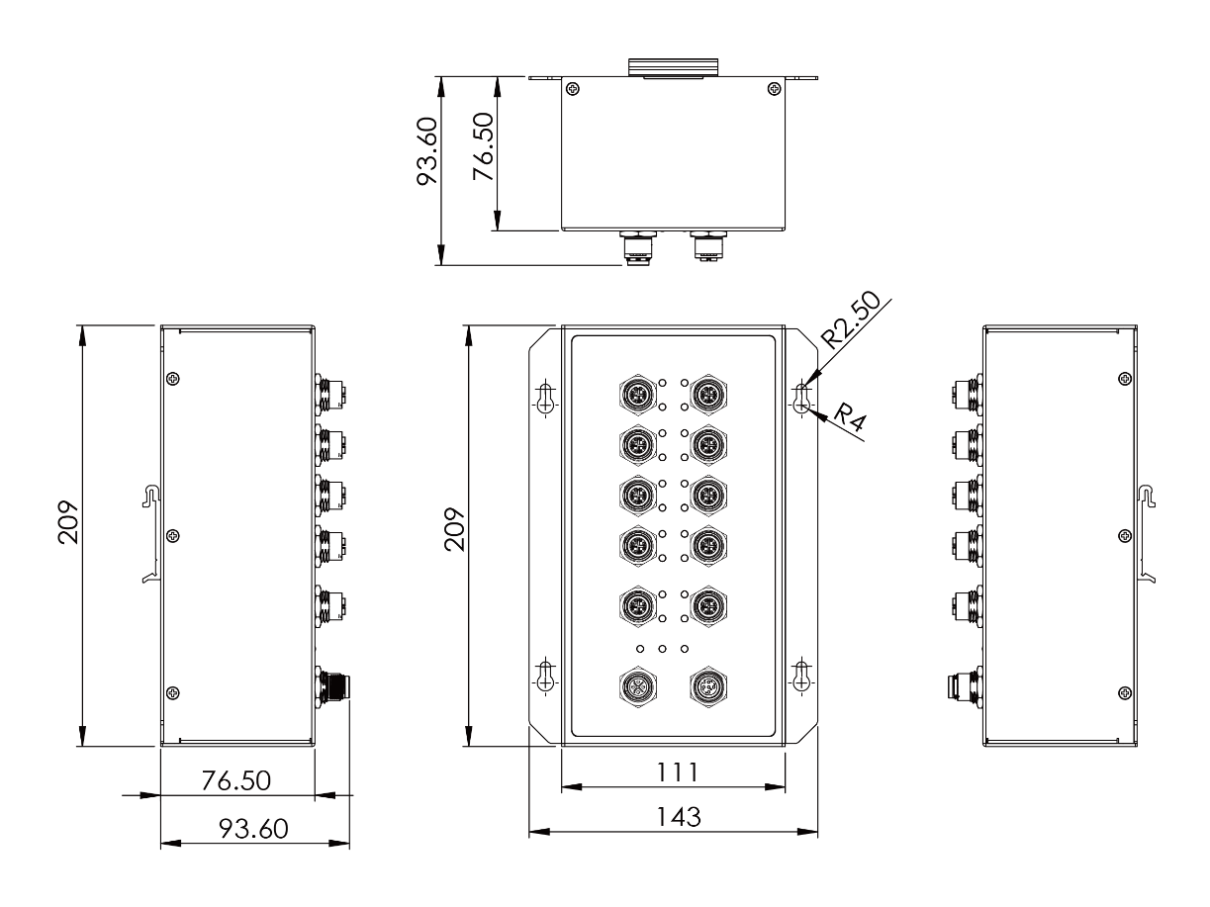

Ordering Information
KY-MT1000G-M12-LV | 10 Port M12 Industrial Managed PoE+ Booster Gigabit Ethernet Switch  - 10 x 10/100/1000T(x) M12 connector with 8 x 30W PSE  - Power Input: 24-48 Volts DC  - Operating Temperature: -40°C ~ 85°C (40°F ~ 176°F)
KY-MT1000G-M12-HV | 10 Port M12 Industrial Managed PoE+ Booster Gigabit Ethernet Switch  - 10 x 10/100/1000T(x) M12 connector with 8 x 30W PSE  - Power Input: 72-110 Volts DC  - Operating Temperature: -40°C ~ 85°C (40°F ~ 176°F)



