Industrial Managed Ethernet Switch User Manual – Layer 3

_______________________________________________________________________________

Firmware Version 1.1.72
User Manual

Compliant: For Military contracts that require the continuous monitoring and protection of industrial control systems (ICS) Networks Operating / monitoring the operating utilities such as Water, Sewer, Electrical, Security, Video, Building Controls, Street, and Intelligent Transportation Systems (ITS).

Uses: Cyber-Lock, IP Device Binding, Cyber-Secure Video, Clean Code Technology, & Secure Console / Chassis (Patent Pending)

Meets NSA Guidelines for Secure Network Endpoints
Models



Copyright DYMEC 2020 – All Rights Reserved

DYMEC Models Covered by This Manual
All Layer 3 Series: | KY-CSxxxx, KY-CPxxxx, KY-CTxxxx

Content

VLAN IP 3
Static Route 5
OSPFv2 8
RIPv1/v2 15
VRRP 21

VLAN IP
We usually configure VLANs to divide broadcast domains in the Local Area Network (LAN). To communicate with others in another VLAN, we need the device to support inter-VLAN routing. Users can use VLANs to create Layer 3 interfaces by assigning IP address in different subnets to the VLAN. Before configuring any kind of routing protocols, users have to make sure the VLAN IP Address is configured.
Configure VLAN IP Address - WEB
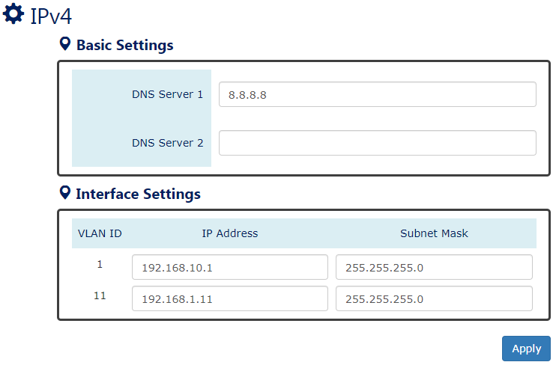
- DNS Server 1 / 2
Specifies the IP address of the DNS Server so that the users can connect to another device based on the URL instead of the IP address.
The default DNS Server 1 is "8.8.8.8". It is provided by Google.
The default DNS Server 2 is BLANK.
- Interface Settings
  - VLAN ID
Users have to create VLAN in the VLAN Settings Page before configure its IP Address.
  - IP Address
Assign a unique static IP Address for the VLAN ID.
The default IP Address for VLAN 1 is "192.168.10.1".
  - Subnet Mask
Define the type of network, to which this device is connected to.
The default Subnet Mask for VLAN 1 is "255.255.255.0".
-  (Apply Button)
After configuring above fields, click "Apply" button to make the changes effective.
Configure VLAN IP Address - CLI
- Configure VLAN IP Address (VLAN Mode)
Cmd: ip address [IP_ADDR] [NETMASK]
- Display VLAN IP Address (VLAN Mode)
Cmd: show ip address
- Remove VLAN IP Address (VLAN Mode)
Cmd: no ip address
- Display All Configured VLAN IP Address (Config Mode)
Cmd: show vlan ip table

Static Route
Static Route is the most basic routing method. Users have to manually-configure routing entries into routing table. Static Route is fixed and unchanged if the Network is changed. Static Route is best to be configured at a gateway of last resort. The Network administrator has the full control over the static routing behavior, so the administrator must have enough background knowledge to fully understand and handle the configuration.
Configure Static Route - WEB
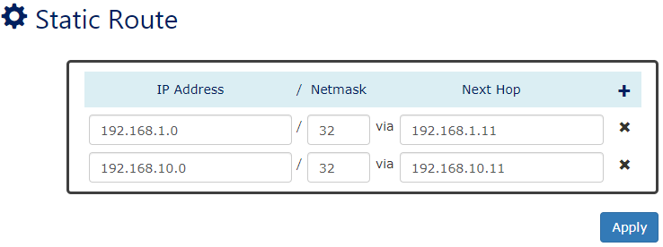
- IP Address
Assign the IP Address to configure the static routing path.
- Netmask
The Netmask is a number mapping to the Subnet Mask. For example, users configure the Netmask to 24 implies to configure the Subnet Mask to 255.255.255.0.
- Next Hop
The Next Hop is an IP Address for a VLAN ID. The Next Hop implies the next node that the packet will be transferred to.
- (Apply Button)
After configuring above fields, click "Apply" button to make the changes effective.
Configure Static Route - CLI
All the following commands are under config mode
- Add Static Route
Cmd: ip route [IP_ADDR] [NETMASK:0-32] [NEXT_HOP]
- Display Static Route
Cmd: show ip route static

- Delete Static Route
Cmd: no ip route [IP_ADDR] [NETMASK:0-32]

Static Route Example
In the following diagram, we are going to configure a topology with Static Route for the system.
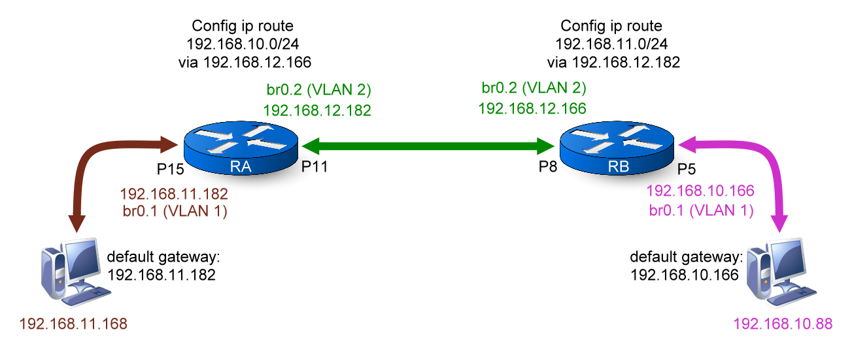
- Configuration for Device RA
Command | Description
Switch> enable | Enter “Privileged mode”
Switch# configure terminal | Enter “Configuration mode”
Switch(config)# vlan 1 | Enter “VLAN mode” for VLAN 1
Switch(config-vlan1)# ip address 192.168.11.182 255.255.255.0 | Configure IP Address to “192.168.11.182” for VLAN 1
Switch(config-vlan1)# vlan 2 | Enter “VLAN mode” for VLAN 2
Switch(config-vlan2)# ip address 192.168.12.182 255.255.255.0 | Configure IP Address to “192.168.12.182” for VLAN 2
Switch(config-vlan2)# member tag 11 | Add Lan11 to VLAN 2 with tagged
Switch(config-vlan2)# exit | Exit “VLAN mode”, back to “Configuration mode”
Switch(config)# ip route 192.168.10.0 24 192.168.12.166 | Configure static router for subnet 192.168.10.0/24.  The next hop is 192.168.12.166

- Configuration for Device RB
Command | Description
Switch> enable | Enter “Privileged mode”
Switch# configure terminal | Enter “Configuration mode”
Switch(config)# vlan 1 | Enter “VLAN mode” for VLAN 1
Switch(config-vlan1)# ip address 192.168.10.166 255.255.255.0 | Configure IP Address to “192.168.10.166” for VLAN 1
Switch(config-vlan1)# vlan 2 | Enter “VLAN mode” for VLAN 2
Switch(config-vlan2)# ip address 192.168.12.166 255.255.255.0 | Configure IP Address to “192.168.12.166” for VLAN 2
Switch(config-vlan2)# member tag 8 | Add Lan8 to VLAN 2 with tagged
Switch(config-vlan2)# exit | Exit “VLAN mode”, back to “Configuration mode”
Switch(config)# ip route 192.168.11.0 24 192.168.12.182 | Configure static router for subnet 192.168.11.0/24.  The next hop is 192.168.12.182

OSPFv2
Open Shortest Path First (OSPF) is one of the dynamic routing protocols and OSPFv2 is for IPv4 Networks. OSPF is the most widely used interior Gateway Protocol (IGP) and it is designed for medium-and-large-scale enterprise networks. OSPF nodes exchange neighbors’ information by Link-State and calculate the shortest path with their Cost to transmit packets. OSPF is operating under a hierarchical system and divide the system to several Areas by different Area IDs. OSPF nodes only exchange information with the nodes in the same Area.
Configure OSPFv2 – WEB
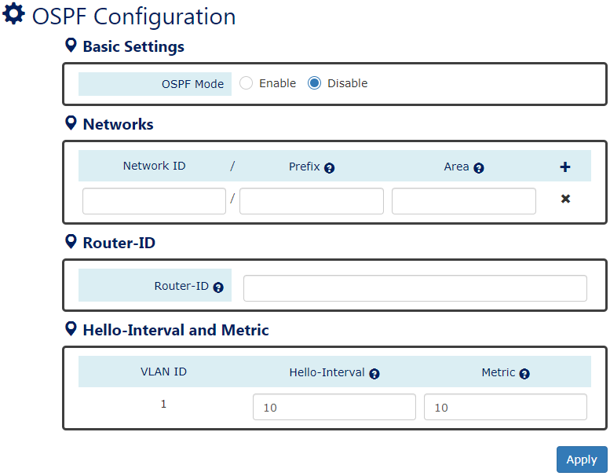
For more information, hover the mouse over the icon in the system.
- OSPF Mode
“Enable” or “Disable” OSPFv2 Function. The OSPFv2 function is default disabled.
Please make sure the status of RIP is Disabled before Enable OSPFv2 function.
- Networks
  - Network ID
The Networks ID implies the first IP Address of the subnet that will join the OSPF routing.
  - Prefix
The Prefix is a number mapping to the Subnet Mask. For example, users configure the Prefix to 24 implies to configure the Subnet Mask to 255.255.255.0.
The range of Prefix is from 0 to 32.
  - Area
The Area is an identify and only the nodes in the same area will exchange the OSPF information with each other. The Area 0 is a special area, and also called Backbone Area. All other areas must connect to the backbone area.
The range of Area is from 0 to 4294967295.
: Click the plus icon to add an OSPF entry.
: Click the remove icon to delete the OSPF entry.
- Router-ID
The Router-ID implies the identity for the working OSPFv2.
The format of Router-ID is A.B.C.D.
- Hello Interval
The Hello Interval is the period to send “Hello Message” to OSPF neighbors.
The range of Hello Interval is from 1 to 65535 second(s).
The default Hello Interval is 10 seconds.
- Metric
The Metric is the total cost of the path from source device to destination device.
The range of Metric is from 1 to 65535.
The default Metric is 10.
- (Apply Button)
After configuring above fields, click "Apply" button to make the changes effective.

OSPFv2 Status
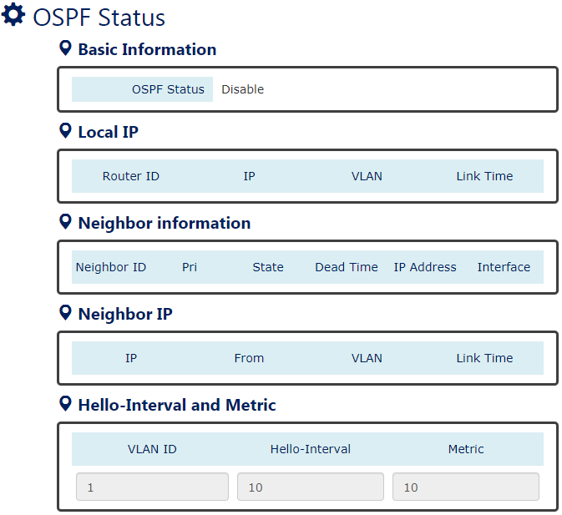
- OSPF Mode
Display the state (“Enable” or “Disable”) of OSPF function.
- Local IP
Display the information that configured on the localhost for OSPFv2.
- Neighbor Information
Display the status of the neighborhood.
- Neighbor IP
Display the information that learned from OSPF neighbors.
- Hello Interval
Display the Hello Interval value of designated VLAN.
- Metric
Display the Metric of designated VLAN.
Configure OSPFv2 - CLI
All the following commands are under Config Mode
- Enable OSPF Function
Cmd: router ospf enable
- Disable OSPF Function
Cmd: no router ospf
- Display OSPF Running State
Cmd: show router ospf mode
- Configure OSPF Router ID
Cmd: router ospf router-id [ROUTER_ID]
- Display OSPF Router ID
Cmd: show router ospf router-id
- Clear OSPF Router ID
Cmd: no router ospf router-id
- Configure OSPF Network
Cmd: router ospf network [IP_ADDR] [NETMASK:0-32] [AREA_ID]
- Display OSPF Network
Cmd: show router ospf network
- Remove OSPF Network Rule for Specific Subnet
Cmd: no router ospf network [IP_ADDR] [NETMASK:0-32]
- Enable OSPF Authentication with Text on Specific Area
Cmd: router ospf authentication area [AREA_ID]
- Enable OSPF Authentication with MD5 on Specific Area
Cmd: router ospf authentication message-digest area [AREA_ID]
- Display OSPF Authentication State
Cmd: show router ospf authentication
- Disable OSPF Authentication on Specific Area
Cmd: no router ospf authentication area [AREA_ID]
- Display OSPF Operation Status
Cmd: show router ospf
- Display OSPF Neighbors’ Status
Cmd: show router ospf neighbor
All the following commands are under VLAN Mode
- Configure OSPF Hello Interval
Cmd: ip ospf hello-interval [1-65535]
The default OSPF Hello Interval is 10 seconds.
- Display OSPF Hello Interval
Cmd: show ip ospf hello-interval
- Clear OSPF Hello Interval
Cmd: no ip ospf hello-interval
- Configure OSPF Dead Interval
Cmd: ip ospf dead-interval [1-65535]
The default OSPF Dead Interval is 4 times hello interval.
- Display OSPF Dead Interval
Cmd: show ip ospf dead-interval
- Clear OSPF Dead Interval
Cmd: no ip ospf dead-interval
- Enable OSPF Authentication with Text on Specific VLAN
Cmd: ip ospf authentication
- Enable OSPF Authentication with MD5 on Specific VLAN
Cmd: ip ospf authentication message-digest
- Display OSPF Authentication State
Cmd: show ip ospf authentication
- Disable OSPF Authentication on Specific VLAN
Cmd: no ip ospf authentication
- Configure OSPF Authentication Password
Cmd: ip ospf authentication-key [PASSWD]
- Display OSPF Authentication Password
Cmd: show ip ospf authentication-key
- Clear OSPF Authentication Password
Cmd: no ip ospf authentication-key
- Configure OSPF MD5 Authentication Password
Cmd: ip ospf message-digest-key [KEY_ID] md5 [PASSWD]
- Display OSPF MD5 Authentication Password
Cmd: show ip ospf message-digest-key
- Clear OSPF MD5 Authentication Password
Cmd: no ip ospf message-digest-key [KEY_ID]
OSPFv2 Example
In the following diagram, we are going to configure a topology with Dynamic Routing – OSPFv2 for the system. Use the following commands to check the link state after configurations are completed:
  - show router ospf
  - show router ospf neighbor
  - show ip route
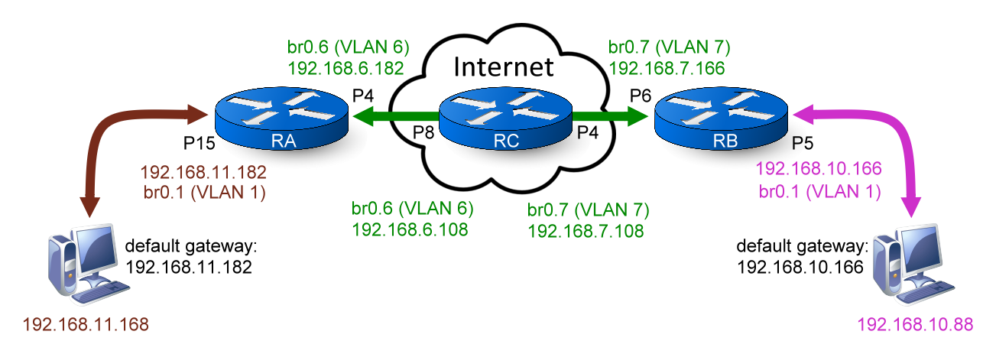
*Simulation Internet through RC.*
- Configuration for RA
Command | Description
Switch> enable | Enter “Privileged mode”
Switch# configure terminal | Enter “Configuration mode”
Switch(config)# vlan 1 | Enter “VLAN mode” for VLAN 1
Switch(config-vlan1)# ip address 192.168.11.182 255.255.255.0 | Configure IP Address to “192.168.11.182” for VLAN 1
Switch(config-vlan1)# vlan 6 | Enter “VLAN mode” for VLAN 6
Switch(config-vlan6)# ip address 192.168.6.182 255.255.255.0 | Configure IP Address to “192.168.6.182” for VLAN 6
Switch(config-vlan6)# member tag 4 | Add Lan4 to VLAN6 with tagged
Switch(config-vlan6)# exit | Exit “VLAN mode”, back to “Configuration mode”
Switch(config)# router ospf router-id 0.0.0.1 | Configure OSPF router id to 0.0.0.1
Switch(config)# router ospf network 192.168.11.0 24 0 | Configure subnet 192.168.11.0/24 to join OSPF network area 0
Switch(config)# router ospf network 192.168.6.0 24 0 | Configure subnet 192.168.6.0/24 to join OSPF network area 0
Switch(config)# router ospf enable | Enable OSPFv2 function on RA

- Configuration for RB
Command | Description
Switch> enable | Enter “Privileged mode”
Switch# configure terminal | Enter “Configuration mode”
Switch(config)# vlan 1 | Enter “VLAN mode” for VLAN 1
Switch(config-vlan1)# ip address 192.168.10.166 255.255.255.0 | Configure IP Address to “192.168.10.166” for VLAN 1
Switch(config-vlan1)# vlan 7 | Enter “VLAN mode” for VLAN 7
Switch(config-vlan7)# ip address 192.168.7.166 255.255.255.0 | Configure IP Address to “192.168.7.166” for VLAN 7
Switch(config-vlan7)# member tag 6 | Add Lan6 to VLAN 7 with tagged
Switch(config-vlan7)# exit | Exit “VLAN mode”, back to “Configuration mode”
Switch(config)# router ospf router-id 0.0.0.2 | Configure OSPF router id to 0.0.0.2
Switch(config)# router ospf network 192.168.10.0 24 0 | Configure subnet 192.168.10.0/24 to join OSPF network area 0
Switch(config)# router ospf network 192.168.7.0 24 0 | Configure subnet 192.168.7.0/24 to join OSPF network area 0
Switch(config)# router ospf enable | Enable OSPFv2 function on RB

- Configuration for RC
Command | Description
Switch> enable | Enter “Privileged mode”
Switch# configure terminal | Enter “Configuration mode”
Switch(config)# vlan 1 | Enter “VLAN mode” for VLAN 1
Switch(config-vlan1)# ip address 192.168.3.108 255.255.255.0 | Configure IP Address to “192.168.3.108” for VLAN 1
Switch(config-vlan1)# vlan 6 | Enter “VLAN mode” for VLAN 6
Switch(config-vlan6)# ip address 192.168.6.108 255.255.255.0 | Configure IP Address to “192.168.6.108” for VLAN 6
Switch(config-vlan6)# member tag 8 | Add Lan8 to VLAN6 with tagged
Switch(config-vlan6)# vlan 7 | Enter “VLAN mode” for VLAN 7
Switch(config-vlan7)# ip address 192.168.7.108 255.255.255.0 | Configure IP Address to “192.168.7.108” for VLAN 7
Switch(config-vlan7)# member tag 4 | Add Lan4 to VLAN 7 with tagged
Switch(config-vlan7)# exit | Exit “VLAN mode”, back to “Configuration mode”
Switch(config)# router ospf router-id 0.0.0.3 | Configure OSPF router id to 0.0.0.3
Switch(config)# router ospf network 192.168.6.0 24 0 | Configure subnet 192.168.6.0/24 to join OSPF network area 0
Switch(config)# router ospf network 192.168.7.0 24 0 | Configure subnet 192.168.7.0/24 to join OSPF network area 0
Switch(config)# router ospf enable | Enable OSPFv2 function on RC

RIPv1/v2
Routing Information Protocol (RIP) is another dynamic routing protocol for a small-scale Network. RIP uses Distance Vector to determine the routing path. The best path for RIP is the least hops during transmission. This is also the weakness of RIP because the path with least hops might not be the fastest path.
The RIP members broadcast their routing table to each other every 30 seconds to synchronize the Network and maintain the routing paths to be the least hops. The max number of hops that can be transferred between two nodes (routers) is 15. This is why the RIP function is only suitable for a small Network.
Configure RIPv1/v2 - WEB

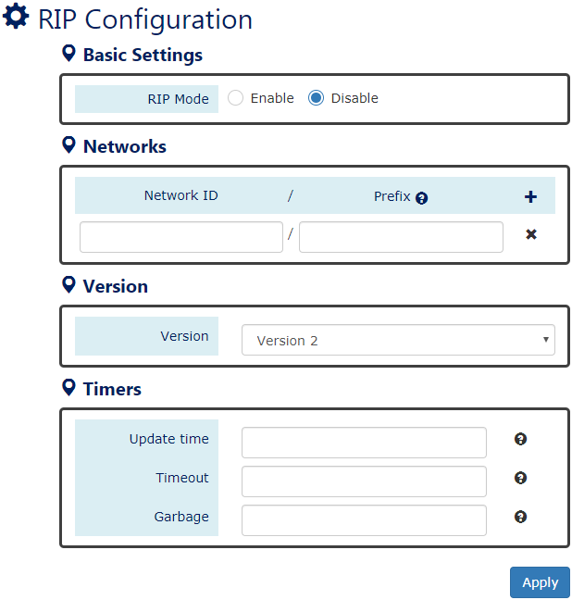
- RIP Mode
“Enable” or “Disable” RIP Function. The RIP function is default disabled.
Please make sure the status of OSPFv2 is Disabled before Enable RIP function.
- Networks
  - Network ID
The Networks ID implies the first IP Address of the subnet that will join the RIP routing.
  - Prefix
The Prefix is a number mapping to the Subnet Mask. For example, users configure the Prefix to 24 implies to configure the Subnet Mask to 255.255.255.0.
The range of Prefix is from 0 to 32.
- Version
Configure the Version of RIP. We support RIPv2 by default but users can configure the version to support RIPv1.
- Timers
  - Update Time
The Update Time is the interval to send broadcast for updating routing table with other routers in the same RIP Network.
The range of Update Time is from 5 to 2147483647.
The default Update Time is 30 seconds.
  - Timeout
The Timeout value is also called Aging Time. It will be count down from configured value until 0. If the system received a packet with the same RIP path, the Aging Time will be reset to the initial configured value and count down again. If the Aging Time is counting down to 0, the routing entry will be deleted from the routing table.
The range of Timeout is from 5 to 2147483647.
The default Timeout is 180 seconds.
  - Garbage
The Garbage-Collection Timer is used for a newly created routing path. When a new routing path is built, the timer creates and counts down. The routing path will be discarded if the timer is 0.
The range of Garbage is from 5 to 2147483647.
The default Garbage is 120 seconds.

RIPv1/v2 Status
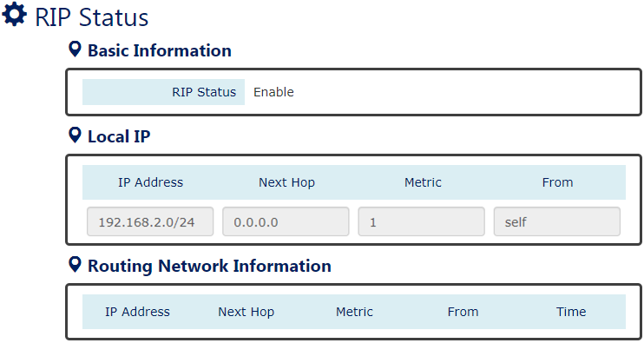
- RIP Status
Display the state (“Enable” or “Disable”) of RIP function.
- Local IP
Display the information that configured on the localhost for RIP.
- Routing Network Information
Display the routing information that exchanges with other routers.

Configure RIPv1/v2 - CLI
All the following commands are under Config Mode
- Enable RIP Function
Cmd: router rip enable
- Disable RIP Function
Cmd: no router rip
- Display RIP Running State
Cmd: show router rip mode
- Configure RIP Neighbor IP Address
Cmd: router rip neighbor [IP_ADDR]
- Remove RIP Neighbor IP Address
Cmd: no router rip neighbor [IP_ADDR]
- Configure RIP Network
Cmd: router rip network [IP_ADDR] [NETMASK: 0-32]
- Display RIP Network
Cmd: show router rip network
- Remove RIP Network Rule for Specific Subnet
Cmd: no router rip network [IP_ADDR] [NETMASK: 0-32]
- Configure RIP Timers
Cmd: router rip timers [UPDATE_TIMER] [TIMEOUT] [GARBAGE]
Note: the range of timers is [5- 2147483647]
- Clear RIP Timers
Cmd: no router rip timers
- Configure RIP Version
Cmd: router rip version [1|2]
- Clear RIP Version
Cmd: no router rip version
- Display RIP Routing Table
Cmd: show router rip state
- Display RIP Operation Status
Cmd: show router rip status

RIP Example
In the following diagram, we are going to configure a topology with Dynamic Routing – RIP for the system. Use the following commands to check the link state after configurations are completed:
  - show router rip status
  - show router rip state
  - show ip route
*Simulation Internet through RC.*
- Configuration for RA
Command | Description
Switch> enable | Enter “Privileged mode”
Switch# configure terminal | Enter “Configuration mode”
Switch(config)# vlan 1 | Enter “VLAN mode” for VLAN 1
Switch(config-vlan1)# ip address 192.168.11.182 255.255.255.0 | Configure IP Address to “192.168.11.182” for VLAN 1
Switch(config-vlan1)# vlan 6 | Enter “VLAN mode” for VLAN 6
Switch(config-vlan6)# ip address 192.168.6.182 255.255.255.0 | Configure IP Address to “192.168.6.182” for VLAN 6
Switch(config-vlan6)# member tag 4 | Add Lan4 to VLAN6 with tagged
Switch(config-vlan6)# exit | Exit “VLAN mode”, back to “Configuration mode”
Switch(config)# router rip network 192.168.11.0 24 0 | Configure subnet 192.168.11.0/24 to join RIP network
Switch(config)# router rip network 192.168.6.0 24 0 | Configure subnet 192.168.6.0/24 to join RIP network
Switch(config)# router rip enable | Enable RIP function on RA

- Configuration for RB
Command | Description
Switch> enable | Enter “Privileged mode”
Switch# configure terminal | Enter “Configuration mode”
Switch(config)# vlan 1 | Enter “VLAN mode” for VLAN 1
Switch(config-vlan1)# ip address 192.168.10.166 255.255.255.0 | Configure IP Address to “192.168.10.166” for VLAN 1
Switch(config-vlan1)# vlan 7 | Enter “VLAN mode” for VLAN 7
Switch(config-vlan7)# ip address 192.168.7.166 255.255.255.0 | Configure IP Address to “192.168.7.166” for VLAN 7
Switch(config-vlan7)# member tag 6 | Add Lan6 to VLAN 7 with tagged
Switch(config-vlan7)# exit | Exit “VLAN mode”, back to “Configuration mode”
Switch(config)# router rip network 192.168.10.0 24 0 | Configure subnet 192.168.10.0/24 to join RIP network
Switch(config)# router rip network 192.168.7.0 24 0 | Configure subnet 192.168.7.0/24 to join RIP network
Switch(config)# router rip enable | Enable RIP function on RB

- Configuration for RC
Command | Description
Switch> enable | Enter “Privileged mode”
Switch# configure terminal | Enter “Configuration mode”
Switch(config)# vlan 1 | Enter “VLAN mode” for VLAN 1
Switch(config-vlan1)# ip address 192.168.3.108 255.255.255.0 | Configure IP Address to “192.168.3.108” for VLAN 1
Switch(config-vlan1)# vlan 6 | Enter “VLAN mode” for VLAN 6
Switch(config-vlan6)# ip address 192.168.6.108 255.255.255.0 | Configure IP Address to “192.168.6.108” for VLAN 6
Switch(config-vlan6)# member tag 8 | Add Lan8 to VLAN6 with tagged
Switch(config-vlan6)# vlan 7 | Enter “VLAN mode” for VLAN 7
Switch(config-vlan7)# ip address 192.168.7.108 255.255.255.0 | Configure IP Address to “192.168.7.108” for VLAN 7
Switch(config-vlan7)# member tag 4 | Add Lan4 to VLAN 7 with tagged
Switch(config-vlan7)# exit | Exit “VLAN mode”, back to “Configuration mode”
Switch(config)# router rip network 192.168.6.0 24 0 | Configure subnet 192.168.6.0/24 to join RIP network
Switch(config)# router rip network 192.168.7.0 24 0 | Configure subnet 192.168.7.0/24 to join RIP network
Switch(config)# router rip enable | Enable RIP function on RC

VRRP
Virtual Router Redundancy Protocol (VRRP) is a function to avoid single point of failure in the static default routed environment. There are two or more routers in a VRRP group to backup each other. They share the same virtual IP address in the Network and one of them called Master provides routing services for other devices. Others in the same VRRP group are Backup routers. When the Master router is broken, the Backup routers will replace the original Master router based on their Priority value. The router with the highest Priority value will be the next Master, so that the routing can be uninterrupted.
Configure VRRP – WEB
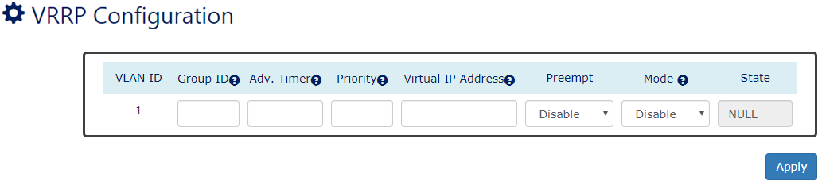
For more information, hover the mouse over the icon in the system.
- VLAN ID
Display the current VLAN ID that is configured with members and IP Address.
- Group ID
The Group ID is the identity for the VRRP Group. All routers in the same VRRP group MUST be configured with the same Group ID.
The range of Group ID is from 1 to 255
- Adv. Timer
The timer is the period to send Advertisement to make sure the Master is still alive. The Master route will be changed if other Backup routers miss Advertisement message after the timer expired to make sure the continuous services.
The range of Adv. Timer is from 1 to 60 seconds
- Priority
The Priority is used to decide the Master in the VRRP group.
The range of Priority is from 1 to 254
Note: the higher the value the higher the priority
- Virtual IP Address
The Virtual IP Address is a public IP Address in the Network. All routers in the same VRRP group are configured with the same Virtual IP Address.
Note: The Virtual IP Address has to be configured different from VLAN IP Addresses.
- Preempt
“Enable” or “Disable” Preempt Mode. When the Preempt Mode is disabled, other VRRP routers are not allowed to preempt the Master role.
- Mode
“Enable” or “Disable” VRRP function on this VLAN.
Note: Users have to configure all VRRP parameters before enable VRRP function.
- State
There are four states for the VRRP
Master: This is a major router that provides services in the VRRP group.
Backup: This is a backup router in the VRRP group. When the VRRP Master is broken, the backup router will provide services.
Init: VRRP function is under initialization.
NULL: VRRP function is disabled.

Configure VRRP – CLI
All the following commands are under Config Mode
- Display All VRRP Configuration Information
Cmd: show vrrp-config
All the following commands are under VLAN Mode
- Display All VRRP Configurations
Cmd: show vrrp all
- Disable VRRP and Remove All VRRP Configuration
Cmd: no vrrp all
- Set Advertise Interval Timer of VRRP
Cmd: vrrp adv-timer [1-60]
- Display Advertise Interval Timer of VRRP
Cmd: show vrrp adv-timer
- Disable VRRP and Remove Advertise Interval Timer of VRR
Cmd: no vrrp adv-timer
- Enable VRRP Function
Cmd: vrrp enable
- Display State of VRRP
Cmd: show vrrp state
- Disable VRRP
Cmd: no vrrp state
- Set Virtual Group ID of VRRP
Cmd: vrrp group-id [1-255]
- Display Virtual Group ID of VRRP
Cmd: show vrrp group-id
- Disable VRRP and Remove Virtual Group ID of VRRP
Cmd: no vrrp group-id
- Set Virtual Server IP of VRRP
Cmd: vrrp ip-address [Virtual IP address]
- Display Virtual IP of VRRP
Cmd: show vrrp ip-address
- Disable VRRP and Remove Virtual IP of VRRP
Cmd: no vrrp ip-address
- Enable Preemption Mode of VRRP
Cmd: vrrp preempt
- Display Preemption Mode of VRRP
Cmd: show vrrp preempt
- Disable Preemption Mode of VRRP
Cmd: no vrrp preempt
- Set Priority of VRRP
Cmd: vrrp priority [1-254]
- Display Priority of VRRP
Cmd: show vrrp priority
- Disable VRRP and Remove Priority of VRRP
Cmd: no vrrp priority

