KY-MTX0804 / DYMEC MTG Series
8+4 Port, Industrial, Managed, PoE+ Booster, Ethernet Switch with 10 GbE Uplinks, Low Power / NSA Endpoint Certified with ERPsv2

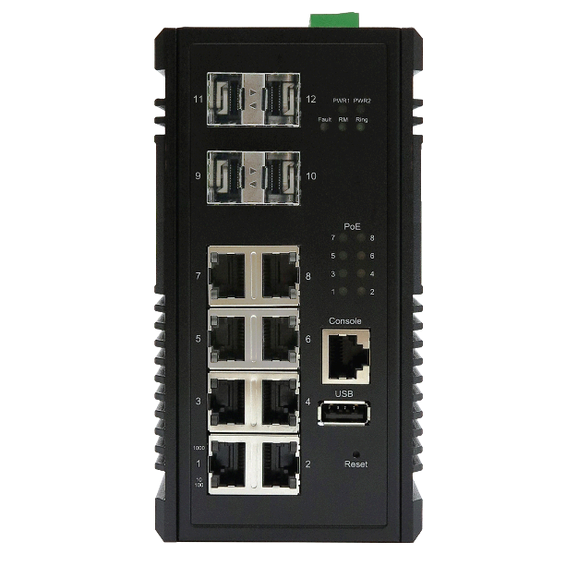 | - 8 x Gigabit Ethernet ports with IEEE 802.3at PoE+  (30 Watt)  - 4 x 1 / 10 Gigabit Ethernet SFP+ Slots  - Built for harsh environments and wide temperature range applications  - G. 8032 ERPsv2, RSTP, MSTP, ERPS, LACP for Network Redundancy  - QoS CoS/DSCP to increase determinism  - Supports IGMP Snooping v1/v2/v3, up to 1023 groups  - DHCP Relay Option 82 for policies IP address assignment  - SNMP v1/v2c/v3 for network management  - Supports Storm Protection  - USB storage for configuration-free replacement  - Support industrial automation protocols Ethernet/IP and Modbus TCP  - Supports PoE PD Alive Check Function for PoE Device Power Recycle  - Power Boost for PoE+  - 5 Year Warranty  
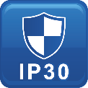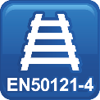

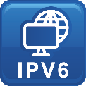


Specifications

Technology
Standards | IEEE 802.3 10BaseT  IEEE 802.3u 100BaseTX  IEEE 802.3ab 1000BaseT  IEEE 802.3ae 10GBase over Fiber  IEEE 802.3x Flow Control  IEEE 802.3af Power over Ethernet  IEEE 802.3at PoE+  IEEE 802.3ad/802.1AX LACP  IEEE 802.1D Spanning Tree Protocol  IEEE 802.1w Rapid STP  IEEE 802.1s Multiple STP  ITU-T G.8032 / Y.1344 ERPS  IEEE 802.1Q VLAN Tagging  IEEE 802.1ad Stacked VLANs  IEEE 802.1p Class of Service  IEEE 802.1X Network Authentication  IEEE 802.1AB LLDP  IEEE 1588 PTP
Processing Type | Store and Forward
Switch Properties
Priority Queues | 8 Queues
Jumbo Frame | 9216bytes
MAC Table Size | 16K
VLAN Table Size | 4094
IGMP Group | 1023
Packet Buffer | 12Mbits
Software Features
Network Redundancy | RSTP, MSTP, G.8032 ERPSv2, Port Trunking with LACP
Security | 802.1X, RADIUS, TACACS+, SSL, SSH
Management | IPv4, IPv6, Web, Telnet, Serial Console, CLI, SNMP v1/v2c/v3, uPnP
Diagnostics | RMON, SNMP Inform/Trap, Syslog, SMTP, Port Mirroring, LLDP
Configuration | DHCP Server/Client, Relay Option 82, TFTP, USB
Filter | 802.1Q VLAN, Q-in-Q, IGMP Snooping v1/v2/v3, IGMP Querier, Independent Vlan Learning
Time Sync. | NTP, IEEE1588v2 OC (Software Timestamp)
QoS | CoS, DSCP, WRR/SPQ Queuing, Storm Protection
PoE | Powering Status, PoE Monitoring, Scheduling, PD Alive Check
Industrial Profiles | Ethernet/IP, Modbus TCP
Interface
RJ45 Port | 8 x 10/100/1000T(x) with PoE+, auto negotiation speed duplex mode, auto MDI/MDI-X
Fiber Port | 4 x 1/10 Gigabit Ethernet SFP+ Slots
PoE Pin Out | V+, V+, V-, V-, for pin 1, 2, 3, 6, End-span, MDI Mode A
LED Indicators | Per unit: PWR1, PWR2, Fault, Ring Master, Ring State  Ports: Link/Active with highest speed(Green), low speed(Amber)  PoE: Output Power
Alarm Contact | 1 x relay output with current carrying capacity of 1A @ 24 Volts DC
Digital Inputs | 1 x isolated input from the electronics.  +13 to +30 Volts for state "1"  -30 to +3 Volts for state "0"  Maximum input current: 8mA
Button | Multiple functions reset button
Serial Console | 1 x RS232 in RJ45 connector with console cable, 115.2Kbps, 8N1
Storage | 1 x USB 2.0 storage for firmware update, configuration backup, restore, boot up and syslog
Power Requirements
Operation Voltage | 12-57 Volts DC, redundant dual inputs, >50 Volts DC for PoE+ output recommended
Connection | 1 x removable 4-contact terminal block
Power Consumption | 0.90A@24 Volts DC without PDs' consumption
PoE Power Budget | Maximum 30 Watts per PoE port. Maximum total output power for PD: 190 Watts @24 Volts input, 90 Watts @12 Volts input.
Protection | Overload Current Protected, Reverse Polarity Protected
Mechanical Construction
Enclosure | Military Grade – Structural Aluminum
Protection Class | IP30
Dimensions | 72 x 145 x 118 mm (W x H x D)
Weight | 1.04 kg
Mounting | DIN-Rail Mounting, Optional Wall Mounting Kits
Environmental Limits
Operating Temperature | Extended: -40°C ~ 80°C (-40°F ~ 176°F)
Storage Temperature | -40°C ~ 85°C (-40°F ~ 185°F)
Ambient Relative Humidity | 5 to 95%, (Non-Condensing)
Regulatory Approvals
Altitude – GB4943.1-2011 | 0 ~ 5000 Meters
EMI | CE EN 55032 Class A
EMS | IEC61000-4-2 (ESD)  IEC61000-4-3 (RS)  IEC61000-4-4 (EFT)  IEC61000-4-5 (Surge)  IEC61000-4-6 (CS)  IEC61000-4-8 (Magnetic Field)
Free Fall | IEC60068-2-32
Shock | IEC60068-2-27
Vibration | IEC60068-2-6
Green | RoHS Compliant
Certifications | UL 60950-1/62368  IEC 61000-6-2 / FCC / UL / ITUT  IEC 61000-6-4 / NEMA TS-2  EN 50121-4
MTBF | >100,000 hours
Warranty  TAA Compliant | 5 Years / Limited Lifetime  Certified TAA Compliant

Note from DYMEC Development.
In a continuing effort of improvement and updated technology, product specifications are subject to change without notice.

Dimensions (unit = mm)
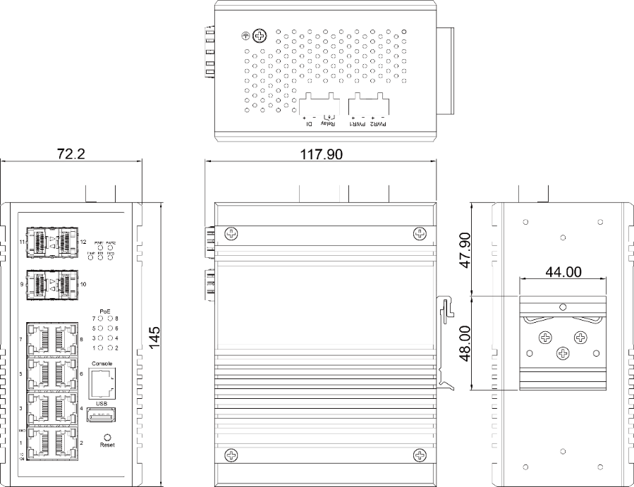

DYMEC Supports: 2 & 4 Wire LONG RANGE ETHERNET / VDSL2 SFP Modem
With long reach coverage, high noise immunity, and compact board size, DYMEC KY-Pro-180-CRD Ruggedized SFP modem is an ideal upgrade for your Enterprise or Industry applications. Used in Pairs.

VDSL2 – Long Range Ethernet Application (KY-Pro-180-CRD)
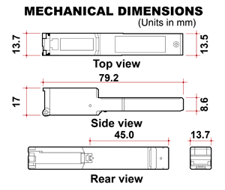 | 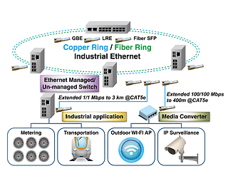

DYMEC KY-SFP-T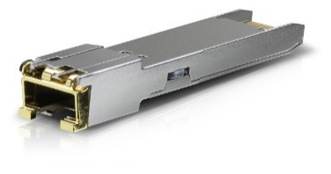
Copper SFP Transceiver – Used to Add Additional RJ-45 Copper Ports to your KY-3170 Series Switch
Easy to Install & Configure – GUI Selectable

Ordering Information
KY-MTX0804 | 8+4 Port Industrial Managed PoE+ Booster Ethernet Switch with 1 / 10 GbE Uplinks  - 8x 10/100/1000T(x) with 30W PSE + 4 x 1/10 Gigabit Ethernet SFP+ Slots  - Operating Temperature: -40°C ~ 80°C (-40°F ~ 176°F)  NSA Guideline Certified for Console Port Shutdown and Chassis Full Security
DYMEC – Temperature Hardened, American Made, Ruggedized, NSA Certified Endpoint, Industrial Ethernet Switches / Routers for SCADA, ITS, Transportation, Automation, Power Utilities, Edge Computing, AI and Industrial Control Systems. Made in USA. Cyber-Secure, TAA Compliant. Uses SFP’s / BiDi SFP’s / Mini Gbic & VDSL2 Industrial SFP for Long Range Ethernet.


