KY-MSG2404 / DYMEC G Series
16+8+4 Port Industrial, Managed, Temperature Hardened, Gigabit, Rackmount, Combo Ethernet Switch with ERPS & NSA Certified Endpoint

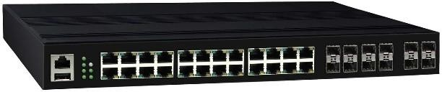    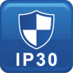 | - 16 x Gigabit Ethernet RJ-45  - 8 x Gigabit combo Ethernet (SFP & RJ-45)  - 4 x 1000 SFP Slots  - NSA Network Endpoint Guideline Certified for Console Port Shutdown and Chassis Full Security (Patent Pending)  - Harsh environment & wide temperature range  - RSTP, MSTP, ERPS, LACP for Network Redundancy  - QoS CoS/DSCP to increase determinism  - Supports IGMP Snooping v1 / v2, up to 1023 groups  - DHCP Relay Option 82 for policies IP  - SNMP v1/v2c/v3 for network management  - USB storage for configuration-free replacement  - Supports protocols Ethernet/IP and Modbus TCP  - MAC Table for Troubleshooting  
Specifications
Security | 802.1X, RADIUS, TACACS+, SSL, SSH
Management | IPv4, IPv6, Web, Telnet, Serial Console, CLI, uPnP, SNMP v1/v2c/v3
Diagnostics | RMON, SNMP Inform/Trap, Syslog, SMTP, Port Mirroring, LLDP
Configuration | DHCP Server/Client, Relay Option 82, TFTP, USB
Filter | 802.1Q VLAN, Q-in-Q, IGMP Snooping v1/v2, IGMP Querier, Independent Vlan Learning, MAC Table
Time Sync. | NTP
QoS | CoS, DSCP, WRR/SPQ Queuing, Storm Protection
Industrial Profiles | Ethernet / IP, Modbus TCP
Interface
RJ45 Port | 16 x 10/100/1000T(x), auto negotiation speed duplex mode, auto MDI/MDI-X
Combo Port | 8 x 10/100/1000T(x) with SFP combo port, auto media detect
Fiber Port | 4 x 1000 SFP Slots
LED Indicators | Per unit: PWR1, PWR2, Fault, Ring Master, Ring State  Ports: Link/Active with highest speed(Green), low speed(Amber)
Alarm Contact | 1 x relay output with current carrying capacity of 1A @ 24Volts DC

Technology
Standards | IEEE 802.3 10BaseT IEEE 802.3u 100BaseTX  IEEE 802.3ab 1000BaseT IEEE 802.3z 1000BaseX  IEEE 802.3x Flow Control IEEE 802.3ad LACP  IEEE 802.1D Spanning Tree Protocol IEEE 802.1w Rapid STP  IEEE 802.1s Multiple STP* ITU-T G.8032 / Y.1344 ERPS IEEE 802.1Q VLAN Tagging  IEEE 802.1ad Stacked VLANs IEEE 802.1p Class of Service  IEEE 802.1X Network Authentication IEEE 802.1AB LLDP
Processing Type | Store and Forward
Switch Properties
Priority Queues | 8 Queues
Jumbo Frame | 16000bytes
MAC Table Size | 16K
VLAN Table Size | 4094
IGMP Group | 1023
Packet Buffer | 12Mbits
Software Features
Network Redundancy | RSTP, MSTP, G.8032 ERPSv2, Port  Trunking with LACP

Digital Inputs | 1 x isolated input from the electronics  +13 to +30V for state "1"  -30 to +3V for state "0" Max. input current: 8mA
Button | Multiple function reset button
Serial Console | 1 x RS232 in RJ45 connector with console cable, 115.2Kbps, 8N1
Storage | 1 x USB 2.0 storage for firmware update, configuration backup, restore, boot up and syslog
Power Requirements
Operation Voltage | 90~264 Volts AC or 12~48 Volts DC, redundant dual power supplies
Connection | 1 x 4-contact terminal block
Power Consumption | 30 Watts
Protection | Overload Current Protected, Reverse Polarity Protected
Mechanical Construction
Enclosure | Aluminum / Steel - Military Grade
Protection Class | IP30
Dimensions | 440 x 44 x 331 mm (W x H x D)
Weight | 6.00 kg
Mounting | DIN-Rail Mounting, Optional Wall Mounting Kits

Environmental Limits
Operating Temperature | Standard: -40°C ~ 80°C (-40°F ~ 176°F)
Storage Temperature | -40°C ~ 85°C (-40°F ~ 185°F)
Ambient Relative Humidity | 5 to 95%, (Non-Condensing)
Regulatory Approvals
Altitude – GB4943.1-2011 | 0 ~ 5000 Meters  Certified
EMI | FCC Part 15 Subpart B Class A CE EN 55022 Class A
EMS | IEC61000-4-2 (ESD Level 4) IEC61000-4-3 (RS Level 3) IEC61000-4-4 (EFT Level 4)  IEC61000-4-5 (Surge Level 4) IEC61000-4-6 (CS Level 3)  IEC61000-4-8 (Magnetic Field Level 4)
Free Fall | IEC60068-2-32
Shock | IEC60068-2-27
Vibration | IEC60068-2-6
Green | RoHS Compliant
Certifications | UL 60950-1/62368 / IL / FCC / IEC / NEMA TS-2 / IETF / IEEE / ITUT
MTBF  MIL-HDBK-217  IEC 62380 | >150,000 hours
Warranty  TAA Compliant | 5 Years / Limited Lifetime  Certified TAA Compliant  *

Dimensions (unit = mm)

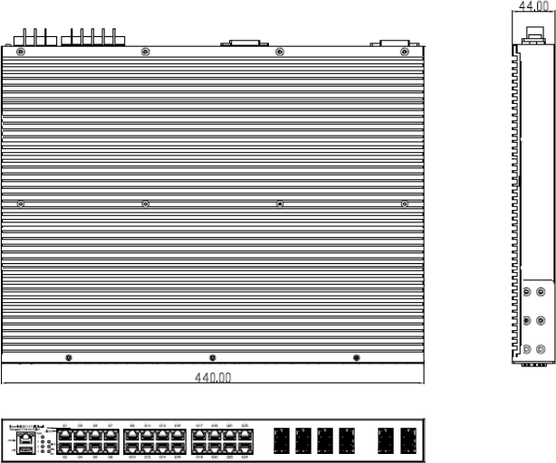

Ordering Information
KY-MSG2404-AC | 16+8+4 Port Industrial Managed Gigabit Ethernet Switch  - 1 6x 10/100/1000T(x) + 8 x Combo Ports + 4 x 1000 SFP Slots  - Operating Temperature: -40°C ~ 85°C (-40°F ~ 185°F)  - 2 x AC power inputs  NSA Guideline Certified for Console Port Shutdown and Chassis Full Security
KY-MSG2404-AD | 16+8+4 Port Industrial Managed Gigabit Ethernet Switch  - 16 x 10/100/1000T(x) + 8 x Combo Ports + 4 x 1000 SFP Slot  - Operating Temperature: -40°C ~ 85°C (-40°F ~ 185°F)  - 1 x AC power and 1 x 12-48 Volts DC power inputs  NSA Guideline Certified for Console Port Shutdown and Chassis Full Security
KY-MSG2404-DC | 16+8+4 Port Industrial Managed Gigabit Ethernet Switch  - 16 x 10/100/1000T(x) + 8 x Combo Ports + 4 x 1000 SFP Slots  - Operating Temperature: -40°C ~ 85°C (-40°F ~ 185°F)  - 2 x 12-48 Volts DC robust isolation power inputs  NSA Guideline Certified for Console Port Shutdown and Chassis Full Security  DYMEC – Temperature Hardened, American Made, Ruggedized, NSA Certified Endpoint, Industrial Ethernet Switches / Routers for SCADA, ITS, Transportation, Automation, Power Utilities, Edge Computing, AI and Industrial Control Systems. Made in USA.  Cyber-Secure    Copyright DYMEC 2018 – All Rights Reserved  

