KY-MPG2404 / DYMEC GP Series
24+4 Port Managed PoE+ Ruggedized, Temperature Hardened, Gigabit, Industrial Ethernet Switch

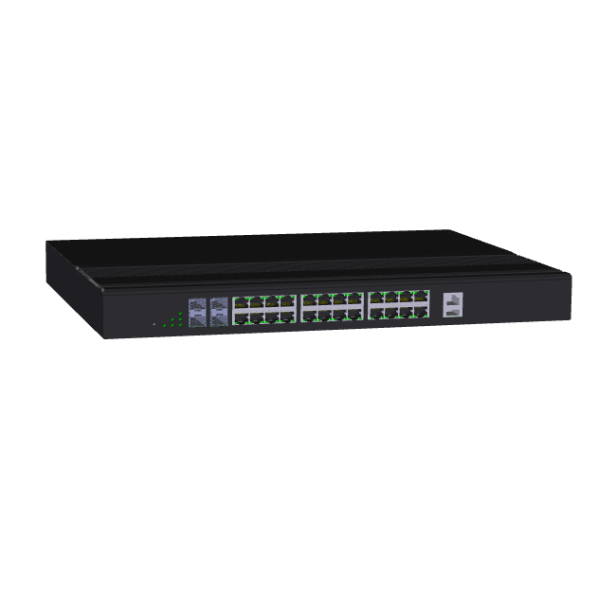 | - 24 x Gigabit Ethernet Ports  - 4 x 1000 SFP Slots  - Protection – IP30 / Fanless Convection Cooled  - NSA Network Endpoint Guideline Certified for Console Port Shutdown and Chassis Full Security (Patent Pending)  - Built for harsh environments and wide temperature range application  - RSTP, MSTP, ERPS, LACP for Network Redundancy  - QoS CoS/DSCP to increase determinism  - Supports IGMP Snooping v1/v2/v3, up to 1024 groups  - DHCP Relay Option 82 for policies IP address  - 30-Watt Power over Ethernet  - SNMP v1/v2c/v3 for network management  - Supports Broadcast Storm Protection  - USB storage for configuration-free replacement  - Support industrial automation protocols Ethernet/IP and Modbus TCP  - ERPS: Ethernet Ring Protection System with DDMI  - Secure File Transfer Protocol (SFTP) & Trivial File Transfer Protocol (TFTP)  - Supports PoE PD Alive Check Functionality for PoE Device Power Recycle
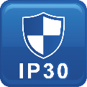

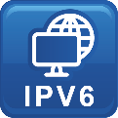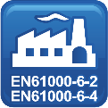

Specifications

Technology
Standards | IEEE 802.3 10BaseT  IEEE 802.3u 100BaseTX  IEEE 802.3ab 1000BaseT  IEEE 802.3z 1000BaseX  IEEE 802.3x Flow Control  IEEE 802.3af Power over Ethernet  IEEE 802.3at PoE+  IEEE 802.3ad/802.1AX LACP  IEEE 802.1D Spanning Tree Protocol  IEEE 802.1w Rapid STP  IEEE 802.1s Multiple STP  ITU-T G.8032 / Y.1344 ERPS  IEEE 802.1Q VLAN Tagging  IEEE 802.1ad Stacked VLANs  IEEE 802.1p Class of Service  IEEE 802.1X Network Authentication  IEEE 802.1AB LLDP
Processing Type | Store and Forward
Switch Properties
Priority Queues | 8 Queues
Jumbo Frame | 16000bytes
MAC Table Size | 16K
VLAN Table Size | 4094
IGMP Group | 1024
Packet Buffer | 12Mbits
Software Features
Network Redundancy | RSTP, MSTP, G.8032 ERPSv2, Port Trunking with LACP
Security | 802.1X, RADIUS, TACACS+, SSL, SSH
Management | IPv4, IPv6, Web, Telnet, Serial Console, CLI, SNMP v1/v2c/v3, uPnP
Diagnostics | RMON, SNMP Inform/Trap, Syslog, SMTP, Port Mirroring, LLDP
Configuration | DHCP Server/Client, Relay Option 82, TFTP, USB
Filter | 802.1Q VLAN, Q-in-Q, IGMP Snooping v1/v2/v3, IGMP Querier, Independent Vlan Learning
Time Sync. | NTP
QoS | CoS, DSCP, WRR/SPQ Queuing, Storm Protection
PoE | Powering Status, PoE Monitoring, Scheduling, PD Alive Check
Industrial Profiles | Ethernet/IP, Modbus TCP
Interfaces
RJ45 Port | 24x 10/100/1000T(x)auto negotiation speed duplex mode, auto MDI/MDI-X
Fiber Port | 4x 1000 SFP Slot
PoE Pin Out | V+, V+, V-, V-, for pin 1, 2, 3, 6, End span, MDI Mode A
LED Indicators | Per unit: PWR1, PWR2, Fault, Ring Master, Ring State  Ports: Link/Active with highest speed(Green), low speed(Amber)  PoE: Output Power
Alarm Contact | 1 x relay output with current carrying capacity of 1A @ 24 VDC
Digital Inputs | 1 x isolated input from the electronics.  +13 to +30 Volts for state "1"  -30 to +3 Volts for state "0"  Max. input current: 8mA
Button | Multiple function reset button
Serial Console | 1 x RS232 in RJ45 connector with console cable, 115.2Kbps, 8N1
Storage | 1 x USB 2.0 storage for firmware update, configuration backup, restore, boot up and syslog
Power Requirements
Operation Voltage | 90~264 Volts AC, 48~57 Volts DC, redundant dual inputs
Connection | AC socket, DC 4-pin terminal block
Power Consumption | 26 Watts without PDs' consumption
PoE Power Budget | Max. 450W@AC or 720W@DC, for total PD consumption, Max. 30 W per PoE port
Protection | Overload Current Protected, Reverse Polarity Protected
Mechanical Construction
Enclosure | Aluminum / Steel Military Grade
Protection Class | IP30
Dimensions | 440 x 44 x 331 mm (W x H x D)
Weight | 6.00 kg
Mounting | 19” Rack Mounting
Environmental Limits
Operating Temperature | Extended: -40°C ~ 80°C (-40°F ~ 176°F)
Storage Temperature | -40°C ~ 85°C (-40°F ~ 185°F)
Ambient Relative Humidity | 5 to 95%, (Non-Condensing)
Regulatory Approvals
Altitude – GB4943.1-2011 | Certified: 0 ~ 5000 Meters
EMI | FCC Part 15 Subpart B Class A  CE EN 55032 Class A
EMS | IEC61000-4-2 (ESD)  IEC61000-4-3 (RS)  IEC61000-4-4 (EFT)  IEC61000-4-5 (Surge)  IEC61000-4-6 (CS)  IEC61000-4-8 (Magnetic Field)
Free Fall | IEC60068-2-32
Shock | IEC60068-2-27
Vibration | IEC60068-2-6
Green | RoHS Compliant
Certifications | UL 60950-1/62368 (Pending)  61000-6-2 / ITUT / FCC  61000-6-4 / NEMA TS2 / IEEE / CE
MTBF  MIL-HDBK-217  IEC 62380 | >147,000 hours
Warranty  TAA Compliant | 5 Years / Limited Lifetime  Certified TAA Compliant

In a continuing effort of improvement and updated technology, product specifications are subject to change without notice.
Dimensions (unit = mm)
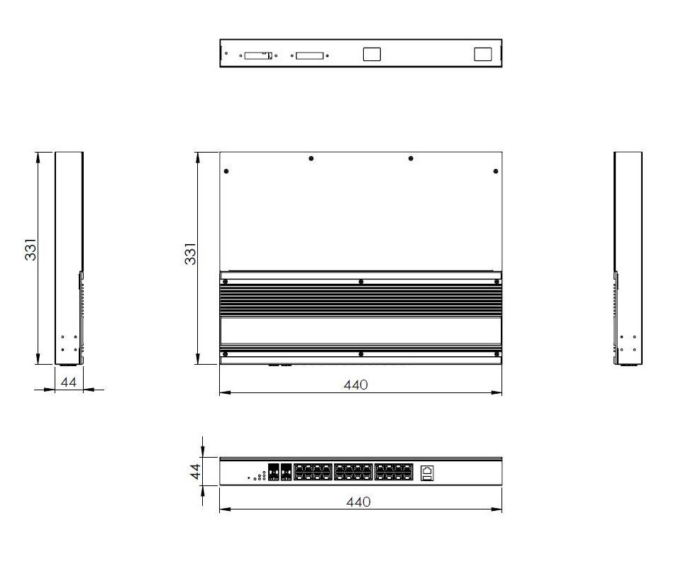

DYMEC Ordering Information
KY-MPG2404-AC  DYMEC GP  Series | 24 + 4 Port Industrial Managed PoE+ Gigabit Ethernet Switch  - 24 x 10/100/1000T(x) with 30 Watts PSE + 4 x 1000 SFP Slots  - Operating Temperature: -40°C ~ 80°C (-40°F ~ 176°F)  - 1 x AC Power Input  NSA Guideline Certified for Console Port Shutdown and Chassis Full Security
KY-MPG2404-AD  DYMEC GP  Series | 24 + 4 Port Industrial Managed PoE+ Gigabit Ethernet Switch  - 24 x 10/100/1000T(x) with 30 Watts PSE + 4 x 1000 SFP Slots  - Operating Temperature: -40°C ~ 80°C (-40°F ~ 176°F)  - 1 x AC Power and 1 x DC Power Input  NSA Guideline Certified for Console Port Shutdown and Chassis Full Security
KY-MPG2404-DC  DYMEC GP  Series | 24 + 4 Port Industrial Managed PoE+ Gigabit Ethernet Switch  - 24 x 10/100/1000T(x) with 30 Watts PSE + 4 x 1000 SFP Slots  - Operating Temperature: -40°C ~ 80°C (-40°F ~ 176°F)  - 2 x DC Robust Isolation Power Inputs  NSA Guideline Certified for Console Port Shutdown and Chassis Full Security

DYMEC – Temperature Hardened, American Made, Ruggedized, NSA Certified Endpoint, Industrial Ethernet Switches / Routers for SCADA, ITS, Transportation, Automation, Power Utilities, Edge Computing, AI and Industrial Control Systems. Made in USA. Cyber-Secure.

