KY-ESC0802-M12 / DYMEC M12 Series
10 Port M12 Industrial Unmanaged Gigabit Ethernet Switch
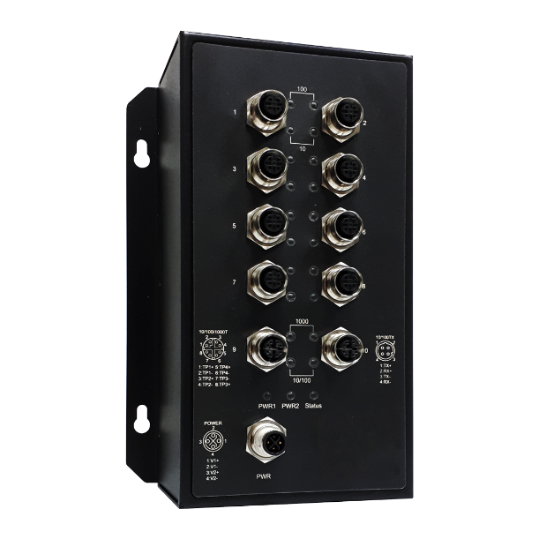 | - Certified EN50155  - 8x 10/100T(x) M12 connector  - 2x 10/100/1000T(x) M12 connector with bypass function  - Built for harsh environments and wide temperature range application  - IP54 housing  - Ruggedized  - Surge Protected  - Low Cost  - SECURE
Specifications

Technology
Standards | IEEE 802.3 10BaseT  IEEE 802.3u 100BaseTX  IEEE 802.3ab 1000BaseT
Processing Type | Store and Forward
Switch Properties
Priority Queues | -
Jumbo Frame | 12000bytes
MAC Table Size | 16K
Packet Buffer | 12Mbits
Interface
Network Connector | 8 x 10/100T(x) M12 Female D-coded 4-pole, 2 x 10/100/1000T(x) M12 Female X-coded 8-pole, auto negotiation speed duplex mode, auto MDI/MDI-X
LED Indicators | Per unit: PWR1, PWR2, Status  Ports: Link/Active with highest speed (Green), low speed (Amber)
Power Requirements
Operation Voltage | LV: 24-48VDC, HV: 72-110VDC, redundant dual inputs
Connection | M12 Male S-coded 4-pole
Power Consumption | <15 Watts
Protection | Overload Current Protected, Reverse Polarity Protected
Mechanical Construction
Enclosure | SECC
Protection Class | IP54
Dimensions | 143 x 209 x 77 mm (W x H x D)
Weight | 1.20 kg
Mounting | Wall Mounting Kits, Optional DIN-Rail Mounting
Environmental Limits
Operating Temperature | Extended: -40°C ~ 85°C (40°F ~ 176°F)
Storage Temperature | -40°C ~ 85°C (40°F ~ 185°F)
Ambient Relative Humidity | 5 to 95%, (Non-Condensing)
Regulatory Approvals
EMI | FCC Part 15 Subpart B Class A  CE EN 55032 Class A
EMS | IEC61000-4-2 (ESD)  IEC61000-4-3 (RS)  IEC61000-4-4 (EFT)  IEC61000-4-5 (Surge)  IEC61000-4-6 (CS)  IEC61000-4-8 (Magnetic Field)
Free Fall | IEC60068-2-32
Shock | IEC61373
Vibration | IEC61373
Green | RoHS Compliant
Certifications | EN 50155  EN 45545-2
MTBF | >100,000 Hours
Warranty | 5 Years / Limited Lifetime

Note from DYMEC Development
In a continuing effort of improvement and updated technology, product specifications are subject to change without notice.
Dimensions (unit = mm)
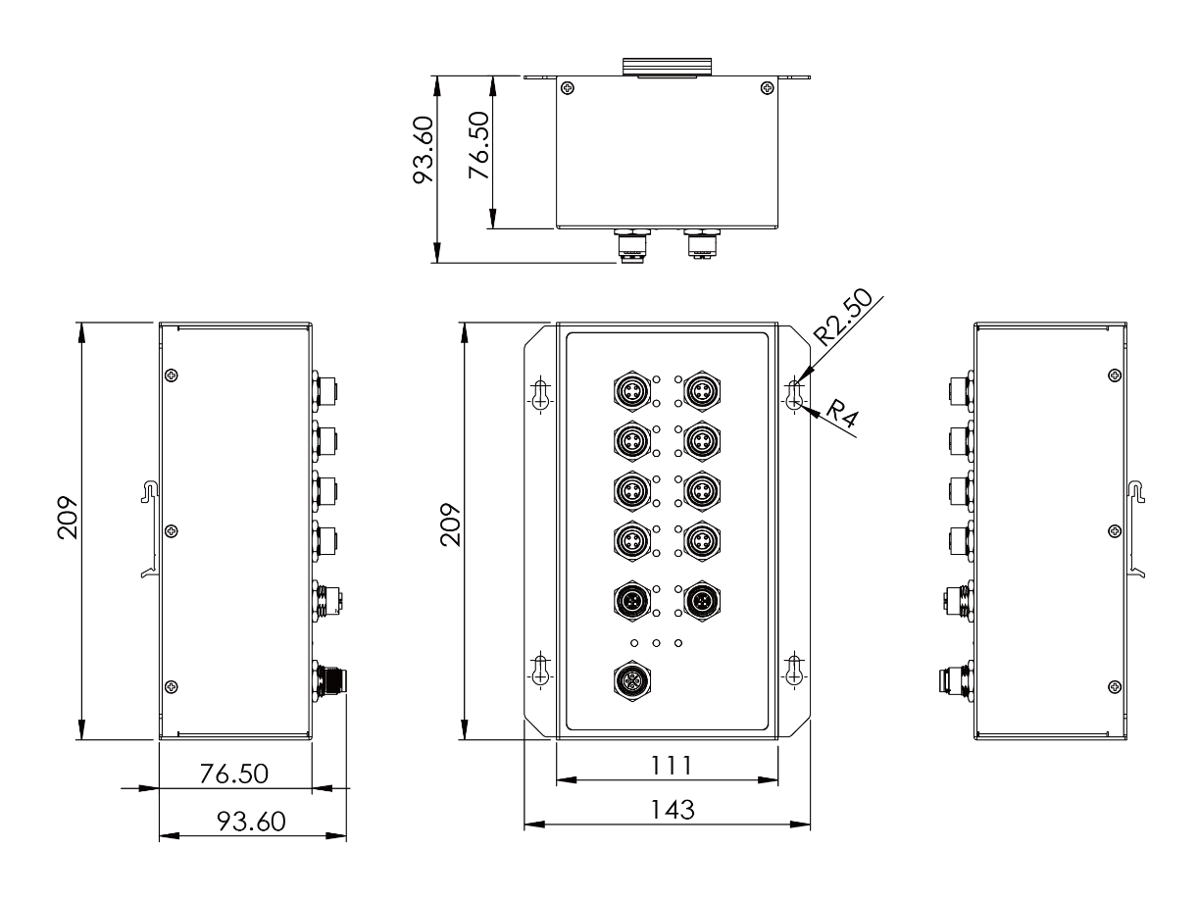

Ordering Information
KY-ESC0802-M12-LV-T | 10 Port M12 Industrial Unmanaged Gigabit Ethernet Switch  - 8x 10/100T(x) + 2x 10/100/1000T(x) M12 connectors  - Power Input: 24-48VDC  - Operating Temperature: -40°C ~ 85°C (40°F ~ 176°F)
KY-ESC0802-M12-HV-T | 10 Port M12 Industrial Unmanaged Gigabit Ethernet Switch  - 8x 10/100T(x) + 2x 10/100/1000T(x) M12 connectors  - Power Input: 72-110VDC  - Operating Temperature: -40°C ~ 85°C (40°F ~ 176°F)

