DYMEC 3170XR
Industrial Managed Ethernet Router User Manual
______________________________________________________________

Firmware Version 1.1.14
User’s Manual
Version 1.0

Compliant: For Military contract that require the continuous monitoring and protection of industrial control systems (ICS) Networks Operating / monitoring the operating utilities such as Water, Sewer, Electrical, Security, Video, Building Controls, Street and Intelligent Transportation Systems (ITS).

Uses: Cyber-Lock, IP Device Binding, Cyber-Secure Video, Clean Code Technology, & Secure Console / Chassis (Patent Pending)

Meets NSA Guidelines for Secure Network Endpoints

COPYRIGHT NOTICE
Copyright © 2018 DYMEC, LLC. All rights reserved.
No part of this publication may be reproduced in any form without the prior written consent of DYMEC, LLC.

TRADEMARKS
DYMEC & 3170 are registered trademarks of K-USA, LLC
All other trademarks belong to their respective owners.

REGULATORY COMPLIANCE STATEMENT
Product(s) associated with this publication complies/comply with all applicable regulations. Please refer to the Technical Specifications section for more details.

WARRANTY
DYMEC warrants that all DYMEC products are free from defects in material and workmanship for a specified warranty period from the invoice date (5 years for most products). DYMEC will repair or replace products found by DYMEC to be defective within this warranty period, with shipment expenses apportioned by DYMEC and the distributor. This warranty does not cover product modifications or repairs done by persons other than DYMEC approved personnel, and this warranty does not apply to DYMEC products that are misused, abused, improperly installed, or damaged by accidents.
Please refer to the Technical Specifications section for the actual warranty period(s) of the product(s) associated with this publication.

DISCLAIMER
Information in this publication is intended to be accurate. DYMEC shall not be responsible for its use or infringements on third-parties because of its use. There may occasionally be unintentional errors on this publication. DYMEC reserves the right to revise the contents of this publication without notice.

CONTACT INFORMATION
DYMEC, LLC
Kansas City, MO 64014
Telephone: (816) 988-7861
Website: www.DYMEC.com
Technical Support
E-mail: Sales@DYMEC.com
Sales Contact
E-mail: sales@DYMEC.com
support@DYMEC.com

Content

VLAN IP 4
Static Route 5
GRE Tunnel 7
IPSec 11
OSPFv2 16

VLAN IP
We usually configure VLANs to divide broadcast domains in the Local Area Network (LAN). To communicate with others in another VLAN, we need the device to support inter-VLAN routing. Users can use VLANs to create Layer 3 interfaces by assigning IP address in different subnets to the VLAN. Before configuring any kind of routing protocols, users have to make sure the VLAN IP Address is configured.
Configure VLAN IP Address
- Configure VLAN IP Address (VLAN Mode)
Cmd: ip address [IP_ADDR] [NETMASK]
- Display VLAN IP Address (VLAN Mode)
Cmd: show ip address
- Remove VLAN IP Address (VLAN Mode)
Cmd: no ip address
- Display All Configured VLAN IP Address (Config Mode)
Cmd: show vlan ip table

Static Route
Static Routing is the most basic routing method for IT networking. Users have to manually-configure the routing entries into a routing table. Static Route is fixed and unchanged, even if the Network is changed. Static Route is best configured as a gateway of last resort. The Network administrator has full and complete control over static routing’s behavior. The network design engineer must have enough background knowledge to handle its complexities and nuances.
Configuring A Static Route
All the following commands are under config mode
- Add Static Route
Cmd: ip route [IP_ADDR] [NETMASK:0-32] [NEXT_HOP]
- Display Static Route
Cmd: show ip route static
- Delete Static Route
Cmd: no ip route [IP_ADDR] [NETMASK:0-32]
Static Route Example
In the following diagram, we are going to configure a topology with Static Route for the network. Note that there are 3 networks in this drawing – each with its own color.
Network – 192.168.10.x (Magenta)
Network – 192.168.11.x (Brown)
Network – 192.168.10.x (Green)

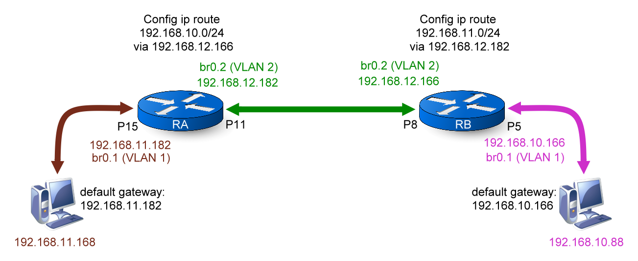

- Configurations for RA
Command | Description
Switch> enable | Enter “Privileged mode”
Switch# configure terminal | Enter “Configuration mode”
Switch(config)# vlan 1 | Enter “VLAN mode” for VLAN 1
Switch(config-vlan1)# ip address 192.168.11.182 255.255.255.0 | Configure IP Address to “192.168.11.182” for VLAN 1
Switch(config-vlan1)# vlan 2 | Enter “VLAN mode” for VLAN 2
Switch(config-vlan2)# ip address 192.168.12.182 255.255.255.0 | Configure IP Address to “192.168.12.182” for VLAN 2
Switch(config-vlan2)# member tag 11 | Add Lan11 to VLAN 2 with tagged
Switch(config-vlan2)# exit | Exit “VLAN mode”, back to “Configuration mode”
Switch(config)# ip route 192.168.10.0 24 192.168.12.166 | Configure static router for subnet 192.168.10.0/24.  The next hop is 192.168.12.166
- Configurations for RB
Command | Description
Switch> enable | Enter “Privileged mode”
Switch# configure terminal | Enter “Configuration mode”
Switch(config)# vlan 1 | Enter “VLAN mode” for VLAN 1
Switch(config-vlan1)# ip address 192.168.10.166 255.255.255.0 | Configure IP Address to “192.168.10.166” for VLAN 1
Switch(config-vlan1)# vlan 2 | Enter “VLAN mode” for VLAN 2
Switch(config-vlan2)# ip address 192.168.12.166 255.255.255.0 | Configure IP Address to “192.168.12.166” for VLAN 2
Switch(config-vlan2)# member tag 8 | Add Lan8 to VLAN 2 with tagged
Switch(config-vlan2)# exit | Exit “VLAN mode”, back to “Configuration mode”
Switch(config)# ip route 192.168.11.0 24 192.168.12.182 | Configure static router for subnet 192.168.11.0/24.  The next hop is 192.168.12.182

GRE Tunnel
GRE implies Generic Routing Encapsulation. It is a communication protocol that used to build up a direct point-to-point connection between network devices. GRE Tunnel is a virtual point-to-point link between two networks. And GRE can encapsulate a wide variety of network protocols inside the tunnel over an Internet Protocol Network. GRE Tunnel provides higher security than normal Network environment and it is also a niche to connect two detached subnetworks.
Configure GRE Tunnel
All the following commands are under config mode
- Configure GRE Tunnel Source & Destination
Cmd: tunnel gre [1-4] src-dest [SOURCE_IP_ADDR] [DESTINATION_IP_ADDR]
- Display GRE Tunnel Source & Destination
Cmd: show tunnel gre [1-4] src-dest
- Remove GRE Tunnel Source & Destination
Cmd: no tunnel gre [1-4] src-dest
- Configure GRE Tunnel Private IP Address
Cmd: tunnel gre [1-4] ip address [IP_ADDR] [NETMASK]
- Display GRE Tunnel Private IP Address
Cmd: show tunnel gre [1-4] ip address
- Remove GRE Tunnel Private IP Address
Cmd: no tunnel gre [1-4] ip address
- Enable/Disable GRE Tunnel
Cmd: tunnel gre [1-4] operation [enable | disable]
- Display GRE Tunnel State
Cmd: show tunnel gre [1-4] operation
GRE Tunnel Example
In the following diagram, we are going to configure a topology with Static Route and GRE Tunnel for the system.
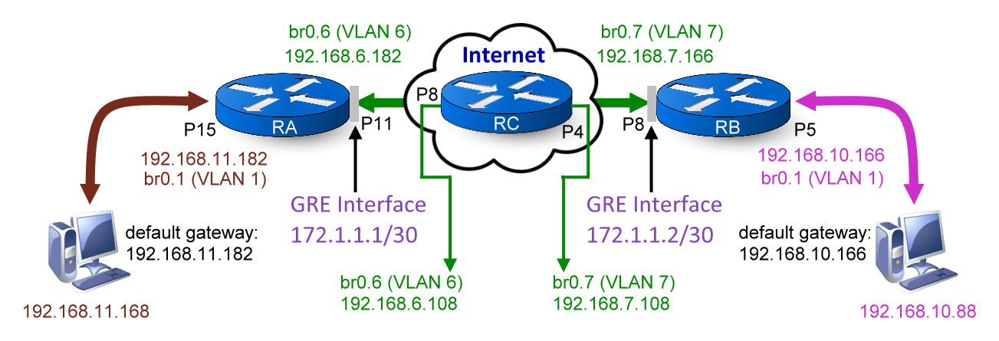
- Configurations for RA
Command | Description
Switch> enable | Enter “Privileged mode”
Switch# configure terminal | Enter “Configuration mode”
Switch(config)# vlan 1 | Enter “VLAN mode” for VLAN 1
Switch(config-vlan1)# ip address 192.168.11.182 255.255.255.0 | Configure IP Address to “192.168.11.182” for VLAN 1
Switch(config-vlan1)# vlan 6 | Enter “VLAN mode” for VLAN 6
Switch(config-vlan6)# ip address 192.168.6.182 255.255.255.0 | Configure IP Address to “192.168.6.182” for VLAN 6
Switch(config-vlan6)# member tag 11 | Add Lan11 to VLAN6 with tagged
Switch(config-vlan6)# exit | Exit “VLAN mode”, back to “Configuration mode”
Switch(config)# tunnel gre 1 src-dest 192.168.6.182 192.168.7.166 | Configure GRE Tunnel’s local and remote IP.  First parameter is “Local”, second one is “Remote”
Switch(config)# tunnel gre 1 ip address 172.1.1.1 30 | Configure GRE Tunnel’s private IP Address
Switch(config)# tunnel gre 1 operation enable | Enable GRE Tunnel 1
Switch(config)# ip route 192.168.10.0 24 172.1.1.2 | Configure static router for subnet 192.168.10.0/24.  The next hop is 172.1.1.2
Switch(config)# ip route 192.168.7.0 24 192.168.6.108 | Configure static router for subnet 192.168.7.0/24.  The next hop is 192.168.6.108

- Configurations for RB
Command | Description
Switch> enable | Enter “Privileged mode”
Switch# configure terminal | Enter “Configuration mode”
Switch(config)# vlan 1 | Enter “VLAN mode” for VLAN 1
Switch(config-vlan1)# ip address 192.168.10.166 255.255.255.0 | Configure IP Address to “192.168.10.166” for VLAN 1
Switch(config-vlan1)# vlan 7 | Enter “VLAN mode” for VLAN 7
Switch(config-vlan7)# ip address 192.168.7.166 255.255.255.0 | Configure IP Address to “192.168.7.166” for VLAN 7
Switch(config-vlan7)# member tag 8 | Add Lan8 to VLAN 7 with tagged
Switch(config-vlan7)# exit | Exit “VLAN mode”, back to “Configuration mode”
Switch(config)# tunnel gre 1 src-dest 192.168.7.166 192.168.6.182 | Configure GRE Tunnel’s local and remote IP.  First parameter is “Local”, second one is “Remote”
Switch(config)# tunnel gre 1 ip address 172.1.1.2 30 | Configure GRE Tunnel’s private IP Address
Switch(config)# tunnel gre 1 operation enable | Enable GRE Tunnel 1
Switch(config)# ip route 192.168.11.0 24 172.1.1.1 | Configure static router for subnet 192.168.11.0/24.  The next hop is 172.1.1.1
Switch(config)# ip route 192.168.6.0 24 192.168.7.108 | Configure static router for subnet 192.168.6.0/24.  The next hop is 192.168.7.108

- Configurations for RC
Command | Description
Switch> enable | Enter “Privileged mode”
Switch# configure terminal | Enter “Configuration mode”
Switch(config)# vlan 1 | Enter “VLAN mode” for VLAN 1
Switch(config-vlan1)# ip address 192.168.3.108 255.255.255.0 | Configure IP Address to “192.168.3.108” for VLAN 1
Switch(config-vlan1)# vlan 6 | Enter “VLAN mode” for VLAN 6
Switch(config-vlan6)# ip address 192.168.6.108 255.255.255.0 | Configure IP Address to “192.168.6.108” for VLAN 6
Switch(config-vlan6)# member tag 8 | Add Lan8 to VLAN6 with tagged
Switch(config-vlan6)# vlan 7 | Enter “VLAN mode” for VLAN 7
Switch(config-vlan7)# ip address 192.168.7.108 255.255.255.0 | Configure IP Address to “192.168.7.108” for VLAN 7
Switch(config-vlan7)# member tag 4 | Add Lan4 to VLAN 7 with tagged
Switch(config-vlan7)# exit | Exit “VLAN mode”, back to “Configuration mode”

IPSec
Internet Protocol Security (IPsec) is a secure Networks protocol for the Internet protocols. It offers the security on the IP Layer to protect the communication data of entire Internet. IPSec provides authentication and confidentiality methods. The authentication function is used to ensure the identities of each other by exchanging host keys and it can prevent the transmitting data from tampering. The other function confidentiality is to encrypt the data of packets to avoid snooping during transmission.
Configure IPSec
All the following commands are under config mode
- Set IP Address for Local IPSec Interface
Cmd: Ipsec left address [IP_ADDR]
- Display IP Address for Local IPSec Interface
Cmd: show ipsec left address
- Remove IP Address for Local IPSec Interface
Cmd: no ipsec left address
- Generate Hostkey for Local IPSec Interface
Cmd: ipsec left hostkey
- Display Hostkey for Local IPSec Interface
Cmd: show ipsec left hostkey
- Remove Hostkey for Local IPSec Interface
Cmd: no ipsec left hostkey
- Set IP Address for Remote IPSec Interface
Cmd: ipsec right address [IP_ADDR]
- Display IP Address for Remote IPSec Interface
Cmd: show ipsec right address
- Remove IP Address for Remote IPSec Interface
Cmd: no ipsec right address
- Configure Hostkey for Remote IPSec Interface
Cmd: ipsec right hostkey [KEY_PATH]
Note: The right hostkey must be saved in the USB
- Display Hostkey for Remote IPSec Interface
Cmd: show ipsec right hostkey
- Remove Hostkey for Remote IPSec Interface
Cmd: no ipsec right hostkey
- Set Key Life Timer
Cmd: ipsec keylife [60-86400secs]
- Display Key Life Timer
Cmd: show ipsec keylife
- Remove Key Life Timer
Cmd: no ipsec keylife
- Enable IPSec Protocol
Cmd: ipsec enable
- Disable IPSec Protocol
Cmd: no ipsec
- Display IPSec Protocol State
Cmd: show ipsec state

IPSec Example
In the following diagram, we are going to configure a topology with Static Route, GRE Tunnel, and IPSec for the system.
- Configurations for RA
Command | Description
Switch> enable | Enter “Privileged mode”
Switch# configure terminal | Enter “Configuration mode”
Switch(config)# vlan 1 | Enter “VLAN mode” for VLAN 1
Switch(config-vlan1)# ip address 192.168.11.182 255.255.255.0 | Configure IP Address to “192.168.11.182” for VLAN 1
Switch(config-vlan1)# vlan 6 | Enter “VLAN mode” for VLAN 6
Switch(config-vlan6)# ip address 192.168.6.182 255.255.255.0 | Configure IP Address to “192.168.6.182” for VLAN 6
Switch(config-vlan6)# member tag 11 | Add Lan11 to VLAN6 with tagged
Switch(config-vlan6)# exit | Exit “VLAN mode”, back to “Configuration mode”
Switch(config)# tunnel gre 1 src-dest 192.168.6.182 192.168.7.166 | Configure GRE Tunnel’s local and remote IP.  First parameter is “Local”, second one is “Remote”
Switch(config)# tunnel gre 1 ip address 172.1.1.1 30 | Configure GRE Tunnel’s private IP Address
Switch(config)# tunnel gre 1 operation enable | Enable GRE Tunnel 1
Switch(config)# ip route 192.168.10.0 24 172.1.1.2 | Configure static router for subnet 192.168.10.0/24.  The next hop is 172.1.1.2
Switch(config)# ip route 192.168.7.0 24 192.168.6.108 | Configure static router for subnet 192.168.7.0/24.  The next hop is 192.168.6.108
Switch(config)# ipsec left address 192.168.6.182 | Configure IPSec local IP address to 192.168.6.182
Switch(config)# ipsec left hostkey | Generate IPSec local hostkey
- Configurations for RB
Command | Description
Switch> enable | Enter “Privileged mode”
Switch# configure terminal | Enter “Configuration mode”
Switch(config)# vlan 1 | Enter “VLAN mode” for VLAN 1
Switch(config-vlan1)# ip address 192.168.10.166 255.255.255.0 | Configure IP Address to “192.168.10.166” for VLAN 1
Switch(config-vlan1)# vlan 7 | Enter “VLAN mode” for VLAN 7
Switch(config-vlan7)# ip address 192.168.7.166 255.255.255.0 | Configure IP Address to “192.168.7.166” for VLAN 7
Switch(config-vlan7)# member tag 8 | Add Lan8 to VLAN 7 with tagged
Switch(config-vlan7)# exit | Exit “VLAN mode”, back to “Configuration mode”
Switch(config)# tunnel gre 1 src-dest 192.168.7.166 192.168.6.182 | Configure GRE Tunnel’s local and remote IP.  First parameter is “Local”, second one is “Remote”
Switch(config)# tunnel gre 1 ip address 172.1.1.2 30 | Configure GRE Tunnel’s private IP Address
Switch(config)# tunnel gre 1 operation enable | Enable GRE Tunnel 1
Switch(config)# ip route 192.168.11.0 24 172.1.1.1 | Configure static router for subnet 192.168.11.0/24.  The next hop is 172.1.1.1
Switch(config)# ip route 192.168.6.0 24 192.168.7.108 | Configure static router for subnet 192.168.6.0/24.  The next hop is 192.168.7.108
Switch(config)# ipsec left address 192.168. 7.166 | Configure IPSec local IP address to 192.168. 7.166
Switch(config)# ipsec left hostkey | Generate IPSec local hostkey
Switch(config)# ipsec right address 192.168. 6.182 | Configure IPSec remote IP address to 192.168. 6.182
Switch(config)# ipsec right hostkey key.txt | Configure IPSec remote hostkey  Users have to save the key in a text file in the USB
Switch(config)# ipsec enable | Enable IPSec protocol
Switch(config)# show ipsec state | Display IPSec state

- Configurations for RC
Command | Description
Switch> enable | Enter “Privileged mode”
Switch# configure terminal | Enter “Configuration mode”
Switch(config)# vlan 1 | Enter “VLAN mode” for VLAN 1
Switch(config-vlan1)# ip address 192.168.3.108 255.255.255.0 | Configure IP Address to “192.168.3.108” for VLAN 1
Switch(config-vlan1)# vlan 6 | Enter “VLAN mode” for VLAN 6
Switch(config-vlan6)# ip address 192.168.6.108 255.255.255.0 | Configure IP Address to “192.168.6.108” for VLAN 6
Switch(config-vlan6)# member tag 8 | Add Lan8 to VLAN6 with tagged
Switch(config-vlan6)# vlan 7 | Enter “VLAN mode” for VLAN 7
Switch(config-vlan7)# ip address 192.168.7.108 255.255.255.0 | Configure IP Address to “192.168.7.108” for VLAN 7
Switch(config-vlan7)# member tag 4 | Add Lan4 to VLAN 7 with tagged
Switch(config-vlan7)# exit | Exit “VLAN mode”, back to “Configuration mode”

OSPFv2
Open Shortest Path First (OSPF) is one of several dynamic routing protocols and OSPFv2 is for IPv4 Networks. OSPF is the most widely used interior Gateway Protocol (IGP) and it is designed for medium-and-large-scale enterprise networks. OSPF nodes exchange neighbors’ information via Link-State information and calculate the shortest path with their Cost to transmit packets. OSPF is operating under a hierarchical system and divide the system to several Areas by different Area IDs. OSPF nodes only exchange information with the nodes in the same Area.
Configuring OSPFv2
All the following commands are under Config Mode
- Configure OSPF Router ID
Cmd: router ospf router-id [ROUTER_ID]
- Display OSPF Router ID
Cmd: show router ospf router-id
- Clear OSPF Router ID
Cmd: no router ospf router-id
- Configure OSPF Network
Cmd: router ospf network [IP_ADDR] [NETMASK:0-32] [AREA_ID]
- Display OSPF Network
Cmd: show router ospf network
- Remove OSPF Network Rule for Specific Subnet
Cmd: no router ospf network [IP_ADDR] [NETMASK:0-32]
- Enable OSPF Authentication with Text on Specific Area
Cmd: router ospf authentication area [AREA_ID]
- Enable OSPF Authentication with MD5 on Specific Area
Cmd: router ospf authentication message-digest area [AREA_ID]
- Display OSPF Authentication State
Cmd: show router ospf authentication
- Disable OSPF Authentication on Specific Area
Cmd: no router ospf authentication area [AREA_ID]
- Display OSPF Operation Status
Cmd: show router ospf
- Display OSPF Neighbors’ Status
Cmd: show router ospf neighbor
All the following commands are under VLAN Mode
- Configure OSPF Hello Interval
Cmd: ip ospf hello-interval [1-65535]
The default OSPF Hello Interval is 10 seconds.
- Display OSPF Hello Interval
Cmd: show ip ospf hello-interval
- Clear OSPF Hello Interval
Cmd: no ip ospf hello-interval
- Configure OSPF Dead Interval
Cmd: ip ospf dead-interval [1-65535]
The default OSPF Dead Interval is 4 times hello interval.
- Display OSPF Dead Interval
Cmd: show ip ospf dead-interval
- Clear OSPF Dead Interval
Cmd: no ip ospf dead-interval
- Enable OSPF Authentication with Text on Specific VLAN
Cmd: ip ospf authentication
- Enable OSPF Authentication with MD5 on Specific VLAN
Cmd: ip ospf authentication message-digest
- Display OSPF Authentication State
Cmd: show ip ospf authentication
- Disable OSPF Authentication on Specific VLAN
Cmd: no ip ospf authentication
- Configure OSPF Authentication Password
Cmd: ip ospf authentication-key [PASSWD]
- Display OSPF Authentication Password
Cmd: show ip ospf authentication-key
- Clear OSPF Authentication Password
Cmd: no ip ospf authentication-key
- Configure OSPF MD5 Authentication Password
Cmd: ip ospf message-digest-key [KEY_ID] md5 [PASSWD]
- Display OSPF MD5 Authentication Password
Cmd: show ip ospf message-digest-key
- Clear OSPF MD5 Authentication Password
Cmd: no ip ospf message-digest-key [KEY_ID]
OSPFv2 Example
In the following diagram, we are going to configure a topology with Dynamic Routing – OSPFv2 for the system. Use the following commands to check the link state after configurations are completed:
  - show router ospf
  - show router ospf neighbor
  - show ip route
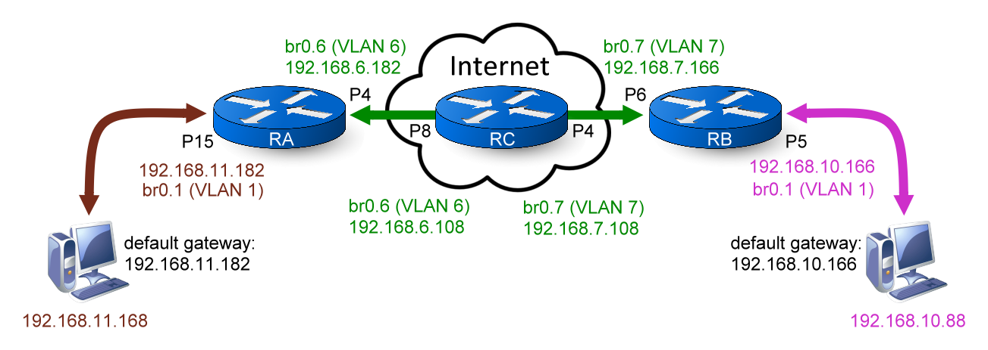
*Simulation Internet by through RC.*
- Configurations for RA
Command | Description
Switch> enable | Enter “Privileged mode”
Switch# configure terminal | Enter “Configuration mode”
Switch(config)# vlan 1 | Enter “VLAN mode” for VLAN 1
Switch(config-vlan1)# ip address 192.168.11.182 255.255.255.0 | Configure IP Address to “192.168.11.182” for VLAN 1
Switch(config-vlan1)# vlan 6 | Enter “VLAN mode” for VLAN 6
Switch(config-vlan6)# ip address 192.168.6.182 255.255.255.0 | Configure IP Address to “192.168.6.182” for VLAN 6
Switch(config-vlan6)# member tag 4 | Add Lan4 to VLAN6 with tagged
Switch(config-vlan6)# exit | Exit “VLAN mode”, back to “Configuration mode”
Switch(config)# router ospf router-id 0.0.0.1 | Configure OSPF router id to 0.0.0.1
Switch(config)# router ospf network 192.168.11.0 24 0 | Configure subnet 192.168.11.0/24 to join OSPF network area 0
Switch(config)# router ospf network 192.168.6.0 24 0 | Configure subnet 192.168.6.0/24 to join OSPF network area 0

- Configurations for RB
Command | Description
Switch> enable | Enter “Privileged mode”
Switch# configure terminal | Enter “Configuration mode”
Switch(config)# vlan 1 | Enter “VLAN mode” for VLAN 1
Switch(config-vlan1)# ip address 192.168.10.166 255.255.255.0 | Configure IP Address to “192.168.10.166” for VLAN 1
Switch(config-vlan1)# vlan 7 | Enter “VLAN mode” for VLAN 7
Switch(config-vlan7)# ip address 192.168.7.166 255.255.255.0 | Configure IP Address to “192.168.7.166” for VLAN 7
Switch(config-vlan7)# member tag 6 | Add Lan6 to VLAN 7 with tagged
Switch(config-vlan7)# exit | Exit “VLAN mode”, back to “Configuration mode”
Switch(config)# router ospf router-id 0.0.0.2 | Configure OSPF router id to 0.0.0.2
Switch(config)# router ospf network 192.168.10.0 24 0 | Configure subnet 192.168.10.0/24 to join OSPF network area 0
Switch(config)# router ospf network 192.168.7.0 24 0 | Configure subnet 192.168.7.0/24 to join OSPF network area 0

- Configurations for RC
Command | Description
Switch> enable | Enter “Privileged mode”
Switch# configure terminal | Enter “Configuration mode”
Switch(config)# vlan 1 | Enter “VLAN mode” for VLAN 1
Switch(config-vlan1)# ip address 192.168.3.108 255.255.255.0 | Configure IP Address to “192.168.3.108” for VLAN 1
Switch(config-vlan1)# vlan 6 | Enter “VLAN mode” for VLAN 6
Switch(config-vlan6)# ip address 192.168.6.108 255.255.255.0 | Configure IP Address to “192.168.6.108” for VLAN 6
Switch(config-vlan6)# member tag 8 | Add Lan8 to VLAN6 with tagged
Switch(config-vlan6)# vlan 7 | Enter “VLAN mode” for VLAN 7
Switch(config-vlan7)# ip address 192.168.7.108 255.255.255.0 | Configure IP Address to “192.168.7.108” for VLAN 7
Switch(config-vlan7)# member tag 4 | Add Lan4 to VLAN 7 with tagged
Switch(config-vlan7)# exit | Exit “VLAN mode”, back to “Configuration mode”
Switch(config)# router ospf router-id 0.0.0.3 | Configure OSPF router id to 0.0.0.3
Switch(config)# router ospf network 192.168.6.0 24 0 | Configure subnet 192.168.6.0/24 to join OSPF network area 0
Switch(config)# router ospf network 192.168.7.0 24 0 | Configure subnet 192.168.7.0/24 to join OSPF network area 0

