KY-3170™XR / DYMEC 3170™ Series
6 x 4 Port, Managed, Ten Gigabit, Temperature Hardened, ITS, Industrial, Input File, Ethernet Router / Switch: 4 x 1/10 GbE Uplinks – Low Power / NSA End Point Certified with ERPSv2

- 6 x (RJ45 10/100/1000) Gigabit Ports
- 4x 1GbE /10 GbE SFP Slots

- NSA Network Endpoint Guideline Certified for Console Port Shutdown and Chassis Full Security (Patent Pending)

- 5 Year / Limited Lifetime Warranty
- Full Line Speed Routing & Switching
- Input File / Low Power Industrial Ethernet Switch
- Built for harsh environments & wide temperature ranges
- Edge Computing & Transport Networks
- Fanless – Convection Cooled
- RSTP, MSTP, ERPS, LACP for Network Redundancy
- QoS CoS / DSCP Advanced Queueing
- Supports IGMP Snooping v1/v2/v3, up to 1024 groups
- DHCP Relay Option 82 Policy for IP address assignment
- SNMP v1/v2c/v3 for network management
- Supports Storm Protection / Broadcast Storm Suppression
- USB storage for configuration-free replacement
- Supports industrial automation protocols Ethernet/IP and Modbus TCP
- Secure File Transfer Protocol (SFTP) & Trivial File Transfer Protocol (TFTP)
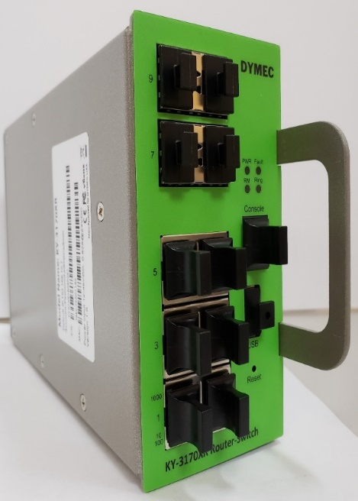
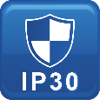

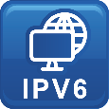

Specifications

Technology
Standards | IEEE 802.3 10BaseT  IEEE 802.3u 100BaseTX  IEEE 802.3ab 1000BaseT  IEEE 802.3ae 10GBase over Fiber  IEEE 802.3x Flow Control  IEEE 802.3ad/802.1AX LACP  IEEE 802.1D Spanning Tree Protocol  IEEE 802.1w Rapid STP  IEEE 802.1s Multiple STP  ITU-T G.8032 / Y.1344 ERPS  IEEE 802.1Q VLAN Tagging  IEEE 802.1ad Stacked VLANs  IEEE 802.1p Class of Service  IEEE 802.1X Network Authentication  IEEE 802.1AB LLDP
Processing Type | Store and Forward
Switch Properties
Priority Queues | 8 Queues
Jumbo Frame | 16000bytes
MAC Table Size | 16K
VLAN Table Size | 4094
IGMP Group | 1024
Packet Buffer | 12Mbits
Router Forwarding Rate | 10 Mbps / GRE  Line Speed for Routing
Software Features
Network Redundancy | RSTP, MSTP, G.8032 ERPSv2, Port Trunking with LACP
Security | 802.1X, RADIUS, TACACS+, SSL, SSH, ACL
Management | IPv4, IPv6, Web, Telnet, Serial Console, CLI, SFTP, SNMP v1/v2c/v3, uPnP
Diagnostics | RMON, SNMP Inform/Trap, Syslog, SMTP, Port Mirroring, LLDP, DDM, Cable Diagnostic*
Configuration | DHCP Server/Client, Relay Option 82, TFTP, SFTP, USB
Filter | 802.1Q VLAN, Q-in-Q, IGMP Snooping v1/v2/v3, IGMP Querier, Independent Vlan Learning, MLDv1/v2 Snooping*
Time Sync. | NTP  IEEE 1588v2*
QoS | CoS, DSCP, WRR/SPQ Queuing, Storm Protection
Industrial Profiles | Ethernet/IP, Modbus TCP
L3 Routing | Static Routing, OSPF v2, GRE, IPSec
Router Interfaces
RJ45 Port | 6 x 10/100/1000T(x), auto negotiation speed duplex mode, auto MDI/MDI-X
Fiber Port | 4 x 1GbE 1/10 GbE SFP Slots
LED Indicators | Per unit: PWR1, Fault, Ring Master, Ring State  Ports: Link/Active with highest speed(Green), low speed(Amber)
Button | Multiple function reset button
Serial Console | 1 x RS232 in RJ45 connector with console cable, 115.2Kbps, 8N1
Storage | 1 x USB 2.0 storage for firmware update, configuration backup, restore, boot up and syslog
Power Requirements
Operation Voltage | 12-48 Volts DC
Connection | PCB Golden Finger
Power Consumption | 0.67A@ 24 Volts DC
Protection | Overload Current Protected, Reverse Polarity Protected
Mechanical Construction
Enclosure | Military Grade Steel / Aluminum
Protection Class | IP30
Dimensions | 58 x 114 x 205 mm (W x H x D)
Weight | 0.87 kg
Mounting | Rack Mounting with Rail Slots
Environmental Limits
Operating Temperature | Extended: -40°C ~ 80°C (-40°F ~ 176°F)
Storage Temperature | -40°C ~ 85°C (40°F ~ 185°F)
Ambient Relative Humidity | 5 to 95%, (Non-Condensing)
Regulatory Approvals
Altitude Certified  GB4943.1-2011 | 0 ~ 5000 Meters
EMI | FCC Part 15 Subpart B Class A  CE EN 55032 Class A
EMS | IEC61000-4-2 (ESD)  IEC61000-4-3 (RS)  IEC61000-4-4 (EFT)  IEC61000-4-5 (Surge)  IEC61000-4-6 (CS)  IEC61000-4-8 (Magnetic Field)
Free Fall | IEC60068-2-32
Shock | IEC60068-2-27
Vibration | IEC60068-2-6
Green | RoHS Compliant
Certifications | UL 60950-1/62368  61000-6-2 / FCC / NEMA TS-2  61000-6-4 / ITUT / IEEE
MTBF  MIL-HDBK-217  IEC 62380 | >157,000 hours
Warranty  TAA Compliant | 5 Years / Limited Lifetime  Certified TAA Compliant

Note from DYMEC development.
In a continuing effort of improvement and updated technology, product specifications are subject to change without notice.
Dimensions (unit = mm)
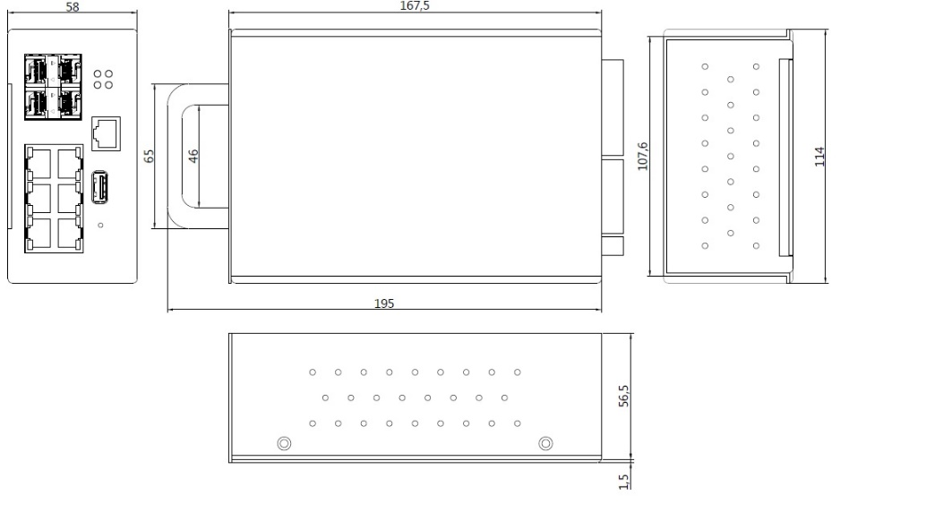
DYMEC 3170 Supports: 2 & 4 Wire LONG RANGE ETHERNET / VDSL2 SFP Modem
With long reach coverage, high noise immunity, and compact board size, DYMEC KY-Pro-180-CRD Ruggedized SFP modem is an ideal upgrade for your Enterprise or Industry applications. Used in Pairs.

VDSL2 – Long Range Ethernet Application (KY-Pro-180-CRD)

DYMEC KY-SFP-T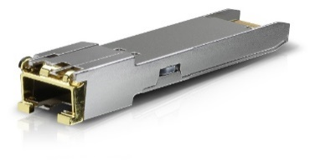
Copper SFP Transceiver – Used to Add Additional RJ-45 Copper Ports to your KY-3170 Series Switch
Easy to Install & Configure – GUI Selectable

Ordering Information
KY-3170™XR  DYMEC 3170™ Series | 6 x 4 Port, 10GbE, Industrial, Managed, ITS, Ethernet Router with 4 x 1 / 10 GbE Uplinks  - 6 x 10/100/1000BaseT(X) + 4 x 1 /10 GbE SFP Slots  - Operating Temperature: -40°C ~ 80°C (-40°F ~ 176°F)  NSA Guideline Certified for Console Port Shutdown and Chassis Full Security

KY-3170™XR/2  DYMEC 3170™ Series | 6 x 4 Port, 10GbE, Industrial, Managed, ITS, Ethernet Router with 4 x 1 / 10 GbE Uplinks (Configured for 8 Copper RJ45 Ports)  - 6 x 10/100/1000BaseT(X) + 2 x 10/100/1000 Copper SFP + 2 x 1 /10 GbE SFP Slots  - Operating Temperature: -40°C ~ 80°C (-40°F ~ 176°F)  NSA Guideline Certified for Console Port Shutdown and Chassis Full Security

DYMEC – Temperature Hardened, American Made, Ruggedized, NSA Certified Endpoint, Industrial Ethernet Switches / Routers for SCADA, ITS, Transportation, Automation, Power Utilities, Edge Computing, AI and Industrial Control Systems. Made in USA. TAA Compliant. Uses SFP’s / BiDi SFP’s / Mini Gbic & VDSL2 Industrial SFP for Long Range Ethernet.

