KY-3170™EM4-Pbt / DYMEC 3170bt™ Series
6 x 4 Port PSE, Managed, Gigabit, Power over Ethernet (IEEE 802.3 af / at, bt), 30 / 60 / 95 - Watt, Temperature Hardened, ITS, Industrial, Input File, Ethernet Switch – Low Power / NSA Endpoint Certified with ERPSv2 Redundant Fiber Technology
- Security Certified – IEC 62443 Compliant
- 2 x 10/100/1000 - (60 / 95-Watt bt) PSE Ports
- 4 x Gigabit Ethernet (30 Watt) PSE Ports
- 4 x 1000 Mbps SFP Slot (Mini Gbic) / ERPS Multi Ring
- Power over Ethernet Plus / IEEE 802.3 af/at (30 Watt)
- New IEEE 802.3bt 60 / 95 Watt PoE++ standard

- NSA Network Endpoint Guideline Certified for Console Port Shutdown and Chassis Full Security

- Built for harsh environments and wide temperature range applications / Edge Computing
- RSTP, MSTP, ERPS, LACP for Network Redundancy
- QoS CoS/DSCP to increase determinism
- Input File / Low Power Industrial Ethernet Switch
- Supports IGMP Snooping v1/v2/v3, up to 1024 groups
- DHCP Relay Option 82 IP address assignment
- SNMP v1/v2c/v3 for network management
- Supports Storm Protection / Broadcast Control
- USB storage for configuration-free replacement
- Supports industrial automation protocols Ethernet/IP & Modbus TCP
- Secure File Transfer Protocol (SFTP) & Trivial File Transfer Protocol (TFTP)
- Supports PoE PD Alive Check Function for PoE Device Power Recycle

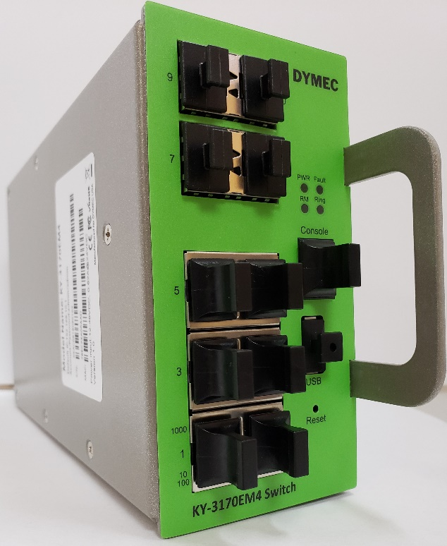



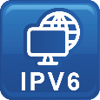




Specifications

Technology
Standards | IEEE 802.3 10BaseT  IEEE 802.3u 100BaseTX  IEEE 802.3ab 1000BaseT  IEEE 802.3z 1000BaseX  IEEE 802.3x Flow Control  IEEE 802.3af Power over Ethernet  IEEE 802.3at PoE+  IEEE 802.3bt PoE++  IEEE 802.3ad/802.1AX LACP  IEEE 802.1D Spanning Tree Protocol  IEEE 802.1w Rapid STP  IEEE 802.1s Multiple STP  ITU-T G.8032 / Y.1344 ERPS  IEEE 802.1Q VLAN Tagging  IEEE 802.1ad Stacked VLANs  IEEE 802.1p Class of Service  IEEE 802.1X Network Authentication  IEEE 802.1AB LLDP
Processing Type | Store and Forward
Switch Properties
Priority Queues | 8 Queues
Jumbo Frame | 9216 bytes
MAC Table Size | 16K
VLAN Table Size | 4094
IGMP Group | 1023
Packet Buffer | 12Mbits
Software Features
Network Redundancy | RSTP, MSTP, G.8032 ERPSv2, Port Trunking with LACP
Security | 802.1X, RADIUS, TACACS+, SSL, SSH, ACL / Security ACL Package
Management | IPv4, IPv6, Web, Telnet, Serial Console, CLI, SFTP, SNMP v1/v2c/v3, uPnP
Diagnostics | RMON, SNMP Inform/Trap, Syslog, SMTP, Port Mirroring, LLDP, DDMI, Cable Diagnostic*
Configuration | DHCP Server/Client, Relay Option 82, TFTP, SFTP, USB
Filter | 802.1Q VLAN, Q-in-Q, IGMP Snooping v1/v2/v3, IGMP Querier, Independent Vlan Learning
Time Sync. | NTP
QoS | CoS, DSCP, WRR/SPQ Queuing, Storm Protection, Broadcast Control
Industrial Profiles | Ethernet/IP, Modbus TCP
Switch Interfaces
RJ45 Port | 6x 10/100/1000T(x) with 4x PoE+ and 2x PoE++, auto negotiation speed duplex mode, auto MDI/MDI-X
Fiber Port | 4 x 1000 Mbps Fx SFP Slots
PoE Pin Out | V+, V+, V-, V-, for pin 1, 2, 3, 6, End-span, MDI Mode A  V+, V+, V-, V-, for pin 4, 5, 7, 8, End-span, MDI Mode B  4-pair mode for 802.3bt
LED Indicators | Per unit: PWR1, PWR2, Fault, Ring Master, Ring State  Ports: Link/Active with highest speed (Green), low speed (Amber)  PoE: Output Power
Button | Multiple functions reset button
Serial Console | 1 x RS232 in RJ45 connector with console cable, 115.2Kbps, 8N1
Storage | 1 x USB 2.0 storage for firmware update, configuration backup, restore, boot up and syslog
Power Requirements
Operation Voltage | 12 ~ 24 ~48 Volts DC
Connection | PCB Golden Finger
Power Consumption  _______________  PoE Power Budget | 0.82A@24 Volts DC without PD’s Consumption  _______________________________  48~57 Volts DC /300 Watts Maximum for Total PD Consumption. Maximum 30 / 60 95 Watts per PoE Port
Protection | Overload Current Protected, Reverse Polarity Protected
Mechanical Construction
Enclosure | Metal / Military - Structural Grade
Protection Class | IP30
Dimensions | 58 x 114 x 205 mm (W x H x D)
Weight | 0.87 kg
Mounting | Input File / Rack Mount with Rail Slots
Environmental Limits
Operating Temperature | Extended: -40°C ~ 85°C (-40°F ~ 185°F)
Storage Temperature | -40°C ~ 85°C (40°F ~ 185°F)
Ambient Relative Humidity | 5 to 95%, (Non-Condensing)
Regulatory Approvals
Altitude Certified  GB4943.1-2011 | 0 ~ 5000 Meters
EMI | FCC Part 15 Subpart B Class A  CE EN 55032 Class A
EMS | IEC61000-4-2 (ESD)  IEC61000-4-3 (RS)  IEC61000-4-4 (EFT)  IEC61000-4-5 (Surge)  IEC61000-4-6 (CS)  IEC61000-4-8 (Magnetic Field)
Free Fall | IEC60068-2-32
Security | IEC62443
Shock | IEC60068-2-27
Vibration | IEC60068-2-6
Green | RoHS Compliant
Certifications | UL 60950-1/62368 / EN50155  IEC 61000-6-2 / NEMA TS-2  IEC 61000-6-4, IEEE, ITUT  EN 50121-4
MTBF  MIL-HDBK-217  IEC 62380 | >171,000 hours
Warranty  TAA Compliant | 5 Years / Limited Lifetime  TAA Certified Compliant

Note from DYMEC Development
In a continuing effort of improvement and updated technology, product specifications are subject to change without notice.
Dimensions (unit = mm)
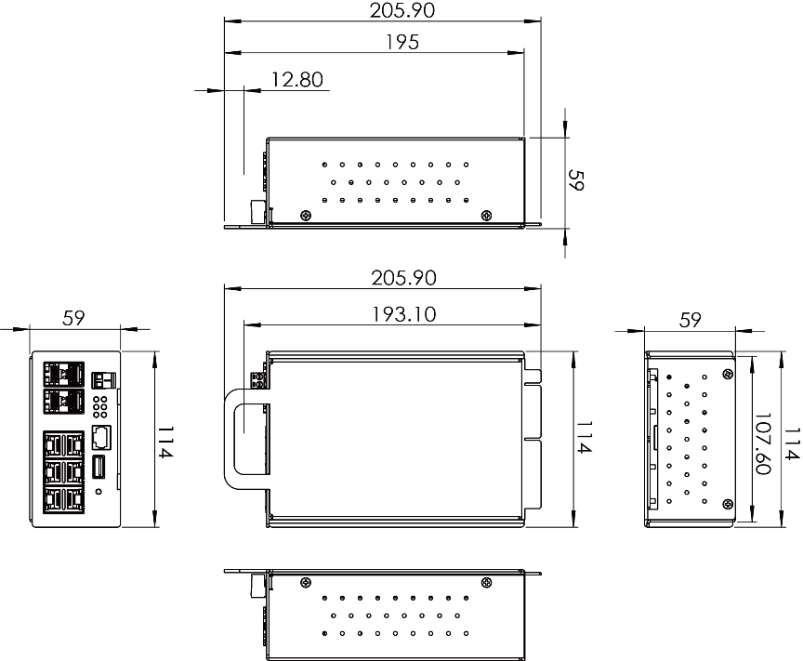

DYMEC 3170 Supports: 2 & 4 Wire LONG RANGE ETHERNET / VDSL2 SFP Modem
With long reach coverage, high noise immunity, and compact board size, DYMEC KY-Pro-180-CRD Ruggedized SFP modem is an ideal upgrade for your Enterprise or Industry applications. Used in Pairs.

VDSL2 – Long Range Ethernet Application (KY-Pro-180-CRD)
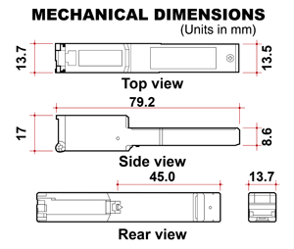 | 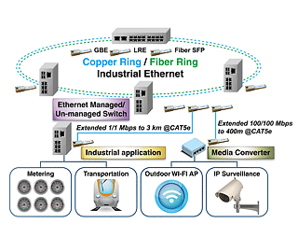

DYMEC KY-SFP-T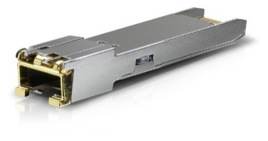
Copper SFP Transceiver – Used to Add Additional RJ-45 Copper Ports to your KY-3170 Series Switch
Easy to Install & Configure – GUI Selectable

Ordering Information
KY-3170™EM4-Pbt  DYMEC 3170bt™ Series | 6+4 Port, Industrial, Managed, PoE+, Gigabit Ethernet ITS Switch  - 6 x 10/100/1000T(x) PSE + 4 x 1000 SFP Slots / ERPS  - Operating Temperature: -40°C ~ 85°C (-40°F ~ 185°F)  - 400 Watts PoE Maximum  NSA Guideline Certified for Console Port Shutdown and Chassis Full Security  Made in USA

KY-3170™EM4-Pbt / 2  DYMEC 3170bt™ Series | 8+2 Port, Industrial, Managed, PoE+, Gigabit Ethernet ITS Switch (Configured 8 Copper RJ45 Ports)  - 6 x 10/100/1000T(x) PSE + 2 x 10/100/1000 Copper SFP + 2 x 1000 SFP Slot / ERPS  - Operating Temperature: -40°C ~ 85°C (-40°F ~ 185°F)  - 400 Watts PoE Maximum  NSA Guideline Certified for Console Port Shutdown and Chassis Full Security  Made in USA



DYMEC – Temperature Hardened, American Made, Ruggedized, NSA Certified Endpoint, Industrial Ethernet Switches / Routers for SCADA, ITS, Transportation, Automation, Power Utilities, Edge Computing, AI and Industrial Control Systems. Made in USA. Cyber-Secure, TAA Compliant. Uses SFP’s / BiDi SFP’s / Mini Gbic & VDSL2 Industrial SFP for Long Range Ethernet.

