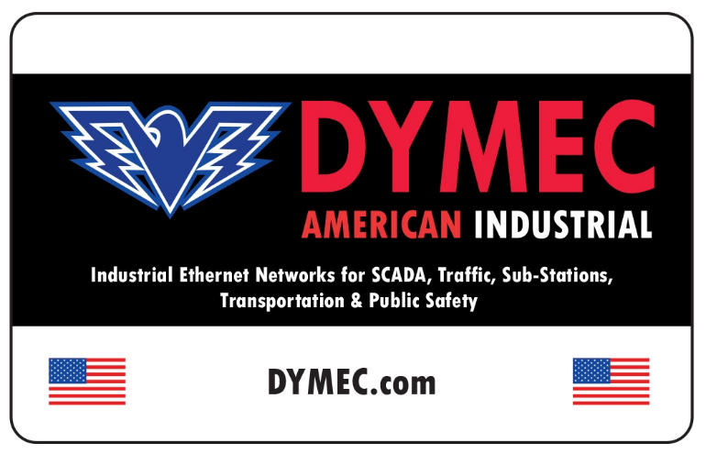
To request a Return Material Authorization (RMA) Number, please complete the following:

Please email the completed form to sales@DYMEC.com. You will be notified with an RMA number if your return request has been approved. Shipping address information for sending the unit to DYMEC is provided at the bottom of each page of this form.

For any questions concerning completion of the form please contact your DYMEC Sales Representative.

Please complete all information requested. Thank you.

First Name: |  | Last Name:
Email:
Company:
Telephone: |  | Extension:
Your Shipping Information:
Address: City:
State/Province/Region:
Country: | Zip Code:

Product Information:
Product Name/ Model Number: Serial Number:
PO Number:
Description of Issue:

Additional Comments:

RMA PROCESS

GENERAL

- – RMA REQUEST: A customer with hardware that requires repair should request a Return Merchandise Authorization (RMA) number by filling out this form and submitting it to DYMEC via email to your sales channel representative or sales@dymec.com.

- – RMA REVIEW: The RMA Administrator will review the request and, before proceeding, may request additional information, or suggest additional diagnostic steps to ensure that the hardware is not returned for repair unnecessarily.

- – RMA CHARGES: For Warranty or Extended Hardware Maintenance claims, there will be no test/repair charges. Out-of-Warranty (OOW) RMA returns will require a charge. Prior to the RMA being issued the RMA Administrator will inform the customer of the flat rate charge for test/repair of the hardware and request the customer to provide a Purchase Order (PO) for the RMA to be issued. A formal quote for the associated RMA charges can be provided upon request.

- – PO REQUIREMENTS: A PO is not required for Warranty or Extended Hardware Maintenance claims. A customer provided PO number can be included in the RMA information for customer reference upon request. A PO must be provided for all OOW RMA returns. Additional details on PO requirements can be provided upon request.

– RMA ISSUED: When the RMA Administrator has confirmed a repair is necessary and all other requirements have been satisfied a reply will be sent to the customer with an RMA number including packaging and shipping instructions.

- – SHIPMENT OF RMA TO DYMEC: The customer is responsible for the safe shipment of the hardware in appropriate packaging. Any hardware product arriving on our receiving dock without an RMA issued is subject to return to the customer without test/repair being conducted.

- – TEST/REPAIR: DYMEC will make a best effort to repair all returned hardware. Warranty and Extended Hardware Maintenance covered hardware that cannot be repaired with reasonable effort will be replaced at no charge to the customer.

- – RMA TURN-AROUND TIME: The Average RMA turn-around time is 15-30 days from the date the RMA arrives on the DYMEC dock thru the date of reshipment from DYMEC.

- – Advanced Replacement: Customers with Advanced Replacement contract should note the fact on the RMA form when it is submitted. Serial numbers must be provided.

ADDITIONAL DETAILS

NO TROUBLE FOUND RMAS
If an RMA is determined to be NO Trouble Found (NTF), DYMEC will request additional information from the customer in an attempt to allow DYMEC to replicate the observed failure. If no additional information is available or the observed failure cannot be reproduced, DYMEC will return the RMA to the customer as NTF. The policy applies to Warranty, Extended Hardware Maintenance and OOW RMAs. Full OOW charges do apply.

Not REPAIRABLE WARRANTY AND EXTENDED HARDWARE MAINTENANCE
Hardware returned to DYMEC covered by Warranty or Extended Hardware Maintenance determined to be not repairable because of a hardware fault that has not been induced by customer misuse will be replaced for no charge to the customer.

UNREPAIRABLE OOW (Out of Warranty)
Hardware returned to DYMEC and determined to be not repairable for any reason will not be automatically replaced. A replacement hardware product can be ordered through the customer’s normal DYMEC sales channel. OOW hardware found to be not repairable can either be returned to the customer ‘as is’ for final disposition or scrapped at DYMEC upon customer request.
DYMEC will request final disposition instructions from the customer when a hardware product is determined to be not repairable.

SHIPPING OF RMAS to DYMEC
Shipping of all Warranty, Extended Hardware Maintenance and OOW RMAs from the customer to DYMEC is at customer expense after the RMA is issued unless there is an agreement in advance for DYMEC to pay for the shipment via collect shipping on a DYMEC shipper account. Customers are encouraged to notify DYMEC when RMAs are shipped and to provide shipment tracking details. RMAs are to be appropriately packaged to ensure the safe transit of the hardware product to DYMEC and with observance of proper ESD requirements for the packing materials used. Any damage or subsequent failure of the hardware product related to inappropriate packaging will result in additional charges for the repair of the product.

SHIPPING OF WARRANTY AND EXTENDED HARDWARE MAINTENANCE RMAS FROM DYMEC
Shipping of all Warranty and Extended Maintenance RMAs from DYMEC to the customer are at DYMEC’s expense using the DYMEC preferred shipper unless a prior agreement is entered with the customer to ship differently. RMA shipments within the continental US are shipped via FedEx Ground for all US customer locations, unless other arrangements are made in advance between the customer and DYMEC. International shipments are made using DHL International Delivery unless other arrangements are made in advance between the customer and DYMEC.

SHIPPING OF Out of Warranty (OOW) RMAS FROM DYMEC
Shipping of all OOW RMAs from DYMEC is at customer expense. The cost of shipping from DYMEC is not included in the quoted OOW RMA repair charge. The customer has the option of providing a shipper name and account number for collect shipping of the RMA at the time the RMA is issued via the RMA Request or on the customer provided PO, or DYMEC to add the cost of shipping to the DYMEC Invoice in addition to the OOW RMA repair charge.

ADVANCE REPLACEMENT OF WARRANTY AND EXTENDED HARDWARE MAINTENANCE RMAS
DYMEC may provide an Advance Replacement of a failed hardware product on a case by case basis. Only Warranty and Extended Hardware Maintenance covered hardware products will be considered for Advance Replacement upon request or at DYMEC discretion. Advance Replacements are only considered for Dead on Arrival (DOA) hardware products that are reported to DYMEC within 60 days of original shipment or for mission critical installations. Advance Replacements are subject to hardware product availability.

CONTRACTED ADVANCE REPLACEMENT PROGRAM
DYMEC can provide a quote for an Advance Replacement Program on a flat fee basis. The cost of the program is based on the model and quantity of hardware product(s) being covered. Please contact your DYMEC Sales representative for further information on this program.

EXPEDITED RMA PROCESSING
DYMEC can provide expedited testing and repair of RMAs on a case by case basis for an additional charge. A quotation for expedited processing can be provided upon request.

Signature:

Printed Name:

Printed Title:

Date:

RMA NUMBER ISSUED:

Date:

