KY-MSX0812 / DYMEC X Series
8+12 Port Industrial Managed Temperature Hardened, Industrial Ethernet Switch with 10GbE Uplinks
Email: Sales@DYMEC.com
Web: DYMEC.com
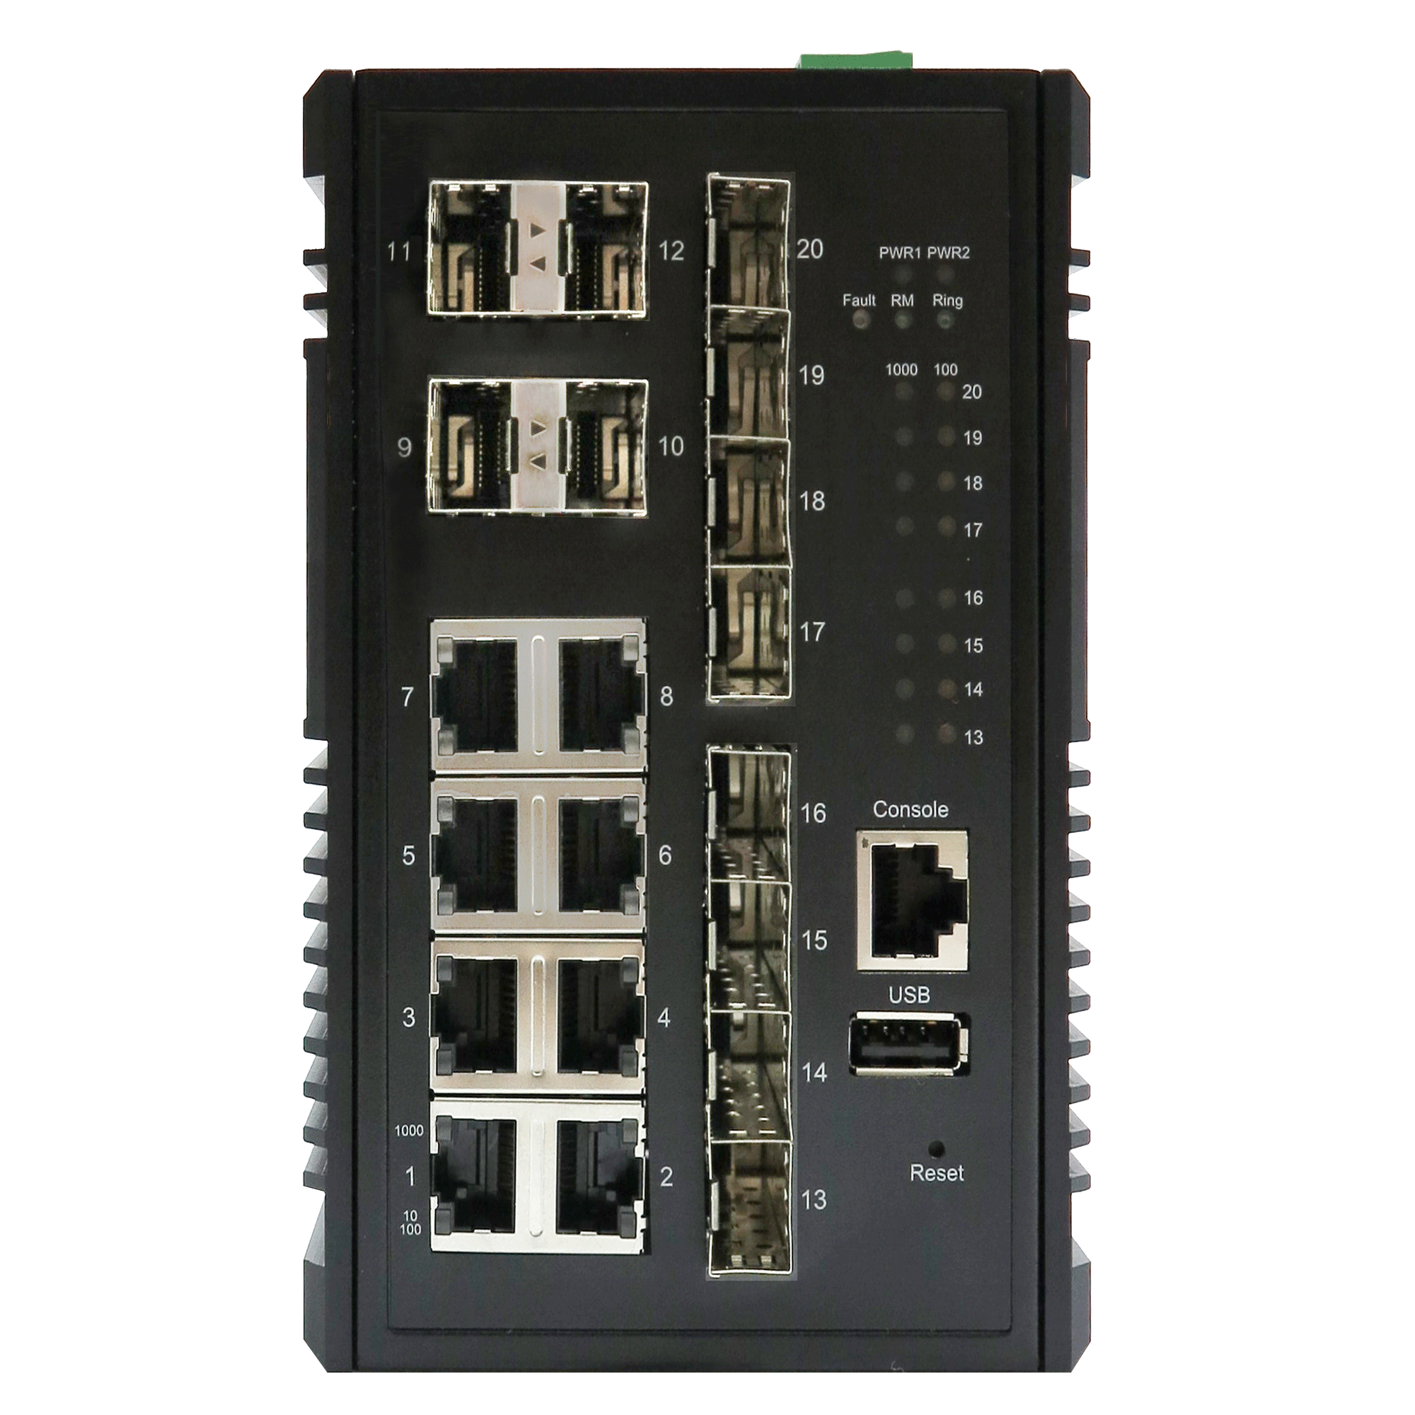 | - 8 x Gigabit Ethernet ports  - 4 x 1/10 Gigabit (GbE) Ethernet SFP+ Slot  - 8 x 100/1000F(x) SFP Slot  - NSA End Point Certified  - NSA Network Endpoint Guideline Certified for Console Port Shutdown and Chassis Full Security (Patent Pending)  - Built for harsh environments and wide temperature range applications / Edge Computing  - RSTP, MSTP, ERPS, LACP for Network Redundancy  - QoS CoS/DSCP to increase determinism  - Supports IGMP Snooping v1/v2/v3, up to 1024 groups  - DHCP Relay Option 82 IP address assignment  - SNMP v1/v2c/v3 for network management  - Supports Storm Protection / Broadcast Control  - USB storage for configuration-free replacement  - Supports industrial automation protocols Ethernet/IP & Modbus TCP  - Secure File Transfer Protocol (SFTP) & Trivial File Transfer Protocol (TFTP)  
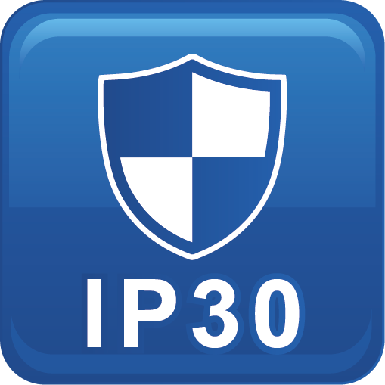

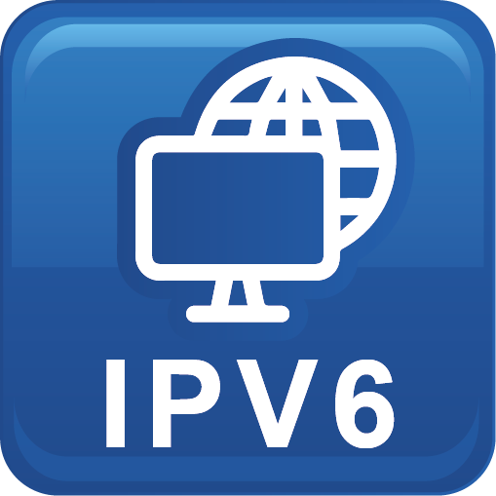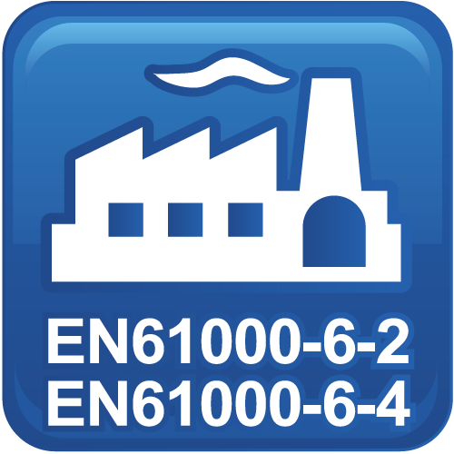
Specifications

Technology
Standards | IEEE 802.3 10BaseT  IEEE 802.3u 100BaseTX  IEEE 802.3ab 1000BaseT  IEEE 802.3z 1000BaseX  IEEE 802.3ae 10GBase over Fiber  IEEE 802.3x Flow Control  IEEE 802.3ad/802.1AX LACP  IEEE 802.1D Spanning Tree Protocol  IEEE 802.1w Rapid STP  IEEE 802.1s Multiple STP  ITU-T G.8032 / Y.1344 ERPS  IEEE 802.1Q VLAN Tagging  IEEE 802.1ad Stacked VLANs  IEEE 802.1p Class of Service  IEEE 802.1X Network Authentication  IEEE 802.1AB LLDP
Processing Type | Store and Forward
Switch Properties
Priority Queues | 8 Queues
Jumbo Frame | 16000bytes
MAC Table Size | 16K
VLAN Table Size | 4094
IGMP Group | 1023
Packet Buffer | 12Mbits
Software Features
Network Redundancy | RSTP, MSTP, G.8032 ERPSv2, Port Trunking with LACP
Security | 802.1X, RADIUS, TACACS+, SSL, SSH, ACL / Security ACL Package
Management | IPv4, IPv6, Web, Telnet, Serial Console, CLI, SNMP v1/v2c/v3, uPnP
Diagnostics | RMON, SNMP Inform/Trap, Syslog, SMTP, Port Mirroring, LLDP
Configuration | DHCP Server/Client, Relay Option 82, TFTP, USB
Filter | 802.1Q VLAN, Q-in-Q, IGMP Snooping v1/v2/v3, IGMP Querier, Independent Vlan Learning
Time Sync. | NTP
QoS | CoS, DSCP, WRR/SPQ Queuing, Storm Protection
Industrial Profiles | Ethernet/IP, Modbus TCP
Interface
RJ45 Port | 8 x 10/100/1000T(x), auto negotiation speed duplex mode, auto MDI/MDI-X
Fiber Port | 4 x 1/10 Gigabit Ethernet SFP+ Slot  4 x 1000F(x) SFP Slot + 4x 100/1000F(x) SFP Slots
LED Indicators | Per unit: PWR1, PWR2, Fault, Ring Master, Ring State  Ports: Link/Active with highest speed(Green), low speed(Amber)
Alarm Contact | 1 x relay output with current carrying capacity of 1A @ 24 Volts DC
Digital Inputs | 1 x isolated input from the electronics.  +13 to +30 Volts for state "1"  -30 to +3 Volts for state "0"  Maximum input current: 8mA
Button | Multiple functions reset button
Serial Console | 1 x RS232 in RJ45 connector with console cable, 115.2Kbps, 8N1
Storage | 1 x USB 2.0 storage for firmware update, configuration backup, restore, boot up and syslog
Power Requirements
Operation Voltage | 12-48 Volts DC, redundant dual inputs
Connection | 1 x removable 4-contact terminal block
Power Consumption | 0.79A@ 24 Volts DC
Protection | Overload Current Protected, Reverse Polarity Protected
Mechanical Construction
Enclosure | Aluminum – Military Grade
Protection Class | IP30
Dimensions | 91 x 145 x 118 mm (W x H x D)
Weight | 1.38 kg
Mounting | DIN-Rail Mounting, Optional Wall Mounting Kits
Environmental Limits
Operating Temperature | Extended: -40°C ~ 80°C (-40°F ~ 176°F)
Storage Temperature | -40°C ~ 85°C (-40°F ~ 185°F)
Ambient Relative Humidity | 5 to 95%, (Non-Condensing)
Regulatory Approvals
Altitude Certified  GB4943.1-2011 | 0 ~ 5000 Meters
EMI | FCC Part 15 Subpart B Class A  CE EN 55032 Class A
EMS | IEC61000-4-2 (ESD)  IEC61000-4-3 (RS)  IEC61000-4-4 (EFT)  IEC61000-4-5 (Surge)  IEC61000-4-6 (CS)  IEC61000-4-8 (Magnetic Field)
Free Fall | IEC60068-2-32
Shock | IEC60068-2-27
Vibration | IEC60068-2-6
Green | RoHS Compliant
Certifications | UL 60950-1/62368  61000-6-2 / FCC / NEMA TS-2  61000-6-4 / ITUT / IEEE
MTBF  MIL-HDBK-217  IEC 62380 | >150,000 hours
Warranty  TAA Compliant | 5 Years / Limited Lifetime  Certified TAA Compliant

Note from DYMEC Development.
In a continuing effort of improvement and updated technology, product specifications are subject to change without notice.
Email: Sales@DYMEC.com
Web: DYMEC.com
Dimensions (unit = mm)
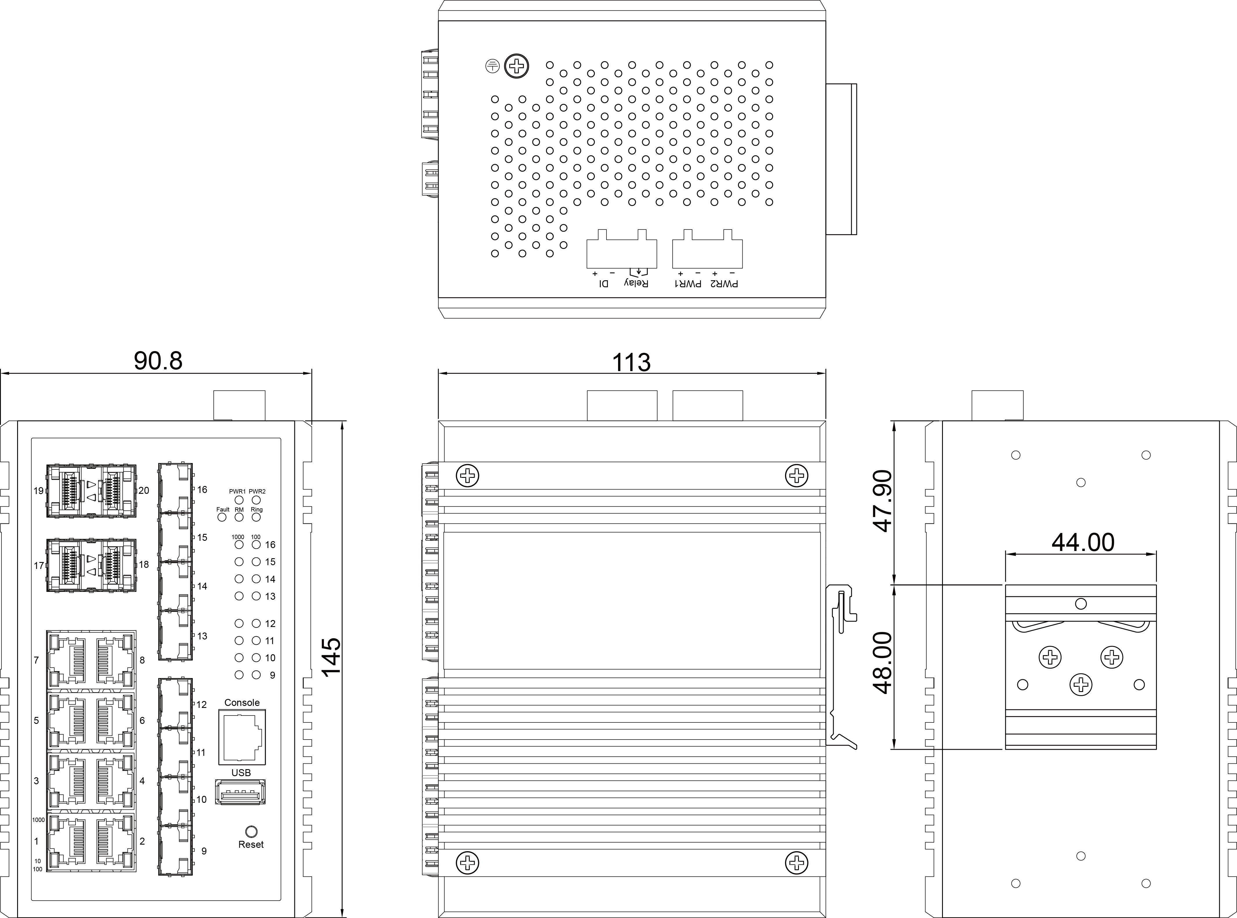

Ordering Information
KY-MSX0812  DYMEC X  Series |  |  | 8 + 12 Port Industrial Managed Ethernet Switch with 10GbE Uplinks  - 8 x 10/100/1000T(x) & 8 x 100/1000F(x) SFP Slots & 4 x 1 / 10 Gigabit Ethernet SFP+ Slots  - Operating Temperature: -40°C ~ 80°C (-40°F ~ 176°F)  NSA Guideline Certified for Console Port Shutdown and Chassis Full Security
Optional Accessories
 | KY-PS24-40W | Industrial Sealed Block Supply with 24 Volts DC Output, provides a maximum of 40 Watts Power. Teflon Shielding includes AC Cord, Temperature Hardened, Military Grade
 | KY-PS24-45W/2A/DR | Industrial DIN-Rail Power Supply with 24 Volts DC Output, provides a maximum of 45 Watts Power. Temperature Hardened, Military Grade
 | KY-PS48-120W/2.5A/DR | Industrial DIN-Rail Power Supply with 48 Volts DC Output, provides a maximum of 120 Watts Power. Temperature Hardened, Military Grade

DYMEC – Temperature Hardened, American Made, Ruggedized, NSA Certified Endpoint, Industrial Ethernet Switches / Routers for SCADA, ITS, Transportation, Automation, Power Utilities, Edge Computing, AI and Industrial Control Systems. Made in USA. Cyber-Secure


Email: Sales@DYMEC.com
Web: DYMEC.com

