DYMEC ERPSv2 (ITUT G.8032 / Y1344) Explained

This white paper describes how to configure Ethernet Ring Protection Switching (ERPS). ERPS is a protocol defined by the International Telecommunication Union - Telecommunication Standardization Sector (ITU-T) to eliminate loops at Layer 2. It implements convergence of carrier-class reliability standards and allows all ERPS-capable devices on a ring network to communicate.

- Overview of ERPS
- Understanding ERPS
- Application Scenarios for ERPS
- Summary of ERPS Configuration Tasks
- Licensing Requirements and Limitations for ERPS
- Default Settings for ERPS
- Configuring ERPS
- Maintaining ERPS
- Configuration Examples for ERPS
- Troubleshooting ERPS

Overview of ERPS

Definition
ERPS is a protocol defined by the International Telecommunication Union - Telecommunication Standardization Sector (ITU-T) to eliminate loops at Layer 2. Because the standard number is ITU-T G.8032/Y1344, ERPS is also called G.8032. ERPS defines Ring Auto Protection Switching (RAPS) Protocol Data Units (PDUs) and protection switching mechanisms.
ERPS has two versions: ERPSv1 released by ITU-T in June 2008 and ERPSv2 released in August 2010. EPRSv2, fully compatible with ERPSv1, provides the following enhanced functions:
- Multi-ring topologies, such as intersecting rings
- RAPS PDU transmission on non-virtual channels (NVCs) in sub-rings
- Forced Switch (FS) and Manual Switch (MS)
- Revertive and non-revertive switching

Purpose
Generally, redundant links are used on an Ethernet switching network such as a ring network to provide link backup and enhance network reliability. The use of redundant links, however, may produce loops, causing broadcast storms and rendering the MAC address table unstable. As a result, communication quality deteriorates, and communication services may even be interrupted. Table 1-1 describes ring network protocols supported by devices.
Table 12-1 Ring network protocols supported by devices
Ring Network Protocol | Advantage | Disadvantage
STP/RSTP/MSTP | - Applies to all Layer 2 networks.  - A standard IEEE protocol that allows standards-based devices to communicate with other devices. | Provides low convergence on a large network, which cannot meet the carrier-class reliability requirement.
ERPS | - Provides fast convergence and carrier-class reliability.  - Is a standard ITU-T protocol that allows any standards based ERPS devices to communicate with other manufacturers standards based ERPS devices.  - Supports single-ring and multi-ring topologies in ERPSv2. | Requires the network topology to be planned. The configuration may be complex.
Industrial Ethernet networks demand faster protection switching. STP & RSTP do not meet the requirement for fast convergence.
ERPS, a standard ITU-T protocol, prevent loops on ring networks. It optimizes detection and performs fast convergence. ERPS allows all ERPS-capable devices on a ring network to communicate, regardless of manufacturer.

Benefits
- Prevents broadcast storms and implements fast traffic switchover on a network where there are loops.
- Provides fast convergence and carrier-class reliability.
- Allows all ERPS-capable devices on a ring network to communicate.

Understanding ERPS
- Basic ERPS Concepts
- RAPS PDUs
- ERPS Single-ring Principles
- ERPS Multi-ring Principles
- ERPS Multi-instance

Basic ERPS Concepts
ERPS eliminates loops at the link layer of an Ethernet network. ERPS works for ERPS rings. There are several nodes in an ERPS ring. ERPS blocks the RPL owner port and controls common ports to switch the port status between Forwarding and Discarding and eliminate loops. ERPS uses the control VLAN, data VLAN, and Ethernet Ring Protection (ERP) instance.
On the network shown in Figure 1-1, Switch A through Switch D constitute a ring and are dual homed to the upstream network. This access mode will cause a loop on the entire network. To eliminate redundant links and ensure link connectivity, ERPS is used to prevent loops.

Figure 1-1 ERPS single-ring networking
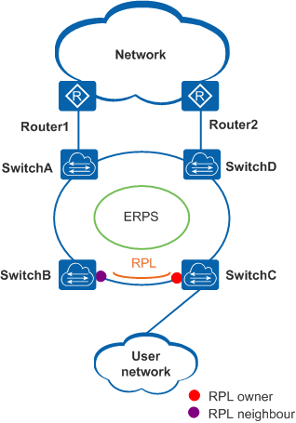
ERPS can be deployed on the network shown in Figure 1-1.

ERPS Ring
An ERPS ring consists of interconnected Layer 2 switching devices configured with the same control VLAN.
An ERPS ring can be a major ring or a sub-ring. By default, an ERPS ring is a major ring. The major ring is a closed ring, whereas a sub-ring is a non-closed ring. The major ring and sub-ring are configured using commands. On the network shown in Figure 1-2, Switch A through Switch D constitute a major ring, and Switch C through Switch F constitute a sub-ring.
Only ERPSv2 supports sub-rings.
Figure 1-2 ERPS major ring and sub-ring networking
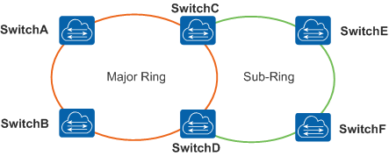

Node
A node refers to a Layer 2 switching device added to an ERPS ring. A maximum of two ports on each node can be added to the same ERPS ring. Switch A through Switch D in Figure 1-2 are nodes in an ERPS major ring.

Port Role
ERPS defines three port roles: RPL owner port, RPL neighbor port (only in ERPSv2), and common port.
- RPL owner port
An RPL owner port is responsible for blocking traffic over the Ring Protection Link (RPL) to prevent loops. An ERPS ring has only one RPL owner port.
When the node on which the RPL owner port resides receives an RAPS PDU indicating a link or node fault in an ERPS ring, the node unblocks the RPL owner port. Then the RPL owner port can send and receive traffic to ensure nonstop traffic forwarding.
The link where the RPL owner port resides is the RPL.
- RPL neighbor port
An RPL neighbor port is directly connected to an RPL owner port.
Both the RPL owner port and RPL neighbor ports are blocked in normal situations to prevent loops.
If an ERPS ring fails, both the RPL owner and neighbor ports are unblocked.
The RPL neighbor port helps reduce the number of FDB entry updates on the device where the RPL neighbor port resides.
- Common port
Common ports are ring ports other than the RPL owner and neighbor ports.
A common port monitors the status of the directly connected ERPS link and sends RAPS PDUs to notify the other ports of its link status changes.

Port Status
On an ERPS ring, an ERPS-enabled port has two statuses:
- Forwarding: forwards user traffic and sends and receives RAPS PDUs.
- Discarding: only sends and receives RAPS PDUs.

Control VLAN
A control VLAN is configured in an ERPS ring to transmit RAPS PDUs.
Each ERPS ring must be configured with a control VLAN. After a port is added to an ERPS ring configured with a control VLAN, the port is added to the control VLAN automatically.
Different ERPS rings must use different control VLANs.

Data VLAN
Unlike control VLANs, data VLANs are used to transmit data packets.

ERP Instance
On a Layer 2 device running ERPS, the VLAN in which RAPS PDUs and data packets are transmitted must be mapped to an Ethernet Ring Protection (ERP) instance so that ERPS forwards or blocks the packets based on configured rules. If the mapping is not configured, the preceding packets may cause broadcast storms on the ring network. As a result, the network becomes unavailable.

Timer
ERPS defines four timers: Guard timer, WTR timer, Holdoff timer, and WTB timer (only in ERPSv2).
- Guard timer
After a faulty link or node recovers or a clear operation is executed, the device sends RAPS No Request (NR) messages to inform the other nodes of the link or node recovery and starts the Guard timer. Before the Guard timer expires, the device does not process any RAPS (NR) messages to avoid receiving out-of-date RAPS (NR) messages. After the Guard timer expires, if the device still receives a RAPS (NR) message, the local port enters the Forwarding state.
- WTR timer
If an RPL owner port is unblocked due to a link or node fault, the involved port may not go Up immediately after the link or node recovers. Blocking the RPL owner port may cause network flapping. To prevent this problem, the node where the RPL owner port resides starts the wait to restore (WTR) timer after receiving a RAPS (NR) message. If the node receives a RAPS Signal Fail (SF) message before the timer expires, it terminates the WTR timer. If the node does not receive any RAPS (SF) message before the timer expires, it blocks the RPL owner port when the timer expires and sends a RAPS (no request, root blocked) message. After receiving this RAPS (NR, RB) message, the nodes set their recovered ports on the ring to the Forwarding state.
- Holdoff timer
On Layer 2 networks running ERPS, there may be different requirements for protection switching. For example, on a network where multi-layer services are provided, after a server fails, users may require a period to rectify the server fault so that clients do not detect the fault. You can set the Holdoff timer. If the fault occurs, the fault is not immediately sent to ERPS until the Holdoff timer expires.
- WTB timer
The wait to block (WTB) timer starts when Forced Switch (FS) or Manual Switch (MS) is performed. Because multiple nodes on an ERPS ring may be in FS or MS state, the clear operation takes effect only after the WTB timer expires. This prevents the RPL owner port from being blocked immediately.
The WTB timer value cannot be configured. Its value is the Guard timer value plus 5. The default WTB timer value is 7s.

Revertive and Non-revertive Switching
After link faults in an ERPS ring are rectified, re-blocking the RPL owner port depends on the switching mode:
- In revertive switching, the RPL owner port is re-blocked after the WTR timer expires, and the RPL is blocked.
- In non-revertive switching, the WTR timer is not started, and the original faulty link is still blocked.
ERPS rings use revertive switching by default.
ERPSv1 supports only revertive switching. ERPSv2 supports both revertive and non-revertive switching.

Port Blocking Modes
Because the Ring Protection Link (RPL) may have high bandwidth, you can block the low-bandwidth link so that user traffic can be transmitted on the RPL. ERPSv2 supports both Forced Switch (FS) and Manual Switch (MS) modes for blocking an ERPS port:
- FS: forcibly blocks a port immediately after FS is configured, irrespective of whether link failures have occurred.
- MS: blocks a port on which MS is configured when the ERPS ring is in Idle or Pending state.
In addition to FS and MS operations, ERPS also supports the clear operation. The clear operation has the following functions:
- Clears an existing FS or MS operation.
- Triggers revertive switching before the WTR or WTB timer expires in the case of revertive switching operations.
- Triggers revertive switching in the case of non-revertive switching operations.
Only ERPSv2 supports port blocking modes.

RAPS PDU Transmission Mode in a Sub-ring
ERPSv2 supports single-ring and multi-ring topologies. In multi-ring topologies, both the virtual channel (VC) and non-virtual channel (NVC) can be used to transmit RAPS PDUs in sub-rings.
- VC: RAPS PDUs in sub-rings are transmitted to the major ring through interconnected nodes. The RPL owner port of the sub-ring blocks both RAPS PDUs and data traffic.
- NVC: RAPS PDUs in sub-rings are terminated on the interconnected nodes. The RPL owner port blocks data traffic but not RAPS PDUs in each sub-ring.
On the network shown in Figure 1-3, a major ring is interconnected with two sub-rings. The sub-ring on the left has a VC, whereas the sub-ring on the right has an NVC.

Figure 1-3 Interconnected rings with a VC or NVC
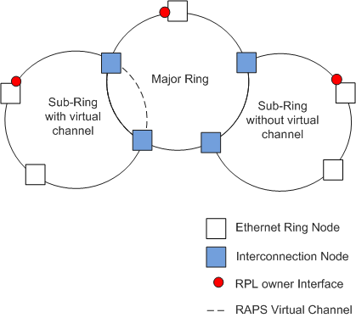

By default, sub-rings use NVCs to transmit RAPS PDUs, except for the scenario shown in Figure 1-4.

When sub-ring links are not contiguous, VCs must be used.
On the network shown in Figure 1-4, links b and d belong to major rings 1 and 2 respectively; links a and c belong to the sub-ring. As links a and c are not contiguous, they cannot detect the status change between each other, so VCs must be used for RAPS PDU transmission.
Figure 1-4 VC networking
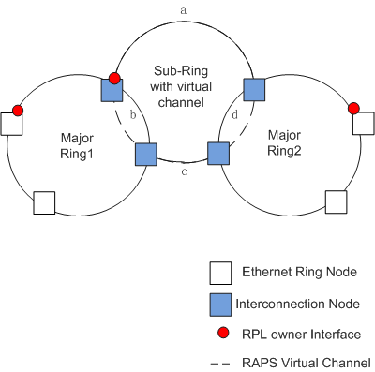
Table 1-2 lists the advantages and disadvantages of RAPS PDU transmission modes in sub-rings with VCs or NVCs.
Table 12-2 Comparison between RAPS PDU transmission modes in a sub-ring with VCs or NVCs
RAPS PDU Transmission Mode in a Sub-ring | Advantage | Disadvantage
VC | Applies to scenarios in which sub-ring links are not contiguous. (Linked) | Requires VC resource reservation and controls VLAN assignment from adjacent rings.
NVC | Does not need to reserve resources or control VLAN assignment from adjacent rings. | Is not applicable to scenarios in which sub-ring links are not contiguous. (Linked)

RAPS PDUs
ERPS protocol packets are called Ring Auto Protection Switching (RAPS) Protocol Data Units (PDUs), which are transmitted in ERPS rings to convey ERPS ring information. Figure 1-5 shows the RAPS PDU format.

Figure 1-5 RAPS PDU format
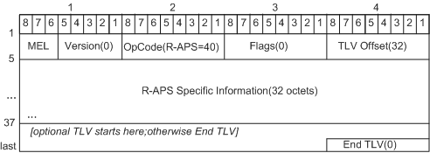
Table 1-3 describes the fields in a RAPS PDU.

Table 1-3 Fields in a RAPS PDU
Field | Length | Description
MEL | 3 bits | Identifies the maintenance entity group (MEG) level of the RAPS PDU.
Version | 5 bits | - 0x00: ERPSv1  - 0x01: EPRSv2
OpCode | 8 bits | Indicates a RAPS PDU. The value of this field is 0x28.
Flags | 8 bits | Is ignored upon RAPS PDU receiving. The value of this field is 0x00.
TLV Offset | 8 bits | Indicates that the TLV starts after an offset of 32 bytes. The value of this field is 0x20.
R-APS Specific Information | 32x8 bits | The core field in a RAPS PDU and carries ERPS ring information. There are differences between sub-fields in ERPSv1 and ERPSv2. Figure 1-6 shows the R-APS Specific Information field format in ERPSv1. Figure 1-7 shows the R-APS Specific Information field format in ERPSv2.
TLV | Not limited | Describes information to be loaded. The end TLV value is 0x00.
Figure 1-6 Format of the R-APS Specific Information field in ERPSv1
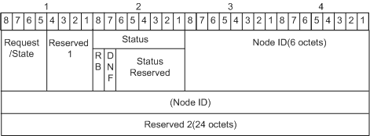
Figure 1-7 Format of the R-APS Specific Information field in ERPSv2
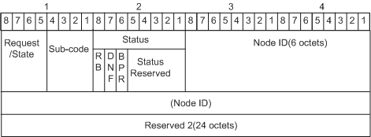
Table 1-4 describes sub-fields in the R-APS Specific Information field.

Table 1-4 Sub-fields in the R-APS Specific Information field
Sub-Field | Length | Description
Request/State | 4 bits | Indicates that this RAPS PDU is a request or state PDU. The value can be:  - 1101: forced switch (FS)  - 1110: Event  - 1011: signal failed (SF)  - 0111: manual switch (MS)  - 0000: no request (NR)  - Others: reserved
Reserved 1 | 4 bits | Reserved 1 is used in ERPSv1 for message reply or protection identifier.  Sub-code is used in ERPSv2. The value depends on the Request/State field value:  - If the Request/State field value is 1110, the Sub-code value is 0000, indicating FDB entry update.  - If the Request/State field value is any other value than 1110, the Sub-code value is 0000 and ignored upon RAPS PDU receiving.
Sub-code | 4 bits
Status | 8 bits | Includes the following status information:  - RPL Blocked (RB) (1 bit): The value 1 indicates that the RPL owner port is blocked; the value 0 indicates that the RPL owner port is unblocked. The nodes where the RPL owner port is not configured set this sub-field to 0 in outgoing RAPS PDUs.  - Do Not Flush (DNF) (1 bit): The value 1 indicates that FDB entries are not updated when RAPS PDUs are received; the value 0 indicates that FDB entries may be updated when RAPS PDUs are received.  - Blocked port reference (BPR) (1 bit): The value 0 indicates that ring link 0 is blocked. The value 1 indicates that ring link 1 is blocked.  BPR is valid only in ERPSv2.  - Status Reserved: This sub-field is reserved. This sub-field is all 0s during RAPS PDU transmission and is ignored upon RAPS PDU receiving. In ERPSv1, this sub-field has 6 bits. In ERPSv2, this sub-field has 5 bits.
Node ID | 6 x 8 bits | Identifies the MAC address of a node in an ERPS ring. It is informational and does not affect protection switching in the ERPS ring.
Reserved 2 | 24 x 8 bits | Is reserved and ignored upon RAPS PDU receiving. The value is all 0 during RAPS PDU transmission.

ERPS Multi-ring Principles
Ethernet Ring Protection Switching Version 1 (ERPSv1) supports only a single-ring topology, whereas ERPSv2 supports both single-ring and multi-ring topologies.
In a multi-ring topology, there are major rings and sub-rings. Depending on whether Ring Auto Protection Switching Protocol Data Units (R-APS PDUs) on a sub-ring are transmitted to a major ring, a sub-ring can either have or not have a virtual channel (VC). If R-APS PDUs on a sub-ring are transmitted to a major ring, the sub-ring has a virtual channel; otherwise, the sub-ring does not have a virtual channel.
This section describes how ERPS is implemented on a multi-ring network when links are normal, when a link fails, and when the link recovers.

Sub-rings Do Not Have VCs
Links Are Normal
On the multi-ring network shown in Figure 1-5, Switch A through Switch E constitute a major ring; Switch B, Switch C, and Switch F constitute sub-ring 1, and Switch C, Switch D, and Switch G constitute sub-ring 2. The LSWs in each ring can communicate with each other.
- To prevent loops, each ring blocks its RPL owner port. All other ports can transmit service traffic.
- The RPL owner port on each ring sends RAPS (NRRB) messages to all other nodes in the same ring at an interval of 5s. The RAPS (NRRB) messages in the major ring are transmitted only in this ring. The RAPS (NRRB) messages in each sub-ring are terminated on the interconnected nodes and therefore are not transmitted to the major ring.
Traffic between PC1 and the upper-layer network travels along the path PC1 -> Switch F -> Switch B -> Switch A -> Router1; traffic between PC2 and the upper-layer network travels along the path PC2 -> Switch G -> Switch D -> Switch E -> Router2.
Figure 1-5 ERPS multi-ring networking with sub-rings that do not have VCs (links are normal)
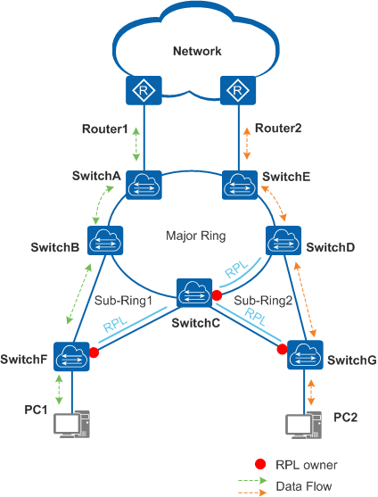
A Link Fails
As shown in Figure 1-6, if the link between Switch D and Switch G fails, the ERPS protection switching mechanism is triggered. The ports on both ends of the faulty link are blocked, and the RPL owner port in sub-ring 2 is unblocked to send and receive traffic. In this situation, traffic from PC1 still travels along the original path. Switch C and Switch D inform the other nodes in the major ring of the topology change so that traffic from PC2 is also not interrupted. Traffic between PC2 and the upper-layer network travels along the path PC2 -> Switch G -> Switch C -> Switch B -> Switch A -> Switch E -> Router2. The process is as follows:
- After Switch D and Switch G detect the link fault, they block their ports on the faulty link and update Filtering Database (FDB) entries.
- Switch G sends three consecutive RAPS (SF) messages to the other LSWs and sends one RAPS (SF) message at an interval of 5s afterwards.
- Switch G then unblocks the RPL owner port and updates FDB entries.
- After the interconnected node Switch C receives a RAPS (SF) message, it updates the FDB entries. Switch C and Switch D then send RAPS Event messages within the major ring to notify the topology change in sub-ring 2.
- After receiving a RAPS Event message, the other LSWs in the major ring update FDB entries.
Then traffic from PC2 is switched to a normal link.
Figure 1-6 ERPS multi-ring networking (unblocking the RPL owner port if a link fails).
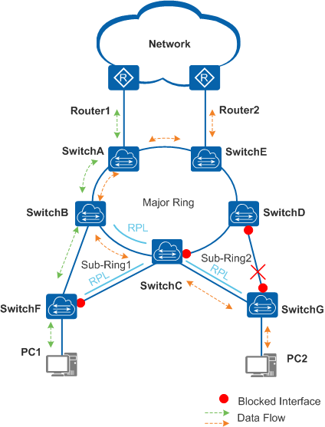
The Link Recovers
After the link fault is rectified, either of two situations may occur:
- If the ERPS ring uses revertive switching, the RPL owner port is blocked again, and the link that has recovered is used to forward traffic.
- If the ERPS ring uses non-revertive switching, the RPL remains unblocked, and the link that has recovered is still blocked.
The following example uses revertive switching to illustrate the process after the link recovers.
- After the link between Switch D and Switch G recovers, Switch D and Switch G start the Guard timer to avoid receiving out-of-date RAPS PDUs. The two devices do not receive any RAPS PDUs before the timer expires. Then Switch D and Switch G send RAPS (NR) messages within sub-ring 2.
- Switch G on which the RPL owner port resides starts the WTR timer. After the WTR timer expires, Switch G blocks the RPL owner port and unblocks its port on the link that has recovered and then sends RAPS (NR, RB) messages within sub-ring 2.
- After receiving a RAPS (NR, RB) message from Switch G, Switch D unblocks its port on the recovered link, stops sending RAPS (NR) messages, and updates FDB entries. Switch C also updates FDB entries.
- Switch C and Switch D (interconnected nodes) send RAPS Event messages within the major ring to notify the link recovery of sub-ring 2.
- After receiving a RAPS Event message, the other LSWs in the major ring update FDB entries.
Then traffic changes to the normal state, as shown in Figure 1-5.

Sub-rings Have VCs
When sub-rings have VCs, the R-APS PDUs of the sub-rings are transmitted to the major ring through the interconnection nodes. In other words, the interconnection nodes do not terminate the R-APS PDUs of the sub-rings. The blocked ports of sub-rings block both R-APS PDUs and data traffic.
Links Are Normal
On the multi-ring network shown in Figure 1-7, Switch A, Switch B, and Switch E constitute major ring 1; Switch C, Switch D, and Switch F constitute major ring 2; Switch A through Switch D constitute a sub-ring. The two major rings are interconnected with the sub-ring. The devices on each ring can communicate with each other.
- To prevent loops, each ring blocks its RPL owner port. All other ports can transmit data traffic.
- The RPL owner port on each ring sends R-APS (NR) messages to all other nodes on the same ring at an interval of 5s. The R-APS (NR) messages of each major ring are transmitted only within the same major ring, whereas the R-APS (NR) messages of the sub-ring are transmitted to the major rings over the interconnection nodes.
Traffic between PC1 and PC2 travels along the path PC1 <-> Switch E <-> Switch B <-> Switch C <-> Switch F <-> PC2.
Figure 1-7 ERPS multi-ring networking with a sub-ring that has VCs (links are normal)
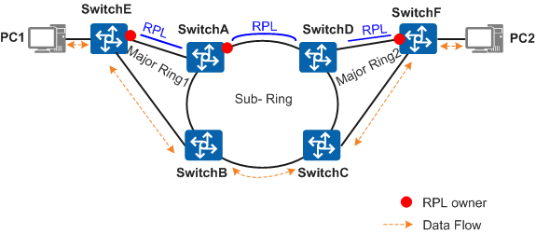

A Link Fails
As shown in Figure 1-8, if the link between Switch B and Switch C fails, ERPS is triggered. Specifically, the ports on both ends of the faulty link are blocked, and the RPL owner port on the sub-ring is unblocked to send and receive user traffic. Switch B and Switch C inform the other nodes on the major rings of the topology change so that traffic between PCs is not interrupted. Traffic between PC1 and PC2 then travels along the path PC1 <-> Switch E <-> Switch B <-> Switch A <-> Switch D <-> Switch C <-> Switch F <-> PC2. The detailed process is as follows:
- After Switch B and Switch C detect the link fault, they both block their ports on the faulty link and perform an FDB flush.
- Switch B sends three consecutive R-APS (SF) messages to the other devices on the sub-ring and then sends one R-APS (SF) message at an interval of 5s afterwards. The R-APS (SF) messages then arrive at major ring 1.
- After receiving an R-APS (SF) message, Switch A on major ring 1 unblocks its RPL owner port and performs an FDB flush.
- The other major ring nodes also perform an FDB flush. Traffic between PCs is then rapidly switched to a normal link.
Figure 1-8 ERPS multi-ring networking with a sub-ring that has VCs (a link fails)
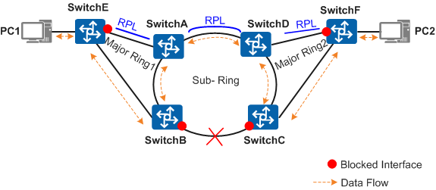

The Link Recovers
After the link fault is rectified, either of the following situations may occur:
- If the revertive switching mode is configured for the ERPS major rings and sub-ring, the RPL owner port is blocked again, and the link that has recovered is used to forward traffic.
- If the non-revertive switching is configured for the ERPS major rings and sub-ring, the RPL owner port remains unblocked, but the link that has recovered remains blocked.
The following example uses revertive switching to describe the process after the link recovers.
- After the link between Switch B and Switch C recovers, Switch B and Switch C start a guard timer to avoid receiving out-of-date R-APS PDUs. The two routers do not receive any R-APS PDUs before the timer expires. Then Switch B and Switch C send R-APS (NR) messages, which are transmitted within the major rings and sub-ring.
- Switch A starts the WTR timer. After the WTR timer expires, Switch A blocks the RPL owner port and then sends R-APS (NR, RB) messages to other connected devices.
- After receiving an R-APS (NR, RB) message from Switch A, Switch B and Switch C unblock its port on the recovered link, stop sending R-APS (NR) messages, and perform an FDB flush.
- After receiving an R-APS (NR, RB) message from Switch A, other devices also perform an FDB flush.
Traffic then travels in the same way as that shown in Figure 1-7.

ERPS Multi-instance
On a common ERPS network, a physical ring can be configured with a single ERPS ring, and only one blocked port can be specified in the ring. When the ERPS ring is in normal state, the blocked port prohibits all service packets from passing through. As a result, all service data is transmitted through one path over the ERPS ring, and the other link on the blocked port becomes idle, wasting bandwidth. As shown in Figure 1-9, when only ERPS Ring1 is configured, Interface1 is blocked and data is forwarded through the path where Data Flow1 travels. The link Switch C -> Switch D -> Switch E is idle.
Figure 1-9 Networking diagram of ERPS multi-instance
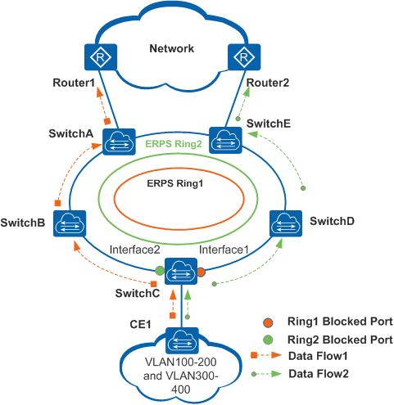
To improve link use efficiency, only two logical rings can be configured in the same physical ring in the ERPS multi-instance. A port may have different roles in different ERPS rings and different ERPS rings use different control VLANs. A physical ring can have two blocked ports accordingly. Each blocked port independently monitors the physical ring status and is blocked or unblocked. An ERPS ring must be configured with an ERP instance, and each ERP instance specifies a range of VLANs. The topology calculated for a specific ERPS ring only takes effect in the ERPS ring. Different VLANs can use separate paths, implementing traffic load balancing and link backup.
As shown in Figure 1-9, you can configure ERPS Ring1 and ERPS Ring2 in the physical ring consisting of Switch A through Switch E. Interface1 is the blocked port in ERPS Ring1. The VLANs mapping to the ERP instance is VLANs 100 to 200. Interface2 is the blocked port in ERPS Ring2. The VLANs mapping to the ERP instance is VLANs 300 to 400. After the configuration is completed, data from VLANs 100 to 200 is forwarded through Data Flow1, and data from VLANs 300 to 400 is forwarded through Data Flow2. In this manner, load balancing is implemented, and link use efficiency is improved.

Application Scenarios for ERPS
Generally, redundant links are used on an Ethernet switching network to provide link backup and enhance network reliability. The use of redundant links, however, may produce loops, causing broadcast storms and rendering the MAC address table unstable. As a result, communication quality deteriorates, and communication services may even be interrupted.
To prevent loops caused by redundant links, enable ERPS on the nodes of the ring network. ERPS is a Layer 2 loop-breaking protocol defined by the ITU-T and provides fast convergence of carrier-class reliability standards.
Figure 1-10 Layer 2 application of ERPS
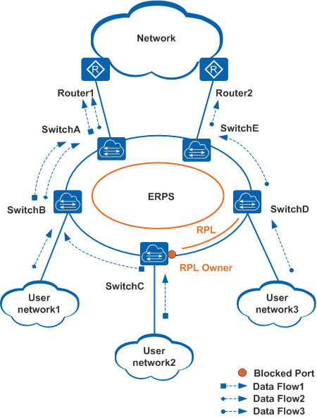

As shown in Figure 1-10, Switch A through Switch E constitute a ring. The ring runs ERPS to provide protection switching for Layer 2 redundant links and prevent loops that cause broadcast storms and render the MAC address table unstable.
Generally, the RPL owner port is blocked and does not forward service packets, preventing loops. If a fault occurs on the link between Switch A and Switch B, ERPS will unblock the blocked RPL owner port and traffic from User network1 and User network2 is forwarded through the path Switch C ->Switch D ->Switch E.

Default Settings for ERPS
Table 1-5 describes default ERPS settings.

Table 1-5 ERPS default setting
Parameter | Default Setting
ERPS ring | Not created
Guard timer | 200 centi-seconds
Wait to restore (WTR) timer | 5 minutes
Holdoff timer | 0 deci-seconds
ERPS version | ERPSv1

