Safety
UL 60950-1
DY-HI8011-9bt - Hardened 90-Watt. Gigabit, IEEE 802.3bt, POE Injector
1 x 95 Watt Gigabit TX PSE + 1 x Gigabit TX, 48-56 Volts DC input voltage,
Operating temp.: -40°C to +75°C

Features:
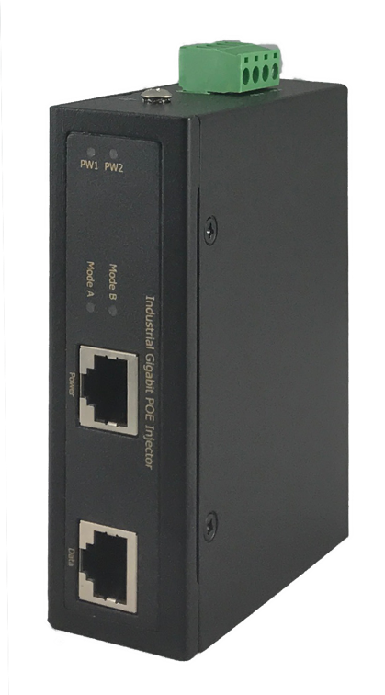
- Safety UL60950-1 Certified
- Rugged Military Grade Aluminum Housing
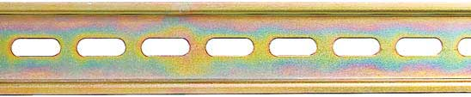
- Deliver ultrahigh power up to 95Watts
- Supports Redundant Power Inputs
- Working in extreme environment -40 to +85°C

DY-HI8011-90bt
Overview

This ultrahigh power hardened Gigabit POE Injector is equipped with 1 x 90-Watt Gigabit PSE port to power up to 90 Watts PD devices. Used for camera, WiFi AP, or LoRa applications. This unit was made especially for IP surveillance, traffic monitoring, outdoor cameras and for a broad range of power applications. It can tolerate -40°C to +75°C in harsh environments.

Specifications
IEEE Standard | IEEE 802.3 10Base-T Ethernet  IEEE 802.3u 100Base-TX Fast Ethernet  IEEE 802.3ab 1000Base-T Gigabit Ethernet  IEEE 802.3 af/at/bt
Network Connector | 1xRJ-45 10/100/1000BaseT(X) Data  1xRJ-45 10/100/1000BaseT(X) Data with POE Output Power
Network Cable | UTP/STP Cat.5e or above Cable
Network Cable | EIA/TIA-568 10-ohm (100m)
Protocol | CSMA/CD
LED | PW1 (Green): ON－Power is detected  PW2 (Green): ON－Power is detected  Mode A (Green): For End-Span PoE power 1,2,3,6  Mode B (Green): Reserved
POE Pin Assignment | Pin 1 (V-), 2 (V-), 3 (V+), 6 (V+)  Pin 4 (V+), 5 (V+), 7 (V-), 8 (V-)
Reverse polarity protection | Present
Overload current protection | Present
Power Supply | 2 Redundant input power sources  48V-57V VDC Power Input
Power Consumption | 1 Watt @48 VDC Without POE
POE power | Maximum POE power 95watts at 56VDC input
Removable Terminal Block | Provide 4 pin terminal block  Wire range: 0.34mm^2 to 2.5mm^2  Solid wire (AWG):12-24/14-22  Stranded wire(AWG): 12-24/14-22  Torque:5lb-In/0.5Nm/0.56Nm  Wire Strip length: 7-8mm
Operating Temperature | -40°C to 85°C
Operating Humidity | 5% to 95% (Non-condensing)
Storage Temperature | -40°C to 75°C
MTBF (mean time between failure) | >5000,000 hours ( MIL-HDBK-217F) at 25°C
Housing | Rugged Aluminum, IP30 Protection
Case Dimension (L X W X D)mm | 103.5 x 32 x 81.5 mm (L x W x D)
Installation mounting | DIN Rail and Wall Mount options included

Certifications:
Safety | UL 60950-1
Safety | IEC EN60950-1
EMC/EMS | CE, FCC, VCCI
EN 60068-2-6 | Vibration
EN 60068-2-27 | Shock
EN 60068-2-32 | Free Fall

