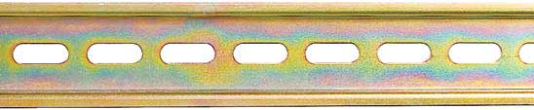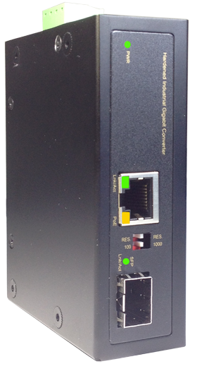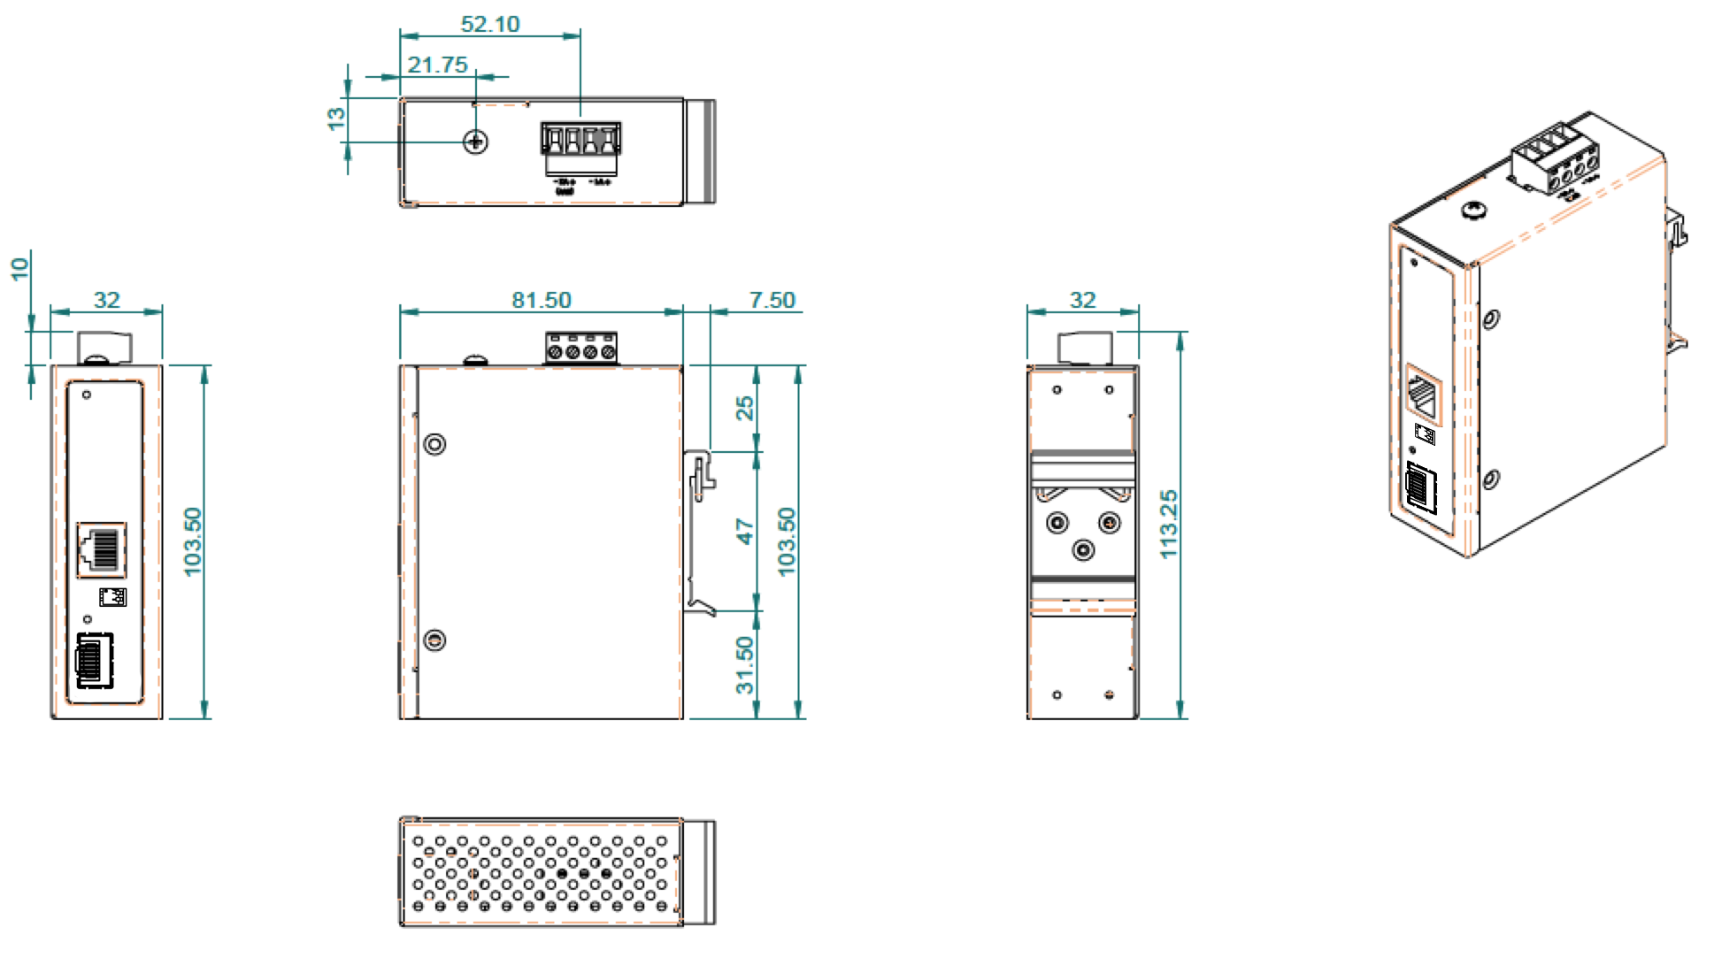

**DY-HCS8011SFP-60W**

**American Industrial 60 Watts Hardened Gigabit POE++ Mediaconverter, designed with the Hardened Marvell IC, 1x10/100/1000M 60W PSE (supports 802.3af/at) TX + 100/1000M SFP, 48-56VDC,**

**Operating Temperature: -40°C to +85°C //**

**Limited Lifetime Warranty**

**DY-GCS8011SFP-60W**

**Summary:**

This Rugged 60 Watt Industrial POE+ Media converter is designed with the latest hardened Marvell PoE++ Chipset. It delivers a FULL 60 Watts of PoE power and can tolerate extreme temperatures as well as a harsh environment. Our Cool Design technology will not only power up your PD device, but also reduce the excessive heat problem to an absolute minimum. The Input DC voltage ranges from 48 Volts DC to 56 Volts DC and meets the IEEE802.3af/at standard required voltages. The PoE++ converter can deliver up to 60 Watts of power via 4 pairs of Cat 5/6/7 UTP Wire up to 100 Meters. The device meets IEEE / IEC and Bicsi Power Over Ethernet Standards to deliver 48 Volts DC to your high powered PD device. DYMEC has rigorously the device to meet the toughest conditions for your Security, Transportation, IT, Railway, Industrial and Telecom applications.

**60 WATTS**

**Power Over Ethernet**

**American**

**Certified**

**Ethernet**

No Counterfeit

Chinese Chips or PCB’s

|  |  |
| --- | --- |
| **IEEE Standards** | IEEE 802.3 10Base-T Ethernet IEEE 802.3u 100Base-TX Fast Ethernet IEEE 802.3ab 1000Base-T Gigabit Ethernet  IEEE 802.3z 1000Base-X Gigabit Ethernet IEEE802.3x Flow Control and Back Pressure,  IEEE802.3af for POE  IEEE802.3at for POE+ |
|
| **Switch Architecture** | Back-plane (Switching Fabric): 4Gbps |
| **Data Processing** | Store and Forward |
| **Flow Control:** | IEEE 802.3x Flow Control and Back Pressure |
| **Jumbo Frame** | 9KB |
| **MAC address Table Size** | 2K |
| **Packet Buffer Size** | 1M |
| **Network Connector:** | 1xRJ-45 10/100/1000BaseT(X) PSE with POE++ Output power up to 95Watts  1 x 100/1000M SFP |
| **Network Cable** | UTP/STP Cat.5e, 6, 7 or above Cable |
| EIA/TIA-568 10-ohm (100m) |
| **Protocol** | CSMA/CD |
| **LED** | PW1 (power 1) Green: ON- power good, OFF-power failed  UTP LEDS:  Amber ON- PD detected  Green ON – Link/active –  SFP LED:  Green ON – SFP detected |
| **POE Pin Assignment** | 95 watts 4 pairs  V+, V+, V-, V- for pin 1, 2, 3, 6  V+, V+, V-, V- for pin 4, 5, 7, 8 |
| **DIP Switch** | To select SFP speed 100M or 1000M. |
| **Reverse polarity protection** | YES |
| **Overload current protection** | YES |
| **Power Supply** | 4 pin terminal block with 48V-56V VDC Power Input,  SW (Relay): Relay switch for alarm |
| **Alarm Relay Contact** | Relay outputs with current carrying capacity of 1 A @24VDC,  Relay in short circuit mode when power fails. in open circuit mode when power supply is connected |
| **Power Consumption** | 2 Watts @48 Volts DC Without POE |
| **POE power** | Maximum POE power 60 Watts at 57 Volts DC input |

**Specifications:**

**DYMEC**

Kansas City, Missouri, U.S.A.

Email: [**Sales@DYMEC.com**](mailto:Sales@DYMEC.com)

**Representative:**

Telephone: (816) 988-7862

FAX: (480) 287-8605

We Sell –

**American Industrial**

**American Certified Ethernet**

**Housing Dimensions:**