DY-H8080XRF
DYMEC – Hardened, Industrial 6 port Gigabit Flat PoE Switch,
4 x 10/100/1000 TX, 30 Watt PSE & 2 x 100/1000 SFP Slots, 2KV Surge Immunity / Isolation. Supports Multi-mode and Single-mode SFP’s.
Supports power 1, power 2, and power din (for external power adapter),
Input Voltage: 48 ~ 56 Volts DC, Operating Temperature: -40°C to +75°C

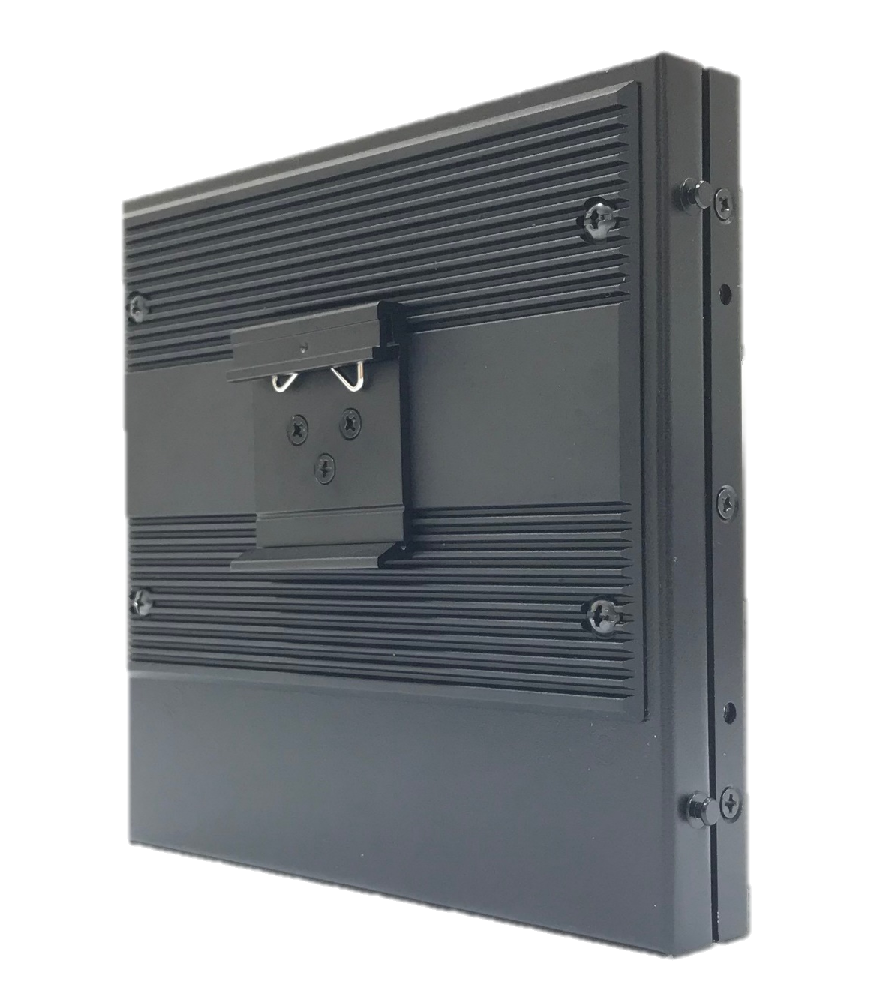
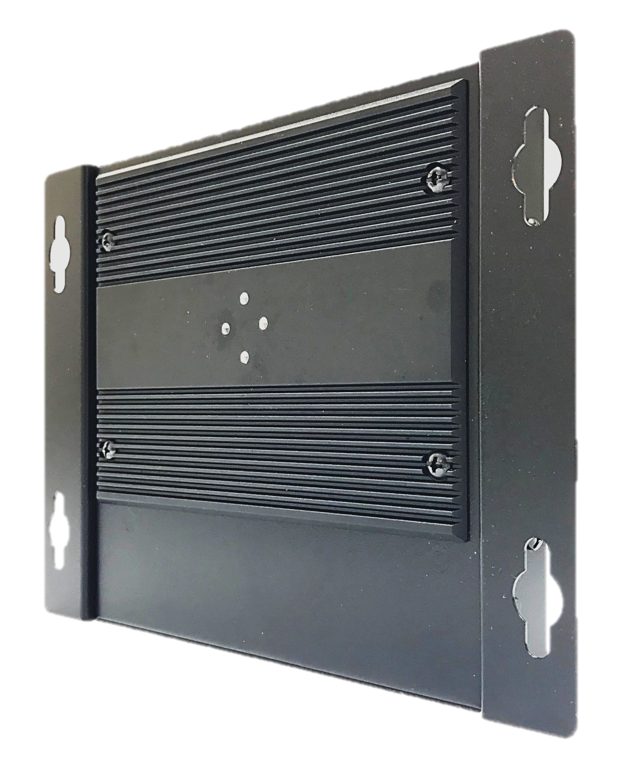
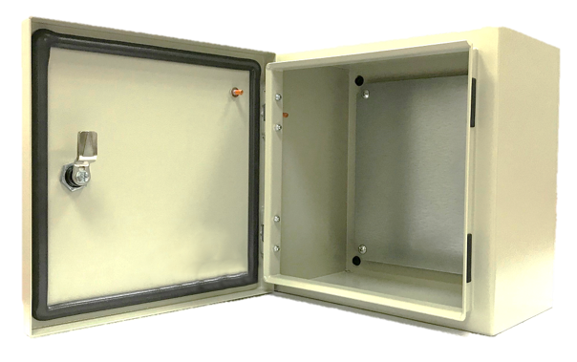
Din rail mount

Wall mount
Cabinet
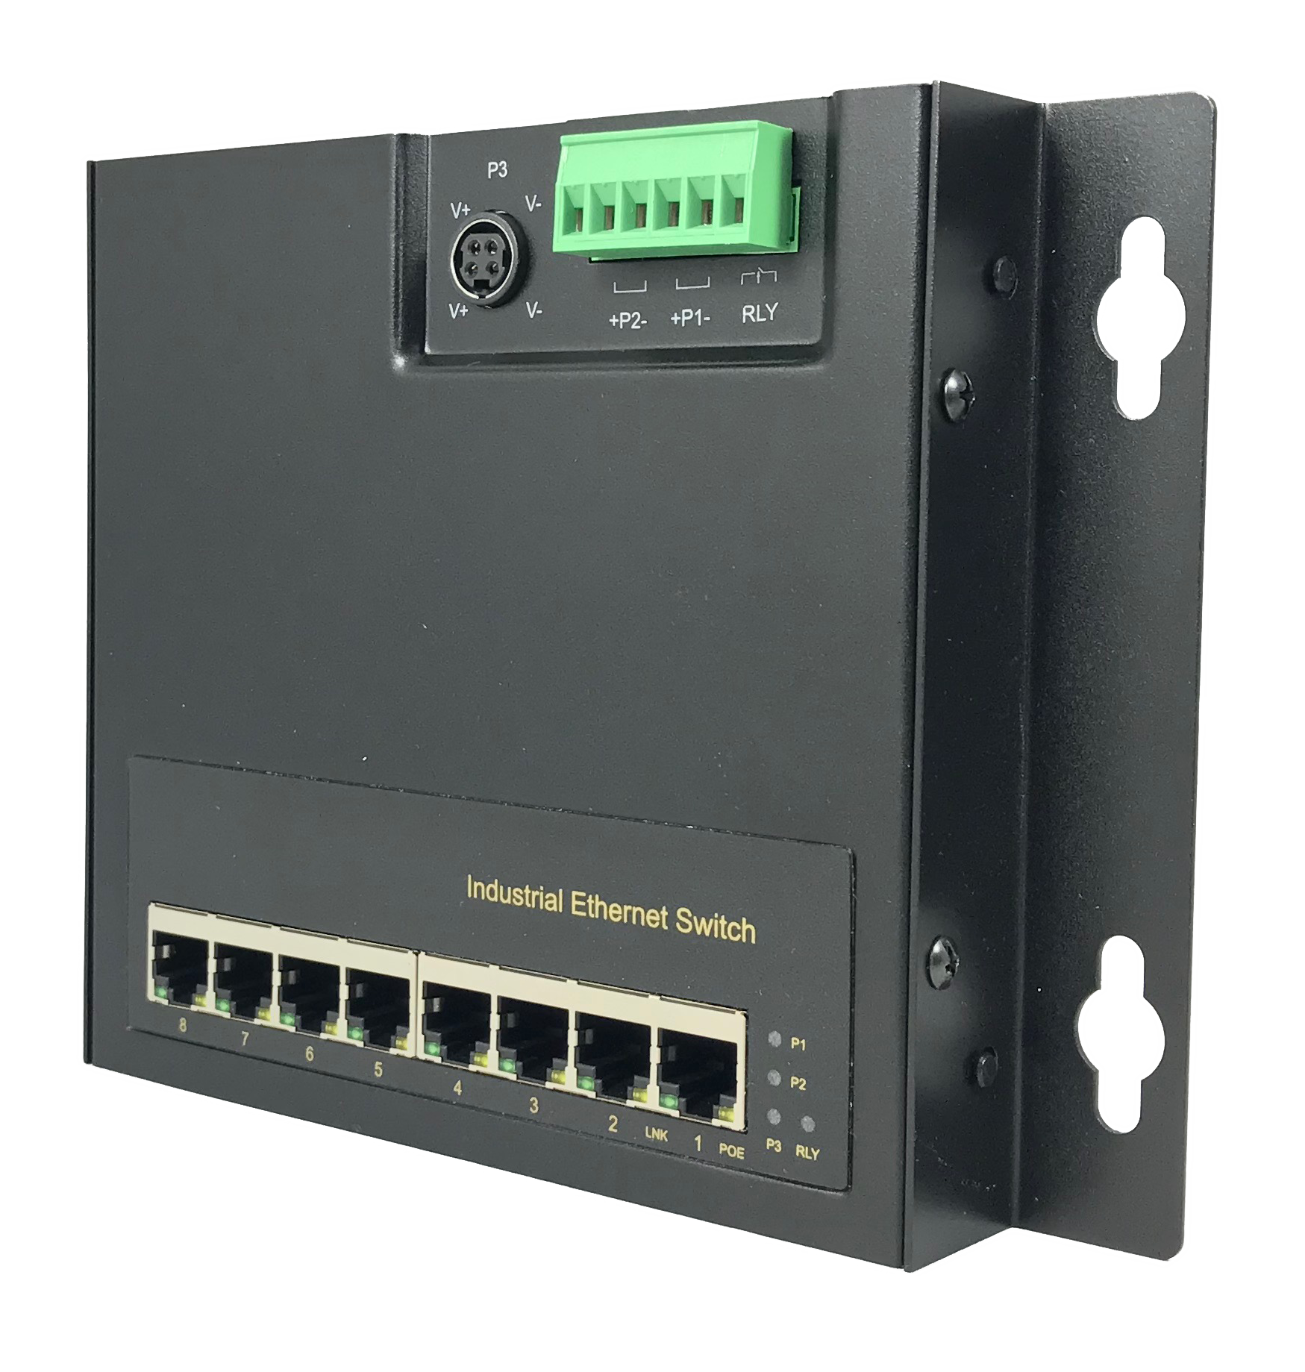

H8080X

Introduction

This Industrial, 6 port, Unmanaged, POE switch (IEEE802.3 af/at) is designed for IP surveillance, traffic monitoring, industrial applications and for a broad range of other applications. The unique flat design is perfect for space-limited environments, such as a shallow cabinet or a small enclosure. It is equipped with 4 x 30W PSE ports, and can deliver up to 200 Watts of power to your PD devices. Supports 2 x 100/1000 SFP Ports for Media Conversion, Extended Distance Requirements, or Network Redundancy. It can be used as a stand-alone device for buses, trucks, and other vehicles for surveillance purposes. It has been rigorously tested for your security, transportation, and telco applications.

Specifications
IEEE Standards | IEEE 802.3 10Base-T Ethernet  IEEE 802.3u 100Base-TX Fast Ethernet  IEEE 802.3ab 1000Base-T Gigabit Ethernet  IEEE 802.3x Flow Control and Back Pressure,  IEEE 802.3af for POE  IEEE 802.3at for POE+
Switch Architecture | Back-plane (Switching Fabric): 17Gbps
Data Processing | Store and Forward
Flow Control | IEEE 802.3x Flow Control and Back Pressure
Jumbo Frame | 9KB
MAC address Table Size | 4K
Packet Buffer Size | 1Mbits
Network Connector | 4 x RJ-45 10/100/1000BaseT(X) auto negotiation,  Auto MDI/MDI-X function, Full / Half duplex  4 x Gigabit POE+ 802.3at/af PSE port, 30 Watts per port. 2 x 100/1000 SFP Slots for Multi-mode or Single-mode SFP support. (Any Distance)
Network Cable | UTP/STP above Cat.5e Cable
Network Cable | EIA/TIA-568 10-ohm (100m)
Protocol | CSMA/CD
LED | PW1 (Green): ON－Power 1 is detected  PW2 (Green): ON－Power 2 is detected  PW3 (Green): ON－Power 3 is detected for Power DIN  RLY (Amber): ON－Connect only PW1 or PW2  OFF－Both PW1 and PW2 are  connected
LED | TX/RJ-45 port:  LNK (Link/Active) (Green): ON－TX port is detected  Flashing－TX data is  transmitting/receiving  POE (Amber): ON－PD is detected and PSE is activated  OFF－PD is not detected
Reserve polarity protection | Yes
Overload current protection | Yes
Power Supply | Redundant Dual DC 48 ~ 56 Volt Power Inputs
Power Consumption | 5.76 Watts @ 48 Volts DC full load, Without POE

Alarm Relay Contact |  | Relay outputs - current carrying capacity of 1 AMP @ 24 Volts DC,  Relay in open circuit mode when 2 powers are connected. in short circuit mode when only one power supply is connected
POE power |  | POE power per port 30 Watts.  Maximum total power 240 Watts with 56VDC input, Supports IEEE802.3af/at
Removable Terminal Block |  | Provides 2 Redundant power inputs, Alarm relay contact ,6 Pin  Wire range: 0.34mm^2 to 2.5mm^2  Solid wire (AWG):12-24/14-22  Stranded wire(AWG): 12-24/14-22  Torque:5lb-In/0.5Nm/0.56Nm  Wire Strip length: 7-8mm
Operating Temperature |  | -40°C to +85°C
Operating Humidity |  | 5% to 95% (Non-condensing)
Storage Temperature |  | -40°C to 85°C
MTBF (mean time between failure) |  | >525,000 hours ( MIL-HDBK-217F) at 25°C
Housing |  | Military Grade with Aluminum, IP30 Protection
Case Dimension |  | 150 x 145 x 26.7 mm (L x W x D)  198 x 145 x 26.7 mm (L x W x D) (with brackets)
Weight |  | 0.75kg (with brackets)
Installation |  | DIN Rail Mount or Wall Mount
Certifications:
Safety | LVD(EN60950-1)
EMC | CE, FCC, EN 55032/24, NEMA TS-2
EMI | CISPR 32, FCC Part 15B Class A
EMS | IEC 61000-4-2 ESD: Contact: 6KV; Air: 8KV  IEC 61000-4-4 EFT: Power: 2KV; Signal: 2KV  IEC 61000-4-5 Surge: Power: 2KV; Signal: 2KV
Vibration | EN 60068-2-6
Shock | EN 60068-2-27
Free Fall | EN 60068-2-32

Housing Dimensions (mm)

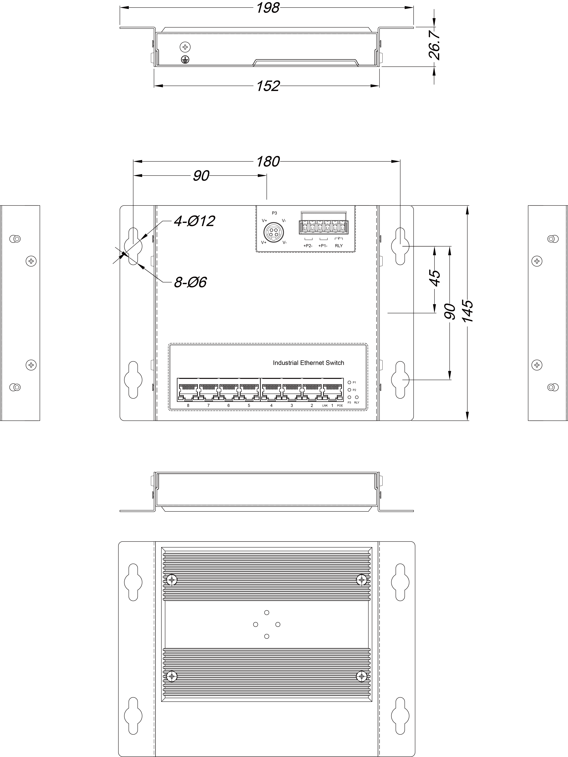

Typical Application

Intelligent Layer 2 Flat IP Network Surveillance System

Each intersection is deployed with four PZT cameras (each respectively pointing north, south, east and west). Three DYMEC switches supply channels with images and videos to three HDTV monitors. Video and Data is reliably transmitted over the network to the intersection via Gigabit optical ﬁber. The DYMEC switch aggregates and transmits trafﬁc lights control details,
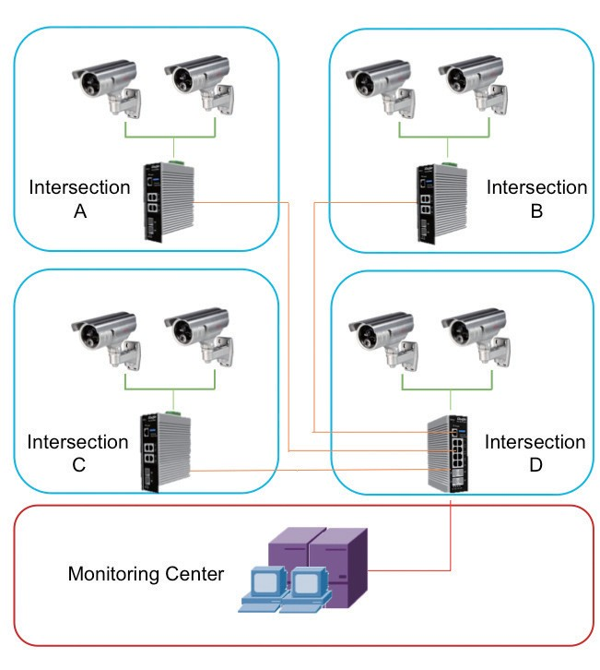
environmental monitoring data and video data to the control branch through optical ﬁber. Such data are ﬁnally sent to the traffic control and maintenance center via the core network.

Use DYMEC PoE+

Switches or DYMEC Traffic Switches

Intelligent IP Surveillance System

for Security & Intelligent Traffic Systems

