DY-H8080XR
DYMEC – Hardened, Industrial 8 port Gigabit Flat PoE Switch,
8 x 10/100/1000 TX, 30 Watt PSE, 2KV Surge Immunity / Isolation
Supports power 1, power 2, and power din (for external power adapter),
Input Voltage: 48 ~ 56 Volts DC, Operating Temperature: -40°C to +75°C

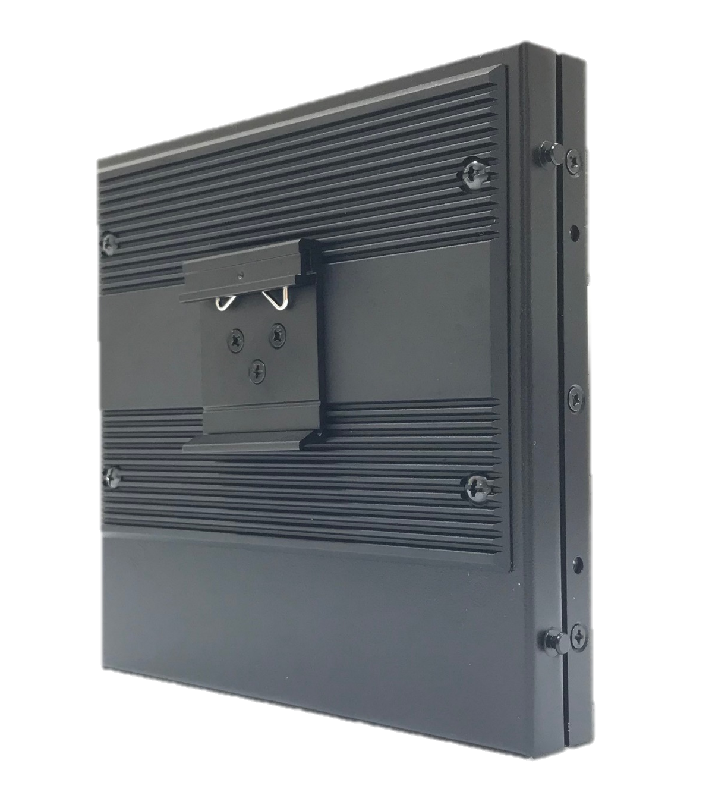
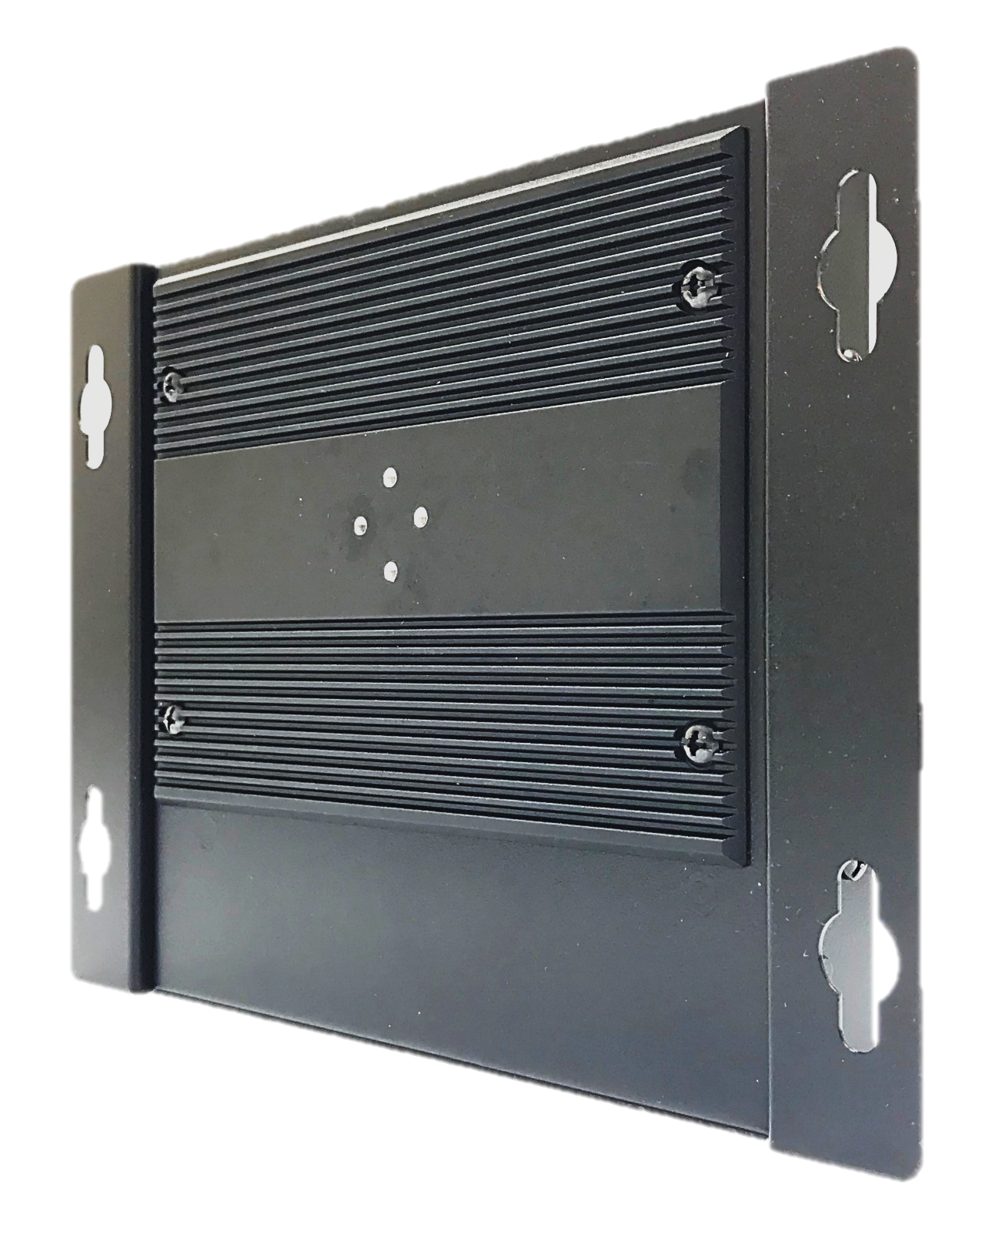
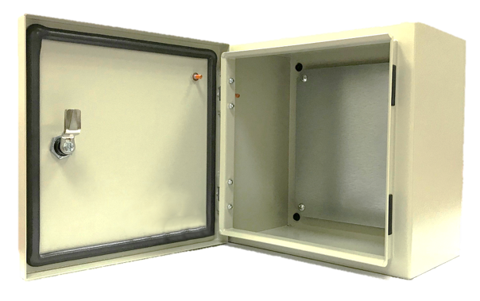
Din rail mount

Wall mount
Cabinet
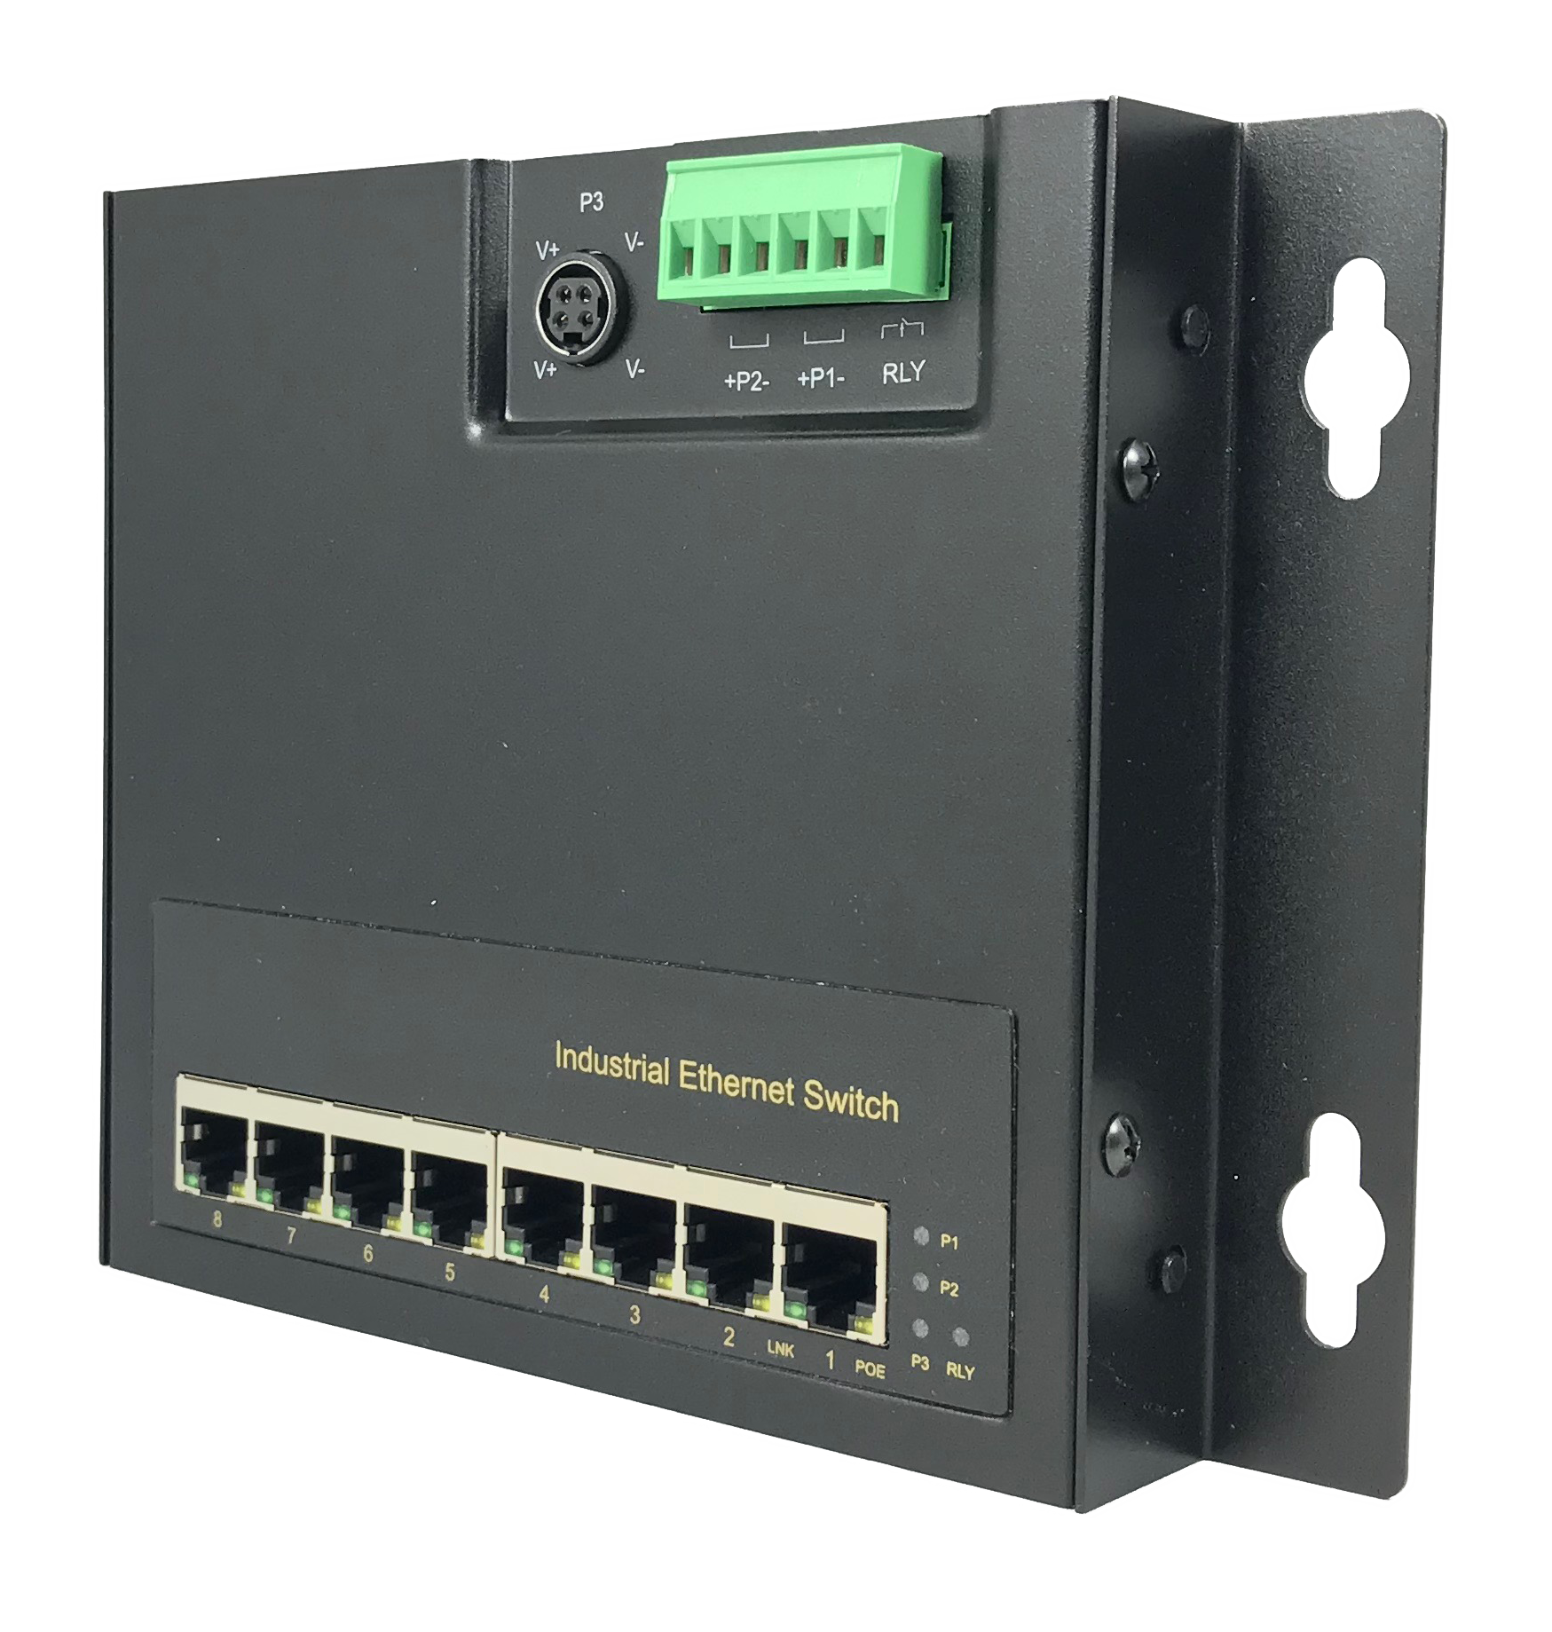

H8080X

Introduction

This Industrial 8 port POE switch is designed for IP surveillance, traffic monitoring, industrial applications and for a broad range of other applications. The unique flat design is perfect for space-limited environments, such as a shallow cabinet or a small enclosure. It is equipped with 8 x 30W PSE ports, and can deliver up to 200 Watts of power to your PD devices. It can be used as a stand-alone device for buses, trucks, and other vehicles for surveillance purposes. It has been rigorously tested for your security, transportation and telco applications.

Specifications
IEEE Standard | IEEE 802.3 10Base-T Ethernet  IEEE 802.3u 100Base-TX Fast Ethernet  IEEE 802.3ab 1000Base-T Gigabit Ethernet  IEEE 802.3x Flow Control and Back Pressure,  IEEE 802.3af for POE  IEEE 802.3at for POE+
Switch Architecture | Back-plane (Switching Fabric): 17Gbps
Data Processing | Store and Forward
Flow Control | IEEE 802.3x Flow Control and Back Pressure
Jumbo Frame | 9KB
MAC address Table Size | 4K
Packet Buffer Size | 1Mbits
Network Connector | 8 x RJ-45 10/100/1000BaseT(X) auto negotiation,  Auto MDI/MDI-X function, Full/Half duplex  8 x Gigabit POE+ 802.3at/af PSE port, 30 Watts per port
Network Cable | UTP/STP above Cat.5e Cable
Network Cable | EIA/TIA-568 10-ohm (100m)
Protocol | CSMA/CD
LED | PW1 (Green): ON－Power 1 is detected  PW2 (Green): ON－Power 2 is detected  PW3 (Green): ON－Power 3 is detected for Power DIN  RLY (Amber): ON－Connect only PW1 or PW2  OFF－Both PW1 and PW2 are  connected
LED | TX/RJ-45 port:  LNK (Link/Active) (Green): ON－TX port is detected  Flashing－TX data is  transmitting/receiving  POE (Amber): ON－PD is detected and PSE is activated  OFF－PD is not detected
Reserve polarity protection | Yes
Overload current protection | Yes
Power Supply | Redundant Dual DC 48 ~ 56 Volt Power Inputs
Power Consumption | 5.76 Watts @ 48 Volts DC full load, Without POE

Alarm Relay Contact |  | Relay outputs - current carrying capacity of 1 AMP @ 24 Volts DC,  Relay in open circuit mode when 2 powers are connected. in short circuit mode when only one power supply is connected
POE power |  | POE power per port 30 Watts.  Maximum total power 240 Watts with 56VDC input, Supports IEEE802.3af/at
Removable Terminal Block |  | Provides 2 Redundant power inputs, Alarm relay contact ,6 Pin  Wire range: 0.34mm^2 to 2.5mm^2  Solid wire (AWG):12-24/14-22  Stranded wire(AWG): 12-24/14-22  Torque:5lb-In/0.5Nm/0.56Nm  Wire Strip length: 7-8mm
Operating Temperature |  | -40°C to +85°C
Operating Humidity |  | 5% to 95% (Non-condensing)
Storage Temperature |  | -40°C to 85°C
MTBF (mean time between failure) |  | >525,000 hours ( MIL-HDBK-217F) at 25°C
Housing |  | Military Grade with Aluminum, IP30 Protection
Case Dimension |  | 150 x 145 x 26.7 mm (L x W x D)  198 x 145 x 26.7 mm (L x W x D) (with brackets)
Weight |  | 0.75kg (with brackets)
Installation |  | DIN Rail Mount or Wall Mount
Certifications:
Safety | LVD(EN60950-1)
EMC | CE, FCC, EN 55032/24, NEMA TS-2
EMI | CISPR 32, FCC Part 15B Class A
EMS | IEC 61000-4-2 ESD: Contact: 6KV; Air: 8KV  IEC 61000-4-4 EFT: Power: 2KV; Signal: 2KV  IEC 61000-4-5 Surge: Power: 2KV; Signal: 2KV
Vibration | EN 60068-2-6
Shock | EN 60068-2-27
Free Fall | EN 60068-2-32

Housing Dimensions (mm)



