DY-6077 (M / S): 8 x Serial Multiplexer over Fiber Modem

8 x RS-232 / RS-485 / RS-422 Multiplexer Fiber Modem
Model：DY-6077M
DYMEC SERIAL LINKS
Operators Manual
Printed April 2020 Rev 1.1

DYMEC

Kansas City, Missouri,
Telephone: (916) 988-7861
FAX: (480) 287-8605

Web Sites: www.DYMEC.com

Copyright DYMEC™ 2020 – All Rights Reserved
Official Copyright Notice: The information in this manual is subject to change without notice to improve reliability, design and function and does not represent a commitment on the part manufacturer. No part of this manual may be reproduced, copied, or transmitted in any form, without prior written permission by the manufacturer. Products mentioned in this manual are mentioned for identification purposes only. In this manual, product names appearing may or may not be registered trademarks of their respective companies or copyright.

- Brief introduction
DY-6077M multiplexer fiber modem can transmit 8 separate channels of RS-232/RS-485/422 signals bidirectionally across-one fiber optic line.
- Capability Parameter
Electronic Port | Supports RS-232 / RS-485 / RS-422
Fiber Optic Port | FC/ST/SC
Isolation protection | 20Kv static and 600W/ms lightning protection
Power Supply | DC5~12V
Power loss | <5W
Fiber Communication distances | Multi-mode Fiber (-M): 2~5 km.  Single-mode Fiber (-S): 20Km ( Note: 40Km, 60Km are also available)
Baud rate | 300～115.2 Kbps Auto-adaptive
Bit error rate | ≤10⁻⁹
Transmission power | ≥-10dBm
Sensitivity | ≤-34dBm
Wavelength  Opto-isolation | Multi-mode(-M): 850nm/1310nm.  Single Mode(-S): 1310nm/1550nm  3 KV DC
Applicable optical fibers | Multi-mode: 62.5/125μm or 50/125μm  Single mode: 9/125μm
Dimensions:  (mm) (W x H x D) | 225 × 30 × 96
Working temperature | -40°～+85℃
Ambient Relative Humidity | 0~95%
- User guide
- Indicator lights
POW: Power indicator red, light on
TXD: Fiber optic port data sent green, Blinking
RXD: Fiber optic port data receive green, Blinking
TX1-TX8: 8 x serial port data sent (TX) green, Blinking
RX1-RX8: 8 x serial port data receive (RX) green，Blinking
ERR: Fiber link fault indicator light red: when the port is first powered on. If the fiber line has a link fault or the optical port does not receive the correct data, the light turn on (RED); when the fiber link is good, the light is turned off. (No ERR)
- The DIP Switch
K1 to K8 are dip switches that control channels 1 to 8 respectively. When the switch position is down, the associated channel port works in RS485 mode. When the switch position is up, the associated channel port works in RS422 mode.
- RJ45 function
The DY-6077(M/S) has 8 x RJ45 ports for RS-232/485/422 communications.
Note: The 8 x Serial ports are individual and separate channels. They have no relation to each other. CH1 communicates with CH1, CH2 communicates with CH2,and so on..
The following illustration shows the associated connections:
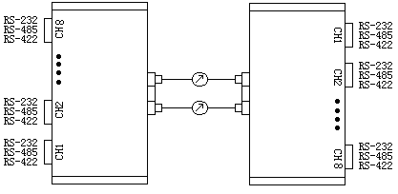
The DY-6077 (M / S) has 8 serial ports. The ports are User Selectable to RS232, RS485 or RS422 via the DIP switch settings
Port pinouts are defined as follows：
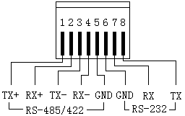
      - RS232 Connection Guide
RS232 connections use three lines. RS-232 uses RJ45 port pin 6, pin 7 and pin 8. These three signal lines are defined as: Pin 6 is GND, pin 7 is RX (RS232 signal from the external device to the DY-6077M), pin 8 is TX (RS232 signal from the DY-6077M to the external device).
Note: When communicating in RS232 mode, the RJ45 port pins 1, 2, 3,and pin 4 are NOT used. The pins MUST not be connected to any signal lines. Dip Switch K1～K8 must be in the OFF position.

      - RS485 Connection Guide:
Please insure the following:
Short circuit the TX+ and RX+ as signal line A+.
Short circuit the TX- and RX- as a signal B-.
The associated DIP switch should be down. Pins 7 and 8 should / must be neutral and not connected to any signal lines.

      - RS-422 Connection Guide
RS-422 connections utilize 4 lines. They are: TX+、RX+、TX-、RX-. The associated channel DIP switch should be up(OFF). Pins 7 and8 should / must be neutral and not connected to any signal lines.
- Ground Connection Guide
It is important to connect the GND (ground) lines. This must be done because the RS-485 (or RS-422) line communications potential difference must be <12V.
RS-485 Serial connections utilize 3 lines (A＋,B－,GND). RS-422 Serial connections utilize 5 lines (TX+,TX-,RX+,RX-,GND). The Signal GND line will connect with each other, but do not connect to the earth ground.
- Fiber Optic Port
Connect the two fiber modems end to end via the fiber cable line, TX connects with RX of the opposite modem. The ERR light should be off when the fiber link is GOOD.
6）RJ45 Line Guide
NOTE: RS-232 signals are easy influenced by RS-485 / RS-422 signals. When the device is connected with RS-485 (or RS-422) signals, please ensure the RS232 lines (pin 7 - RX line and pin 8 - TX line) are not connected. Make the RJ45 connection as followings：
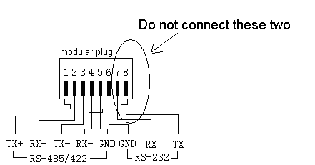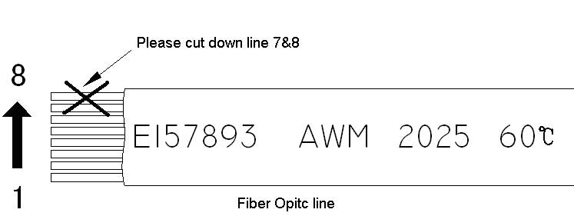
Thank you

