RS-232/RS-485/RS-422 Fiber Optic Media Converter / Serial Link | 
Model：DY-5877S
DYMEC Original Replacement Part
Brief introduction
The RS-232 / RS-485 / RS- 422 fiber optic modem serial link can be used for the transfer of RS232, RS485 or RS422 signals by using a fiber link. (Opto-Isolation) It can extend the distance of serial communications and resist electromagnetic disturbances and provide opto-isolation.

Main Functions
RS-232, RS-485 or RS-422 signal ports can be chosen on the green terminal block.
The Internal intelligent module auto recognizes RS485 signal flow, with no need for CTS control.
The Serial Link provides transparent data communication, baud rate adapted with no need to reset the user link.

PIN Selection for Serial Copper Connection
The RS232/485/422 signal port is an industrial terminal block as shown below：
Din-rail Type utilizes a 7-pin terminal block. Pin connections are clearly marked on the serial link casing.
Location: Just below the fiber connectors.

Pin # | 1 | 2 | 3 | 4 | 5 | 6 | 7
Definition | T+ | T- | R+ | R- | GND | TXD | RXD
Signal Type | RS-485/RS-422 |  |  |  |  | RS-232

BE AWARE: the input power polarity is important. A wrong connection will damage the equipment.

Attention:
Indicator Lights
The DY-5877S has four indicator lights (LED’s):
- The PWR1 light is for the power input marked V1+ & V1-.
- The PWR2 light is for the power input marked V2+ & V2-.
- The TX light shows transmission data (outbound).
- The RX light shows receive data (ingress).
DEVICE SPECIFICATIONS:

Power Supply | AC85-264V or DC110-370V
Working current | <20mA
Baud Rate | 300～115.2Kbps
Communication Fiber distance | Single mode <20Km，
Serial port | 7 - Way Industrial Terminal Block (SCREW)
Dual Power Input | 5 - Way Industrial Terminal Block (SCREW)
Optical Port | ST Connector (Default) with SC/FC are Optional
Wavelength | Single mode 1310nm
Fiber type | Single mode 9 / 125μm
Transmission power | ≥-8dBm
Incept delicacy | ≤-20dBm
ESD Static Protection | 20 KV ESD
Opto-Isolation | 3 KV DC
Lightning Protection | 600 W/ms – Anti-lightning Strike
Dimensions | 108mm × 34mm × 126mm  4.46” x 1.34” x 4.97”
Weight | ,4Kg / .89 Lb.
Working temperature | -40℃～85℃ / -40 ~185F

BE AWARE: the input power polarity is important. A wrong connection will damage the equipment.

PIN Selection for POWER Connections
The Dual Input Power ports are an industrial terminal block as shown below：
Din-rail Type utilizes a 7-pin terminal block. Power Pin connections are clearly marked on the serial link casing.
Location: On the top of the device.

Pin # | V1+ | V1- | GND | V2+ | V2-
Definition | T+ | T- | R+ | R- | GND
Input Type | AC85-264V or DC110-370V  BE AWARE OF POLARITY  WHEN CONNECTING POWER.  ENSURE ALL CONNECTIONS  ARE TIGHT

DATA APPLICATIONS:

Please NOTE:
- The DY-5877S RS-485/422 ports are auto-adaptable.
- When used as an RS-485 port, it connects with Pin 1, Pin 2, and Pin 5. These three pins are defined as follows: Pin 1 is A+（485+), Pin 2 is B- (485-) with Pin 5 being GND (Ground).

- When used as an RS-422 port, it connects with Pin1, Pin 2, Pin 3, Pin 4, and Pin5. These five pins are defined as follows: Pin1 is T+, Pin 2 is T-, Pin 3 is R+，Pin 4 is R- with Pin 5 being GND (Ground).

- When used as an RS-232 port, it connects with Pin 5, Pin 6, and Pin 7. These three pins are defined as follows: Pin5 is GND, Pin 6 is TXD (Transmit Signal), and Pin 7 is RXD (Receive Signal)

Applications:

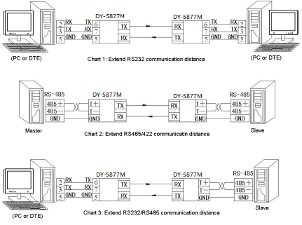

Kansas City, Missouri, Telephone: (816) 988-7861
Web Sites: www.DYMEC.com
Copyright DYMEC 2024
All Rights Reserved
ADDITIONAL INFORMATION:
DB-9 PORT STRUCTURE

Pin Out Assignment
Pin # | Signal | DTE | DCE
1 | Data Carrier Detect (DCD) | IN | OUT
2 | Receive Data (RD) | IN | OUT
3 | Transmit Data (TD) | OUT | IN
4 | Data Terminal Ready (DTR) | OUT | IN
5 | Signal Ground (SGND) | - | -
6 | Data Set Ready (DSR) | IN | OUT
7 | Request to Send (RTS) | OUT | IN
8 | Clear to Send (CTS) | IN | OUT
9 | Ring Indicator (RI) | IN | OUT

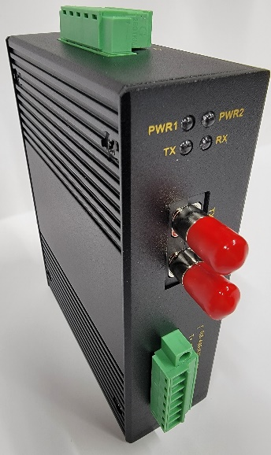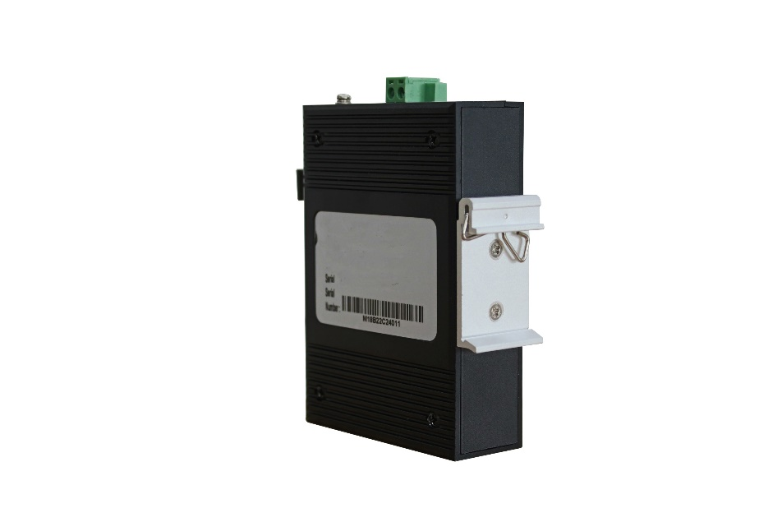

Warranty
This product is warranted to the original purchaser (Buyer) against defects in material and workmanship for a period of five (5) years from the date of shipment. During the warranty period, DYMEC will, at its option, repair or replace a product which is proven to be defective with the same product or with a product with at least the same functionality.
For warranty service, the product must be sent to an DYMEC designated facility, at the Buyer’s expense. DYMEC will pay the shipping charge to return the product to Buyer’s designated US address using DYMEC’s standard shipping method.

Limitation of Warranty
The foregoing warranty shall not apply to product malfunctions resulting from improper or inadequate use and /or maintenance of the equipment by Buyer, Buyer-supplied equipment, Buyer-supplied interfacing, unauthorized modifications or tampering with equipment (including removal of equipment cover by personnel not specifically authorized and certified by DYMEC), or misuse, or operating outside the environmental specification of the product (including but not limited to voltage, ambient temperature, radiation, unusual dust, etc.), or improper site preparation or maintenance.
No other warranty is expressed or implied. DYMEC specifically disclaims the implied warranties of merchantability and fitness for any particular purpose.
The remedies provided herein are the Buyer’s sole and exclusive remedies. DYMEC shall not be liable for any direct, indirect, special, incidental, or consequential damages, whether based on contract, tort, or any legal theory.

Environmental Notices
The equipment covered by this manual must be disposed of or recycled in accordance with the Waste Electrical and Electronic Equipment Directive (WEEE Directive) of the European Community directive 2012/19/2021 EU on waste electrical and electronic equipment (WEEE) which, together with the RoHS Directive 2015/863/EU, for electrical and electronic equipment sold in the EU after July 2019. Such disposal must follow national legislation for IT and Telecommunication equipment in accordance with the WEEE directive:
(a) Do not dispose of waste equipment with unsorted municipal and household waste.
(b) Collect equipment waste separately.
(c) Return equipment using collection method agreed with DYMEC.

Safety Warnings and Cautions

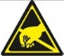 ATTENTION: Observe precautions for handling electrostatic discharge sensitive devices.

WARNING: Potential damage to equipment and personal injury.
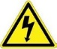 WARNING: Risk of electrical shock.

Customer Support Information
Phone: (816) 988-7861

Address: DYMEC, Inc.
1107 SE Willow Pl
Blue Springs, MO 64014 USA
Email: support@DYMEC.com URL: www.DYMEC.com

