DATA SHEET

Security as a Service - SaaS // Cyber-Secure

BWS700-74/40 BLE Padlock

Anti-Bolt Cutter

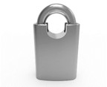

GENERAL
Dimensions & Weight | 74 x 40 mm | 340g
Usage | Indoor / Outdoor / Hazardous Locations
Shackle Dimensions | Height: 40 mm (standard) 30 mm, 20 mm | Thickness 11 mm
Build Material | 304 Stainless Steel | Bottom Cover: TPE Sealing Cap: Silicon
ENVIRONMENT
Temperature | -40 °C to +85 °C (Operation)
Relative Humidity (RH) | 0 to 95% (without condensation)
Ingress Protection | IP67
ELECTRONICS
Power Supply - None | Lock Powered by a USB Micro rechargeable USB Key Fob – Lithium Battery
Encryption | AES 256-bit
LOGIC
Accessible Keys | >2 Million
Encrypted Audit Trail | >60,000 Audit Events | >20,000 Cylinders
COMPATIBILITY
Keys | All Key BLE Types / Rechargeable USB BLE 4.0 Lithium – via USB Mini C
CERTIFICATIONS
CE / NIST / BLE / NEMA TS-2
WARRANTY
Warranty | 5 years




33mm
1.29”
69mm
130mm
5.11”
79mm
3.11”
37mm
1.45”

2.71”

Ø11mm
0.43”
61mm
2.40”
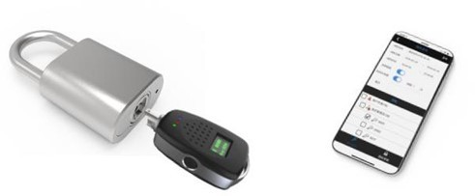
SHACKLE HEIGHTS

40mm

STANDARD

30mm

20mm

BlueKey™ Rugged, Military Grade, 304 Stainless Steel, Encrypted, Bluetooth Low Energy (BLE), High Security Padlock.
No wires, No Batteries & No Maintenance.
America’s #1 Security Padlock for use indoors or outdoors. Waterproof and Dustproof – IP65 Ingress Protection
5 Year Warranty – NIST Compliant
Transportation Security – Patent Pending

