

BlueKey® Smart Lock Encrypted Platform System
Bluetooth Key User Manual

www.BlueWARRIOR.com

Data Sheet
BLE Key
Part Number: BW-Bluetooth Key
Copyright BlueWARRIOR 2021 – All Rights Reserved
Patent Pending

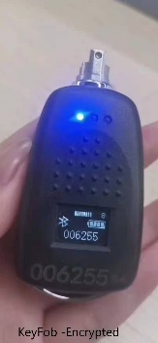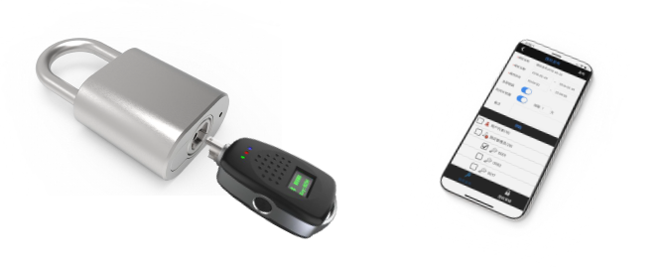

Important Notice

The publication is intended to be distributed to qualified customers (person / organization) whose official e-mail address has been recorded and assigned.

BlueWARRIOR reserves the right to make changes to its product specifications and this document without notice. A customer may request the latest version of product specifications and this document by contacting the contact point listed at the end of this document.
BlueWARRIOR assumes no responsibility, for any loss, harm or other consequences resulting from the use of information contained herein.
BlueWARRIOR recommends the product described in this document being used for the application it is designed to; detailed qualification is recommended before the judgment of suitability. BlueWARRIOR makes no warranty or guarantee regarding the suitability of its products for any particular purpose, including but not limited to aircraft, space, military, medical and life-support systems; and BlueWARRIOR assumes no responsibility for such use.
This document shall not be used to transfer or convey the right to use intellectual property mentioned herein, including but not limited to patents, trademarks or software copyrights.





FEDERAL SECURITY / SUITABILITY CLEARANCE CHART

SENSITIVITY REINVESTIGATION LEVEL (1) | CATEGORY |  |  | SECURITY/SUITABILITY CLEARANCE DETERMINATION
Level 1  None | Non-Sensitive |  |  | None, HSPD-12 PIV Card
Level 2  NACLC every 5 years (4) | National Security  Non-Critical Sensitive |  |  | Confidential, Secret or DOE “L”
Level 3  SSBI-PR every 5 years | National Security  Critical Sensitive |  |  | Top Secret
Level 4  “Q” SSBI-PR or PPR (6) every 5 years | National Security  Special Sensitive |  |  | Top Secret w/ SCI eligibility or DOE
Level 5  NACLC (9) | Public Trust (PT) (7) |  |  | Moderate Risk
Level 5  NACLC every 5 years | National Security & PT |  |  | Secret & Moderate Risk
Level 6  PRI every 5 years | Public Trust |  |  | High Risk
Level 6  PRI every 5 years | Public Trust Duties |  |  | High Risk involving designated
Level 6  PRI every 5 years | National Security & PT |  |  | Secret & High Risk

Table of Contents
Important Notice 2
FEDERAL SECURITY / SUITABILITY CLEARANCE CHART 3
Table of Contents 4
1 Introduction & Overview 5
2 Overview 6
2.1 Key Shape & Dimensions 6
2.2 Bluetooth Key Fob Schematic diagram 7
3 Feature Sets 8
3.1 Exterior & Interior Functionality 8
3.2 Unlock function 8
3.3 Bluetooth communication 8
3.4 Calendar function 8
3.5 Displaying Sound & Light Prompts 9
3.5.1 Screen Display, Sound & Light prompts - Function List 9
3.5.2 Bluetooth wake up screen display information 8
3.5.3 Prompt message for unlocking operation 12
3.10 Electrical Characteristics 2
4 Use process 3
5 Accessories list 4

Introduction & Overview

The electronic device (LOCK) controlled by the Bluetooth Key Fob is turned on and unlocked through the passive lock core components of each lock.
There are NO batteries in any lock.
There is NO wiring required for any lock

Key Fobs for Bluetooth locks.
Key Fobs are rechargeable via a micro-USB port.
Each Key Fob has a built-in lithium battery
Each Key Fob
The owner can authorize the Bluetooth Key unlocking authority through mobile phones, computers, or via the network with an appropriate connection.

Upon finishing daily operations with maintenance and other personnel turning on and off the locks, with the smart lock and the smart key simultaneously recording the unlocking time, personnel id, lock id number, time stamp and other information. The records are uploaded through the mobile application for records and analysis. The manager can check the records to confirm whether the inspectors / maintenance / contractors have been in the correct place and at the right time.
BENEFITS:
Full Audit Trail for all employees and departments
Lower costs than key systems
Complete Data Analytics
Control Inventory Loss
Grant After-Hours and Contractor Temporary Access
Meets Federal & State Government Physical Security Mandates
Eliminates costly Re-keying
Provides Accountability to Sensitive Information
Prevents Copied Keys
Respond to Missing Keys

This document provides the basic information and electrical characteristics of the BlueWARRIOR Bluetooth Key Fob.

Overview

Key Shape & Dimensions

The shape and size of the BlueWARRIOR Bluetooth Key Fobs are as shown in the figure below. Unit Dimensions: mm.

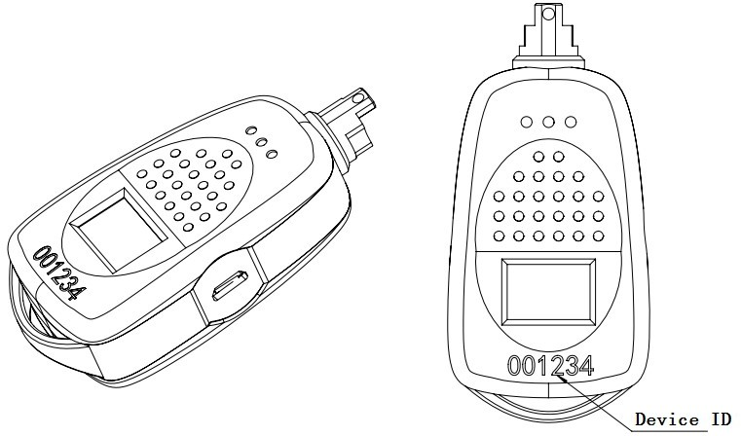

Figure 2-1 key shape

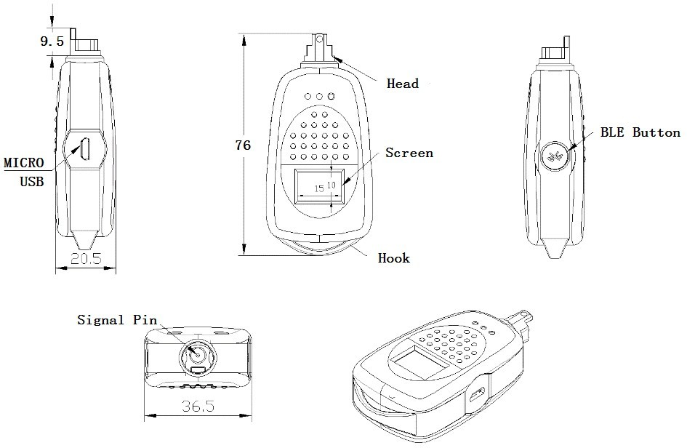

Figure 2-2 Key Dimensions in mm

Bluetooth Key Fob Schematic diagram

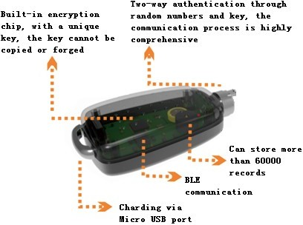

Figure 2-3 Schematic diagram

Feature Sets

Exterior & Interior Functionality

The electronic key is rugged, waterproof and is easy to carry. The front unlocking head should match the passive lock core interface of the padlock. The volume and shape should be suitable for operation.
- Built-in lithium battery.
- Built-in FULL Encryption
- Equipped with a standard micro-USB interface for charging.
- Configure the Bluetooth key switch to turn on or turn off Bluetooth.
- Configure the status display screen and status indicator to display the status of the electronic key and operation prompts.
- It is equipped with a portable metal hook, which is easy to Secure & carry.
- The device number is printed on the front of the electronic key.

Unlock function

The electronic key communicates with the mobile phone APP, through the operation of the mobile phone APP, after the authentication is successful, the unlocking is performed. It can also be unlocked by pre-writing the unlocking authority (with time effectiveness), inserting a padlock through a single-point contact with the passive lock cylinder and two-way encrypted communication to achieve unlocking without the mobile APP, so that the lock can be unlocked in an emergency when there is no network.

Bluetooth communication

The electronic key is equipped with a Bluetooth BLE 4.0 module (single mode), which communicates with the mobile phone APP via Bluetooth. It allows the Fob to receive instructions, to execute the applications instructions, and download / upload relevant information. All data exchanges are encrypted. By pressing the round button on the side to wake up the Bluetooth, you can connect with other Bluetooth devices.

Calendar function

With the calendar function, the user can calibrate the time through the mobile application.

Displaying Sound & Light Prompts

Screen Display, Sound & Light prompts - Function List

Table 1 Display, Sound and Light prompts Function List
No. | Type | Function
1 | Screen | Device ID
2 | Screen | Time
3 | Screen | Current authorization status
4 | Screen | Remaining battery
5 | Screen | Low battery reminder: When the battery voltage value is lower than 3.75V,  a low voltage indicator appears
6 | Screen | Charging status reminder: Charging, fully charged
7 | Screen | Bluetooth connection status: Connected, not connected
8 | Screen | Unlocking prompt: prompt message for unlocking failure
9 | Sound | Fully charged, 2 beeps
10 | Sound | Bluetooth connection is successful, 1 beep
11 | Sound | Low battery reminder: The buzzer beeps once
12 | Sound | Locking: 2 beeps; unlock: 1 beep (locking function)
13 | Sound | Unlock failure, full charge, 3 beeps
14 | Light | Bluetooth ready to connect: The blue light keeps flashing for 15s
15 | Light | Bluetooth connection: The blue light is always on
16 | Light | Low battery: Red light flashes 3 times
17 | Light | Unlocking: The red light is always on
18 | Light | Unlock failure: Red light flashes 3 times
19 | Light | Successful unlocking: Green light flashes once

..

Bluetooth wake up screen display information
The screen does not work when the key is in sleep mode. After triggering the Bluetooth wakeup, the screen is activated, and the following sequences executed.

Basic information interface

Display the basic information of the key, the user enters the platform, activates the power and connects to the APP to operate.
IIIIIIIIIIIIIII 15
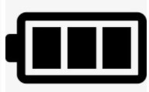
123456

The device shows - Sleep countdown, Bluetooth connection icon, remaining power, key device id number.

All interfaces are played in a loop for a total of 15s, and the basic information of the key will continue to be displayed after the 1-7 sequence information is displayed.

Version interface

This is used for checking when troubleshooting the key fob remote assistance problem and has nothing to do with general usage.
IIIIIIIIIIIIIIII
14 sw: V3.0.05 hw: V3.0.07
The fob will display - Sleep countdown, key hardware version number, key software version number.

Time Interface & Syncing

Should the internal clock of the key fob drift, you may use the mobile application to reconnect and synchronize the time displayed.
IIIIIIIIIIIIIII
13
2020.01.05
08:05:33

Sleep countdown, key time

Authorization start time interface

Different displays when the key is authorized and not authorized
IIIIIIIIIIIIIII
12
2020.01.05
S:10:20:11
IIIIIIIIIIIIIII
12
no permission

Or

Shows - Sleep countdown, key time.

Authorization stop time interface

Different displays when the key is authorized and not authorized.
IIIIIIIIIIIIIII
12
no permission
IIIIIIIIIIIIIII
12
2020.03.05
E:10:20:11

or

Shows - Sleep countdown, authorization start time

Number of operations interfaces

When the user is authorized, this interface is shown when the authorized user is limited the number of unlocks.
IIIIIIIIIIIIIII |  | IIIIIIIIIIIIIII |  | IIIIIIIIIIIIIII
10 |  | 10 |  | 10
op limit |  | op limit |  | op limit
60000 |  | none |  | no limit
Shows - Sleep countdown, remaining unlock times. Interface 1: There is the number of operations; Interface 2: No remaining operations.
Interface 3: No limit on the number of operations.

Read lock information interface

When the Bluetooth is awakened, the lock cylinder is inserted to unlock, and the lock information will be displayed
00000001
reg fail
99999999
reg ok

An Unregistered lock indicates that the lock has not been used by the user key and can be unlocked with the engineering master key.
The registered lock means that the lock has been used by the user key and needs to be unlocked with the authorized user key. The engineering key cannot be used to unlock the lock.
Note: This effect will only be triggered when the key is awakened by Bluetooth and there is no connection. This function does not appear when the lock is unlocked in the normal sleep state or when the lock is unlocked online.

Prompt message for unlocking operation
Fig 1 Unlocking prompt message table

Trigger  method | Screen information |  |  | Status | Buzzer | Light
Charge | BLE | Battery  flashing | Key  ID | Charging |  |  | ———
 |  |  |  | Fully charged | — — |  | ———
BLE  button | Bluetooth  flashes | Battery | Key  ID | not connected | / | ● | – – –
 |  |  |  | connected | – | ● | ———
BLE  button | Low battery |  |  |  | —
unlock
unlock |  |  |  | Successfully  unlocked | – | ● | – – –
unlock | Password match failed |  |  | Failed to unlock | – – – | ● | – – –
unlock | No permission |  |  | Failed to unlock | – – – | ● | – – –
unlock | Permission expired |  |  | Failed to unlock | – – – | ● | – – –
unlock | Permission not reached |  |  | Failed to unlock | – – – | ● | – – –
unlock | Poor contact |  |  | Failed to unlock | – – – | ● | – – –
unlock | Insufficient number of unlocks |  |  | Failed to unlock | – – – | ● | – – –
Note 1: “—”Indicates that the buzzer beeps for a long time “–”Indicates that the buzzer beeps for a short time “–”Indicates that the light flashes once “———”Indicates the lights are always on
“●●●”Respectively indicate that the blue, green, and red lights are on
Note 2: Bluetooth connection: Click the tail button, Bluetooth will activate and start, and it will go to sleep again by default for about 30 seconds. The app is successfully connected, and the blue LED on the rear front will change from flashing to steady to enter the Bluetooth communication configuration state.

  - Torsional stress

When the key is turned on, it can withstand the 3N·m torque transmitted by the key.

  - Flexibility

When the key is opened and locked, it is flexible and does not jam.
The axial static pulling force when the key is pulled out is less than or equal to 5N.

  - Durability

The key insertion, rotation and withdrawal are considered one operation. The battery operating life is ≥6000 operations under normal working conditions. .

  - Stability

Under normal working conditions of the battery, the battery should be opened and closed continuously for no less than 5000 times without malfunction, electrical failure or mechanical failure.

Electrical Characteristics

Table 2 Electrical characteristics

Parameter | Conditions | Minimum | Maximum | Unit
Operating voltage |  | 3.6 | 4.2 | V
Low voltage alert |  | 3.75 |  | V
Operating current |  |  | 30 | mA
Unlock current |  |  | 300 | mA
Sleep current |  |  | 10 | uA
Standby time |  |  | 30 | Days
Number of unlocks |  | 300 |  | Times
Charging voltage |  | 4.2 | 5.5 | V
Data retention time | Power down | 10 |  | Years
Calendar hold time | Power down | 0.5 |  | Years
# of authorization records |  | 0 ~ 6000 |  | cycles
# of unlock records |  | 3000 |  | cycles

Use Process

Platform Authorization:
After the account / platform has been registered or assigned an account, complete the basic information and proceed to issue the electronic key authorization.

Mobile Phone Authorization:
Electronic key application: login system, mobile phone - Bluetooth connection electronic key automatically upload records, downloads permissions.
Bluetooth disconnection: Disconnect Bluetooth or exit the application, then wait for the light to go out before unlocking.
Perform unlocking: The key head of the electronic key is completely pushed into the lock cylinder, and the key is turned to unlock after the two parties are successfully authenticated.
Complete unlocking: The electronic key is pulled out of the lock, and the unlocking is completed. All data recorded.

Accessories list
Parameter | NO. | Remark
BLE key | 1
Nameplate | 1
Packing box | 1
Charging Cable | 1 | Micro USB


Please Contact us at:

BlueWARRIOR.com
SecurityTransform.com
DYMEC.com
Address: Kansas City, Missouri, USA

Telephone: 816-988-7861

Email:
Sales@BlueWARRIOR.com (Commercial Sales)
Sales@DYMEC.com.cn (Domestic Sales)

Support@BlueWARRIOR.com (Technical & Account Support)
Support@DYMEC.com (Technical & Account Support)

Websites:
www.BlueWARRIOR.com
http://www.SecurityTransform.com
http://www.DYMEC.com

Sales Contacts:

Terry Shelton Thom Sherer
Email: terryshelton909@gmail.com Thom.Sherer@DYMEC.com
Telephone: (303) 229-7068 (713) 826-0739
Golden, Colorado Houston, Texas

Carl Johnson Tom West
Email: carl.johnson@dymec.com twest@dymec.com
Telephone: (512) 635-5630 (816) 214-1946
Dallas, Texas Kansas City, Missouri

