DATA SHEET

Security as a Service - SaaS // Cyber-Secure // BlueKey™

BW- Bluetooth Key
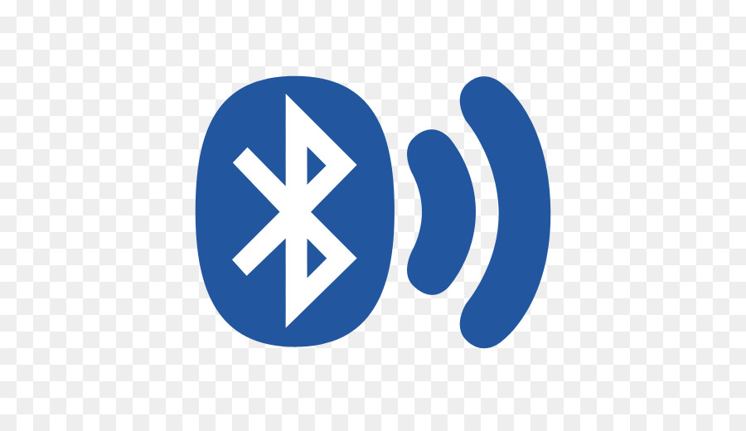
Rugged, Military Grade, 304 Stainless Steel, Encrypted, Bluetooth Low Energy (BLE), High Security Key Fob.
No wires, No Batteries & No Maintenance.
America’s #1 Traffic Enclosure Lock.
Waterproof and Dustproof – IP65 Ingress Protection. Full Audit Trail
3 Year Warranty – NIST Compliant – Patent Pending

BW-Bluetooth Key

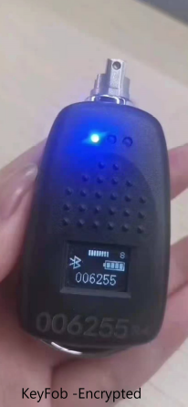

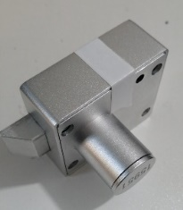

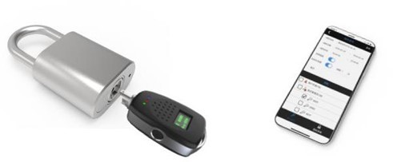
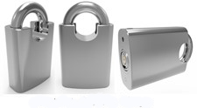


GENERAL
Dimensions & Weight | 76 x 36.5 x 20.5 mm | 55g
Usage | Indoor / Outdoor / Hazardous Locations
Indicators | Yes – LED Lights, LED Screen, BEEPS
Build Material | 304 Stainless Steel | Bottom Cover: TPE Sealing Cap: Silicon
ENVIRONMENT
Temperature | -40 °C to +85 °C (Operation)
Relative Humidity (RH) | 0 to 95% (without condensation)
Ingress Protection | IP65
ELECTRONICS
Power Supply – Lithium Battery | USB Micro rechargeable USB Key – Lithium Battery
Encryption | AES 256-bit
LOGIC
Accessible Keys | >2 Million
Encrypted Audit Trail | >60,000 Audit Events | >20,000 Cylinders
COMPATIBILITY
Keys | All Key Types / Rechargeable USB C Port
CERTIFICATIONS
CE / NIST / BLE / NEMA TS-2
WARRANTY
Warranty | 3 years

